Concepts covered:
- Solving other problems in sales order dataset
- Sub-query
- Joins

Solving other problems in sales order dataset:
Sales order questions:
- Find total no of orders per each day. Sort data based on highest orders.
- Display the total sales figure for each quarter. Represent each quarter with their respective period ("JAN-MAR", "APR-JUN", ...).
- Identify how many cars, Motorcycles, trains and ships are available in the inventory. Treat all type of cars as just "Cars".
- Find the countries which have purchased more than 500 motorcycles.
-- Assignment:
- Find the orders where the sales amount is incorrect.
- Fetch the total sales done for each day.
- Fetch the top 3 months which have been doing the lowest sales.
- Find total no of orders per each day of the week (Monday to Sunday).
- Sort data based on highest orders.
- Find out the vehicles which was sold the most and which was sold the least. Output should be a single record with 2 columns.One column for most sold vehicle and other for least sold vehicle.
.

Sales order questions answers:
3. Find total no of orders per each day. Sort data based on highest orders.
select order_date,count(order_date) no_of_orders
from Sales_order
group by order_date
order by count(order_date) DESC;
OR
select order_date, count(*) as no_of_orders
from Sales_order
group by order_date
order by count(*) desc;
OR
select order_date, count(1) as no_of_orders
from Sales_order
group by order_date
order by count(1) desc;

4. Display the total sales figure for each quarter. Represent each quarter with their respective period ("JAN-MAR", "APR-JUN", ...).
select
CASE
WHEN qtr_id=1 THEN 'JAN-MAR'
WHEN qtr_id=2 THEN 'APR-JUN'
WHEN qtr_id=3 THEN 'JUL-SEP'
WHEN qtr_id=4 THEN 'OCT-DEC'
END as Quater,
round(sum(sales)::decimal,2)
from Sales_order
group by qtr_id
order by qtr_id;

OR
select
CASE
WHEN extract(quarter from order_date)=1 THEN 'JAN-MAR'
WHEN extract(quarter from order_date)=2 THEN 'APR-JUN'
WHEN extract(quarter from order_date)=3 THEN 'JUL-SEP'
WHEN extract(quarter from order_date)=4 THEN 'OCT-DEC'
END as Quater,
round(sum(sales)::decimal,2)
from Sales_order
group by extract(quarter from order_date)
order by extract(quarter from order_date);

- Identify how many cars, Motorcycles, trains and ships are available in the inventory. Treat all type of cars as just "Cars".
select product_line,count(product_line) as count
from Products
where lower(product_line) in ('motorcycles','trains','ships')
group by product_line
UNION ALL
select 'Cars' as product_line,count(product_line) as count
from Products
where lower(product_line) like '%cars%';
OR
select
CASE
WHEN lower(product_line) like '%cars%' THEN 'Cars'
ELSE product_line
END as Vehical_type,count(*)
from Products
where lower(product_line) in ('motorcycles','trains','ships') or
lower(product_line) like '%cars%'
group by CASE
WHEN lower(product_line) like '%cars%' THEN 'Cars'
ELSE product_line END;
OR
select
CASE
WHEN lower(product_line) like '%cars%' THEN 'Cars'
ELSE product_line
END as Vehical_type,count(*)
from Products
where lower(product_line) in ('motorcycles','trains','ships') or
lower(product_line) like '%cars%'
group by Vehical_type;

- Find the countries which have purchased more than 500 motorcycles.
select c.country,sum(so.quantity_ordered)
from Sales_order so
JOIN products p on so.product =p.product_code
JOIN customers c on so.customer=c.customer_id
where lower(p.product_line)='motorcycles'
group by c.country
having sum(so.quantity_ordered)>500
order by 2 DESC;

- Find out the vehicles which was sold the most and which was sold the least.
Output should be a single record with 2 columns.
One column for most sold vehicle and other for least sold vehicle.
Using sub-query:
select MAX(Total_sales) as Most_sold,MIN(Total_sales) as List_sold from (
select p.product_line,sum(so.quantity_ordered) as Total_sales
from Sales_order so
join products p on p.product_code = so.product
group by p.product_line
);

Using cross join to make 2 columns:
select *
from (select product_line ||' - '||sum(quantity_ordered) as most_sold_vehicle
from sales_order so
join products p on p.product_code = so.product
group by product_line
order by sum(quantity_ordered) desc
limit 1
) t1,
(
select product_line ||' - '||sum(quantity_ordered) as least_sold_vehicle
from sales_order so
join products p on p.product_code = so.product
group by product_line
order by sum(quantity_ordered)
limit 1
) t2;

Concepts :
Difference between COUNT(*), COUNT(constant like 1,2 etc..), COUNT(column_name) (As a solution of 3rd question Find total no of orders per each day. Sort data based on highest orders.)
create table baby_names
(
id int,
name varchar(20)
);

insert into baby_names values(1, 'Zayn');
insert into baby_names values(2, 'Zeke');
insert into baby_names values(3, 'Zoya');
insert into baby_names values(1, 'Zohan');
insert into baby_names values(4, null);

select count(*), count(1), count(name), count(id)
from baby_names;

count(*) Will give no of records. It won’t care what values in side.
count(constant) Works same as count(*)
count(column name) It count only non-null values in that column.

Output:
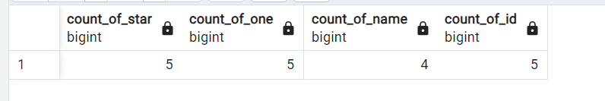

Subquery and Joins: ( as solution of 12th question Find out the vehicles which was sold the most and which was sold the least. Output should be a single record with 2 columns. One column for most sold vehicle and other for least sold vehicle)
SUB-QUERIES A query inside a query is called a subquery

Joins:
create table baby_names_bkp as select * from baby_names where id in (2,3);
create table baby_names_bkp2 as select * from baby_names where id in (3);
create table baby_names_bkp3 as select * from baby_names where id in (2);

select * from baby_names; -- 5 records
select * from baby_names_bkp; -- 2 records
select * from baby_names_bkp2; -- 1 records
select * from baby_names_bkp3; -- 1 records

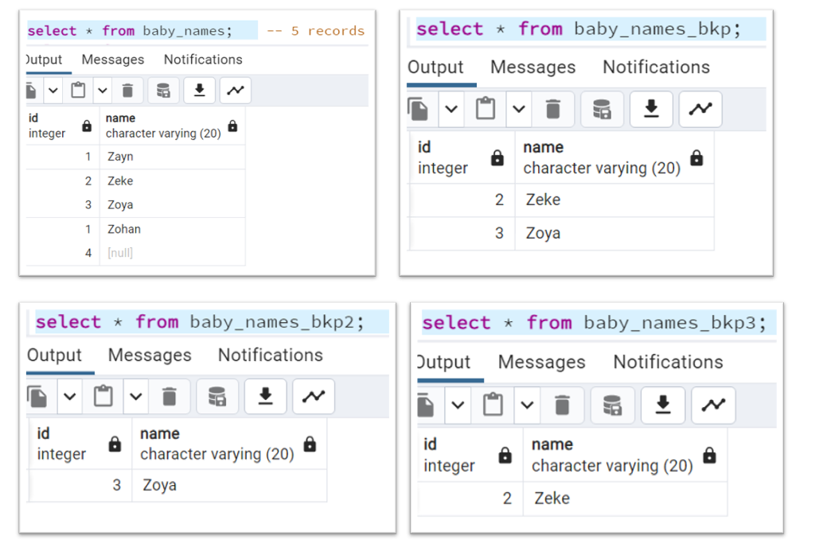

ANSI way of writing Inner join query :
select *
from baby_names a
join baby_names_bkp b on a.id=b.id;

Non-ANSI way of Inner join writing SQL :
select *
from baby_names a,baby_names_bkp b
where a.id=b.id;

Output:
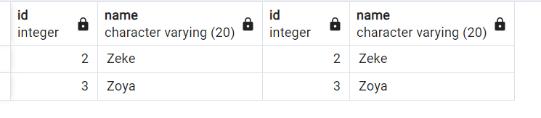

Note : If we not use any condition then that become cross join.

Cross Join :
select *
from baby_names a,baby_names_bkp b;

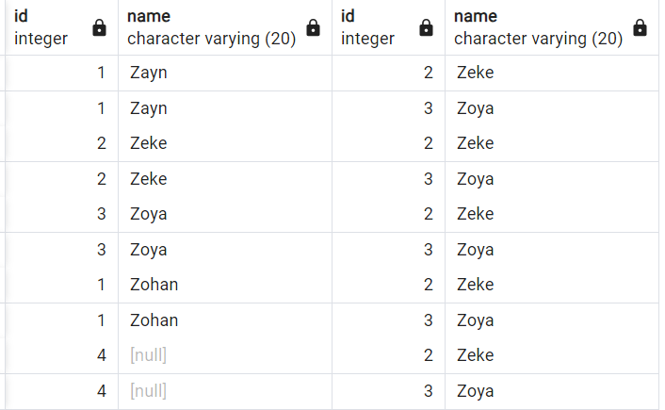

Use case of cross join If we have only 1 row in 1 table and to multiple with all rows in other table then cross join would useful.
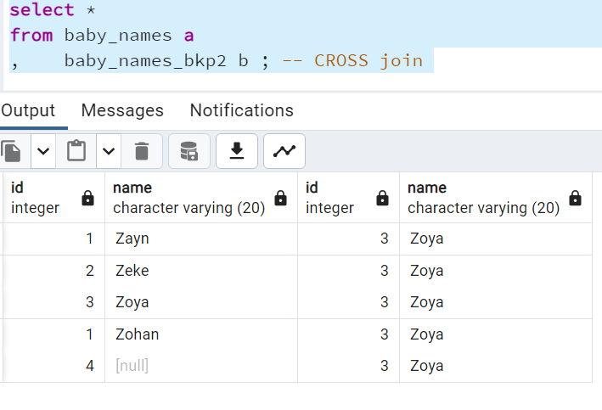
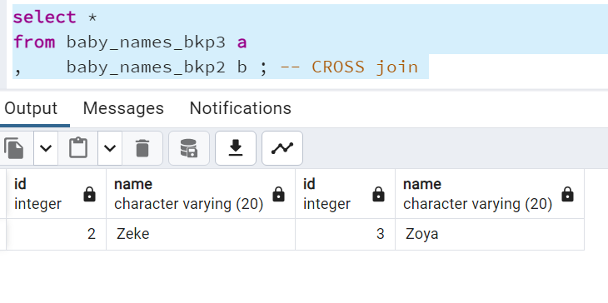

Normalization in SQL:
Different types of Normalization
-- 1NF (First Normal form)
-- 2NF (Second Normal form)
-- 3NF (Third Normal form)

