Topics covered :
- As assessment solve credit card and Bella beat dataset problems (20 questions).
- Subquery
- Order of execution
- exists clause
- How do you delete duplicate data using SQL?
- Joins

Create and Import credit card data into cc stables :
Create database cc_trns;

select * from Card_base; -- 500
select * from Customer_base; -- 5674
select * from Fraud_base; -- 109
select * from Transaction_base; -- 10000

Creating and import painting dataset into painting tables:
Create database Painting;

create table paintings
(
id int,
name varchar(40),
artist_id int,
listed_price float
);

create table artists
(
id int,
first_name varchar(40),
last_name varchar(40)
);

create table collectors
(
id int,
first_name varchar(40),
last_name varchar(40)
);

create table sales
(
id int,
sale_date date,
painting_id int,
artist_id int,
collector_id int,
sales_price float
);

insert into paintings values (11,'Miracle',1,300);
insert into paintings values (12,'Sunshine',1,700);
insert into paintings values (13,'Pretty woman',2,2800);
insert into paintings values (14,'Handsome man',2,2300);
insert into paintings values (15,'Barbie',3,250);
insert into paintings values (16,'Cool painting',3,5000);
insert into paintings values (17,'Black square #1000',3,50);
insert into paintings values (18,'Mountains',4,1300);

insert into artists values (1,'Thomas','Black');
insert into artists values (2,'Kate','Smith');
insert into artists values (3,'Natali','Wein');
insert into artists values (4,'Francesco','Benelli');

insert into collectors values (101,'Brandon','Cooper');
insert into collectors values (102,'Laura','Fisher');
insert into collectors values (103,'Christina','Buffet');
insert into collectors values (104,'Steve','Stevenson');

insert into sales values (1001,'2021-11-01',13,2,104,2500);
insert into sales values (1002,'2021-11-10',14,2,102,2300);
insert into sales values (1003,'2021-11-10',11,1,102,300);
insert into sales values (1004,'2021-11-15',16,3,103,4000);
insert into sales values (1005,'2021-11-22',15,3,103,200);
insert into sales values (1006,'2021-11-22',17,3,103,50);

select * from paintings; -- 8
select * from artists; --4
select * from collectors; --4
select * from sales; --6

Subquery :
- Subquery is also known as a nested query or inner query, is a query within another SQL statement.
- Subqueries can be used in multiple places within a SELECT statement such as JOINS, FROM clause, WHERE clause, HAVING clause, SELECT clause etc.
Examples:
Subquery in from clause:
select * -- Outer query / Main query
from (select * from tab1) x; -- Subquery / Inner query

Subquery in where clause:
select *
from tab1
where col1 in (select col1 from tab2);

Subquery in select clause:
select col1, (select col2 from tab2)
from tab1;

Subquery in join clause:
select *
from tab1 t1
join (select col2 from tab2) sq on sq.col2 = t1.col1;

Types of subqueries :
- Scalar subquery: Subquery returns single column and single row.
- Multi-row subquery: Subquery that returns multiple rows, multiple columns.
  - Multi row Single column subquery
  - Multi row multi column subquery
- Co-related subquery: Subquery or inner query is related (or dependent) on outer query

Order of execution:
In which order SQL fetch data:
Clause | Order
FROM | 1
JOIN | 2
WHERE | 3
GROUP BY | 4
HAVING | 5
SELECT | 6
ORDER BY | 7
LIMIT | 8

Problems for subqueries using painting dataset:
- Fetch paintings that are priced higher than the average painting price.
- Fetch all collectors who purchased paintings.
- Fetch the total amount of sales for each artist who has sold at least one painting. Display artist name and total sales amount.
- Find the names of the artists who had zero sales.

Solution of above problems:
- Fetch paintings that are priced higher than the average painting price.
select *
from paintings
where listed_price>(
select avg(listed_price) from paintings); --Scalar subquery

- Fetch all collectors who purchased paintings.
Using sub-query:
select * from collectors
where id in (select distinct collector_id from sales); --Multi row Single column subquery
Using Inner join:
select distinct c.*
from collectors c
JOIN sales s on s.collector_id=c.id;

Note : Try to avoid sub quires if get chance. Reason to avoid multiple query execution.

- Fetch the total amount of sales for each artist who has sold at least one painting. Display artist name and total sales amount.
Without using subquery:
select a.first_name || ' ' || a.last_name ,sum(sales_price) from sales s
join artists a on s.artist_id=a.id
group by a.first_name || ' ' || a.last_name;
OR
select a.first_name || ' ' || a.last_name ,sum(sales_price) from sales s
join artists a on s.artist_id=a.id
group by a.first_name,a.last_name;
OR
select a.first_name || ' ' || a.last_name ,sum(sales_price) from sales s
join artists a on s.artist_id=a.id
group by 1;

With using subquery :
select a.first_name || ' ' || a.last_name as name ,st.sum_of_sales
from artists a
JOIN (select artist_id,sum(sales_price) as sum_of_sales
from sales
group by artist_id) as st
ON a.id=st.artist_id; --Multi row multi column subquery

- Find the names of the artists who had zero sales.
Solution 1 using multi row subquery:
select first_name || ' ' || last_name as name
from artists
where id not in (select distinct artist_id from sales);

select a.first_name|| ' '||a.last_name as name
from artists a
where id not in (select artist_id from sales);

Solution 2 using corelated subquery :
select a.first_name|| ' '||a.last_name as name
from artists a
where not exists (select * from sales s
where s.artist_id = a.id);

What means exists:
- NOT EXISTS Operator, it is used for testing that if any records exist or not based on column that attached(In above it is id).
- Unlike in operator we don’t need to provide column name left and right of Clause. we provide column name like join using on keyword.

Let’s do order of execution above query:

- First it goes to from clause and fetch artist’s table
select a.first_name|| ' '||a.last_name as name
from artists a
where not exists (select * from sales s where s.artist_id = a.id);

- Then it goes to where clause and start exacting subquery.
And realize this is normal subquery it is co-related subquery. So every time inner query ask id of outer query.
select a.first_name|| ' '||a.last_name as name
from artists a
where not exists (select * from sales s where s.artist_id = a.id);

- Then execute select and give result.
select a.first_name|| ' '||a.last_name as name
from artists a
where not exists (select * from sales s where s.artist_id = a.id);

Which one is better in above 2 quires...?
Ans : solution-1

Reason is in co-related query inner query execute 4 times but in solution-1 only 1 time.

How do you delete duplicate data using SQL?

Insert some records into paints table:
insert into artists values (5,'Kate','Smith');
insert into artists values (6,'Natali','Wein');

select * from artists;

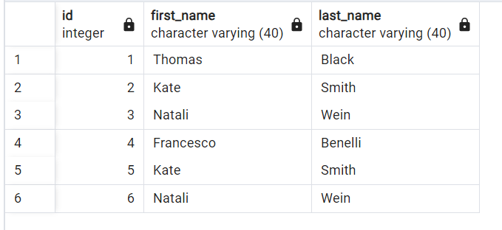

Solution-1: Delete single copy of duplicate data using max
Get ids of all duplicated records and delete highest id rows.
Get all duplicated records with max id:
select first_name,last_name,max(id),count(1)
from artists
group by first_name,last_name
having count(1)>1;
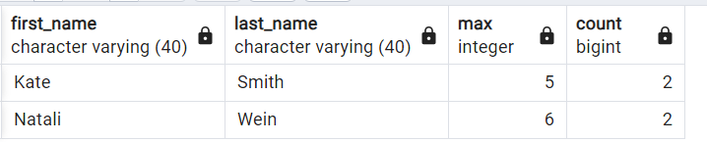

Delete highest id records:
delete from artists
where id in (select max(id)
from artists
group by first_name,last_name
having count(1)>1);
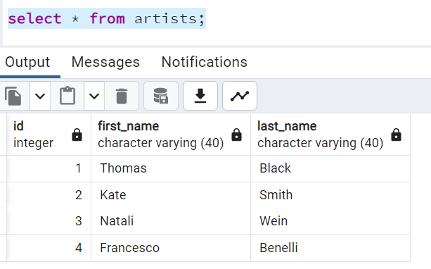
Note : Above query only delete max id records if we have duplicated more then 2 times then it won’t delete all duplicated records. Reason is we are taking max so it give maximum one not all duplicated ids.
Insert now multiple duplicated records:
insert into artists values (5,'Kate','Smith');
insert into artists values (6,'Natali','Wein');
insert into artists values (7,'Kate','Smith');
insert into artists values (8,'Natali','Wein');

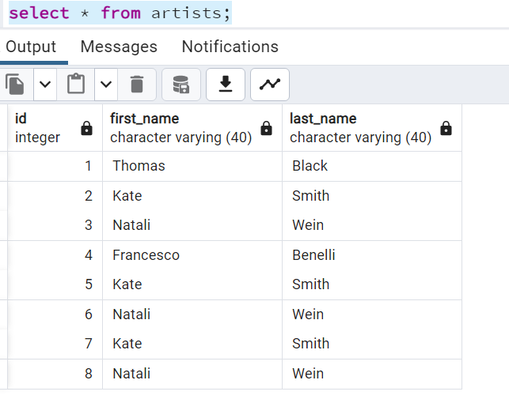

Solution-2: Delete multiple copies of duplicate data using min
Get all duplicated records with min id:
select first_name,last_name,min(id)
from artists
group by first_name,last_name;
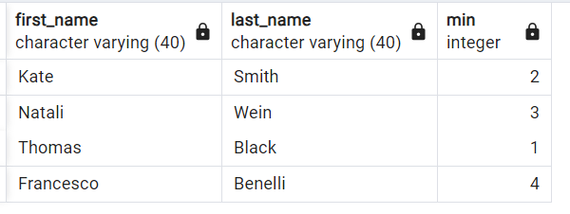
Delete all records except min id records:
delete from artists
where id not in (
select min(id)
from artists
group by first_name,last_name);
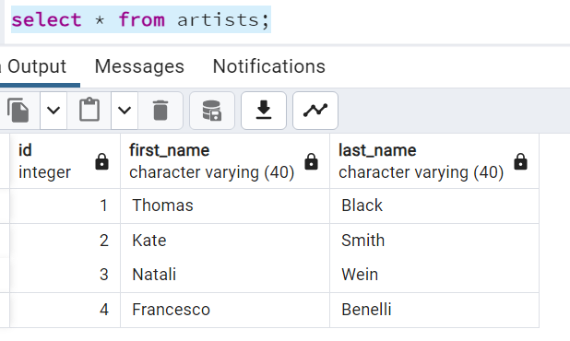
Note : This we can do only when we have no duplicated data in at least 1 column. But we have to use other method to delete duplicates if all columns are duplicated.
Solution 3: when data duplicated in all columns - using CTID
insert into artists values (2,'Kate','Smith');
insert into artists values (3,'Natali','Wein');
select * from artists;
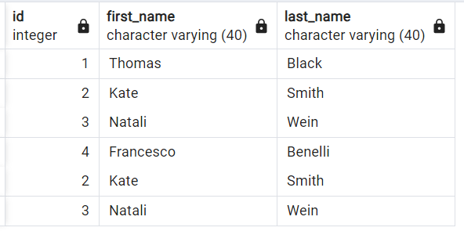

CTID is used in PostgreSQL to uniquely identify each record in result. Same like RowID in oracle.

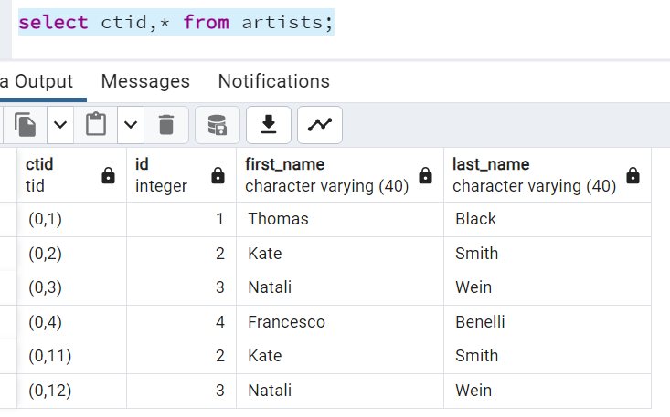

delete from artists
where ctid not in (select min(ctid)
from artists
group by first_name,last_name);

Note : Some databases don’t have concept like this so it was not that much useful.

Solution 4: when data duplicated in all columns (Generalized way)
insert into artists values (2,'Kate','Smith');
insert into artists values (3,'Natali','Wein');
select * from artists;

Create backup table truncate main table Insert distinct into main table.
-- Create backup table
create table artists_bkp as
select * from artists;

-- Truncate main table
truncate table artists;

-- Insert distinct into main table.
insert into artists
select distinct * from artists_bkp;

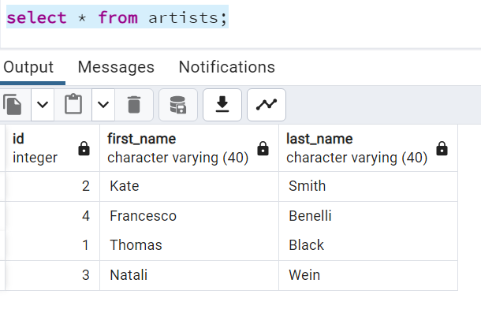

Joins :
A JOIN clause is used to combine rows from two or more tables, based on a related column between them.
Types of joins :
- INNER JOIN - JOIN
- LEFT JOIN / LEFT OUTER JOIN
- RIGHT JOIN / RIGHT OUTER JOIN
- FULL JOIN / FULL OUTER JOIN -- Not supported in MySQL
- CROSS JOIN
- SELF JOIN
- NATURAL JOIN -- Not recommended

INNER Join Connects 2 table and fetches matching records
LEFT JOIN INNER JOIN + fetches all remaining records from Left table
RIGHT Join INNER JOIN + fetches all remaining records from RIGHT table
FULL Join INNER JOIN + fetches all remaining records from Left table + fetches all remaining records from RIGHT table
CROSS Join Joins every record of left table with every record of right table so, result will be a cartesian product

Example:
TABLE_1 TABLE_2
'Apple' 'Apple'
'Orange' 'Kiwi'
'Banana' 'Papaya'
'Mango' 'Orange'

INNER join 2
LEFT join 2+2=4
RIGHT join 2+2=4
FULL Join 2+2+2=6
CROSS Join 4*4=16

