Topics covered :
- Solving problems on joins using joins painting dataset.
- Cross, natural and self joins practical’s
- CTE(Common table expression)
- Window functions

Create and import Joins_painting_dataset :
Create database Joins_painting_dataset;

select * from paintings; -- 10
select * from artists; -- 6
select * from collectors; -- 4
select * from sales; -- 6

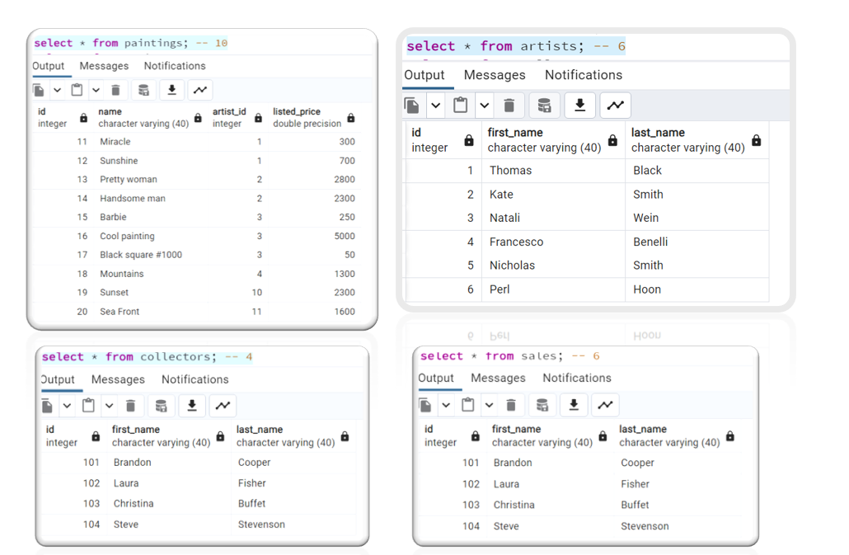

Question on joins using join paintings dataset:
- Fetch names of all the artists along with their painting name. If an artist does not have a painting yet, display as "NA"
- Find collectors who did not purchase any paintings.
- Find how much each artist made from sales. And how many paintings did they sell.
- Display all the available paintings and all the artist. If a painting was sold then mark them as "Sold". and if more than 1 painting of an artist was sold then display a "**" beside their name.

Answers on joins using join paintings dataset:
- Fetch names of all the artists along with their painting name. If an artist does not have a painting yet, display as "NA"
select a.first_name || ' ' || a.last_name as Artist_name,
CASE
WHEN p.name is NULL THEN 'NA'
ELSE p.name
END as Painting_name2
from artists a
left join paintings p on a.id = p.artist_id;
OR
select a.first_name || ' ' || a.last_name as Artist_name,
coalesce(p.name,'NA')
from artists a
left join paintings p on a.id = p.artist_id;
OR
select a.first_name || ' ' || a.last_name as Artist_name,
coalesce(p.name,'NA')
from paintings p
right join artists a on a.id = p.artist_id;

- Find collectors who did not purchase any paintings.
select * from collectors
where id not in (select collector_id from sales);
OR

select c.* from collectors c
left join sales s on c.id=s.collector_id
WHERE s.collector_id is null;

- Find how much each artist made from sales. And how many paintings did they sell.
select s.artist_id,a.first_name || ' ' || a.last_name as Artist_name,
sum(s.sales_price) as total_sales,
count(s.artist_id) as total_no_paints
from sales s
join artists a on s.artist_id=a.id
group by s.artist_id,a.first_name,a.last_name;

- Display all the available paintings and all the artist. If a painting was sold then mark them as "Sold". and if more than 1 painting of an artist was sold then display a "**" beside their name.
select
CASE
WHEN sq.painting_sold is not null then concat(a.first_name,' ',a.last_name,'**')
ELSE concat(a.first_name,' ',a.last_name)
END as Artist_name,
p.name,
CASE
WHEN s.id is not null then 'Sold'
end as sales_flag
from paintings p
FULL JOIN artists a on a.id=p.artist_id
left join sales s on s.painting_id=p.id
left join ( select a.id,count(s.id) as painting_sold
from sales s
join artists a on a.id = s.artist_id
group by a.id
having count(s.id)>1) as sq on sq.id=a.id;
OR
select
CASE
WHEN sq.painting_sold >1 then concat(a.first_name,' ',a.last_name,'**')
ELSE concat(a.first_name,' ',a.last_name)
END as Artist_name,
p.name,
CASE
WHEN s.id is not null then 'Sold'
end as sales_flag
from paintings p
FULL JOIN artists a on a.id=p.artist_id
left join sales s on s.painting_id=p.id
left join ( select a.id,count(s.id) as painting_sold
from sales s
join artists a on a.id = s.artist_id
group by a.id) as sq on sq.id=a.id;

Note : Solve above problem without using FULL join.

CROSS Join :
select concat(a.first_name,' ',a.last_name) as Artist_name,p.name as paintiang
from artists a
cross join paintings p
order by 1;

Natural join :
- It Joins 2 tables naturally based on the identical column names in these tables.
- If identical column exists then it does an inner join using this column.
- If identical column does not exist then it will perform a cross join.
- In Natural join we do not need to provide the join condition.

SELF Join:
When you want to compare or match 1 column of table with another column of same table then self-join could useful.
drop table employee_master;
create table employee_master
(
id int,
name varchar(40),
salary int,
manager_id int
);

insert into employee_master values (1 ,'John Smith', 10000, 3);
insert into employee_master values (2 ,'Jane Anderson', 12000, 3);
insert into employee_master values (3 ,'Tom Lanon', 15000, 4);
insert into employee_master values (4 ,'Anne Connor', 20000, null);
insert into employee_master values (5 ,'Jeremy York', 9000, 1);

select * from employee_master;

Write a query to display the employee’s name and their corresponding manager name.

select emp.name as employee,mng.name as manger
from employee_master emp
join employee_master mng on emp.manager_id=mng.id;

Modify above query to get all employees:
select emp.name as employee,COALESCE(mng.name,'CEO') as manger
from employee_master emp
left join employee_master mng on emp.manager_id=mng.id;

CTE(Common Table Expression) :
-- Also referred to as WITH clause
Syntax:
WITH cte AS
(select * from tab2)
Select *
from tab1 t1
join cte on t1.col1 = cte.col2;
OR
WITH temp2 AS
(select * from tab2)
Select *
from tab1 t1
join temp2 on t1.col1 = temp2.col2;

Solve below 4th problem using CTE.
Display all the available paintings and all the artist. If a painting was sold then mark them as "Sold". and if more than 1 painting of an artist was sold then display a "**" beside their name.
WITH cte as(
select a.id,count(s.id) as painting_sold
from sales s
join artists a on a.id = s.artist_id
group by a.id)
select
CASE
WHEN sq.painting_sold >1 then concat(a.first_name,' ',a.last_name,'**')
ELSE concat(a.first_name,' ',a.last_name)
END as Artist_name,
p.name,
CASE
WHEN s.id is not null then 'Sold'
end as sales_flag
from paintings p
FULL JOIN artists a on a.id=p.artist_id
left join sales s on s.painting_id=p.id
left join cte as sq on sq.id=a.id;

Advantages of using CTE:
- Increase the readability.
- Easy to do changes.
- Query executed once compare to sub-quires.

Example of CTE with sales dataset:
select * from sales_order;--2823
select * from customers;--92
select * from products;--109

- Find the most profitable orders. Most profitable orders are those whose sale price exceeded the average sale price for each city and whose deal size was not small.
select *
from sales_order so
JOIN customers c on c.customer_id=so.customer
JOIN (select c.city as city,round(avg(so.sales)::decimal,2) as avg_sales_city
from sales_order so
JOIN customers c on c.customer_id=so.customer
group by c.city) AS sp_city on sp_city.city=c.city
where so.sales > sp_city.avg_sales_city
and deal_size <> 'Small';
OR
WITH sp_city as
(select c.city as city,round(avg(so.sales)::decimal,2) as avg_sales_city
from sales_order so
JOIN customers c on c.customer_id=so.customer
group by c.city)
select *
from sales_order so
JOIN customers c on c.customer_id=so.customer
JOIN sp_city on sp_city.city=c.city
where so.sales > sp_city.avg_sales_city
and deal_size <> 'Small';

- Find the difference in average sales for each month of 2003 and 2004.
with cte_avg_sales_2003 as (
select extract(year from order_date) as year,
extract(month from order_date) as month,
round(avg(sales)::decimal,2) as avg_month_sales
from sales_order
where extract(year from order_date)=2003
group by extract(year from order_date),extract(month from order_date)),
cte_avg_sales_2004 as (
select extract(year from order_date) as year,
extract(month from order_date) as month,
round(avg(sales)::decimal,2) as avg_month_sales
from sales_order
where extract(year from order_date)=2004
group by extract(year from order_date),extract(month from order_date))

select avg_2003.month,
abs(avg_2003.avg_month_sales-avg_2004.avg_month_sales) as diff_avg_sales
from cte_avg_sales_2003 avg_2003
JOIN cte_avg_sales_2004 avg_2004 on avg_2003.month=avg_2004.month;
OR
Using self-join:
with cte as (
select extract(year from order_date) as year,
extract(month from order_date) as month,
round(avg(sales)::decimal,2) as avg_month_sales
from sales_order
where extract(year from order_date) in (2003,2004)
group by extract(year from order_date),extract(month from order_date))

select y3.month,abs(y3.avg_month_sales-y4.avg_month_sales)
from cte y3
JOIN cte y4 on y3.month = y4.month
where y3.year = 2003 and y4.year = 2004;

Window functions:
They allow users to perform advanced calculations across a specified set of rows known as a “window” while retaining the individual data rows.

Create database and table:
create database emp_window;

drop table employee;
create table employee
( emp_ID int
, emp_NAME varchar(50)
, DEPT_NAME varchar(50)
, SALARY int);

insert into employee values(101, 'Mohan', 'Admin', 4000);
insert into employee values(102, 'Rajkumar', 'HR', 3000);
insert into employee values(103, 'Akbar', 'IT', 4000);
insert into employee values(104, 'Dorvin', 'Finance', 6500);
insert into employee values(105, 'Rohit', 'HR', 3000);
insert into employee values(106, 'Rajesh', 'Finance', 5000);
insert into employee values(107, 'Preet', 'HR', 7000);
insert into employee values(108, 'Maryam', 'Admin', 4000);
insert into employee values(109, 'Sanjay', 'IT', 6500);
insert into employee values(110, 'Vasudha', 'IT', 7000);
insert into employee values(111, 'Melinda', 'IT', 8000);
insert into employee values(112, 'Komal', 'IT', 10000);
insert into employee values(113, 'Gautham', 'Admin', 2000);
insert into employee values(114, 'Manisha', 'HR', 3000);
insert into employee values(115, 'Chandni', 'IT', 4500);
insert into employee values(116, 'Satya', 'Finance', 6500);
insert into employee values(117, 'Adarsh', 'HR', 3500);
insert into employee values(118, 'Tejaswi', 'Finance', 5500);
insert into employee values(119, 'Cory', 'HR', 8000);
insert into employee values(120, 'Monica', 'Admin', 5000);
insert into employee values(121, 'Rosalin', 'IT', 6000);
insert into employee values(122, 'Ibrahim', 'IT', 8000);
insert into employee values(123, 'Vikram', 'IT', 8000);
insert into employee values(124, 'Dheeraj', 'IT', 11000);
COMMIT;

select * from employee;

Syntax:
select row_number() over(partition by col1 order by col2) as rowno
from table1;

Where ,
- Row_number() Is window function.
- Over Over clause
- Col1 Column name on which partition should happen.
- Col2 Column name on which order by should apply.

Types of window functions:
- ROW_NUMBER()
- RANK()
- DENSE_RANK()
- FIRST_VALUE()
- LAST_VALUE()
- NTH_VALUE()
- LEAD()
- LAG()
- CUME_DIST()
- PERCENT()
- NTILE()

Problems on window:
- Fetch the first 2 employees from each department to join the company.
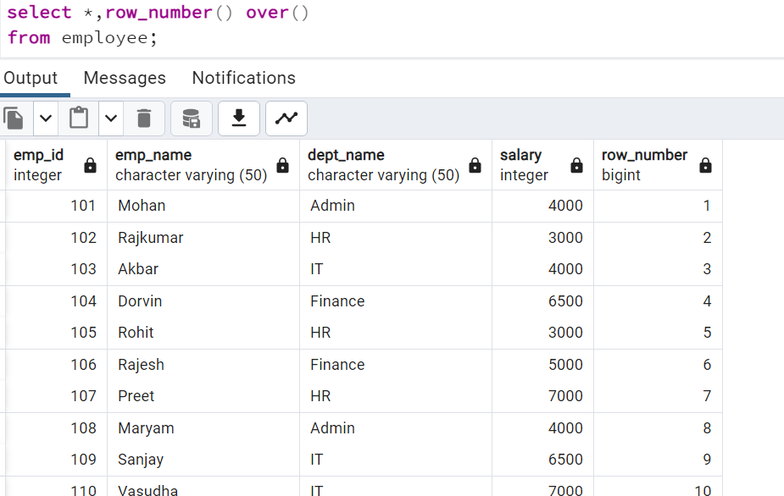
Note : This treats total table as 1 window. So, it given unique number for each record in table. So now let’s do partition based on department name.
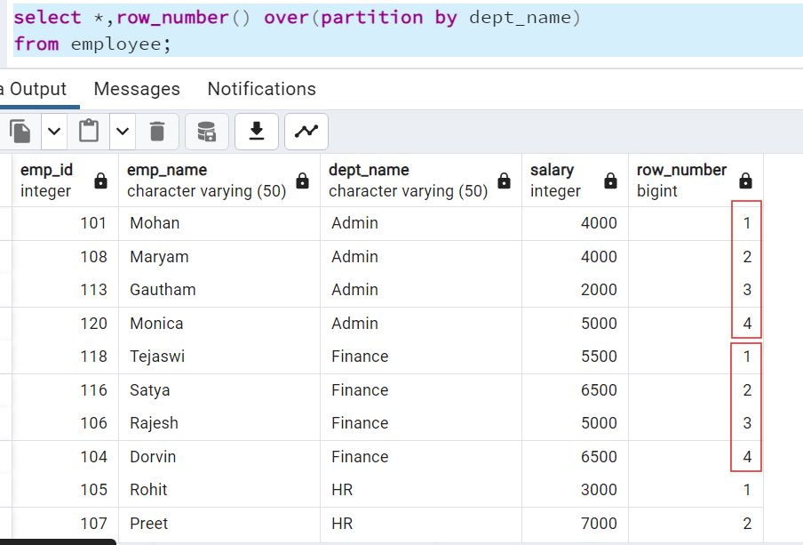
Note : We can see that now partition happened based on department name.
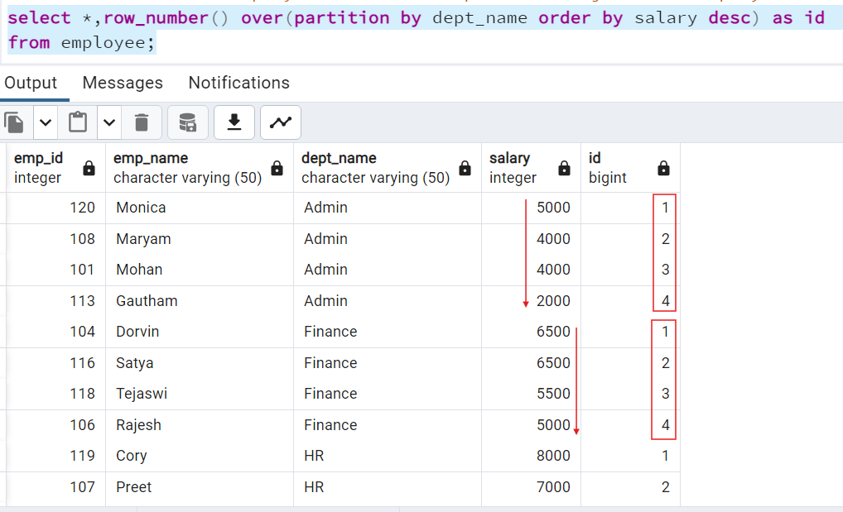
Note : In partition we are ordering data based on salary from highest to lowest. First apply partition then order by then function that we applied.
But our case we need to sort partition bases on employee id. The employee who joined first will have less employee number.

-- Does not work
select *
, row_number() over(partition by dept_name order by emp_id ) as id
from employee
where id <=2;

-- Works
select *
from (
select *
, row_number() over(partition by dept_name order by emp_id ) as id
from employee) sq
where sq.id <= 2;
OR
with cte as
(select *,row_number() over(partition by dept_name order by emp_id) as id
from employee)
select *
from cte
where cte.id<=2;

