Today agenda:
- Problems on windows functions (Row_number, Rank and Dense_rank)
- Interview problems(Lead() and Lag() window functions)
- Problems on windows functions (first value, last value, nth value and NTILE)
- Using aggregate functions as window functions
- Interview questions (recursive query)

- Problems on windows functions
- Fetch the top 3 employees in each department earning the max salary
Using row number function:
select *
from (select *,row_number() over(partition by dept_name order by salary DESC) as id
from employee) sq
where sq.id <=3;
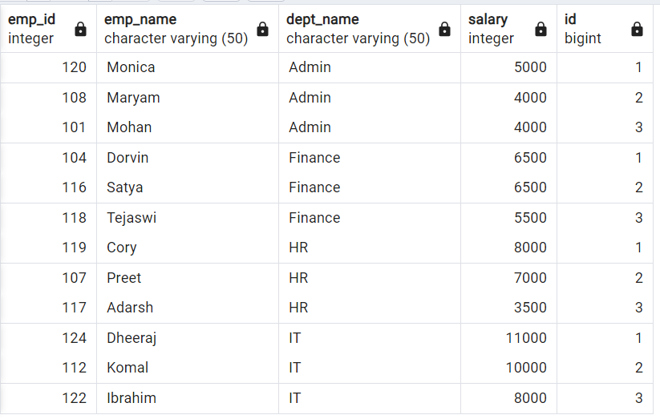

Note :
- But this gives wrong result as we have same max 2 salary with 5 employees in IT department so better use rank.
- Row number doesn’t see value it just gives unique number for each record.
- Rank will check value and give same rank if both having same value.

Using RANK()

select *
from (select *,rank() over(partition by dept_name order by salary DESC) as id
from employee) sq
where sq.id <=3;

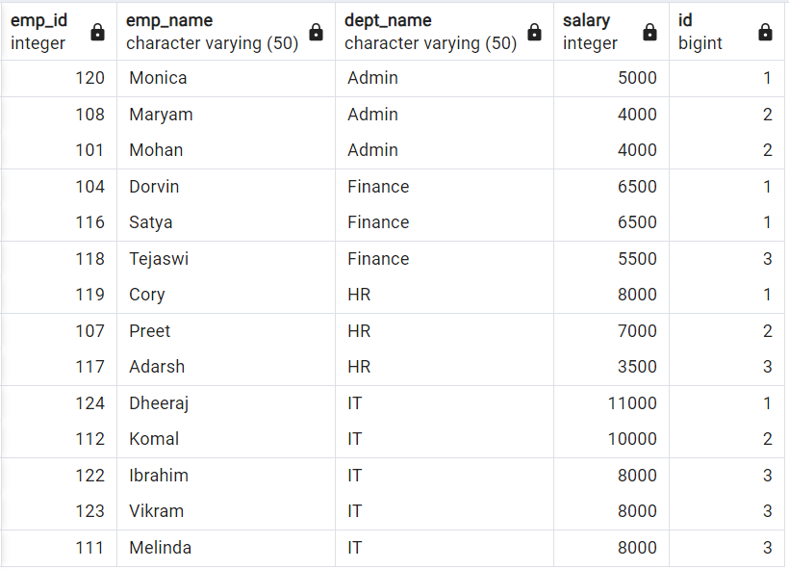

See how ranking give values to unique records:
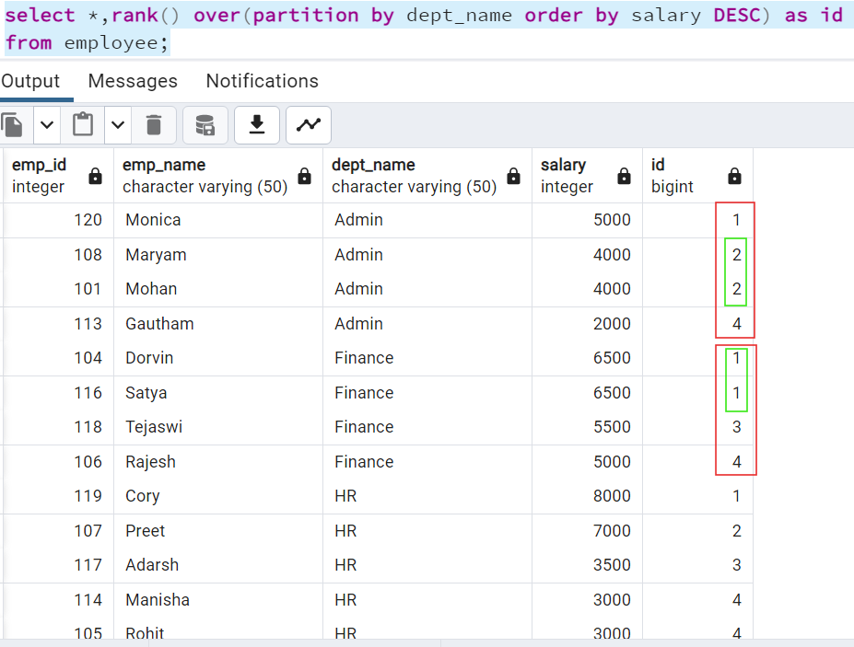

If we see above in admin, we have 4 records. 2nd and 3rd given same rank as both employee having same salary but see 4th employee given rank as 4. Means it skipped 3rd rank.

Using DENSE_RANK()
Difference between RANK and DENSE RANK is that RANK will skip rows continues number if any where we have same values. but DENSE RANK won’t skip any row values.

select *,
ROW_NUMBER() over(partition by dept_name order by salary DESC) as id_rowno,
RANK() over(partition by dept_name order by salary DESC) as id_rank,
DENSE_RANK() over(partition by dept_name order by salary DESC) as id_dense_rank
from employee;

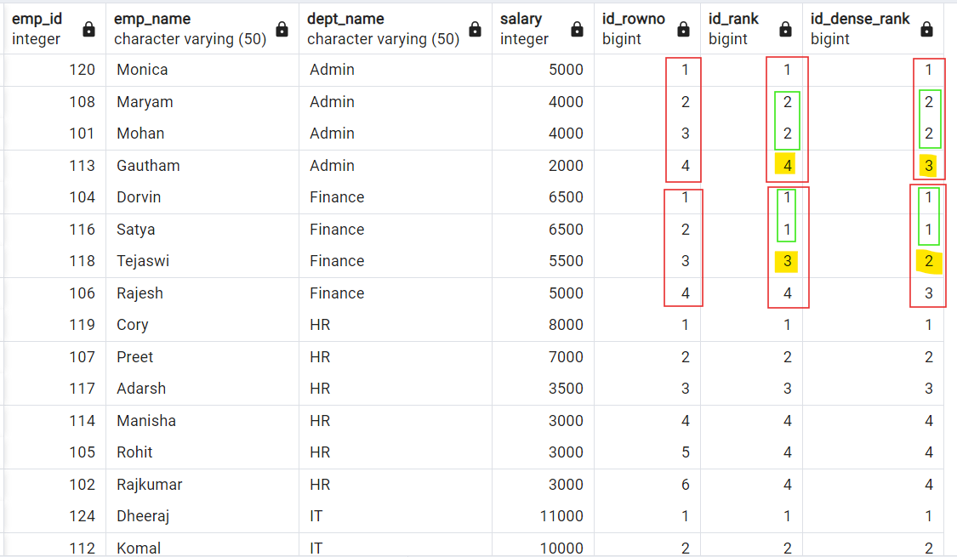

What is the difference between rank, dense_rank and row_number window function?

Row_number : Always returns unique value (starting from 1) for each record
irrespective of whether there are duplicate values or not

Rank : Returns unique values when there are no duplicates.
If there are duplicates then it shares same rank between those dup records
and skips the next rank.

Dense Rank: Returns unique values when there are no duplicates.
If there are duplicates then it shares same rank between those dup
records and DOES NOT skip the next rank.

Note : If there are no duplicated values then all above 3 will return same values.

- Interview problems

create database interview_prep;
Interview problem - 1
Create database and table:
drop table if exists fb_eu_energy;
create table fb_eu_energy
(
date date,
consumption int
);

drop table if exists fb_asia_energy;
create table fb_asia_energy
(
date date,
consumption int
);

drop table if exists fb_na_energy;
create table fb_na_energy
(
date date,
consumption int
);
insert into fb_eu_energy values ('2020-01-01',400);
insert into fb_eu_energy values ('2020-01-02',350);
insert into fb_eu_energy values ('2020-01-03',500);
insert into fb_eu_energy values ('2020-01-04',500);
insert into fb_eu_energy values ('2020-01-07',600);

insert into fb_asia_energy values ('2020-01-01',400);
insert into fb_asia_energy values ('2020-01-02',400);
insert into fb_asia_energy values ('2020-01-04',675);
insert into fb_asia_energy values ('2020-01-05',1200);
insert into fb_asia_energy values ('2020-01-06',750);
insert into fb_asia_energy values ('2020-01-07',400);

insert into fb_na_energy values ('2020-01-01',250);
insert into fb_na_energy values ('2020-01-02',375);
insert into fb_na_energy values ('2020-01-03',600);
insert into fb_na_energy values ('2020-01-06',500);
insert into fb_na_energy values ('2020-01-07',250);

select * from fb_eu_energy;
select * from fb_asia_energy;
select * from fb_na_energy;

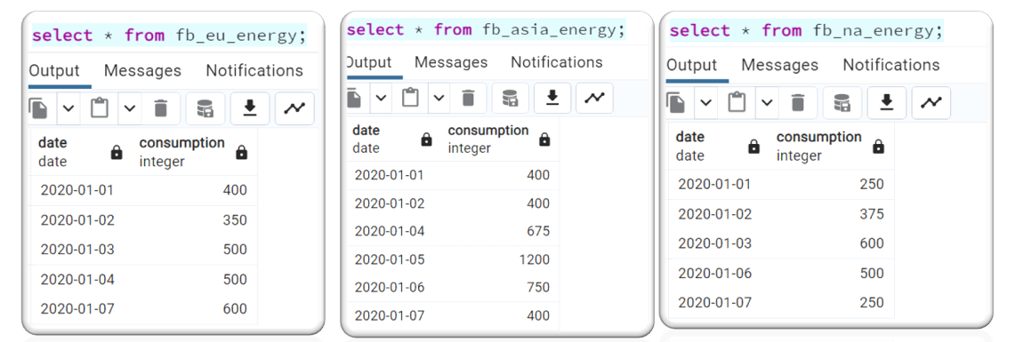

Problem statement:
Find the date with the highest total energy consumption from the Meta/Facebook
data centers.
Output the date along with the total energy consumption across all data centers.
If there are multiple days with same highest energy consumption then display both dates.

Solution:
WITH cte as(
select * from fb_eu_energy
UNION ALL
select * from fb_asia_energy
UNION ALL
select * from fb_na_energy)
select date,sum(consumption) as total_consumption
from cte
group by date
order by total_consumption DESC
LIMIT 1;

Note : Above query is wrong as we can see that energy consumption of 1250 is for 2 days. To get that we need to change limit to 1 but in future if data changes then we have to manually change limit value. To tackle this, we can use rank here.

WITH cte as(
select * from fb_eu_energy
UNION ALL
select * from fb_asia_energy
UNION ALL
select * from fb_na_energy),
final_cte as(
select date,sum(consumption) as total_consumption,
RANK() over(order by sum(consumption) DESC) rnk
from cte
group by date)
select date,total_consumption
from final_cte
where rnk=1;
OR
WITH cte as(
select * from fb_eu_energy
UNION ALL
select * from fb_asia_energy
UNION ALL
select * from fb_na_energy)
select date,total_consumption from(
select date,sum(consumption) as total_consumption,
RANK() over(order by sum(consumption) DESC) rnk
from cte
group by date) as sq
where sq.rnk=1;

Interview problem - 2
Create database and table:
drop table if exists students;
create table students
(
id int primary key,
student_name varchar(50) not null
);
insert into students values
(1, 'James'),
(2, 'Michael'),
(3, 'George'),
(4, 'Stewart'),
(5, 'Robin');

select * from students;

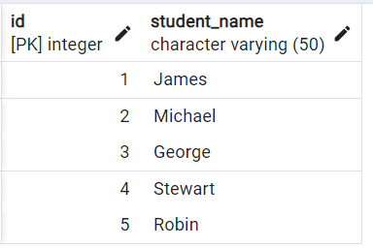

Problem statement:
From the students table, write a SQL query to interchange the adjacent student names. Note: If there are no adjacent student then the student’s name should stay the same.

Solution:
We can solve this problem using lead() and lag() window functions.
select *,
CASE
WHEN id%2=0
THEN LAG(student_name) over(order by id)
ELSE LEAD(student_name) over(order by id)
END as Swapped_name
from students;

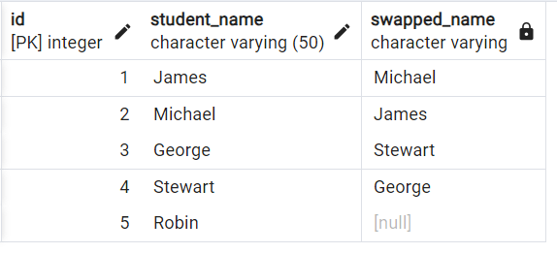

Syntax:
LAG/LEAD (column name, Index value, default value)
Where,
- column name Which column value to be returned
- Index value Which index value should return( like if we do for 1 then we need fetch next record means 1, next to next record means 2 like and so on)
- default value Default value if there is no value fetched.

select *,
CASE
WHEN id%2=0
THEN LAG(student_name) over(order by id)
ELSE LEAD(student_name,1,student_name) over(order by id)
END as Swapped_name
from students;

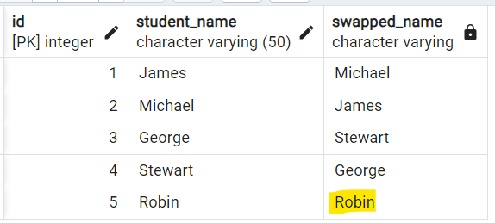

- Problems on windows functions (first value, last value, nth value and NTILE)
Create below tables in emp_window database:
DROP TABLE product;
CREATE TABLE product
(
product_category varchar(255),
brand varchar(255),
product_name varchar(255),
price int
);

INSERT INTO product VALUES
('Phone', 'Apple', 'iPhone 16 Pro Max', 1300),
('Phone', 'Apple', 'iPhone 16 Pro', 1100),
('Phone', 'Apple', 'iPhone 16', 1000),
('Phone', 'Samsung', 'Galaxy Z Fold 6', 1800),
('Phone', 'Samsung', 'Galaxy Z Flip 6', 1000),
('Phone', 'Samsung', 'Galaxy S24 Ultra', 1200),
('Phone', 'Samsung', 'Galaxy S24', 1000),
('Phone', 'Nothing', 'Nothing Phone 2a', 300),
('Phone', 'Google', 'Pixel 9 Pro', 900),
('Phone', 'Google', 'Pixel 9', 600),
('Laptop', 'Apple', 'MacBook Pro 16', 3000),
('Laptop', 'Apple', 'MacBook Air', 1200),
('Laptop', 'Microsoft', 'Surface Laptop 7', 2100),
('Laptop', 'Dell', 'XPS 13', 2000),
('Laptop', 'Dell', 'XPS 15', 2300),
('Laptop', 'Dell', 'XPS 17', 2500),
('Earphone', 'Apple', 'AirPods Pro', 280),
('Earphone', 'Samsung', 'Galaxy Buds 3 Pro', 220),
('Earphone', 'Samsung', 'Galaxy Buds 3', 170),
('Earphone', 'Sony', 'WF-1000XM4', 250),
('Headphone', 'Sony', 'WH-1000XM4', 400),
('Headphone', 'Apple', 'AirPods Max', 550),
('Headphone', 'Microsoft', 'Surface Headphones 2', 250),
('Smartwatch', 'Apple', 'Apple Watch Series 10', 1000),
('Smartwatch', 'Apple', 'Apple Watch SE', 400),
('Smartwatch', 'Samsung', 'Galaxy Watch 5 Pro', 600),
('Smartwatch', 'Google', 'Pixel Watch 3', 220);

select * from product;

- Write query to display the most expensive product under each category (corresponding to each record)
-- Below is wrong solution as we need to display most expensive product for each record.
select *
from product
where (product_category,price) in
(select product_category,max(price)
from product
group by product_category
order by product_category);
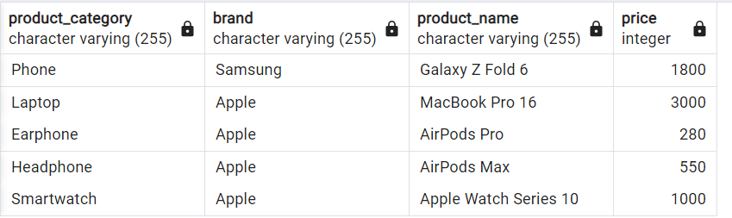

select *,
FIRST_VALUE(product_name) over(partition by product_category order by price desc)
from product;
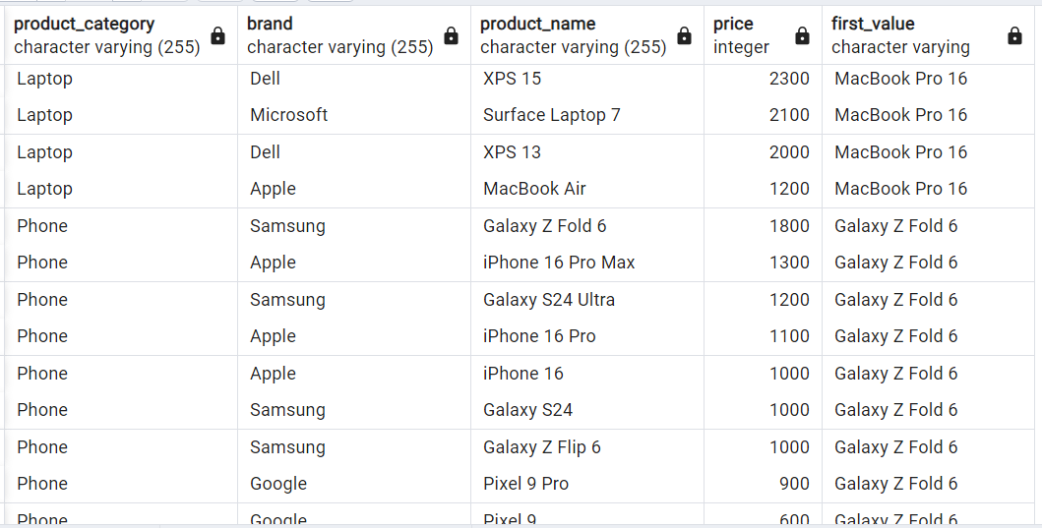

- Write query to display the most & least expensive product under each category (corresponding to each record)
If we try to get most and least expensive products like below.
select *,
FIRST_VALUE(product_name) over(partition by product_category order by price desc) as most_exp,
LAST_VALUE(product_name) over(partition by product_category order by price desc) as least_exp
from product;
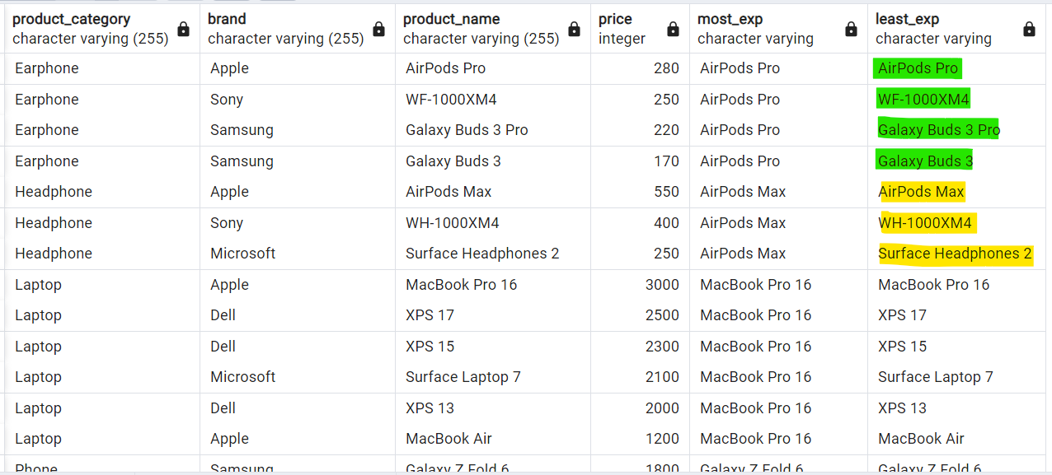

Note : We are not getting least expensive product name. Reason for this is .

Hierarchy of how SQL gets access to your data from query is:
Result set Window/Partition Frame
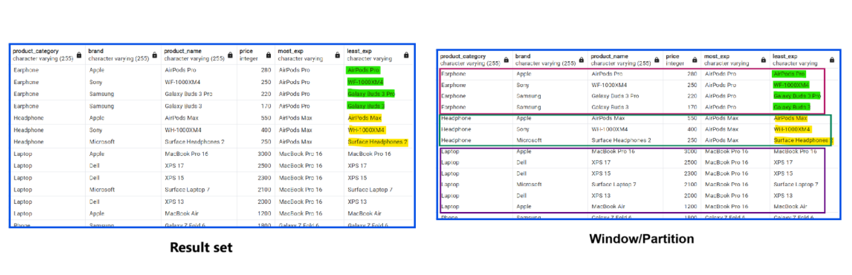

How SQL fetch data from windows as frames:
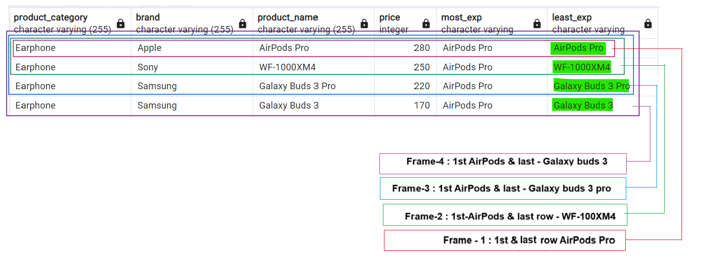

This we can fix by using frame clause.
select *,
FIRST_VALUE(product_name)
over(partition by product_category order by price desc) as most_exp,
LAST_VALUE(product_name)
over(partition by product_category order by price desc) as least_exp,
LAST_VALUE(product_name)
over(partition by product_category order by price desc
range between unbounded preceding and current row) as least_exp_current,
LAST_VALUE(product_name)
over(partition by product_category order by price desc
range between unbounded preceding and unbounded following) as least_exp_following
from product;

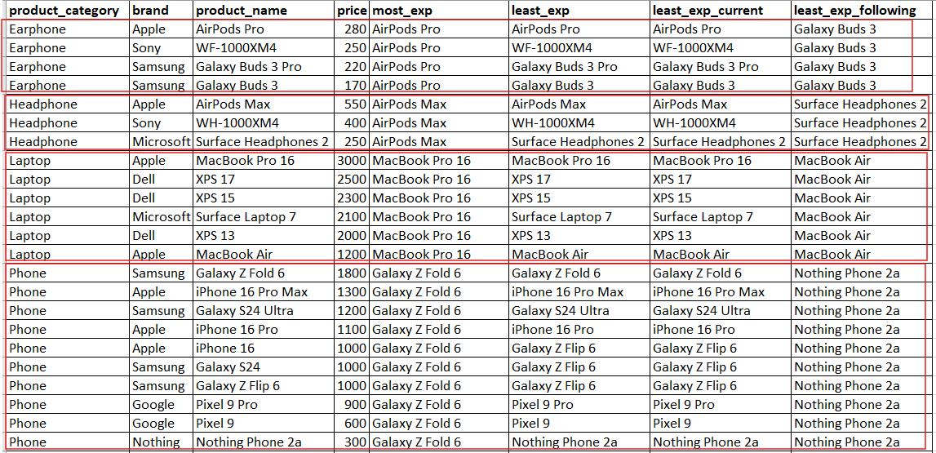

First_value() This window function can return any column value of first row in each partition.
Last_value() This window function can return any column value of last row in each partition.
Nth_value() This window function can return any column value of n^{th} row in each partition.

select *,
FIRST_VALUE(product_name)
over(partition by product_category order by price desc) as most_exp,
LAST_VALUE(product_name)
over(partition by product_category order by price desc) as least_exp,
LAST_VALUE(product_name)
over(partition by product_category order by price desc
range between unbounded preceding and current row) as least_exp_current,
LAST_VALUE(product_name)
over(partition by product_category order by price desc
range between unbounded preceding and unbounded following) as least_exp_following,
NTH_VALUE(product_name,2)
over(partition by product_category order by price desc
range between unbounded preceding and unbounded following) as least_exp_following
from product;
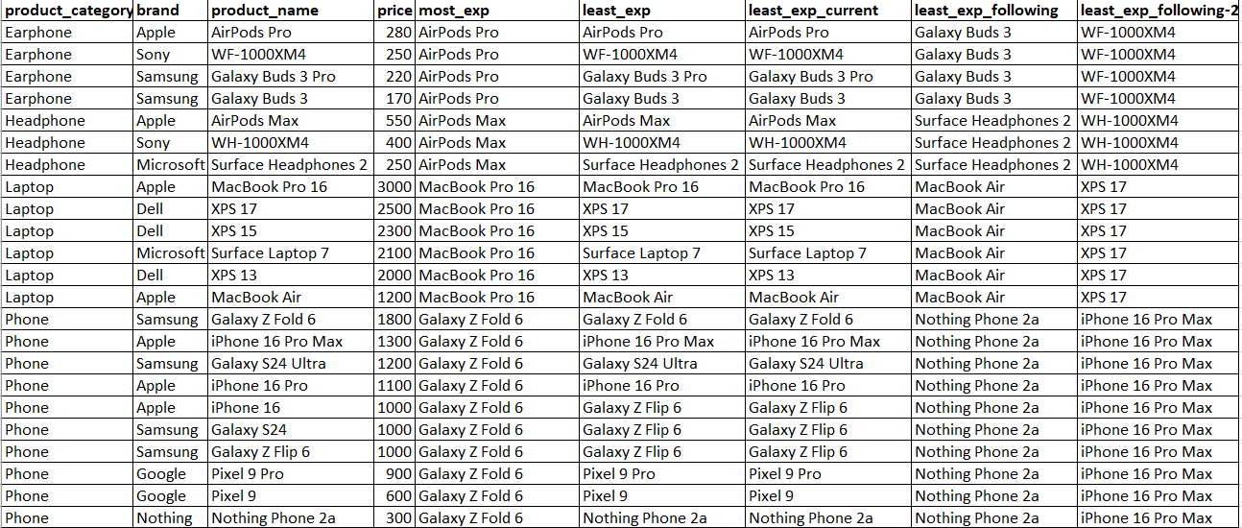

- Write a query to roughly segregate all the expensive phones, mid-range phones and the cheaper phones.

Above question is saying that segregate mobile category but these is no specific range is mentioned. That time we can us windows NTILE function.

NTILE() -- (Based on no of records we can segregate/create data into buckets randomly)

select *,
NTILE(3) over(order by price DESC) as bucket
from product
where product_category='Phone';
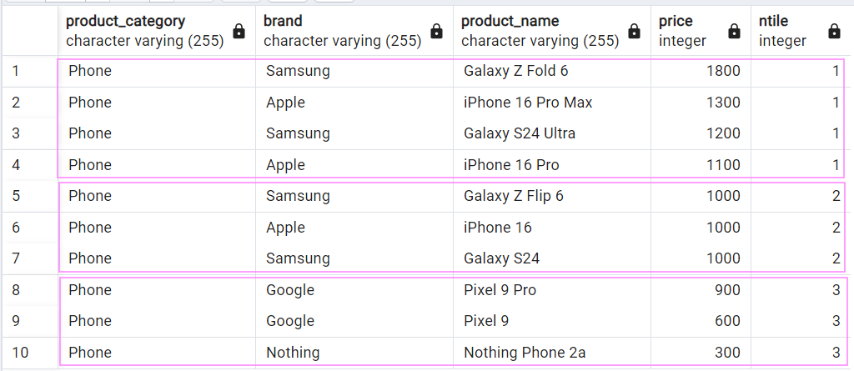

Final query:
select *,
CASE
WHEN bucket=1 THEN 'expensive'
WHEN bucket=2 THEN 'mid-range'
ELSE 'Cheaper'
end as Type
from (
select *,
NTILE(3) over(order by price DESC) as bucket
from product
where product_category='Phone');
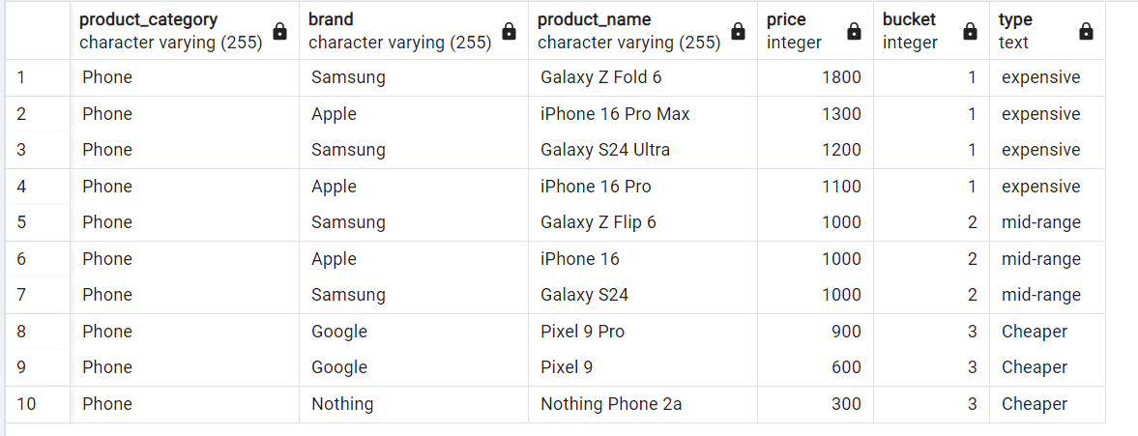

- Using aggregate functions as window functions:
Using aggregate function with group by:
select product_category,count(*) as no_of_prods
from product
group by product_category
order by product_category;
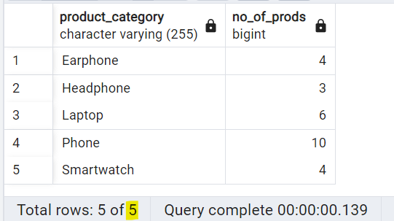

Using aggregate function, a window:
select product_category,
count(*) over(partition by product_category order by product_category)as no_of_prods
from product;
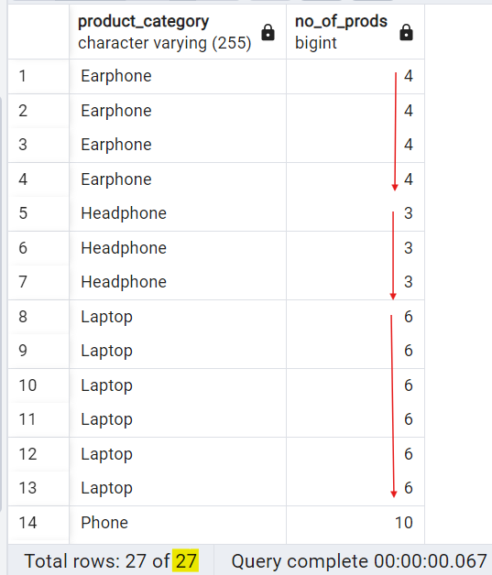

- Interview questions
Note : Will use interview_prep database for solving interview questions.
Interview problem 3
Write a SQL query to display numbers from 1 to 10 with and without using any inbuilt functions

Method 1: Using generate_series() :
SELECT generate_series(1, 10) AS number;

select * from generate_series(1,5)

Method 2: Using a Recursive Common Table Expression (CTE) :
Syntax :
Recursive means exacting same query until a condition fails.

with recursive cte as
(
select * from -- base query
union / union all
select * from cte join other tables
where termincation condition ...--recursive part of the query
)
select * from cte;

Where ,
- With recursive recursive query keyword.(like with keyword for CTE)
- Cte Recursive table name.
- Base query This executes in the 1st iteration & executes just once in total execution.
- Union / union To combine starting and next output.
- recursive part of the query This executes from the 2nd iteration and can execute multiple times until the termination condition is met

Note : Inside we have to provide 2 quires and SQL execute recursive query(i.e 2nd query) multiple times until specific condition met.

with recursive cte as
(
select 1 as num
union all
select num+1 as num from cte
where num<10
)
select * from cte;

Execution flow of above query:
-- 1st Iteration
select 1 as num

-- 2nd Iteration
select num + 1 as num
from (select 1 as num) cte
where num < 10

-- 3rd Iteration
select num + 1 as num
from (select num + 1 as num
from (select 1 as num) cte
where num < 10) cte
where num < 10

-- 4th Iteration
select num + 1 as num
from (select num + 1 as num
from (select num + 1 as num
from (select 1 as num) cte
where num < 10) cte
where num < 10) cte
where num < 10

.
.
.
.
-- 11th Iteration
select num + 1 as num
from (select 10 as num) cte
where num < 10

Interview problem 4
Create database and table:
drop TABLE if exists emp_details;

CREATE TABLE emp_details
(
id int PRIMARY KEY,
name varchar(100),
manager_id int,
salary int,
designation varchar(100)
);

INSERT INTO emp_details VALUES (1, 'Shripadh', NULL, 10000, 'CEO');
INSERT INTO emp_details VALUES (2, 'Satya', 5, 1400, 'Software Engineer');
INSERT INTO emp_details VALUES (3, 'Jia', 5, 500, 'Data Analyst');
INSERT INTO emp_details VALUES (4, 'David', 5, 1800, 'Data Scientist');
INSERT INTO emp_details VALUES (5, 'Michael', 7, 3000, 'Manager');
INSERT INTO emp_details VALUES (6, 'Arvind', 7, 2400, 'Architect');
INSERT INTO emp_details VALUES (7, 'Asha', 1, 4200, 'CTO');
INSERT INTO emp_details VALUES (8, 'Maryam', 1, 3500, 'Manager');
INSERT INTO emp_details VALUES (9, 'Reshma', 8, 2000, 'Business Analyst');
INSERT INTO emp_details VALUES (10, 'Akshay', 8, 2500, 'Java Developer');

select * from emp_details;

Problem statement:
Find the hierarchy of employees under a given manager "Asha".

Solution:
with recursive cte as
(
select id,name,designation,1 as itteration from emp_details where name='Asha'
UNION ALL
select e.id,e.name,e.designation,(itteration+1) as itteration from cte
JOIN emp_details e on cte.id=e.manager_id
)
select * from cte;

Execution flow of above query:
-- 1st Iteration
select id, name, designation, 1 as iteration
from emp_details where name = 'Asha'

-- 2nd Iteration
select e.id, e.name, e.designation, (iteration+1) as iteration
from (select id, name, designation, 1 as iteration
from emp_details where name = 'Asha') cte
join emp_details e on cte.id = e.manager_id

-- 3rd Iteration
select e.id, e.name, e.designation, (iteration+1) as iteration
from (select e.id, e.name, e.designation, (iteration+1) as iteration
from (select id, name, designation, 1 as iteration
from emp_details where name = 'Asha') cte
join emp_details e on cte.id = e.manager_id) cte
join emp_details e on cte.id = e.manager_id

-- 4th Iteration
select e.id, e.name, e.designation, (iteration+1) as iteration
from (select e.id, e.name, e.designation, (iteration+1) as iteration
from (select e.id, e.name, e.designation, (iteration+1) as iteration
from (select id, name, designation, 1 as iteration
from emp_details where name = 'Asha') cte
join emp_details e on cte.id = e.manager_id) cte
join emp_details e on cte.id = e.manager_id) cte
join emp_details e on cte.id = e.manager_id

Interview problem 5
Create database and table:
drop table if exists fb_friend_requests;

create table fb_friend_requests
(
user_id_sender varchar(20),
user_id_receiver varchar(20),
date date,
action varchar(20)
);
insert into fb_friend_requests values ('ad4943sdz','948ksx123d','2020-01-04','sent');
insert into fb_friend_requests values ('ad4943sdz','948ksx123d','2020-01-06','accepted');
insert into fb_friend_requests values ('dfdfxf9483','9djjjd9283','2020-01-04','sent');
insert into fb_friend_requests values ('dfdfxf9483','9djjjd9283','2020-01-15','accepted');
insert into fb_friend_requests values ('ffdfff4234234','lpjzjdi4949','2020-01-06','sent');
insert into fb_friend_requests values ('fffkfld9499','993lsldidif','2020-01-06','sent');
insert into fb_friend_requests values ('fffkfld9499','993lsldidif','2020-01-10','accepted');
insert into fb_friend_requests values ('fg503kdsdd','ofp049dkd','2020-01-04','sent');
insert into fb_friend_requests values ('fg503kdsdd','ofp049dkd','2020-01-10','accepted');
insert into fb_friend_requests values ('hh643dfert','847jfkf203','2020-01-04','sent');
insert into fb_friend_requests values ('r4gfgf2344','234ddr4545','2020-01-06','sent');
insert into fb_friend_requests values ('r4gfgf2344','234ddr4545','2020-01-11','accepted');

select * from fb_friend_requests;

Problem statement:
Acceptance Rate by Date
What is the overall friend acceptance rate by date?
Your output should have the rate of acceptances by the date the request was sent. Order by the earliest date to latest.

Assume that each friend request starts by a user sending (i.e., user_id_sender) a friend request to another user (i.e., user_id_receiver) that's logged in
the table with action = 'sent'. If the request is accepted, the table logs action = 'accepted'. If the request is not accepted, no record of action = 'accepted' is logged.

Solution:
We will follow below steps:
- Find the total request sent for each day
- Find the total accepted request for that day
- calculate the rate of acceptance (total accepted req / total request)

- Find the total request sent for each day
select date,count(*) as total_req from fb_friend_requests
where action='sent'
group by date;

- Find the total accepted request for that day
select sent.date,count(*) as total_acpe
from fb_friend_requests as sent
join fb_friend_requests as accepted
on sent.user_id_sender=accepted.user_id_sender
and sent.user_id_receiver=accepted.user_id_receiver
where sent.action='sent' and accepted.action='accepted'
group by sent.date;

- calculate the rate of acceptance (total accepted req / total request)
with cte_sent as (
select date,count(*) as total_req from fb_friend_requests
where action='sent'
group by date),
cte_accepted as (
select sent.date,count(*) as total_acpe
from fb_friend_requests as sent
join fb_friend_requests as accepted
on sent.user_id_sender=accepted.user_id_sender
and sent.user_id_receiver=accepted.user_id_receiver
where sent.action='sent' and accepted.action='accepted'
group by sent.date)
select cte_sent.date,
concat((round((cte_accepted.total_acpe::decimal/cte_sent.total_req::decimal),2)*100)::int,'%') as rate_of_acceptances
from cte_sent
join cte_accepted on cte_sent.date=cte_accepted.date
order by cte_sent.date;

