Agenda:
- Stored procedures or procedures.
- Same code in different database servers
- Final Interview problems(Easy 10 problems)

- Procedures
Definition:
Why we need stored procedure...?
- Procedure is a database object which is stored in the database.
- A stored procedure or procedure is a prepared SQL code that you can save, so the code can be reused over and over again.
- So, if you have an SQL query that you write over and over again, save it as a stored procedure, and then just call it to execute it.
- You can also pass parameters to a stored procedure, so that the stored procedure can act based on the parameter value(s) that is passed.

Procedure is block of code means it contain SQL and PLSQL code.

PLSQL:
- It’s an extension to SQL. Procedural extension to SQL.
- As part of PL/SQL, you then got access to more common programming features, such as variables, if conditions, loop statement, exception handling, collection type (arrays) and much more.
- PL/SQL includes Procedures, user defined functions, packages and trigger etc.

Note : PL/SQL name used in oracle database only. Same refer as below
- PostgreSQL plpgsql
- SQL Server TSQL(No special name in SQL server)

Syntax of Procedure in PostgreSQL:
Create or replace procedure <name of procedure>(par1 datatype,par2 datatype.)
Language plpgsql
As $$
DECLARE
BEGIN
END;
$$
Calling procedure:
call procedure <name of procedure>(arg1,arg2.);

Whereas,
- <name of procedure> Name of procedure that you want create.
- (par1 datatype,par2 datatype…) Optional (parameter name and datatype of inputs.
- Language plpgsql PostgreSQL is newest, this PostgreSQL can also use to write JavaScript like programs. To segregate this key word is mandatory in PostgreSQL.
- DECLARE Here we will declare all variables
- BEGIN and END write logic between begin and end.
- Call To call procedure
- (arg1,arg2…) arguments that need to pass based on procedure inputs.

Practical:
Create database and table:
create database plsql;

drop table if exists products;
drop table if exists sales;

create table products(
product_code varchar(20) primary key,
product_name varchar(100),
price float,
quantity_remaining int,
quantity_sold int);

create table sales(
order_id int generated by default as identity primary key,
order_date date,
product_code varchar(20) references products(product_code),
quantity_ordered int,
sale_price float);

insert into products values('P1','iPhone 15',1000,5,195);

insert into sales values(default,to_date('10-01-2024','dd-mm-yyyy'),'P1',100,100000);
insert into sales values(default,to_date('20-01-2024','dd-mm-yyyy'),'P1',50,50000);
insert into sales values(default,to_date('05-02-2024','dd-mm-yyyy'),'P1',45,45000);

select * from products;
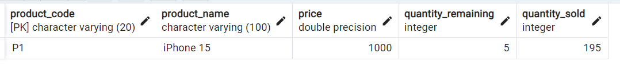

select * from sales;
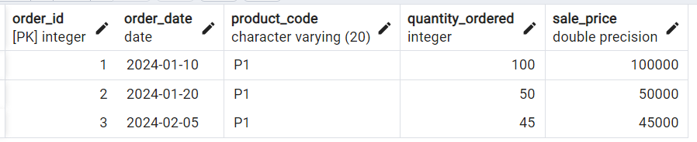

Working procedures:
We are creating multiple versions of queries that solve use case of sales of apple store.

Use case:
Suppose we are creating backend logic for 1 of apple store website. We have above 2 tables which need to update every time sales happen in store. Example sales person will check availability of iPhone and will sale based on that once he sold phone, he just updated details in UI that need to updated in backend tables.

This we can achieve by writing many quires but good way to create procedures for those is proper way to tackle this.

Version – 1 : Build a script which keeps track of every iPhone 15 sales.
Create script , if any person buys 2 or etc. iPhone 15 then in sales table new record should add and need to updated quantity remaining and quantity sold in product table.

create or replace procedure pr_product_sale()
language plpgsql
as $$
declare
v_product_code varchar(20);
v_price float;
begin
select product_code,price
into v_product_code,v_price
from products where product_name = 'iPhone 15';

insert into sales
values(default,current_date,v_product_code,1,v_price * 1);

update products
set quantity_remaining = quantity_remaining -1
,quantity_sold = quantity_sold + 1
where product_code=v_product_code;

raise notice 'Product sold sucessfully';
end;
$$

Check data before call procedure:

call pr_product_sale();

select * from products;
select * from sales;
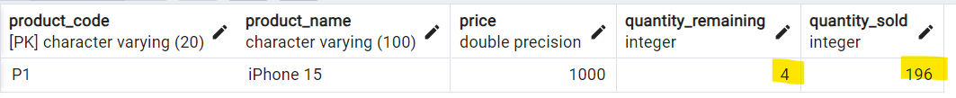

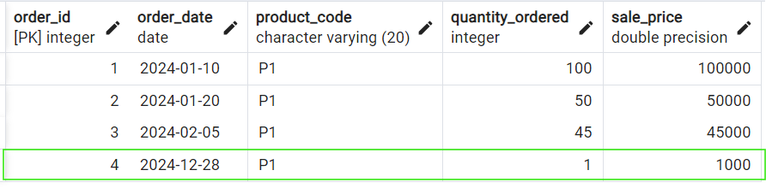

Call procedure again:
call pr_product_sale();

select * from products;
select * from sales;

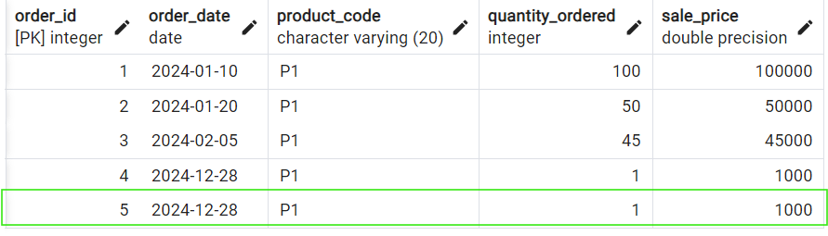

Version – 2 : Eliminate hard coded values in above code by taking input from procedure call.
Note : Recreate table and data as same as before.

create or replace procedure pr_product_sale(p_product_name varchar,p_quantity int)
language plpgsql
as $$
declare
v_product_code varchar(20);
v_price float;
begin
select product_code,price
into v_product_code,v_price
from products where product_name = p_product_name;

insert into sales
values(default,current_date,v_product_code,p_quantity,v_price * p_quantity);

update products
set quantity_remaining = quantity_remaining - p_quantity
,quantity_sold = quantity_sold + p_quantity
where product_code=v_product_code;

raise notice 'Product sold sucessfully';
end;
$$

Let’s call procedure with 3 iPhone sold:
call pr_product_sale('iPhone 15',2);
call pr_product_sale('iPhone 15',2);
call pr_product_sale('iPhone 15',2);

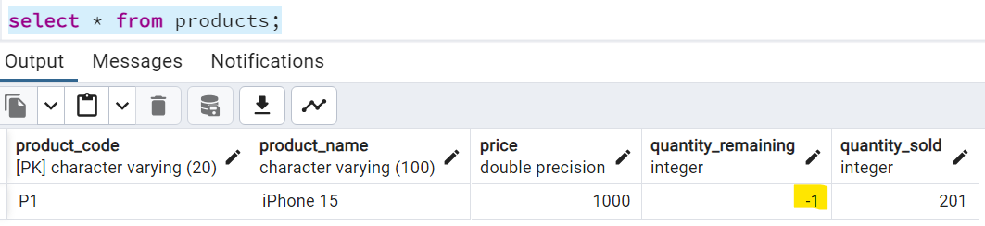

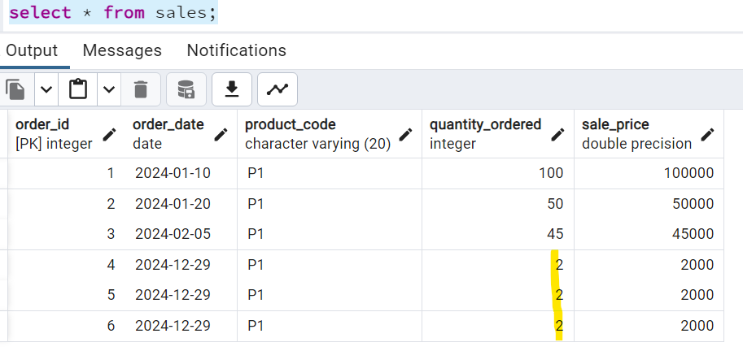

Note : We can see that quantity remaining is updated as -1 but generally that should not happen if any customer asking more product, then stock then we have to show product out of stack message.

Version – 3 : Add check condition of availability if customer ask less then availability then only, we have to allow to sold if not out of stock message.
Create function that check product availability:
create or replace function check_product_availability(p_product_name varchar,p_quantity int)
returns boolean
language plpgsql
as
$$
DECLARE
v_product_cnt int;
BEGIN
select count(*)
INTO v_product_cnt
from products
where product_name = p_product_name
and quantity_remaining>=p_quantity;

if v_product_cnt>0 then
return true;
else
return false;
end if;

END;
$$

select check_product_availability('iPhone 15',2); -- true
select check_product_availability('iPhone 15',6); -- false
select check_product_availability('iPhone 15',5); -- true

Note : Main difference between function and procedure is function will return something but procedure not.

Use above function procedure to make procedure more effective.
create or replace procedure pr_product_sale(p_product_name varchar,p_quantity int)
language plpgsql
as $$
declare
v_product_code varchar(20);
v_price float;
avilabilty_flag boolean;
begin

-- call function
select check_product_availability(p_product_name,p_quantity)
into avilabilty_flag;

if avilabilty_flag is true then
select product_code,price
into v_product_code,v_price
from products where product_name = p_product_name;

insert into sales
values(default,current_date,v_product_code,p_quantity,v_price*p_quantity);

update products
set quantity_remaining = quantity_remaining - p_quantity
,quantity_sold = quantity_sold + p_quantity
where product_code=v_product_code;

raise notice 'Product sold sucessfully';
else
raise notice 'Out of stack...';
end if;
end;
$$

call pr_product_sale('iPhone 15',6); -- Nothing changed products and sales tables

call pr_product_sale('iPhone 15',5);

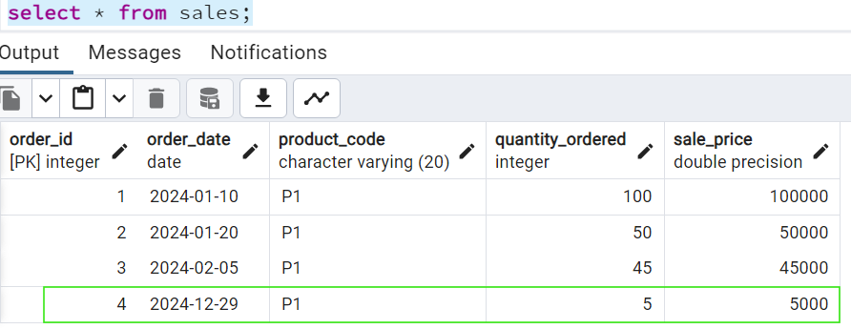

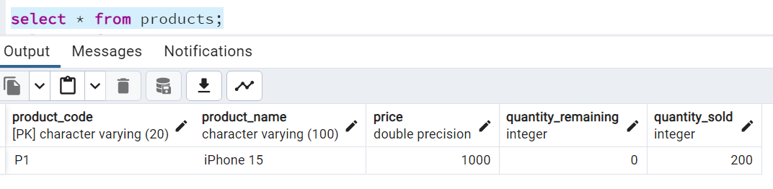

Try to call procedure again:
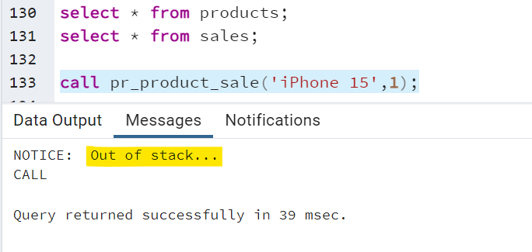

Use of double Doller($$):
PostgreSQL uses this $$ to handle escape characters in you code:

select 'I'am PostgreSQL' -- error

-- We can handle above error below 2 ways:
select E'I\'am PostgreSQL'
select $$I'am PostgreSQL$$

Updated dataset for multiple products:
drop table sales;
drop table products;

create table products
(
product_code varchar(20) primary key,
product_name varchar(100),
price float,
quantity_remaining int,
quantity_sold int
);

create table sales
(
order_id int generated by default as identity primary key,
order_date date,
product_code varchar(20) references products(product_code),
quantity_ordered int,
sale_price float
);

insert into products (product_code,product_name,price,quantity_remaining,quantity_sold)
values ('P1', 'iPhone 14 Pro Max', 1200, 5, 195);
insert into products (product_code,product_name,price,quantity_remaining,quantity_sold)
values ('P2', 'AirPods Pro', 279, 10, 90);
insert into products (product_code,product_name,price,quantity_remaining,quantity_sold)
values ('P3', 'MacBook Pro 16', 5000, 2, 48);
insert into products (product_code,product_name,price,quantity_remaining,quantity_sold)
values ('P4', 'iPad Air', 650, 1, 9);
insert into sales (order_date,product_code,quantity_ordered,sale_price)
values (to_date('10-01-2022','dd-mm-yyyy'), 'P1', 100, 120000);
insert into sales (order_date,product_code,quantity_ordered,sale_price)
values (to_date('20-01-2022','dd-mm-yyyy'), 'P1', 50, 60000);
insert into sales (order_date,product_code,quantity_ordered,sale_price)
values (to_date('05-02-2022','dd-mm-yyyy'), 'P1', 45, 540000);
insert into sales (order_date,product_code,quantity_ordered,sale_price)
values (to_date('15-01-2022','dd-mm-yyyy'), 'P2', 50, 13950);
insert into sales (order_date,product_code,quantity_ordered,sale_price)
values (to_date('25-03-2022','dd-mm-yyyy'), 'P2', 40, 11160);
insert into sales (order_date,product_code,quantity_ordered,sale_price)
values (to_date('25-02-2022','dd-mm-yyyy'), 'P3', 10, 50000);
insert into sales (order_date,product_code,quantity_ordered,sale_price)
values (to_date('15-03-2022','dd-mm-yyyy'), 'P3', 10, 50000);
insert into sales (order_date,product_code,quantity_ordered,sale_price)
values (to_date('25-03-2022','dd-mm-yyyy'), 'P3', 20, 100000);
insert into sales (order_date,product_code,quantity_ordered,sale_price)
values (to_date('21-04-2022','dd-mm-yyyy'), 'P3', 8, 40000);
insert into sales (order_date,product_code,quantity_ordered,sale_price)
values (to_date('27-04-2022','dd-mm-yyyy'), 'P4', 9, 5850);

select * from products;
select * from sales;

- Same code in different database servers:
SQL Server:
create table products
(
product_code varchar(20) primary key,
product_name varchar(100),
price float,
quantity_remaining int,
quantity_sold int
);

create table sales
(
order_id int identity(1,1) primary key,
order_date date,
product_code varchar(20) references products(product_code),
quantity_ordered int,
sale_price float
);

insert into products (product_code,product_name,price,quantity_remaining,quantity_sold)
values ('P1', 'iPhone 13 Pro Max', 1200, 5, 195);
insert into products (product_code,product_name,price,quantity_remaining,quantity_sold)
values ('P2', 'AirPods Pro', 279, 10, 90);
insert into products (product_code,product_name,price,quantity_remaining,quantity_sold)
values ('P3', 'MacBook Pro 16', 5000, 2, 48);
insert into products (product_code,product_name,price,quantity_remaining,quantity_sold)
values ('P4', 'iPad Air', 650, 1, 9);

insert into sales (order_date,product_code,quantity_ordered,sale_price)
values (convert(datetime,'10-01-2022',105), 'P1', 100, 120000);
insert into sales (order_date,product_code,quantity_ordered,sale_price)
values (convert(datetime,'20-01-2022',105), 'P1', 50, 60000);
insert into sales (order_date,product_code,quantity_ordered,sale_price)
values (convert(datetime,'05-02-2022',105), 'P1', 45, 540000);
insert into sales (order_date,product_code,quantity_ordered,sale_price)
values (convert(datetime,'15-01-2022',105), 'P2', 50, 13950);
insert into sales (order_date,product_code,quantity_ordered,sale_price)
values (convert(datetime,'25-03-2022',105), 'P2', 40, 11160);
insert into sales (order_date,product_code,quantity_ordered,sale_price)
values (convert(datetime,'25-02-2022',105), 'P3', 10, 50000);
insert into sales (order_date,product_code,quantity_ordered,sale_price)
values (convert(datetime,'15-03-2022',105), 'P3', 10, 50000);
insert into sales (order_date,product_code,quantity_ordered,sale_price)
values (convert(datetime,'25-03-2022',105), 'P3', 20, 100000);
insert into sales (order_date,product_code,quantity_ordered,sale_price)
values (convert(datetime,'21-04-2022',105), 'P3', 8, 40000);
insert into sales (order_date,product_code,quantity_ordered,sale_price)
values (convert(datetime,'27-04-2022',105), 'P4', 9, 5850);

select * from products;
select * from sales;

create or alter function fn_check_product(@p_product_name varchar(30), @p_quantity int)
returns varchar(10) -- bit is an alternative to boolean bit retruns 0 or 1
as
begin
declare @v_cnt int;
declare @v_result varchar(10);

select @v_cnt = count(1)
from products
where product_name = @p_product_name
and quantity_remaining >= @p_quantity;

if @v_cnt = 0
set @v_result = 'false';
else
set @v_result = 'true';

return @v_result;
end;

select dbo.fn_check_product('AirPods Pro', 14);

create or alter procedure pr_product_sale(@p_product_name varchar(30), @p_quantity int)
as
begin
declare
@v_prod_code varchar(30), -- variable is a pl sql object which stores a ONLY single value.
@v_price int,
@v_check varchar(10);

select @v_check = dbo.fn_check_product(@p_product_name, @p_quantity);

if @v_check = 'true'
begin
select @v_prod_code = product_code, @v_price = price
from products
where product_name = @p_product_name;

insert into sales values (cast(getdate() as date), @v_prod_code, @p_quantity, @v_price * @p_quantity);

update products
set quantity_remaining = quantity_remaining - @p_quantity
, quantity_sold = quantity_sold + @p_quantity
where product_code = @v_prod_code;

print('Product sold successfully!');
end;
else
print('Failure: Out of Stock!');

end;

exec pr_product_sale 'MacBook Pro 16', 2;

ORACLE:
drop table sales;
drop table products;

create table products
(
product_code varchar(20) primary key,
product_name varchar(100),
price float,
quantity_remaining int,
quantity_sold int
);

create table sales
(
order_id int generated by default as identity primary key,
order_date date,
product_code varchar(20) references products(product_code),
quantity_ordered int,
sale_price float
);

insert into products (product_code,product_name,price,quantity_remaining,quantity_sold)
values ('P1', 'iPhone 13 Pro Max', 1200, 5, 195);
insert into products (product_code,product_name,price,quantity_remaining,quantity_sold)
values ('P2', 'AirPods Pro', 279, 10, 90);
insert into products (product_code,product_name,price,quantity_remaining,quantity_sold)
values ('P3', 'MacBook Pro 16', 5000, 2, 48);
insert into products (product_code,product_name,price,quantity_remaining,quantity_sold)
values ('P4', 'iPad Air', 650, 1, 9);

insert into sales (order_date,product_code,quantity_ordered,sale_price)
values (to_date('10-01-2022','dd-mm-yyyy'), 'P1', 100, 120000);
insert into sales (order_date,product_code,quantity_ordered,sale_price)
values (to_date('20-01-2022','dd-mm-yyyy'), 'P1', 50, 60000);
insert into sales (order_date,product_code,quantity_ordered,sale_price)
values (to_date('05-02-2022','dd-mm-yyyy'), 'P1', 45, 540000);
insert into sales (order_date,product_code,quantity_ordered,sale_price)
values (to_date('15-01-2022','dd-mm-yyyy'), 'P2', 50, 13950);
insert into sales (order_date,product_code,quantity_ordered,sale_price)
values (to_date('25-03-2022','dd-mm-yyyy'), 'P2', 40, 11160);
insert into sales (order_date,product_code,quantity_ordered,sale_price)
values (to_date('25-02-2022','dd-mm-yyyy'), 'P3', 10, 50000);
insert into sales (order_date,product_code,quantity_ordered,sale_price)
values (to_date('15-03-2022','dd-mm-yyyy'), 'P3', 10, 50000);
insert into sales (order_date,product_code,quantity_ordered,sale_price)
values (to_date('25-03-2022','dd-mm-yyyy'), 'P3', 20, 100000);
insert into sales (order_date,product_code,quantity_ordered,sale_price)
values (to_date('21-04-2022','dd-mm-yyyy'), 'P3', 8, 40000);
insert into sales (order_date,product_code,quantity_ordered,sale_price)
values (to_date('27-04-2022','dd-mm-yyyy'), 'P4', 9, 5850);

create or replace function fn_check_if_prod_exists(p_product_name varchar2, p_quantity int)
return varchar2
as
v_count int; -- Declaration section
begin
-- Execution section
select count(1)
into v_count
from products
where product_name = p_product_name
and quantity_remaining >= p_quantity;

if v_count > 0 then
return 'True';
else
return 'False';
end if;
exception when others
then
null; -- exception handling section
end;

-- Execute a function:
select fn_check_if_prod_exists('iPhone 13 Pro Max', 2) from dual;

create or replace procedure pr_product_sales(p_product_name varchar, p_quantity int)
as

-- declare variables
v_prod_code varchar(10);
v_price int;
v_check varchar(10);
begin
-- main block of our code
-- Check if product exists:
select fn_check_if_prod_exists(p_product_name, p_quantity)
into v_check
from dual;

if v_check = 'False' then
dbms_output.put_line('Product not available!');
else
-- 1. Fetch the product_code and price for each product from products table
select product_code, price
into v_prod_code, v_price
from products
where product_name = p_product_name;

-- 2. load new data to sales table
insert into sales (order_date, product_code, quantity_ordered, sale_price)
values (current_date, v_prod_code, p_quantity, (p_quantity * v_price));

-- 3. update the products table accordingly as per sale.
update products
set quantity_remaining = quantity_remaining - p_quantity
, quantity_sold = quantity_sold + p_quantity
where product_code = v_prod_code;

dbms_output.put_line('Product sold successfully!');
end if;
end;

-- Execute a procedure:
exec pr_product_sales('AirPods Pro', 6);

select * from products;
select * from sales;

MSSQL:
create table products
(
product_code varchar(20) primary key,
product_name varchar(100),
price float,
quantity_remaining int,
quantity_sold int
);

create table sales
(
order_id int identity(1,1) primary key,
order_date date,
product_code varchar(20) references products(product_code),
quantity_ordered int,
sale_price float
);

insert into products (product_code,product_name,price,quantity_remaining,quantity_sold)
values ('P1', 'iPhone 13 Pro Max', 1200, 5, 195);
insert into products (product_code,product_name,price,quantity_remaining,quantity_sold)
values ('P2', 'AirPods Pro', 279, 10, 90);
insert into products (product_code,product_name,price,quantity_remaining,quantity_sold)
values ('P3', 'MacBook Pro 16', 5000, 2, 48);
insert into products (product_code,product_name,price,quantity_remaining,quantity_sold)
values ('P4', 'iPad Air', 650, 1, 9);

insert into sales (order_date,product_code,quantity_ordered,sale_price)
values (convert(datetime,'10-01-2022',105), 'P1', 100, 120000);
insert into sales (order_date,product_code,quantity_ordered,sale_price)
values (convert(datetime,'20-01-2022',105), 'P1', 50, 60000);
insert into sales (order_date,product_code,quantity_ordered,sale_price)
values (convert(datetime,'05-02-2022',105), 'P1', 45, 540000);
insert into sales (order_date,product_code,quantity_ordered,sale_price)
values (convert(datetime,'15-01-2022',105), 'P2', 50, 13950);
insert into sales (order_date,product_code,quantity_ordered,sale_price)
values (convert(datetime,'25-03-2022',105), 'P2', 40, 11160);
insert into sales (order_date,product_code,quantity_ordered,sale_price)
values (convert(datetime,'25-02-2022',105), 'P3', 10, 50000);
insert into sales (order_date,product_code,quantity_ordered,sale_price)
values (convert(datetime,'15-03-2022',105), 'P3', 10, 50000);
insert into sales (order_date,product_code,quantity_ordered,sale_price)
values (convert(datetime,'25-03-2022',105), 'P3', 20, 100000);
insert into sales (order_date,product_code,quantity_ordered,sale_price)
values (convert(datetime,'21-04-2022',105), 'P3', 8, 40000);
insert into sales (order_date,product_code,quantity_ordered,sale_price)
values (convert(datetime,'27-04-2022',105), 'P4', 9, 5850);

create or alter function dbo.fn_check_if_prod_exists(@p_product_name varchar(20), @p_quantity int)
returns varchar
as
begin
declare @v_count int;
declare @res varchar(10);

select @v_count = count(1)
from products
where product_name = @p_product_name
and quantity_remaining >= @p_quantity;

if @v_count > 0
set @res = 'True';
else
set @res = 'False';

return @res;
end;

-- Execute a function:
select dbo.fn_check_if_prod_exists('iPhone 13 Pro Max', 6);

/* CREATING THE PROCEDURE */
create or alter procedure pr_buy_products(@p_product_name varchar(20), @p_quantity int)
as
begin
declare @v_cnt int,
@v_product_code varchar(20),
@v_price int;

select @v_cnt = count(*)
from products
where product_name = @p_product_name
and quantity_remaining >= @p_quantity;

if @v_cnt > 0
begin
select @v_product_code = product_code, @v_price = price
from products
where product_name = @p_product_name
and quantity_remaining >= @p_quantity;

insert into sales (order_date,product_code,quantity_ordered,sale_price)
values (cast(getdate() as date), @v_product_code, @p_quantity, (@v_price * @p_quantity));

update products
set quantity_remaining = (quantity_remaining - @p_quantity)
, quantity_sold = (quantity_sold + @p_quantity)
where product_code = @v_product_code;

print('Product sold!');
end
else
print('Insufficient Quantity!');
end;

-- Execute procedure:
exec pr_buy_products 'MacBook Pro 16',1;

MYSQL:
use demo;

/* CREATING THE TABLES */
select * from products;
select * from sales;

drop table sales;
drop table products;

create table products
(
product_code varchar(20) primary key,
product_name varchar(100),
price float,
quantity_remaining int,
quantity_sold int
);

create table sales
(
order_id int auto_increment primary key,
order_date date,
product_code varchar(20) references products(product_code),
quantity_ordered int,
sale_price float
);

insert into products (product_code,product_name,price,quantity_remaining,quantity_sold)
values ('P1', 'iPhone 13 Pro Max', 1200, 5, 195);
insert into products (product_code,product_name,price,quantity_remaining,quantity_sold)
values ('P2', 'AirPods Pro', 279, 10, 90);
insert into products (product_code,product_name,price,quantity_remaining,quantity_sold)
values ('P3', 'MacBook Pro 16', 5000, 2, 48);
insert into products (product_code,product_name,price,quantity_remaining,quantity_sold)
values ('P4', 'iPad Air', 650, 1, 9);

insert into sales (order_date,product_code,quantity_ordered,sale_price)
values (str_to_date('10-01-2022','%d-%m-%Y'), 'P1', 100, 120000);
insert into sales (order_date,product_code,quantity_ordered,sale_price)
values (str_to_date('20-01-2022','%d-%m-%Y'), 'P1', 50, 60000);
insert into sales (order_date,product_code,quantity_ordered,sale_price)
values (str_to_date('05-02-2022','%d-%m-%Y'), 'P1', 45, 540000);
insert into sales (order_date,product_code,quantity_ordered,sale_price)
values (str_to_date('15-01-2022','%d-%m-%Y'), 'P2', 50, 13950);
insert into sales (order_date,product_code,quantity_ordered,sale_price)
values (str_to_date('25-03-2022','%d-%m-%Y'), 'P2', 40, 11160);
insert into sales (order_date,product_code,quantity_ordered,sale_price)
values (str_to_date('25-02-2022','%d-%m-%Y'), 'P3', 10, 50000);
insert into sales (order_date,product_code,quantity_ordered,sale_price)
values (str_to_date('15-03-2022','%d-%m-%Y'), 'P3', 10, 50000);
insert into sales (order_date,product_code,quantity_ordered,sale_price)
values (str_to_date('25-03-2022','%d-%m-%Y'), 'P3', 20, 100000);
insert into sales (order_date,product_code,quantity_ordered,sale_price)
values (str_to_date('21-04-2022','%d-%m-%Y'), 'P3', 8, 40000);
insert into sales (order_date,product_code,quantity_ordered,sale_price)
values (str_to_date('27-04-2022','%d-%m-%Y'), 'P4', 9, 5850);

/* CREATING THE PROCEDURE */
drop procedure if exists pr_buy_products;

DELIMITER $$
create procedure pr_buy_products(p_product_name varchar(30), p_quantity int)
begin
declare v_cnt int;
declare v_product_code varchar(20);
declare v_price int;

select count(*)
into v_cnt
from products
where product_name = p_product_name
and quantity_remaining >= p_quantity;

if v_cnt > 0
then
select product_code, price
into v_product_code, v_price
from products
where product_name = p_product_name
and quantity_remaining >= p_quantity;

insert into sales (order_date,product_code,quantity_ordered,sale_price)
values (cast(now() as date), v_product_code, p_quantity, (v_price * p_quantity));

update products
set quantity_remaining = (quantity_remaining - p_quantity)
, quantity_sold = (quantity_sold + p_quantity)
where product_code = v_product_code;

select 'Product sold!';
else
select 'Insufficient Quantity!';
end if;
end$$

-- Execute procedure:
call pr_buy_products('MacBook Pro 16',1);

- Final Interview problems(Easy 10 problems)

