Session – 3(Introduction):

What is cloud computing...?
In Traditional IT, companies used to maintain their own storage and some other services. But as business grows, companies need more effects to maintain that setup.
To solve this, some companies were established to provide many different services like storage, database etc.
Cloud computing is a technology model that allows you to access computing resources—like servers, storage, databases, networking, software, and analytics—over the internet (“the cloud”) instead of owning, operating, or maintaining physical hardware and software yourself.
Cloud computing is typically categorized by deployment models and service models. Let’s cover both for a comprehensive view.

Deployment models:
- Public Cloud:
- Definition: Services offered over the public internet by third-party providers (e.g., AWS, Microsoft Azure, Google Cloud).
- Features:
  - Shared computing resources
  - Pay-as-you-go pricing
  - High scalability and geographic reach
- Use Case: Hosting websites, web apps, or scalable backend services.

- Private Cloud:
- Definition: A cloud environment dedicated to a single organization, hosted either on-premises or by a third-party provider, offering greater control over infrastructure and data.
- Features:
  - Exclusive, non-shared resources
  - Enhanced security and privacy controls
  - Customizable solutions tailored to organizational needs
  - Compliance-friendly for regulated industries
- Use Case: Large enterprises, financial institutions, or government agencies requiring strict data governance and security

- Hybrid Cloud:
- Definition: A computing environment that combines public and private cloud resources, allowing data and applications to move between them for increased flexibility and optimization.
- Features:
  - Mix of on-premises (private) and off-premises (public) infrastructure
  - Seamless integration between environments
  - Optimized cost, performance, and security—use public cloud for scalability while keeping sensitive workloads private
  - Business continuity and disaster recovery benefits
- Use Case: A retail company that processes customer payments and stores sensitive information in a private cloud, while using a public cloud to handle seasonal spikes in web traffic or marketing campaigns.

- Multi-Cloud:
- Definition: The use of multiple public cloud services from different vendors—without necessarily integrating private infrastructure—often to avoid vendor lock-in and optimize offerings.
- Features:
  - Combines services from two or more cloud providers
  - Reduces dependency on a single vendor
  - Flexibility to choose best-fit services (e.g., storage from one provider, machine learning from another)
  - Can improve resilience and minimize outages
- Use Case: A global retailer using AWS for e-commerce hosting in North America, Google Cloud for big data analytics in Europe, and Microsoft Azure for enterprise applications in Asia.

Types of Cloud Computing (service models):
- Infrastructure as a Service (IaaS)
- Definition: Provides basic computing infrastructure—virtual servers, storage, networking—on demand.
- Features:
  - Users manage operating systems, applications, and data
  - Provider manages physical infrastructure
  - Highly scalable, pay-as-you-go
  - Flexibility for IT customization
- Examples: Amazon Web Services (AWS EC2), Microsoft Azure VMs, Google Compute Engine
- Use Case: Hosting virtual servers for development/testing, disaster recovery, website hosting.

- Platform as a Service (PaaS)
- Definition: Offers a cloud-based environment with everything needed to develop, run, and manage applications.
- Features:
  - Users manage their applications/data
  - Provider manages hardware, OS, and platform
  - Built-in scalability, development tools, and middleware
  - Speeds up application development
- Examples: Google App Engine, Microsoft Azure App Service, Heroku
- Use Case: Building and deploying web applications without managing servers or OS.

- Software as a Service (SaaS)
- Definition: Delivers fully functional software applications over the internet.
- Features:
  - Users access applications via web browser
  - Provider manages everything (infrastructure, platform, and software)
  - Subscription or usage-based pricing
  - No need for local installation
- Examples: Salesforce, Microsoft Office 365, Google Workspace, Zoom
- Use Case Example: Email, collaboration, CRM tools, and video conferencing.

- (Optional) 4. Function as a Service (FaaS) / Serverless
- Definition:
Lets you run individual functions or pieces of code in response to events, abstracting all infrastructure management.
- Features:
  - Only pay for compute during execution
  - No server management
  - Highly elastic and event-driven
- Examples:
AWS Lambda, Azure Functions, Google Cloud Functions
- Use Case Example:
Real-time file processing, event-driven microservices, IoT data handling.
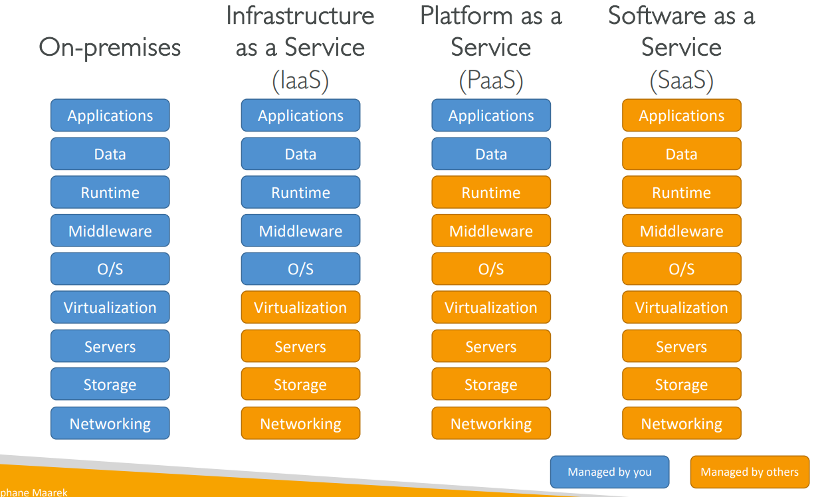

Pricing of the Cloud – Quick Overview:
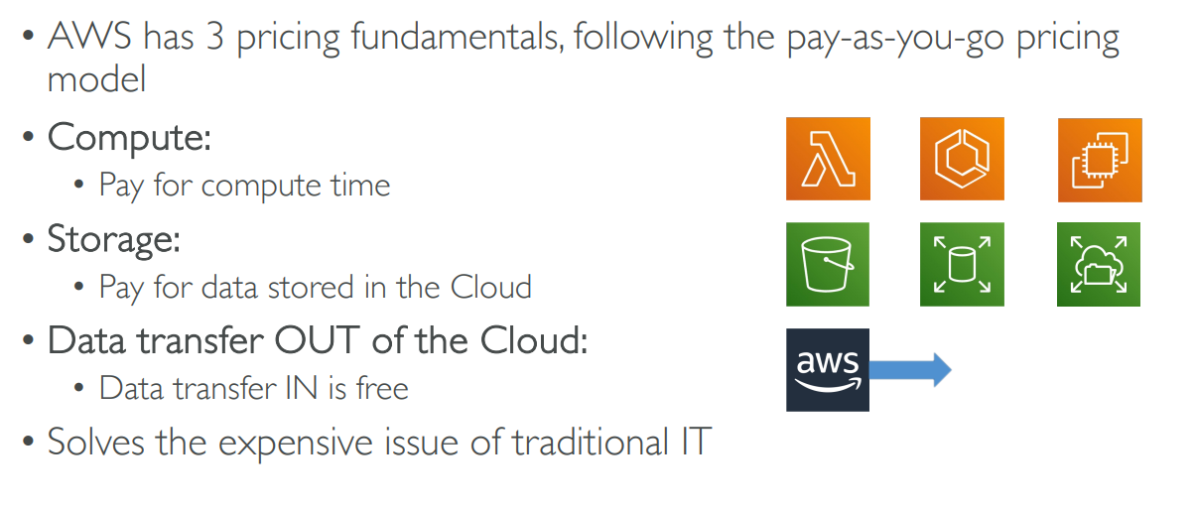

AWS History:
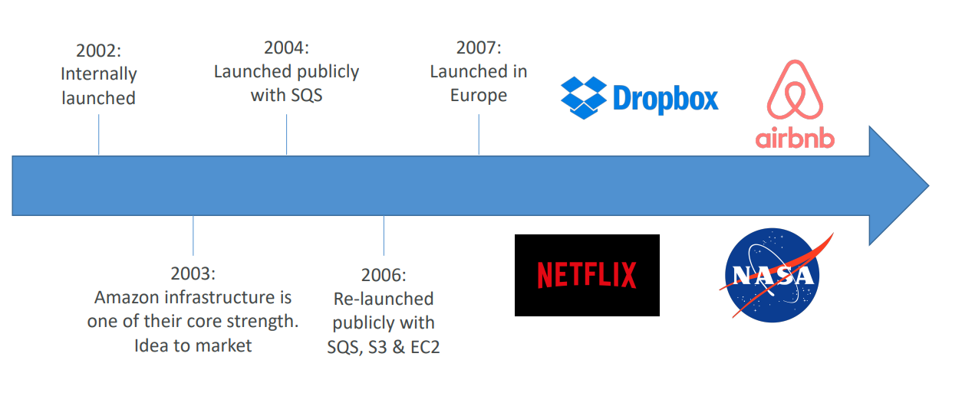

AWS Global Infrastructure:
AWS is global, we have below sub-parts there.
- AWS Regions
- AWS Availability Zones
- AWS Data Centres
- AWS Edge Locations / Points of Presence
Go through this link to see: https://infrastructure.aws/

AWS Regions:
- AWS has Regions all around the world.
- Names can be us-east-1, eu-west-3…
- A region is a cluster of data centers.
- Most AWS services are region-scoped
How to choose an AWS Region?
- Compliance with data governance and legal requirements: data never leaves a region without your explicit permission.
- Proximity to customers: reduced latency.
- Available services within a Region: few services and few features aren’t available in every Region.
- Pricing: pricing varies region to region and is transparent in the service pricing page.

AWS Availability Zones:
- Each region has many availability zones (usually 3, min is 3, max is 6).
- Example: • ap-southeast-2a • ap-southeast-2b • ap-southeast-2c.
- Each availability zone (AZ) is one or more discrete data centres with redundant power, networking, and connectivity.
- They’re separate from each other, so that they’re isolated from disasters.
- They’re connected with high bandwidth, ultra-low latency networking.
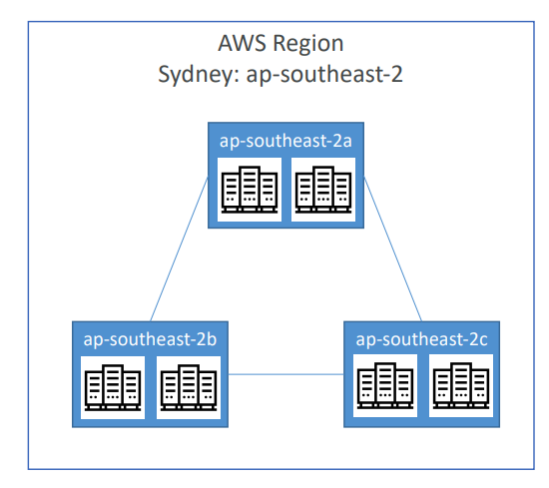

AWS Points of Presence (Edge Locations):
- Amazon has 400+ Points of Presence (400+ Edge Locations & 10+ Regional Caches) in 90+ cities across 40+ countries.
- Content is delivered to end users with lower latency.
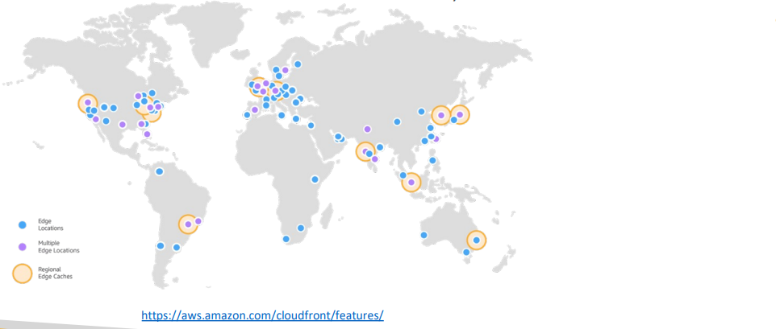
Edge locations are used to serve service with low latency to near by user. When any request go to actual AWS region first it will go to edge location. If data there then fetch it from edge location. If not pull actual data and cache for other users.

Tour of the AWS Console
- AWS has Global Services:
  - Identity and Access Management (IAM)
  - Route 53 (DNS service)
  - CloudFront (Content Delivery Network)
  - WAF (Web Application Firewall)
- Most AWS services are Region-scoped:
  - Amazon EC2 (Infrastructure as a Service)
  - Elastic Beanstalk (Platform as a Service)
  - Lambda (Function as a Service)
  - Rekognition (Software as a Service)
Region Table: https://aws.amazon.com/about-aws/global-infrastructure/regional-product-services

Shared Responsibility Model diagram:
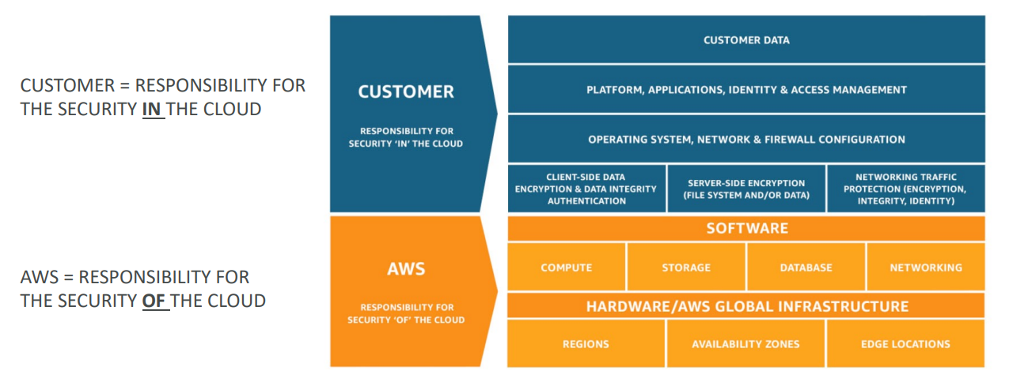
https://aws.amazon.com/compliance/shared-responsibility-model/

