**Kubernetes 201**

**Micro-service Based Java SpringBoot Application:**

* Git Hub Link: <https://github.com/KRams2019/MovieCatalog-Microservice.git>

In this Repository I have created three micro-services movie-info-service, movie-rating-service and movie-catalog-info. And movie-catalog-info service which get data from above two services. And also used MySql database for storing data.

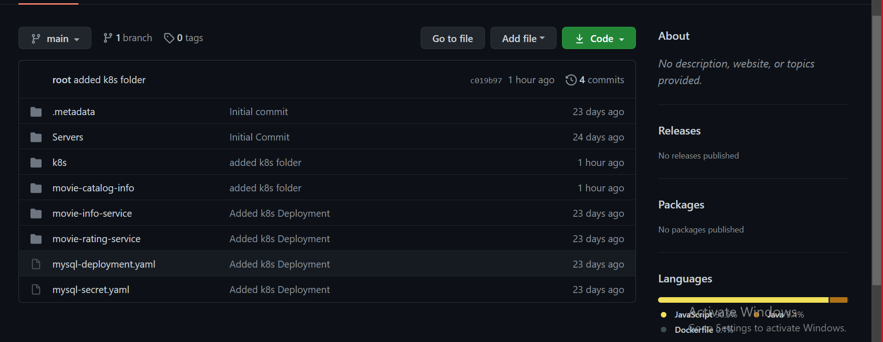

* I also written the docker file for each of services.

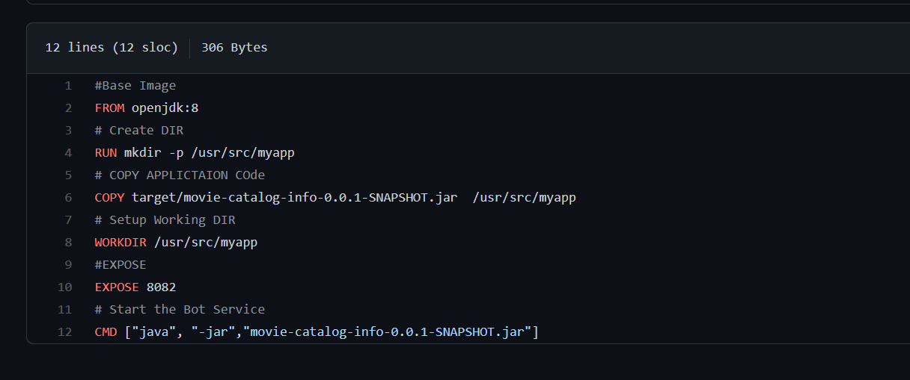

* Push the Docker Image.

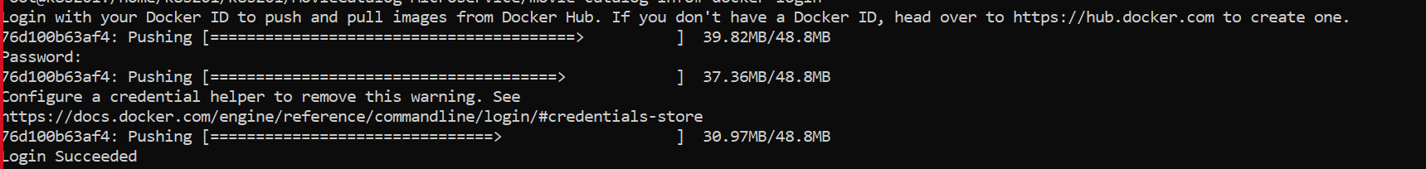

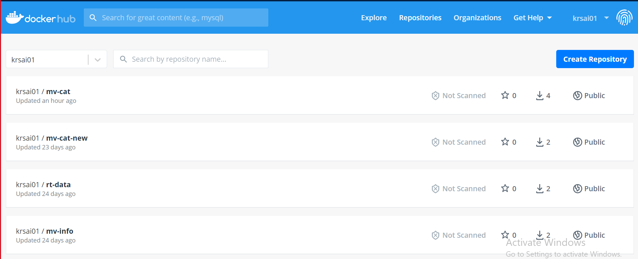

* Created Kubernetes AKS Cluster.

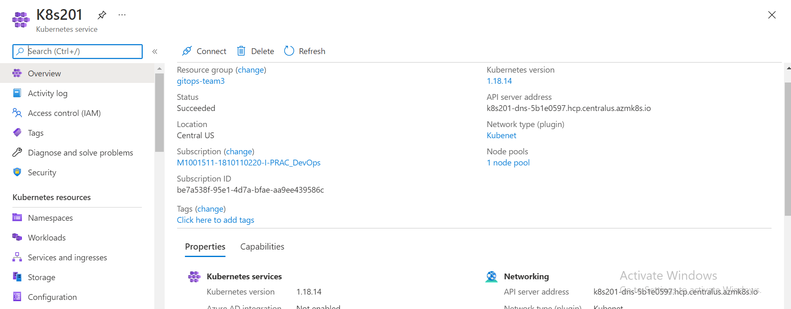

* YAML files in kubernetes:

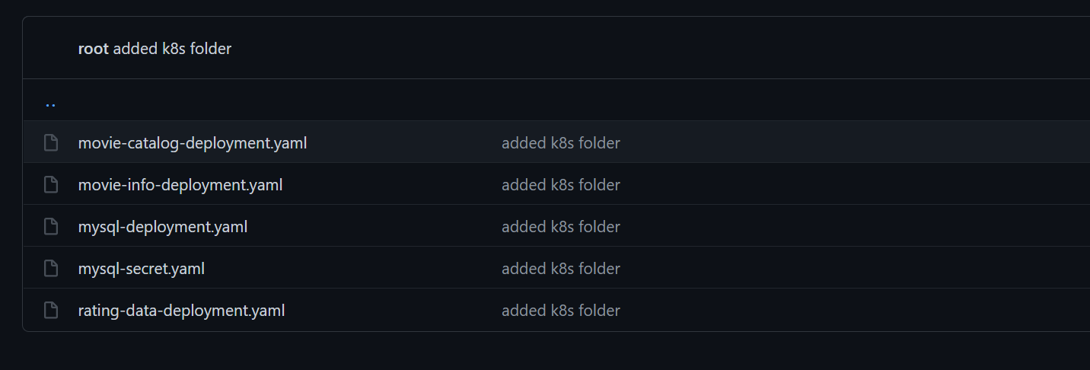

* Deployment/Replication sets

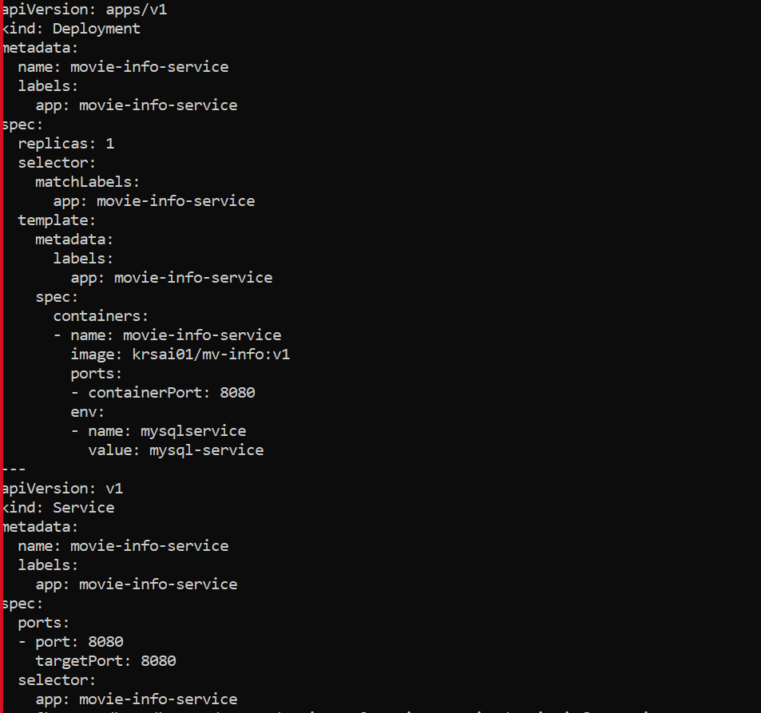

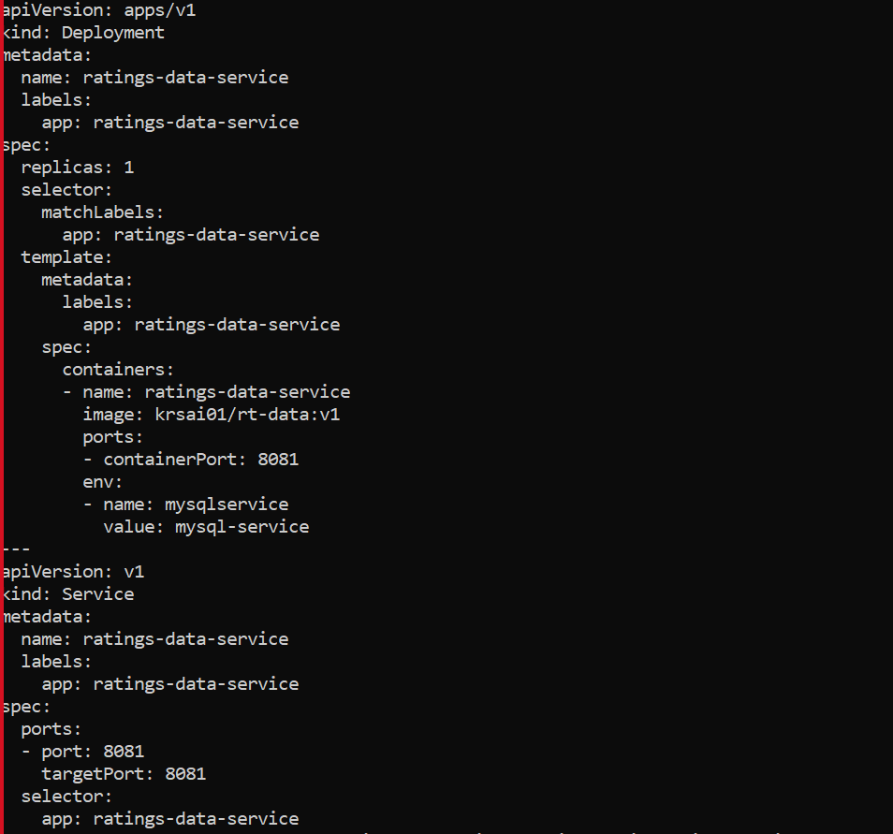

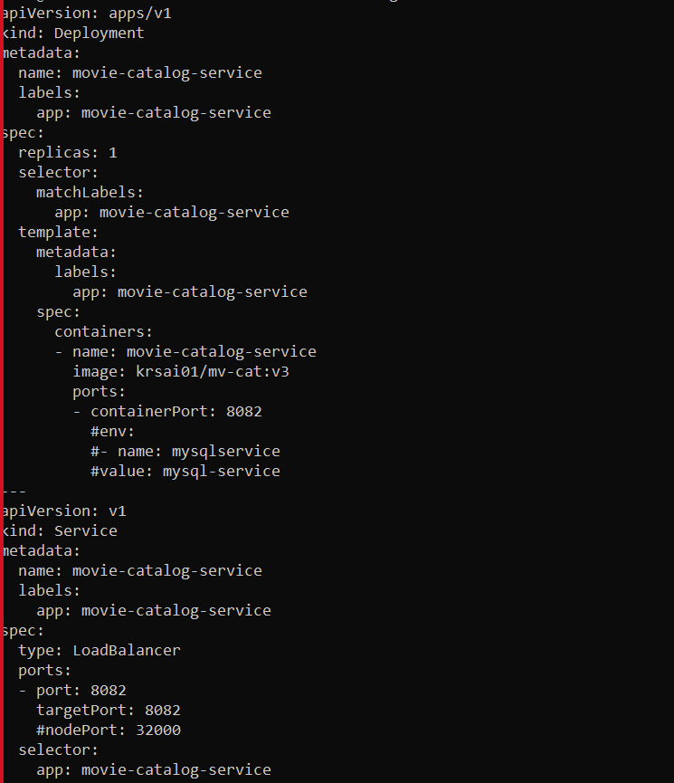

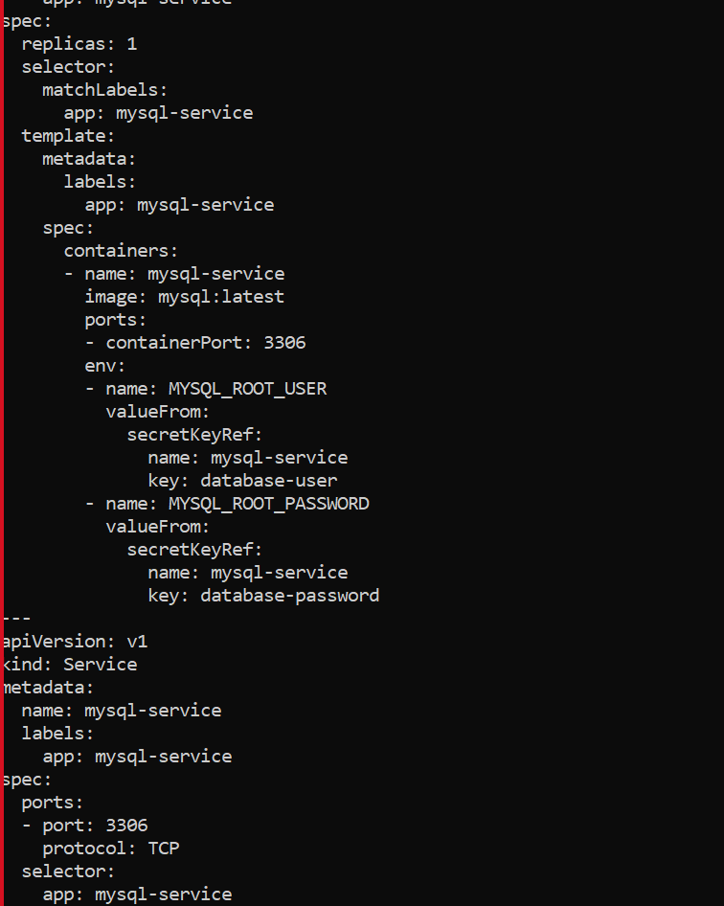

* Application Output And Logs:

