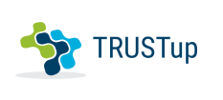
TRUSTup – application for creating cyber-trust in connected homes

System Description Document

Document Version: 0.2
Date: 2/3/2021
Last edited by: Rechowicz, Krzysztof J.

Developed by W&M and ODU under the Coastal VA Commonwealth Cyber Initiative -- "Trust, Interoperability and Inclusion: A Framework for Creating Cyber-Trust in Connected Homes."

Executive Summary
The TRUSTup is a software solution for creating cyber-trust in connected homes by implementing a cyber-trust framework that takes into account the 1) manufacturer, configuration and interoperability of devices in a home, 2) the experience, background and position on individuals occupying the space on a spectrum (hearing, vision, physical/motor, and autism) and 3) the content, type, and amount of data being collected, whether disclosed or undisclosed.
TRUSTup comes from the realization modern Western homes are increasingly equipped with smart and connected devices. This multiplication of sensors brings into the home a multitude of multimodal interfaces (voice, web, tactile), hidden tracking, embedded automation, and adaptive learning. As a result, the home of the future is a massive data collection ecosystem that can be misused for economic and financial gain and is vulnerable to cyber-attacks. The homeowner is often unaware of the data being collected or the security risk they face by introducing a new device in their living space. As a result, there is a deficit of trust between smart and connected spaces and the people occupying the space.
This deficit of trust has a critical impact. While a smart home's goal is to adapt to and support its occupants, current devices and algorithms are not trusted to adapt to the diversity of experience, background, preferences, and physical ranges routinely encountered in real life. As a result, people's experiences on a spectrum (hearing, vision, physical/motor, autism) are often not effectively accommodated. The solution is to increase trust between the people, connected objects, and the companies that make them.
To address these challenges, TRUSTup (1) detects and identifies connected IoT devices in the user's home, (2) retrieves, processes, and analyzes associated Privacy Policies (PPs) and Terms of Service (ToS), (3) identifies security-related software flaws and misconfigurations by leveraging the U.S. government repository and social media, (4) presents cyber-trust-related insights to the user through an accessible and inclusive interface.

Table of Contents
Executive Summary 2
Acronyms and Abbreviations 4
Terms and Definitions 5
1. Introduction 6
2. TRUSTup Overview 6
3. System Architecture 7
3.1 Connected Home 7
3.2 Client mobile application 7
3.3 TRUSTup server-side application 9
3.4 Technical Architecture 9
3.4.1 Technology Stack 9
3.4.2 Cloud Deployment Architecture 9
3.4.3 User Interface 9
4. Role-Based Access and Permission 9
5. Risks 10
6. Team Organization 10
References 11

Acronyms and Abbreviations

AI | Artificial Intelligence
CCI | Commonwealth Cyber-Initiative
COTS | Commercial off-the-shelf
ML | Machine Learning
PP | Privacy Policy
ToS | Terms of Service
NVD | National Vulnerability Database
UI | User Interface
ToS;DR | Terms of Service; Didin’t Read

Terms and Definitions
Accessibility | The practice of making your websites usable by as many people as possible.
Privacy Policy | A statement or legal document that discloses some or all of the ways a party gathers, uses, discloses, and manages a customer or client's data.
Terms of Service | The legal agreements between a service provider and a person who wants to use that service. The person must agree to abide by the terms of service in order to use the offered service. Terms of service can also be merely a disclaimer, especially regarding the use of websites.
Trust | Firm belief in the reliability, truth, ability, or strength of someone or something.
Zero-day | A flaw in software, hardware, or firmware that is unknown to the party or parties responsible for patching or otherwise fixing the flaw. The term zero-day may refer to the vulnerability itself or an attack with zero days between the time the vulnerability is discovered and the first attack.
Terms of Service; Didn't Read | A community project aiming to analyze and grade the terms of service and privacy policies of major Internet sites and services. Each aspect of a ToS or privacy policy is assessed as positive, negative, or neutral.

Introduction
This System Description Document (SDD) was created to outline the system design for TRUSTup and how it was constructed. SDD was also created to ensure that the TRUSTup design meets the requirements specified in the Trust, Interoperability and Inclusion: A Framework for Creating Cyber-Trust in Connected Homes" project requirements documentation. SDD is also intended to provide context and perspective for current and future team members, customers, and stakeholders. SDD describes the system architecture, software, hardware, database design, and security.

TRUSTup Overview
TRUSTup is a software solution aimed at increasing cyber-trust between the people, connected objects, and the companies that make them. It is accomplished by implementing the framework for creating cyber-trust in connected homes in the form of a mobile app and a
TRUSTup integrates seamlessly into the user's current environment. The user can:
- Utilize TRUSTup to identify all IoT devices connected to the internet through their home network.
- Receive information about scores associated with PPs and TOSs (and the fragments raising concerns) corresponding to the IoT devices.
- Receive information about any reported in the NIST's National Vulnerability Database vulnerabilities associated with the IoT devices.
- Receive information regarding any significant mentions of a zero-day vulnerability on social media associated with the IoT devices.
- Access the information through an accessible UI.

TRUSTup can scan the local network to discover IoT devices and automatically identify the associated vendor.
TRUSTup can search for PPs and ToS associated with the IoT devices and the corresponding community-based rating related to how the user's data is handled.
For PPs and ToS that have not been rated by the community, TRUSTup leverages natural language processing to identify similar clauses in the database of rated documents and adopt their rating.

TRUSTup has a modular and extensible software architecture to support the response to new requirements and to allow seamless integration of state-of-the-art algorithms providing novel analytical and machine learning capabilities.

System Architecture
At the highest level of abstraction, TRUSTup ecosystem comprises three core components:
- Connected Home
- Client mobile application
- Server-side application

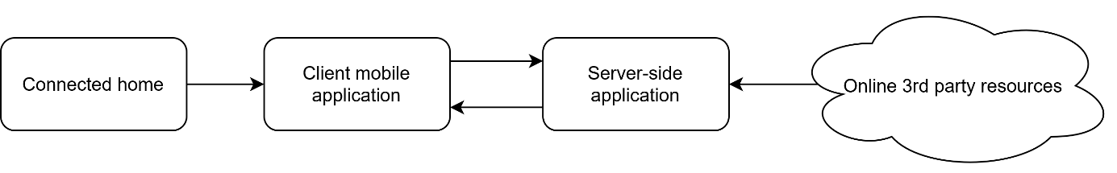
Figure 1. System components.

Connected Home
Connected home is the place where one lives permanently and connected to the network devices monitor and control home attributes such as lighting, climate, entertainment systems, and appliances. In this context, connected devices carried and worn by homeowners which help them communicate, maintain their health, or monitor physical activity are considered part of the ecosystem. Smart vehicles can be also considered as an extension of connected home.
Figure 2. TRUSTup in the context of the connected home.

Client mobile application
TRUSTup mobile app provides the following functionality to the user:
- Scanning the home network for the connected devices.
- Correcting information about the connected devices.
- Searching the database of IoT devices for a connected home.
- Storing the information about the connected devices, including the user-added devices.
- Delivering information about grades and labels associated with PPs and TOSs.
- Choosing and saving user settings.
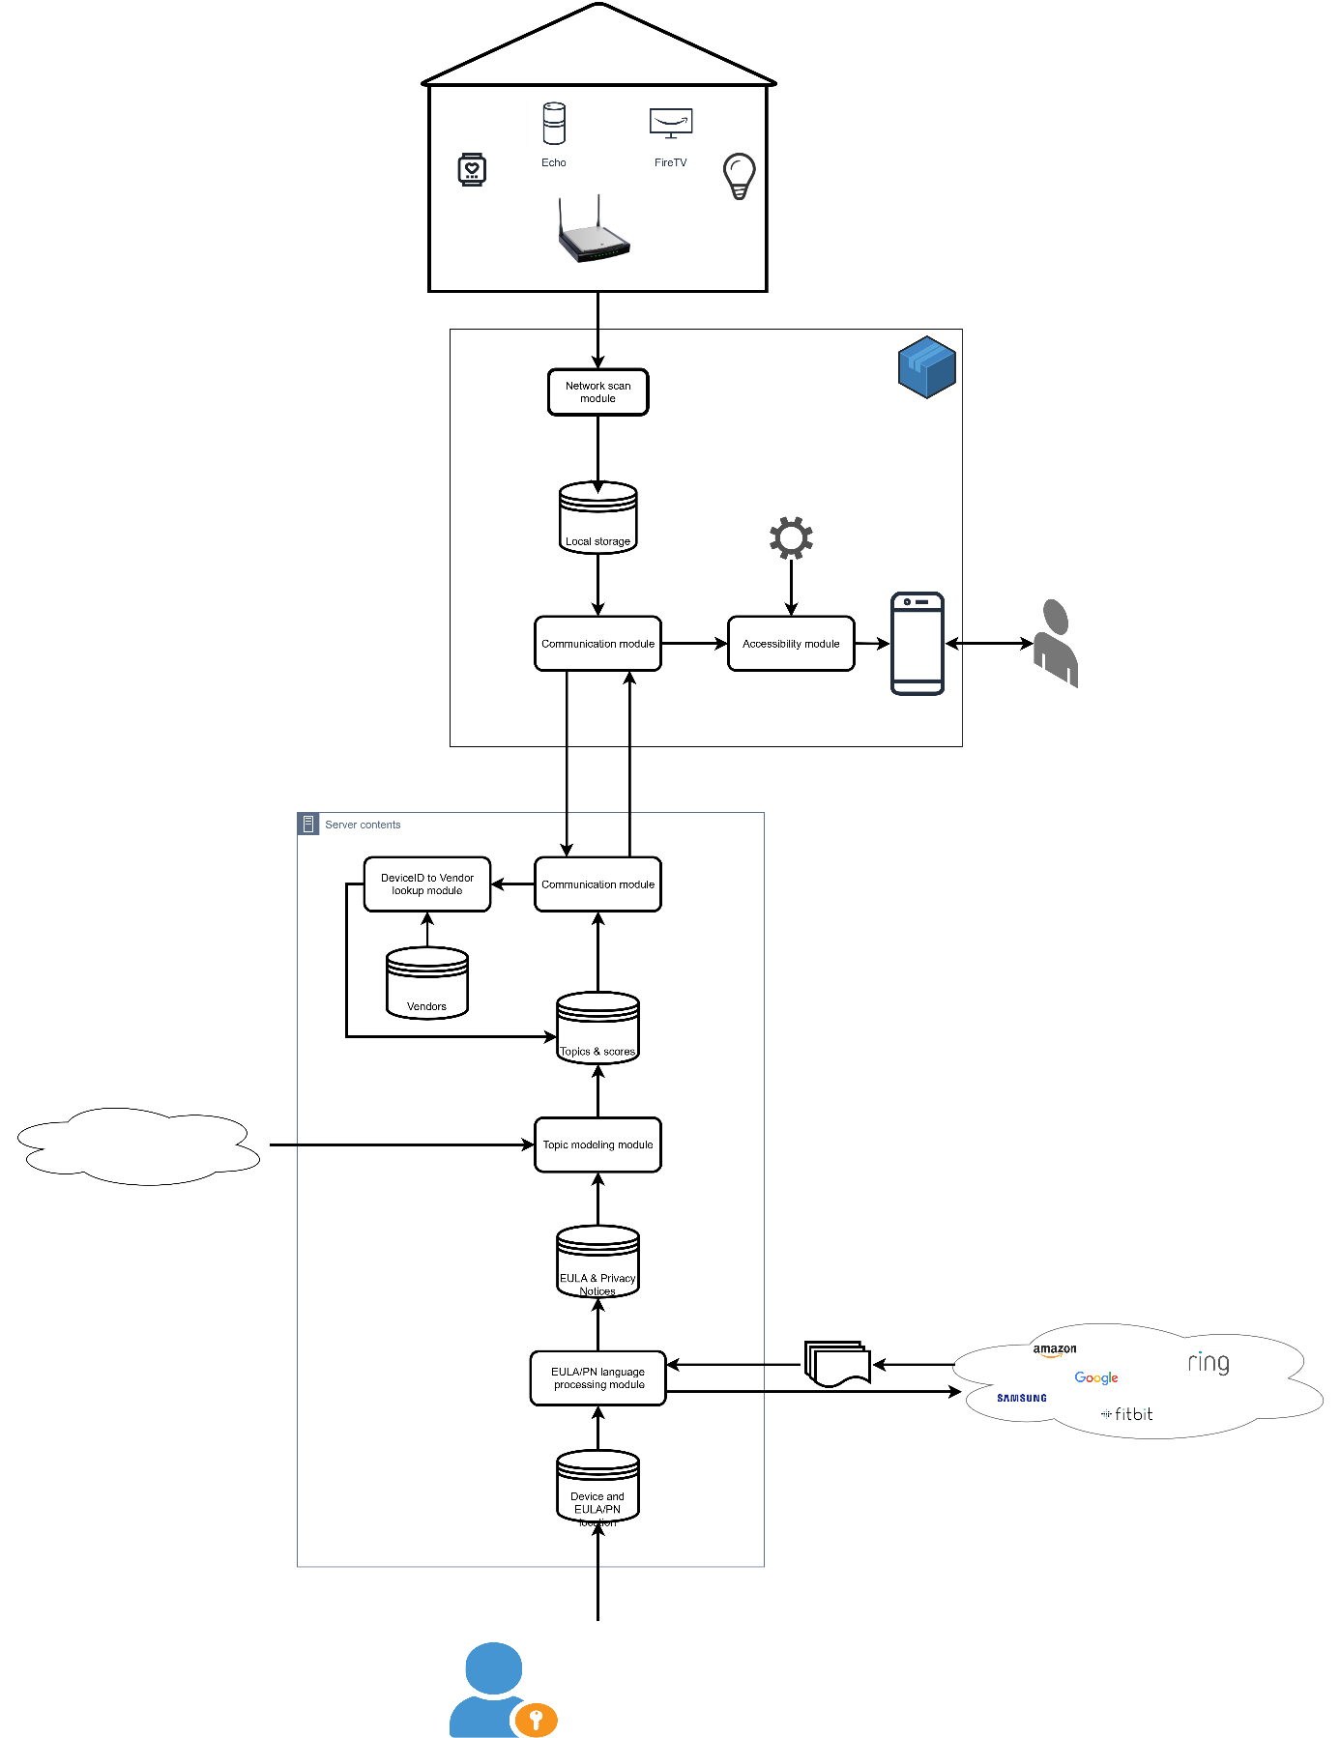
Figure 3. System design diagram.

TRUSTup server-side application
TRUSTup mobile app provides the following functionality:
- Identifying the device's vendor/manufacturer based on DeviceID.
- Searching and retrieving PPs and TOSs for the IoT-associated vendors.
- Searching the ToS;DR (tosdr.org) database for the grades and labels associated with the corresponding PPs and ToSs.
- For the PPs and ToSs that have not been found in the ToS;DR database, identifying the closest, based on the content and characteristics, PPs and ToS in the ToS;DR database and assignment of the existing grades and labels to the new PPs and ToS.
- Searching the National Vulnerbilitites Database for security-related software flaws and misconfigurations.
- Searching social media (Twitter and reditfor zero-day vulnerabilities.
- Asynchronously and periodically updating the PPs and ToS database.
Table 1. Grades and labels associated with PPs and TOSs based on https://tosdr.org
Grade | Description
Grade A | The best terms of services: they treat the user fairly, respect their rights, and will not abuse their data
Grade B | The terms of services are fair towards the user but they could be improved.
Grade C | The terms of service are okay but some issues need your consideration.
Grade D | The terms of service are very uneven or some important issues need the user's attention.
Grade E | The terms of service raise very serious concerns.
No Grade Yet | We haven't sufficiently reviewed the terms yet.

Technical Architecture
[overview of technical architecture here]

Technology Stack
[services and systems information here]

Cloud Deployment Architecture
[cloud deployment pipeline/architecture here]

User Interface

Role-Based Access and Permission
- User
- Admin
- Researcher
- Developer

Risks
As with any complex system construction project, there are risks.
ID | Risk Description | Potential Impact | Mitigation Activities | Status
1 | The students have insufficient development experience. | The app and its components are delivered with delay or in unsatisfying quality. | The students will be provided access to professional developers and practitioners. The students will be reimbursed for the training necessary to complete the task successfully. | Risk is medium to occur.
2 | The student team is disconnected from the researchers working with the potential end-users. | The app does not meet the requirements of the end-users. | The research team (Dr. Blackmon and Wittkower) will be invited twice a month (or more often) to the weekly development meeting. They will update the student team and their advisors on the findings, requirements, and any relevant to the development information during the meetings. | Risk is high to occur.
3 | The requirements and information about the end-users are not provided on time or are changed continuously. | The app and its components are delivered with delay and do not meet the requirements of the end-users. | The development will focus on limited functionality delivering the highest value that meets the grant requirement and allows to seek more funding to develop a more robust app. | Risk is medium to high.
4 | The student team will be required to work remotely. | The app and its components are delivered with delay or in unsatisfying quality. | The students will be provided with collaboration tools: MS Teams, GitHub, zoom, Whiteboard, etc. The Technical Lead will hold weekly meetings and additional meetings as needed by the students. The students will be given additional access to their mentors as needed. | Risk is very high. VMASC encourages telework for all personnel.

Team Organization
TRUSTup is a collaboration between the College of William & Mary and Old Dominion University (ODU). The ODU team is comprised of the Department of Philosophy & Religious Studies and the Virginia Modeling, Analysis, and Simulation Center.
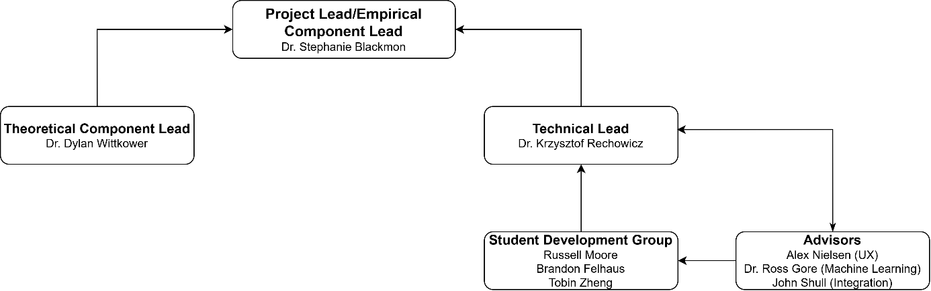
Figure 4. Orgaznization chart.

References

