Kellen Rouff

Matt Salvia

Eng. Comp II

3 April 2018

Video Game Violence: Political Scapegoat

Video game violence have been used as a scapegoat or for political agendas after the happenings of tragic events in the last decade when the topic of violence in America is brought up. Recently there was the school shooting in Florida that politicians have used to push their agendas of the cause being the dehumanization of people through the use of violent video games. This isn’t the first time they have tried to use these dramatic events to push their agendas or use it as a scapegoat; they have also done this after the Columbian shooting that happened many years ago. They use these events to pay research groups to make quickly timed accusations that are done poorly with very little research done correctly just to push it out and try to back up their personal claims. Because of this there is a lot of research but much of it is done wrongly and the need to critically think about each piece is essential to come to the correct conclusion. There needs to be research done for the right reasons so we can truly come to a conclusion that the real problem is mental health that needs and can be treated properly.

Video games have been blamed for violence over the years dating back to the 90’s. Even though the first outcry about a violent video game was in the 70’s with an arcade game called Death Race, it wasn’t till the game Mortal Combat that had the starting and biggest impact. In response to Mortal Combat’s level of violence the government implemented the Entertainment Software Rating Board (ESRB) in 1994; two years after the release of mortal combat. Then in 1999, 12 teachers and students were killed by two gunmen becoming known as the Columbine shooting. During the investigation it was reported that the two suspects were avid players of the game, Doom, and even went as far as to creating levels based on the layout of the Columbine High School. This had many government officials putting videos games into the spotlight as a cause for many problems to the point of trying to pass a bill that would ban the sales of violent video games to children. The Supreme Court ruled against this because Video Games are protected under the First Amendment and announced their doubts about there being no correlation between video games and violence. But this hasn’t stopped government officials from pointing their fingers at video games being one of the main causes of violence in todays youth.

Lately the discussion has recently been brought back up as shown in the post “Inside Trump’s private meeting with the video-game industry — and its critics” by Tony Romm. This was happening after many have come to blame video games for part of the cause of the Florida shooting saying video games “are shaping young people’s thoughts. He also proposed that we have to do something about maybe what they’re seeing and how they’re seeing it” (Romm). But these claims have already been proven wrong as shown in the article, “Teaching Us to Fear: The Violent Video Game Moral Panic and the Politics of Game Research” by Patrick Markey. Markey goes on to show that any regulation against video games for their violence is not allowed because “the United States Supreme Court ruled that all such legislation was unconstitutional and that research evidence could not support claims that it was necessary. The court declared

that video games are art and that, if they are sometimes violent, this is no different from literature, film, or even fairy tales” (Markey 2) The supreme court made this decision after much deliberation and research that was presented to them that showed there is no correlation of video games and violence. This didn’t stop politicians and news outlets using only research that says there are negative effects.

This has happened many times before especially the false reporting in the news as stated by Allen Coperhaver in his article “For **Video Games, Bad News** Is **Good News: News Reporting** of **Violent Video Game Studies.” Coperhaver says how news outlets have pushed these false claims by “**focusing mainly on **studies** supporting negative effects and failing to report **studies** that did not find evidence for such effects” (coperhaver 1). The only way to prove that video games don’t cause violent tendencies in people is to use studies that have been done properly. In the research done by Whitney DeCamp in her article “The Impact of Degree of Exposure to Violent Video Games, Family Background, and Other Factors on Youth Violence”, she looks at more variables, family and social relations, then just video games being reasons for their anger and violence. DeCamp said that the “results offer further support to the conclusion that video game violence is not a meaningful predictor of youth violence and, instead, support the conclusion that family and social variables are more influential factors.” This shows that

there are many aspects that need to be considered when doing research that pertains to violence because many different variables outside of the used ones could cause changes in the results.

The article “Study: Kids Unaffected by Violent Games” by Susan Arendt presses upon this by saying “violent video games only influence the behavior of children who already show aggressive or violent tendencies. This directly refutes other recent studies that have linked the playing of violent video games with increased negativity and violence in kids.” The study was conducted using the game Quake II with 120 eleven to fifteen-year-old children. The results of the study that the article discusses about says that the kids who were diagnosed with violent tendencies were affected but the kids who don’t have any mental illness were unaffected by the violence that was introduced to them.

The video game industry is still a very new industry in the entertainment industry which has had its fair share of controversies throughout the years and one is the growing concern that violent video games causes violent tendencies. The growing concern has been researched over and over again throughout the years but some of these have been personally persuaded through the use of money indorsed by government officials. That’s not saying that all the research that says that video games that do cause violence are bias but there is a clear amount that have been persuaded to be done for others personal gains. This continuous fight to push the agendas of politicians have continually hindered the needed help of what actually cause the violent tendencies, mental illness. The research that was stated in Susan Arendt’s article and the research from Whitney DeCamp presses on this ideology that there are other things that cause the rising violence that has been plaguing the youth in America.

In Whitney DeCamp’s article, she says that “that family and social variables are more influential factors” and this is not the only variable that may affect the results. Much of the research that does say that video games do cause violence don’t take in affect that the video games are not the only variable that they need to count for. If they did look at the other variables, I believe that much of the research that has been done would be greatly impacted in a different way. I have played games for most of my life and yes, I can say I have gotten frustrated/angry before while playing but this isn’t because of the game but for the reasons of me getting frustrate at myself because I know that I could do better or because other outside sources that affected my mood/feelings. As it happened in the research and with myself, its never the game that spawns the anger in people but other sources in our lives or ourselves when we know we can do better. But when it comes to some politicians, they only care about their own agendas and what they want to accomplish or protect.

# Throughout the years that video game violence has been recognized as a possible problem, some politicians have tried to blame video games for many problems that have been popping up in America. ­The most recent attempt at this is with Trumps meeting with video game companies and critics. Instead of him focusing on the two problems that caused the recent shooting in Florida, gun control and mental illness, he tried to turn the focus onto video games and their violent nature. He isn’t the only one just as stated in the article, Trump Blames Violent Video Games For School Shootings -- Here's Why He's Wrong” by Erik Kain. As Mr. Kain goes onto say that:

# Politicians, eager to deflect scrutiny, are falling back on one of the oldest bogeymen in the book: Violent video games. These politicians, ranging from state governors to the president himself, have begun blaming violence in video games and movies in a desperate gambit to change the conversation away from gun violence. Speaking with lawmakers this Thursday, President Trump suggested that violent video games and movies are the real culprit when it comes to school shootings. (1)

This has been a reoccurring tactic that many politicians use when they want the attention shifted from the actual problems and video games is their scapegoat since the early 2000’s. President Trump shows his ignorance on these matters and proves that this is a hoax to try and shift blames when during the meeting he went onto say “the level of violence in video games is really shaping young people’s thoughts… And then you go the further step…movies, and they’re so violent a kid is able to see the movie if sex isn’t involved, but killing is involved, and maybe we need to put a rating system for that” (Kain). As many of us know there is already a rating board for movies and that goes the same for video games. Politicians need to face the actual problems that are causing these problems instead of shifting the blame onto other things but they aren’t the only ones to blame as media helps push these false claims.

# After many violent tragedies, news outlets will pump out articles about them for many weeks. During those weeks, if there is any mention of the suspect had any interest in a violent video game and that will be included within almost any article forcing the blaming onto them. In the article “Violent Video Games and Real-World Violence: Rhetoric Versus Data’ by Patrick M. Markey, Charlotte N. Markey, and Juliana E. French they discuss how the medias perception on violent video games affect on people are wrong and how it actually affect them. As they go on to state that:

In the aftermath of the 1999 Columbine High School shootings… the shootings at Virginia Tech…[and] the Sandy Hook Elementary School [shooting]…[a] search of an online database of newspapers (ProQuest Newsstand) found that nearly 5,000 articles were released in the aftermath of these three tragedies, which discussed video games in the context of these three school shootings. The implication in many of these articles was that these violent acts were precipitated and perhaps even caused by exposure to violent video games. (1-2)

These claims that media have spread within their articles are typically done with little research on the truth about video games and violence. The articles may not even have any research backing up these claims but instead of using either the possible ignorance of people or the scare tactics to scare people into believing what they want them to believe. We are all extremely lucky to have the technology that allows us to have infinite amounts of information at the tips of our fingers. In recent years the term “fake news” has become a huge issue in todays society and we need to take the initiative to research these topics ourselves instead of relying on many news outlets that have their own agendas to push for either funding or privileges. These articles may push this possibility but Patrick M. Markey, Charlotte N. Markey, and Juliana E French says there isn’t a negative affect between violent video games and people but a positive one.

Fig. 1 Annual changes in video game sales and violent crime between 1978 and 2011.

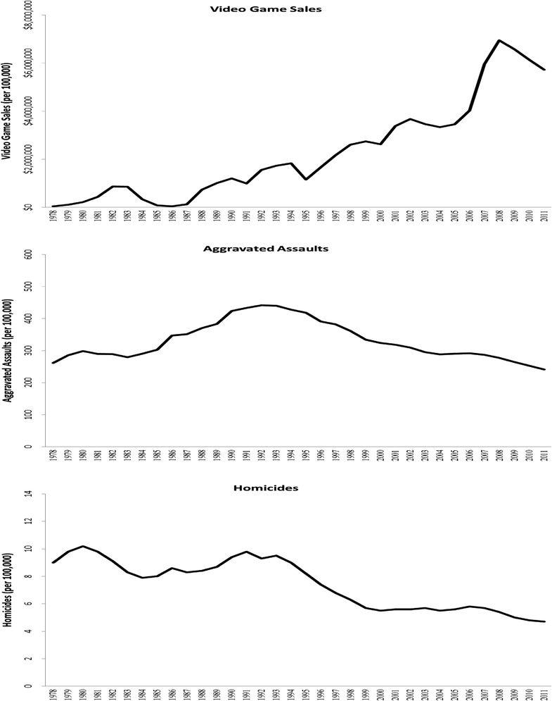

Source: Patrick M. Markey, Charlotte N. Markey, and Juliana E French, “Violent Video Games and Real-World Violence: Rhetoric Versus Data” *Psychology of Popular Media Culture,* 18 Aug 2014, pp. 6

As shown in fig. 1, throughout the years as video games became a more prominent form of entertainment and it also shows how aggravated assault and homicides have decline throughout the years. These aren’t the only crimes that have lowered but also all violent types of crime have been the lowest, only homicides have recently gone up in 2017 but only a very small amount. If what media and politicians tell us that violent video games cause the dehumanization of humans into violent beings then why has the there only been decreasing numbers of violent crime. This helps show that there is no truth to their claims and even in another figure shown in Patrick M. Markey, Charlotte N. Markey, and Juliana E French article shows that after major video game releases there is a significant decline in crime rates. This could possibly be a coincidence but the charts show throughout the years of 2007-2011 and after the highest peaking months for game releases there were significant decreases in violent crimes again and again. Even though many times when video games are in the news its for bad reason but even this bad news can be a good thing because any news is good news.

Video game violence has been a source of topic that has been used for political agendas by politicians through undermining real research. With the research they have personally payed for to be done quickly to provide reinforcement for their personal gain and pushed out to people through news coverage. These agendas damage the video game industry through false accusations causing backlash on the political standings of this developing industry. This needs to stop with these false accusations of how video games cause dehumanization and violence. We need more correctly done research to be implemented for the reason of shutting down false claims that are using falsified research. It needs to be clear that video games are not the cause of violence though thwarting these political agendas by using research that is done correctly. We need to speak up against their false claims with the truth before they can make any more damaging false claims and force attention to the wrong place while the true culprit, Mental Illness, goes unchecked and un-helped. Finally, we need to start helping treat mental illness and become one of the leading industries that helps with this rising problem that is ever growing.

**Work Cited**

Arendt, Susan. “Study: Kids Unaffected by Violent Games.” *Wired*, Conde Nast, 5 June 2017, www.wired.com/2007/04/study-kids-unaf/.

Copenhaver, Allen, Oana Mitrofan, and Christopher J. Ferguson. "For video games, bad news is good news: news reporting of violent video game studies." *Cyberpsychology, Behavior, and Social Networking.* Vol 20. No 12 2017. Pg. 735-739.

DeCamp, Whitney, and Christopher J. Ferguson. "The impact of degree of exposure to violent video games, family background, and other factors on youth violence." *Journal of youth and adolescence* Vol. 46, Issue 2 ,2017, Pg 388-400.

Kain, Erik. “Trump Blames Violent Video Games For School Shootings -- Here's Why He's Wrong.” *Forbes*, Forbes Magazine, 23 Feb. 2018, www.forbes.com/sites/erikkain/2018/02/22/trump-blames-violent-video-games-for-school-shootings-heres-why-hes-wrong/#8a075a867f3c.

Markey, Patrick M., and Christopher J. Ferguson. "Teaching Us to Fear." *American Journal of Play* 10.1.

Markey, Patrick & Markey, Charlotte & French, Juliana. (2014). Violent Video Games and Real-World Violence: Rhetoric Versus Data.. Psychology of Popular Media. 4. 10.1037/ppm0000030.

McCarthy, Randy J, et all. “Does Playing Video Games with Violent Content Temporarily Increase Aggressive Inclinations? A Pre-Registered Experimental Study.” *Journal of Experimental Social Psychology*, Academic Press, 17 Sept. 2016, www.sciencedirect.com/science/article/pii/S0022103115300093.

Robinson, Nicholas. "Video Games and Violence: Legislating on the ‘Politics of Confusion’." *The Political Quarterly* Vol. 83 Issue 2 2012: Pg. 414-423.

Romm, Tony. “Inside Trump's Private Meeting with the Video-Game Industry - and Its Critics.” *The Washington Post*, WP Company, 8 Mar. 2018, www.washingtonpost.com/news/the-switch/wp/2018/03/08/inside-trumps-private-meeting-with-the-video-game-industry-and-its-critics/?utm_term=.a2f915f3b9d0.