Homework4

20180109 김수빈

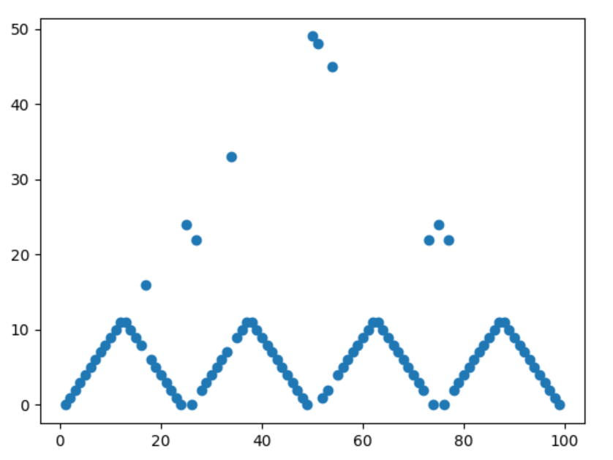

This is plotting optimal actions for every step from 1 to 100 when the probability to win is 0.25 and gamma is 1.

The reason behind such pattern is because the odds are against the gambler (p=0.25<1). Thus, the gambler would want to win within small number of throwing the dice, because the more he throws it, the more possibility he loses his bet. That is why on state 50, the gambler would bet all of his 50, and have maximum 0.25 possibility of winning. In the same sense, when the gambler is at 75, he can bet 25 and have maximum 0.25 probability of winning. Even if he loses, he will still have 50 to bet further.

The gambler will try to stay on the states where he can win within one throw, and also points where he can do big bets even if he loses, such as 50 and 75. For example, when the gambler has 53, the gambler can bet 3, where with 0.25 probability he wins, he can have 56, and when with 0.75 probability he loses, he goes back to having 50 and he can have 0.25 probability of winning on the next state. This way, he can always go back to 50 where he will bet all his money and have maximum winning probability of 0.25. When the gambler has 70, he can bet 5 to reach 75, where he can bet 25 to win in one go, or either lose 5 and fall back to 65 safely.