Chat- Bot

Васил Младенов

Калин Червенков

Александър Божиков

Plan 3

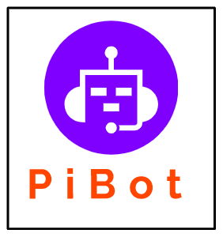

**Content**

* Presentation of the team
* Chat- Bot
* Development
* Block diagram

Presentation of the team





|  |  |  |
| --- | --- | --- |
| Alexandar Bozhikov | AABozhikov19@codingburgas.bg | Q&A engineer  Code Cheker |
| Vasil Mladenov | VLMladenov19@codingburgas.bg | Frontend Backend Developer |
| Kalin Chervenkov | KSChervenkov19@codingburgas.bg | Scrum Trainer |

Chat- Bot

A chatbot is a software application used to conduct an on-line chat conversation via text or text-to-speech, in lieu of providing direct contact with a live human agent.



Chatbots are used in dialog systems for various purposes including customer service, request routing, or information gathering.

Development

|  |  |
| --- | --- |
| Function | Purpose |
| title() | Print out title |
| menue() | Print out menue |
| piBot() | Sets commands to the piBot |

Block diagram

