Lab Manual: Git Commands and Docker Commands for Images and Containers

Student Information
- Name:
- Roll Number:
- Course:
- Date:

Lab 1: Git Commands

Objective
Learn how to use basic and intermediate Git commands for version control, repository management, file tracking, commits, branching, merging, and remote repository operations.

Prerequisites
- Basic knowledge of command line usage
- Git installed on the system
- Internet connection
- A Git hosting account such as GitHub or GitLab
- Text editor installed

Lab Environment
Component | Details
Operating System | Windows 10/11, Linux, or macOS
Software | Git 2.x or above
RAM | Minimum 4 GB
Internet | Required for remote repository operations

Theory / Background
Git is a distributed version control system used to track changes in source code and collaborate with multiple developers. It allows users to create repositories, track file changes, create branches, merge code, and connect with remote repositories.

Lab Tasks

Task 1: Verify Git Installation

Purpose
Check whether Git is installed correctly on the system.

Steps
- Open Command Prompt, Terminal, or PowerShell.
- Run the following command:
git --version

- Verify that the installed Git version is displayed.

Screenshot Placeholder
[Insert Screenshot Here]

Expected Output
git version 2.x.x

Notes
- If Git is not installed, download it from Git official website.
- Ensure Git is added to the system PATH.

Troubleshooting
Problem | Solution
'git' is not recognized | Reinstall Git and enable PATH option
Version not displayed | Restart terminal after installation

Task 2: Configure Git Username and Email

Purpose
Set the username and email for commit tracking.

Steps
- Run the following commands:
git config --global user.name "Your Name"
git config --global user.email "your_email@example.com"

- Verify the configuration:
git config --list

Screenshot Placeholder
[Insert Screenshot Here]

Expected Output
user.name=Your Name
user.email=your_email@example.com

Notes
- Use the same email address associated with your Git hosting account.

Troubleshooting
Problem | Solution
Username not saved | Ensure correct syntax is used
Email incorrect | Re-run the command with correct email

Task 3: Create a New Git Repository

Purpose
Initialize a new Git repository.

Steps
- Create a new folder:
mkdir myproject
cd myproject

- Initialize the repository:
git init

- Verify repository initialization:
git status

Screenshot Placeholder
[Insert Screenshot Here]

Expected Output
Initialized empty Git repository

Notes
- The .git directory stores repository metadata.

Troubleshooting
Problem | Solution
Repository not initialized | Run git init again
Wrong directory | Use pwd or cd to verify current location

Task 4: Add and Commit Files

Purpose
Track files and save changes into the repository.

Steps
- Create a file:
echo "Hello Git" > file1.txt

- Check repository status:
git status

- Add the file:
git add file1.txt

- Commit the file:
git commit -m "Initial commit"

- View commit history:
git log

Screenshot Placeholder
[Insert Screenshot Here]

Expected Output
1 file changed, 1 insertion(+)

Notes
- Use meaningful commit messages.

Troubleshooting
Problem | Solution
Nothing to commit | Ensure file is added using git add
Commit failed | Check username and email configuration

Task 5: Work with Branches

Purpose
Create, switch, and merge branches.

Steps
- Create a new branch:
git branch feature1

- Switch to the branch:
git checkout feature1

- Alternatively, create and switch in one command:
git checkout -b feature2

- List all branches:
git branch

- Switch back to main branch:
git checkout main

- Merge the branch:
git merge feature1

Screenshot Placeholder
[Insert Screenshot Here]

Expected Output
Switched to branch 'feature1'

Notes
- Branches help isolate features and bug fixes.

Troubleshooting
Problem | Solution
Branch not found | Verify branch name
Merge conflict | Edit conflicting file and commit again

Task 6: Connect to a Remote Repository

Purpose
Link the local repository with a remote repository.

Steps
- Create a repository in GitHub.
- Add remote origin:
git remote add origin https://github.com/username/repository.git

- Verify remote:
git remote -v

- Push code to remote:
git push -u origin main

- Clone an existing repository:
git clone https://github.com/username/repository.git

Screenshot Placeholder
[Insert Screenshot Here]

Expected Output
origin https://github.com/username/repository.git (fetch)
origin https://github.com/username/repository.git (push)

Notes
- Replace URL with actual repository URL.

Troubleshooting
Problem | Solution
Authentication failed | Use Personal Access Token
Permission denied | Verify repository access rights

Practical Exercise
Create a new Git repository called student-project, add three text files, commit them, create a new branch called testing, make changes, merge the branch into main, and push the code to a remote repository.

Challenge Task
Create two branches, make conflicting changes in the same file, and resolve the merge conflict manually.

Viva Questions
- What is Git?
- What is the difference between Git and GitHub?
- What does git init do?
- What is a branch?
- What is the purpose of git add?
- What is the difference between git fetch and git pull?
- What is merge conflict?
- What is the purpose of git clone?
- What is a remote repository?
- What is the use of git log?

Review Questions
- Explain the purpose of Git.
- Write the command to initialize a repository.
- Write the command to create a branch.
- How do you commit changes?
- How do you push code to a remote repository?
- What is the use of git status?
- Explain the purpose of .gitignore.
- How do you merge branches?
- What is a detached HEAD state?
- What are Git tags?

Conclusion
Students learned how to configure Git, create repositories, manage commits, work with branches, and connect to remote repositories.

Lab 2: Docker Commands for Images and Containers

Objective
Learn how to use Docker commands to manage images and containers for MySQL, PostgreSQL, WordPress, Nginx, and MongoDB.

Prerequisites
- Basic understanding of containers
- Docker installed on the system
- Internet connection
- Administrator or sudo access

Lab Environment
Component | Details
Operating System | Windows, Linux, macOS
Software | Docker Engine 24.x or later
RAM | Minimum 8 GB
CPU | Dual Core or higher
Internet | Required for image download

Theory / Background
Docker is a containerization platform that allows applications and services to run in isolated environments called containers. Docker images are templates used to create containers.

Common Docker Commands
Command | Description
docker images | List downloaded images
docker ps | List running containers
docker ps -a | List all containers
docker pull | Download an image
docker run | Create and start a container
docker stop | Stop a running container
docker rm | Remove a container
docker rmi | Remove an image
docker logs | View container logs
docker exec -it | Open terminal inside a container

Task 1: Verify Docker Installation

Purpose
Ensure Docker is installed and running.

Steps
- Open terminal or command prompt.
- Run:
docker --version
docker info

Screenshot Placeholder
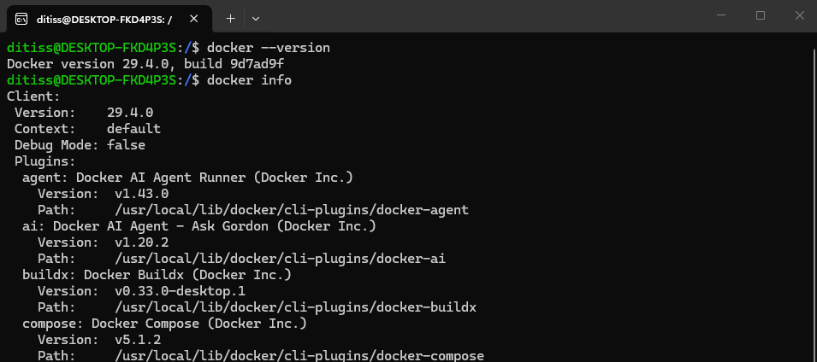

Expected Output
Docker version 29.4.0

Troubleshooting
Problem | Solution
Docker daemon not running | Start Docker Desktop or Docker service
Command not recognized | Reinstall Docker

Task 2: Pull Docker Images

Purpose
Download required images from Docker Hub.

Steps
- Run the following commands:
docker pull mysql
docker pull postgres
docker pull wordpress
docker pull nginx
docker pull mongo

- View downloaded images:
docker images

Screenshot Placeholder
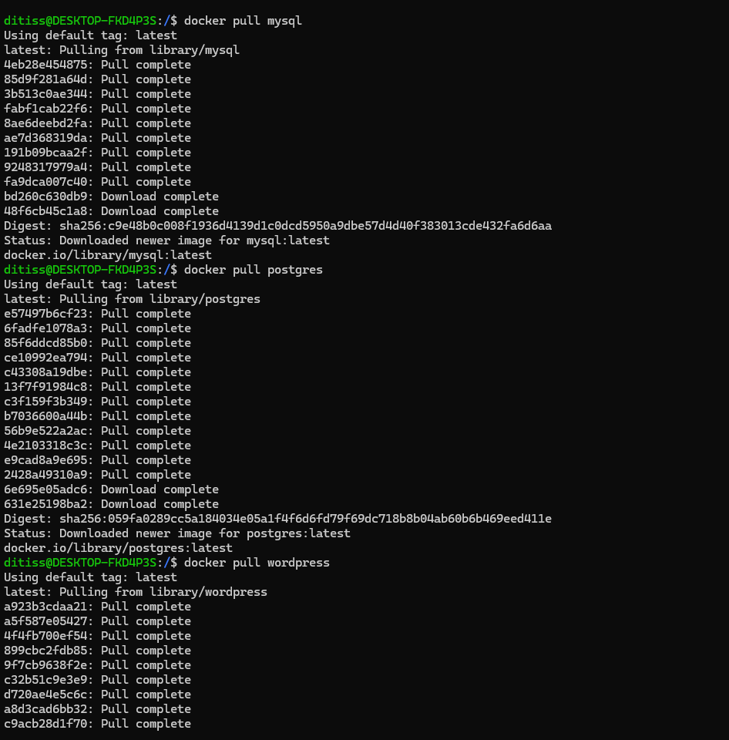
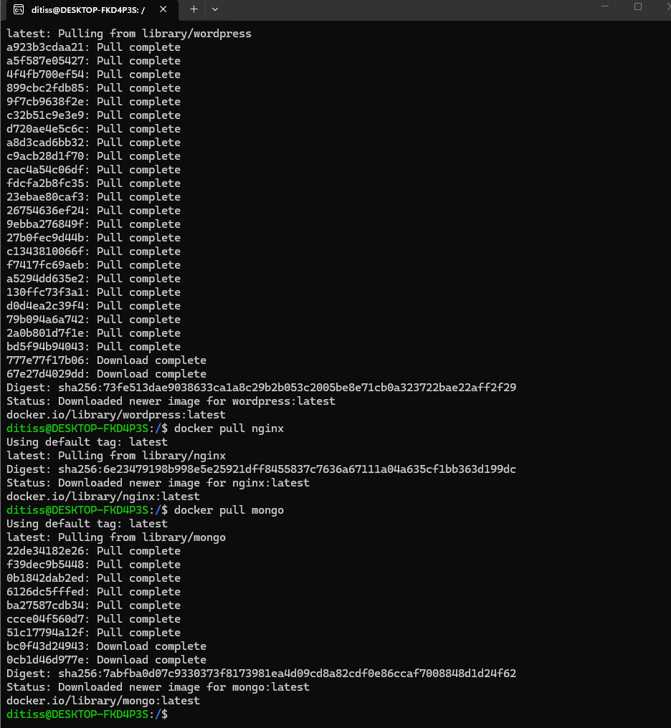

Expected Output
A list of downloaded images should appear.
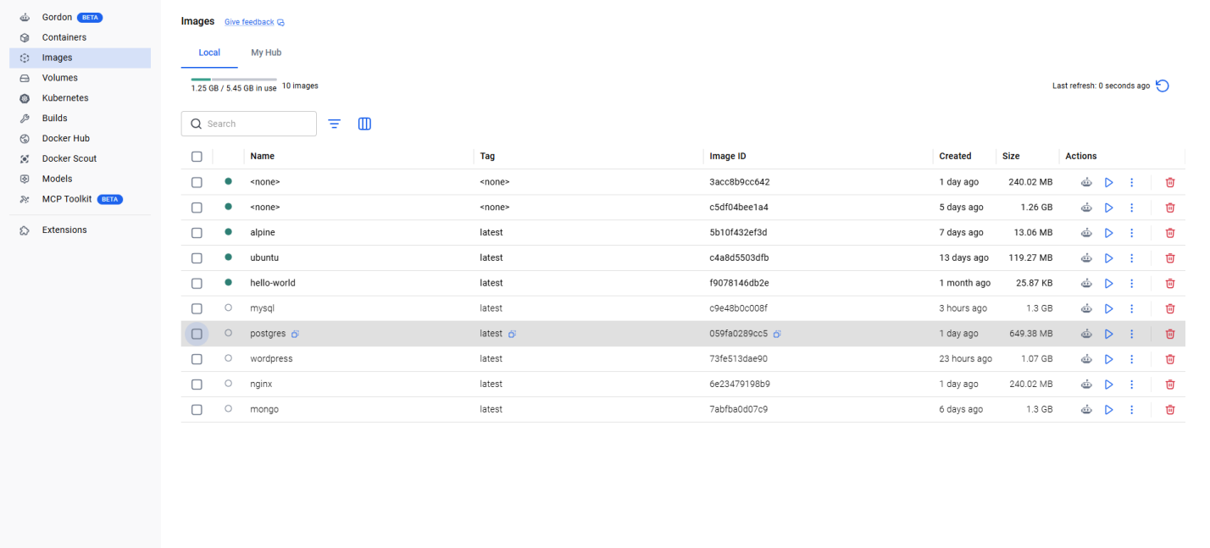

Notes
- Docker downloads images from Docker Hub.

Troubleshooting
Problem | Solution
Pull access denied | Verify image name
Network error | Check internet connection

Task 3: Run a MySQL Container

Purpose
Create and run a MySQL database container.

Steps
- Run the following command:
docker run -d \
--name mysql-container \
-e MYSQL_ROOT_PASSWORD=root123 \
-p 3306:3306 \
mysql

- Verify running container:
docker ps

- Access container shell:
docker exec -it mysql-container bash

- Login to MySQL:
mysql -u root -p
Password - rrot123

Screenshot Placeholder
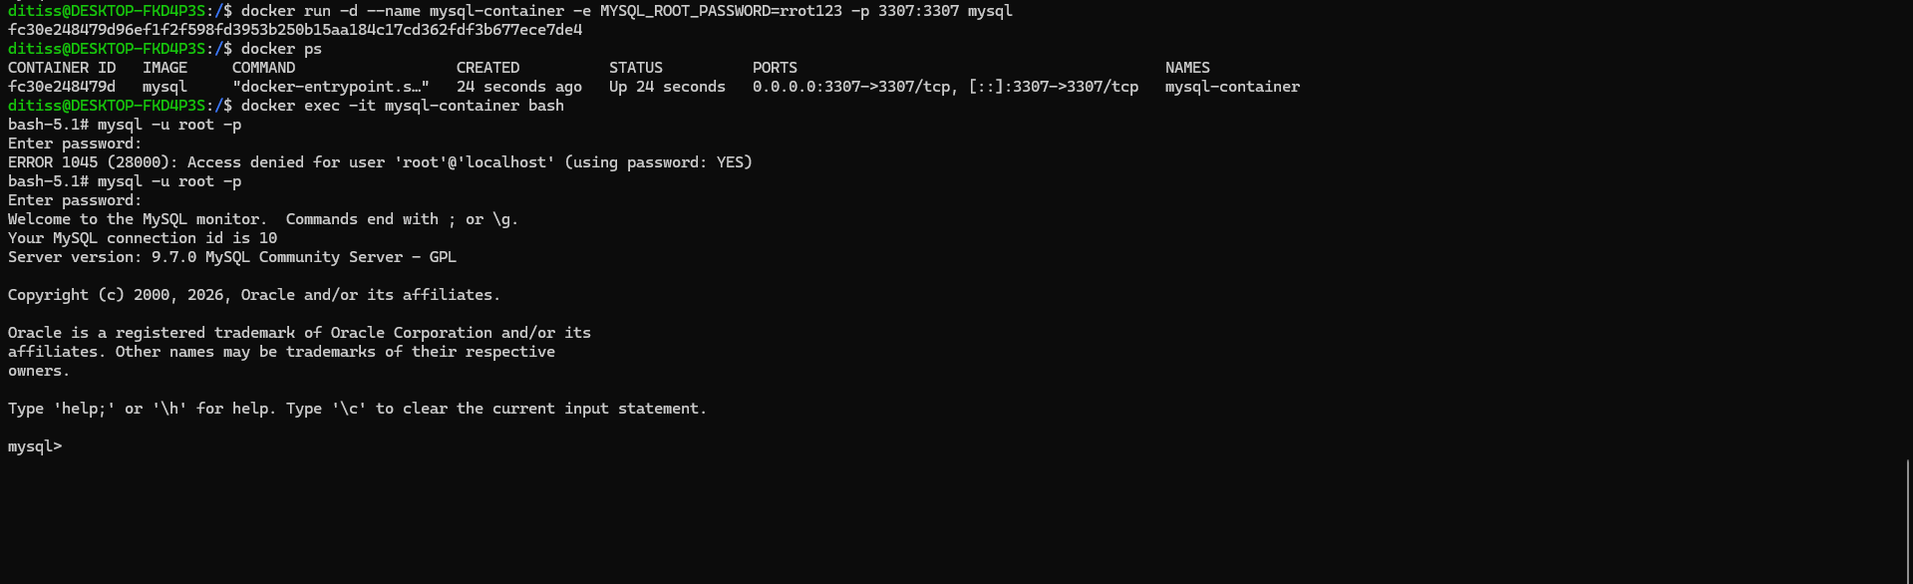

Expected Output
MySQL container should appear in running containers list.

Notes
- Port 3306 is used for MySQL. I am using different port number 3307

Troubleshooting
Problem | Solution
Port already in use | Change host port
MySQL container exits | Check logs using docker logs mysql-container

Task 4: Run a PostgreSQL Container

Purpose
Run a PostgreSQL database container.

Steps
- Execute:
docker run -d \
--name postgres-container \
-e POSTGRES_PASSWORD=postgres123 \
-p 5432:5432 \
postgres

- Check running containers:
docker ps

- Open shell inside container:
docker exec -it postgres-container bash

- Login to PostgreSQL:
psql -U postgres

Screenshot Placeholder
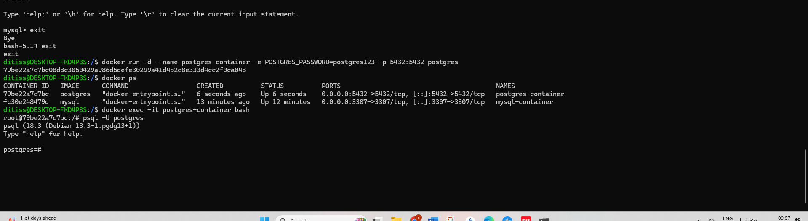

Expected Output
PostgreSQL container should run successfully.

Notes
- Port 5432 is the default PostgreSQL port.

Troubleshooting
Problem | Solution
Connection refused | Verify container is running
Authentication failed | Check password variable

Task 5: Run an Nginx Container

Purpose
Deploy a simple web server using Nginx.

Steps
- Run:
docker run -d \
--name nginx-container \
-p 8080:80 \
nginx

- Verify running container:
docker ps

- Open browser and visit:
http://localhost:8080

Screenshot Placeholder
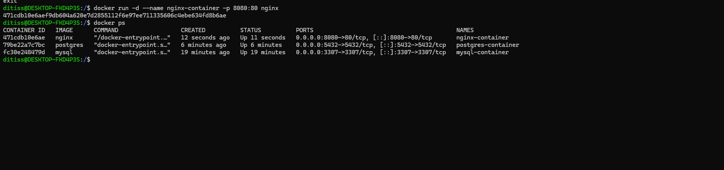

Expected Output
The default Nginx welcome page should appear.
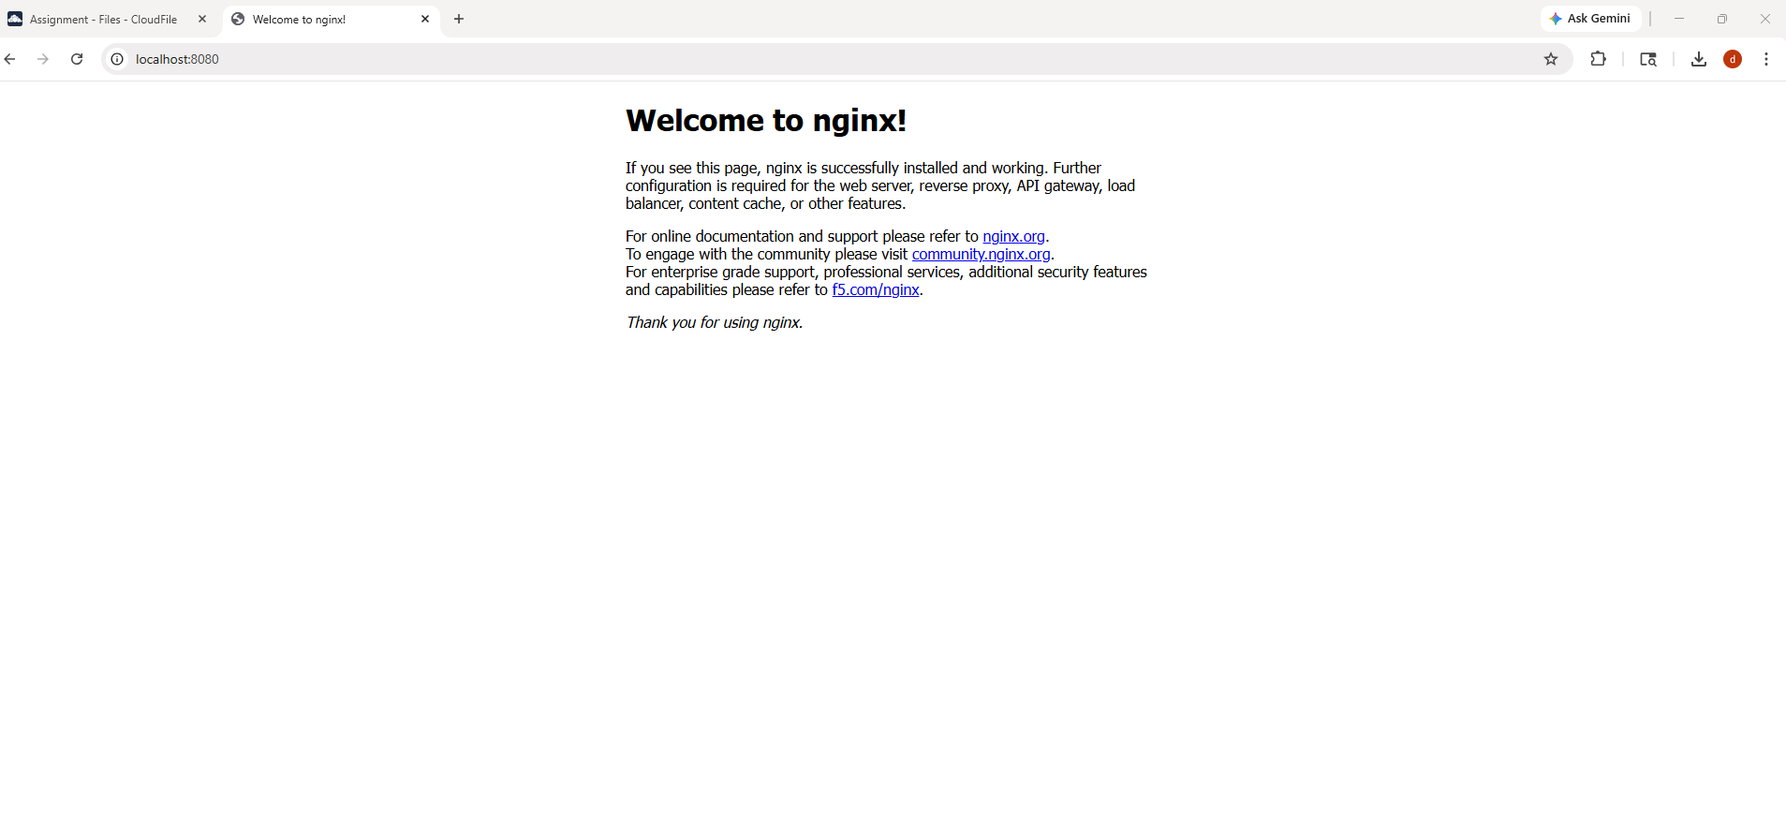

Notes
- Port 8080 on the host is mapped to port 80 inside the container.

Troubleshooting
Problem | Solution
Browser not loading | Verify port mapping
Container stopped | Check logs

Task 6: Run a MongoDB Container

Purpose
Create and run a MongoDB container.

Steps
- Run:
docker run -d \
--name mongo-container \
-e MONGO_INITDB_ROOT_USERNAME=admin \
-e MONGO_INITDB_ROOT_PASSWORD=admin123 \
-p 27017:27017 \
mongo

- Verify running containers:
docker ps

- Access the container:
docker exec -it mongo-container bash

- Open Mongo shell:
mongosh -u admin -p admin123

Screenshot Placeholder
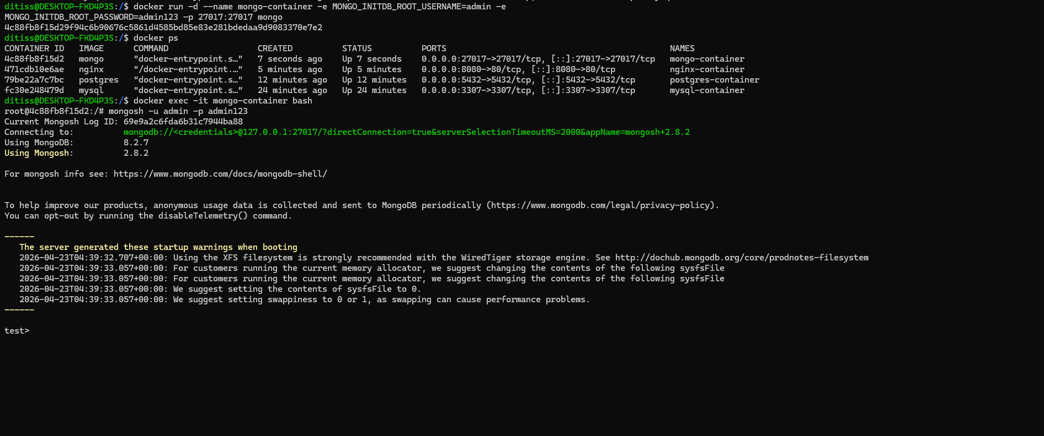

Expected Output
MongoDB shell should open successfully.

Troubleshooting
Problem | Solution
Mongo shell not found | Use mongosh command
Authentication error | Verify username and password

Task 7: Run WordPress with MySQL

Purpose
Deploy WordPress connected to a MySQL container.

Steps
- Create a Docker network:
docker network create wordpress-network

- Run MySQL container:
docker run -d \
--name wordpress-mysql \
--network wordpress-network \
-e MYSQL_ROOT_PASSWORD=root123 \
-e MYSQL_DATABASE=wordpressdb \
-e MYSQL_USER=wpuser \
-e MYSQL_PASSWORD=wppassword \
mysql

- Run WordPress container:
docker run -d \
--name wordpress-container \
--network wordpress-network \
-p 8081:80 \
-e WORDPRESS_DB_HOST=wordpress-mysql:3306 \
-e WORDPRESS_DB_USER=wpuser \
-e WORDPRESS_DB_PASSWORD=wppassword \
-e WORDPRESS_DB_NAME=wordpressdb \
wordpress

- Open browser:
http://localhost:8081

Screenshot Placeholder
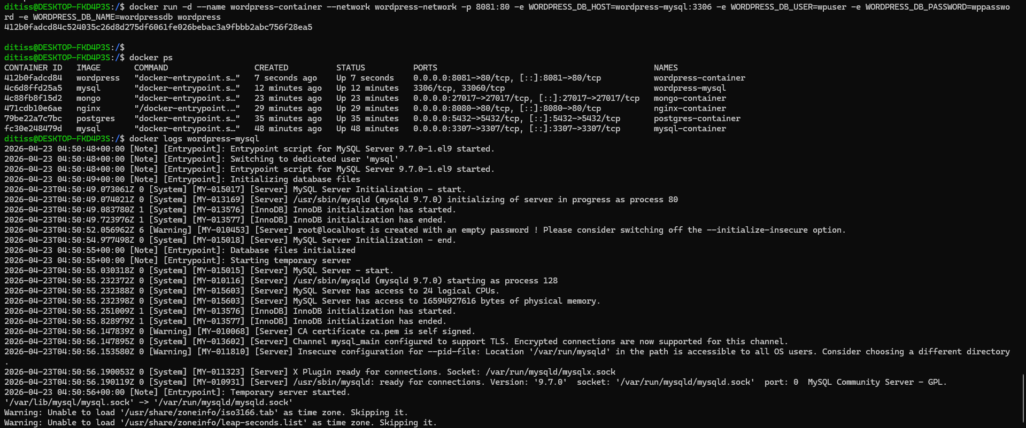

Expected Output
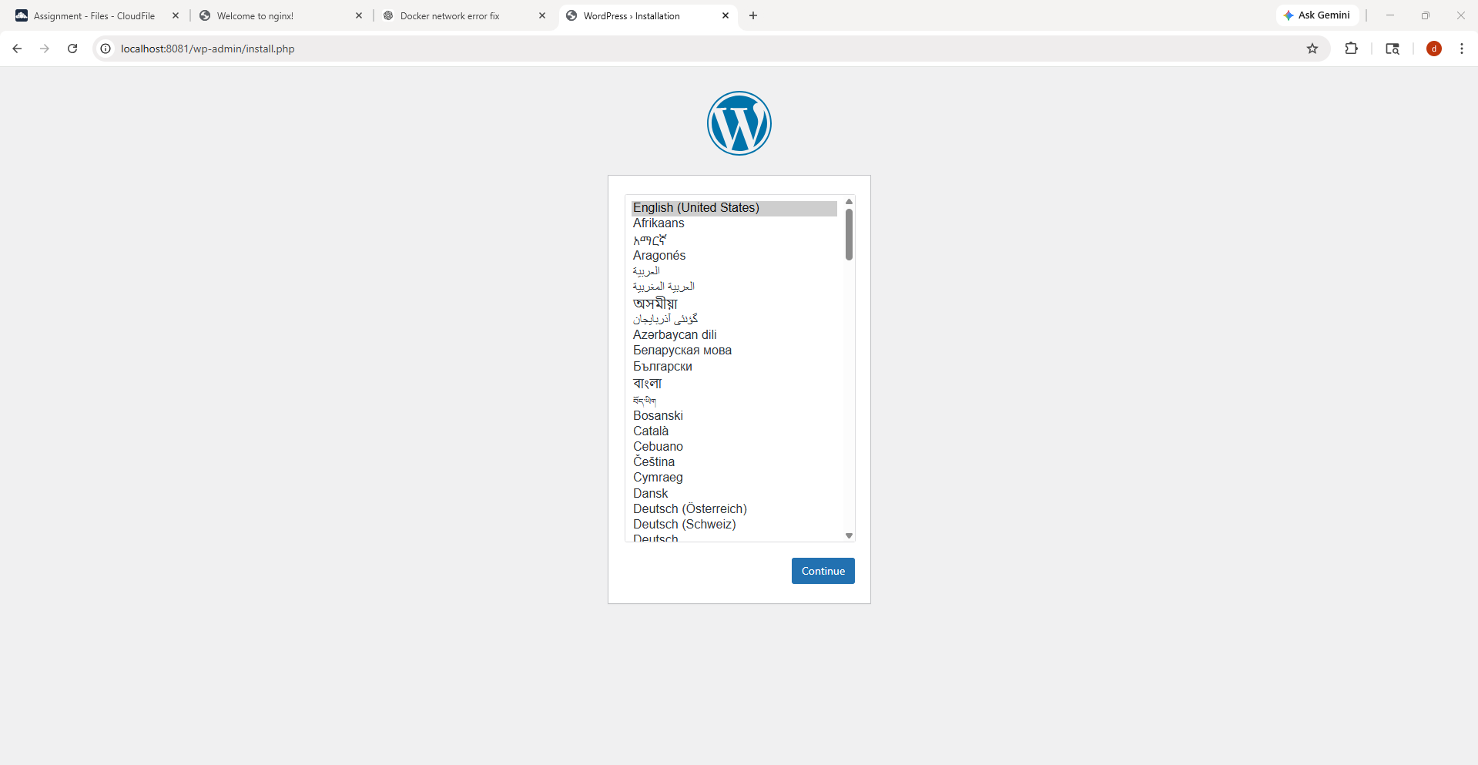
The WordPress installation page should appear.

Notes
- WordPress requires a database container to function.
- Use Docker networks for communication between containers.

Troubleshooting
Problem | Solution
Database connection error | Verify database container name
WordPress page not loading | Check port mapping

Task 8: Manage Containers and Images

Purpose
Learn to stop, start, remove, and inspect containers and images.

Steps
- Stop a container:
docker stop nginx-container

- Start a container:
docker start nginx-container

- Remove a container:
docker rm nginx-container

- Remove an image:
docker rmi nginx

- View logs:
docker logs mysql-container

- Inspect container details:
docker inspect mysql-container

Screenshot Placeholder
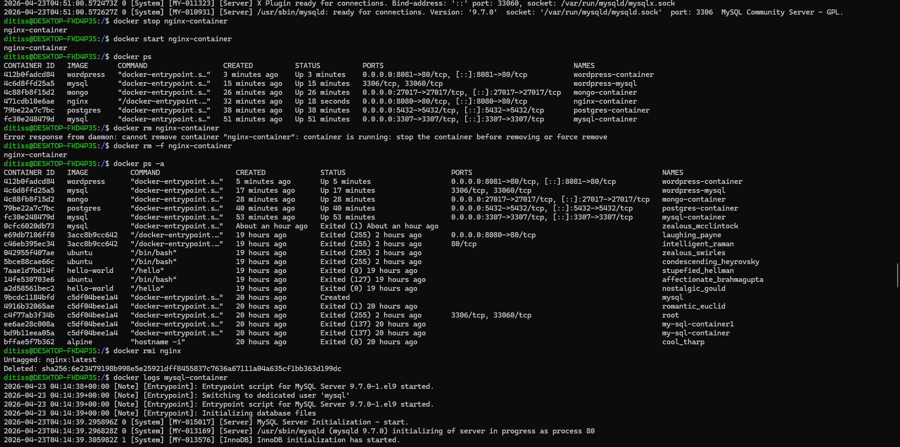
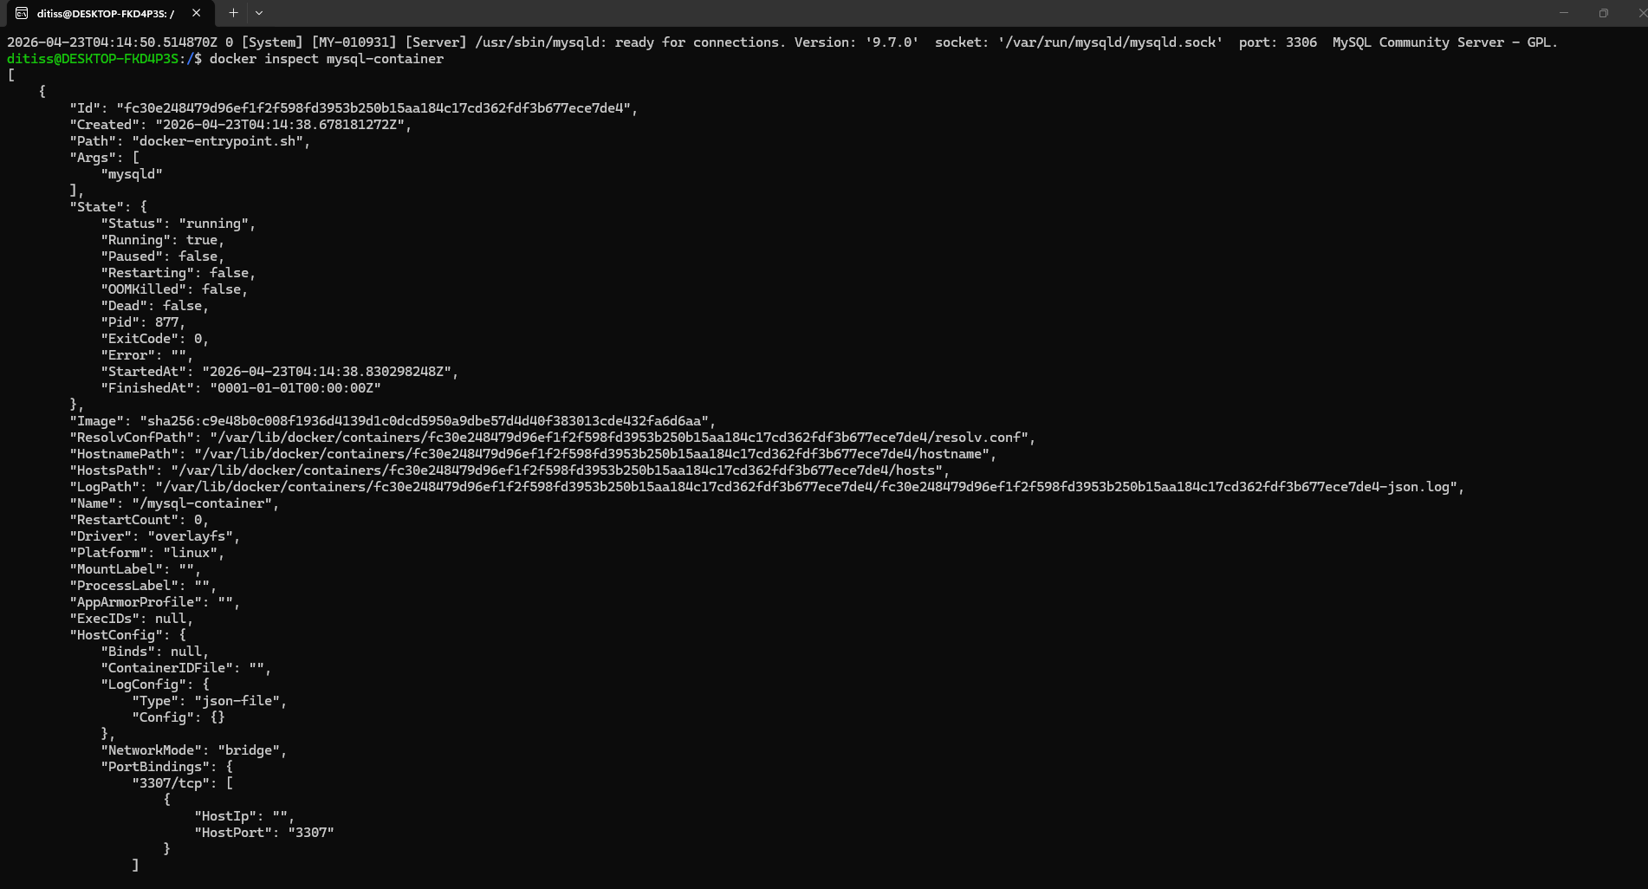

Expected Output
Container status should change according to the command used.

Notes
- A running container must be stopped before removal.

Troubleshooting
Problem | Solution
Container cannot be removed | Stop the container first
Image cannot be removed | Remove dependent containers

Practical Exercise
Perform the following tasks:
- Pull MySQL, PostgreSQL, MongoDB, Nginx, and WordPress images.
- Run all containers with proper names and ports.
- Verify access to each service.
- Stop and restart one container.
- Remove one container and image.

Challenge Task
Create a custom Docker network and run WordPress, MySQL, and Nginx containers on the same network. Verify communication between containers.

Viva Questions
- What is Docker?
- What is the difference between an image and a container?
- What is Docker Hub?
- What is port mapping?
- What is the purpose of docker exec -it?
- What is the use of Docker networks?
- What is the difference between docker stop and docker kill?
- Why is WordPress usually deployed with MySQL?
- What does docker ps -a show?
- What is the purpose of docker logs?

Review Questions
- Explain the difference between images and containers.
- Write the command to pull an image.
- Write the command to run an Nginx container.
- Explain Docker port mapping.
- How do you remove a container?
- What is the purpose of docker inspect?
- How do containers communicate with each other?
- What is the default port for MongoDB?
- What is the default port for PostgreSQL?
- Why do we use environment variables while creating containers?

Conclusion
Students learned how to pull Docker images, run containers, expose ports, manage logs, inspect containers, and deploy commonly used services like MySQL, PostgreSQL, MongoDB, WordPress, and Nginx using Docker.

