Experiment Number : 04 Date:

ARRAYS
Aim:
To understand and implement array operations in Java.
PRE LAB EXERCISE
QUESTIONS
1. What is an array?
An array is a structured data type that allows multiple values of the same data type to be stored under a single variable name, with each value accessed using an index.
2. Why are arrays used?
Arrays are used to store and manage a collection of related data efficiently, reducing the need for multiple variables and making data processing easier through loops and indexed access.
3. What is the difference between an array and a variable?
A variable stores only one value at a time, whereas an array can store multiple values of the same type, enabling organized storage and faster manipulation of large data sets.
IN LAB EXERCISE
Objective:
To perform array operations using simple programs.
PROGRAMS:
1. Program to Read and Print Array Elements
Code:
import java.util.Scanner;
public class ReadPrintArray {
public static void main(String[] args) {
Scanner sc = new Scanner(System.in);
int[] arr = new int[5];
System.out.println("Enter 5 elements:");
for(int i = 0; i < 5; i++)
arr[i] = sc.nextInt();
System.out.println("Array elements are:");
for(int i = 0; i < 5; i++)
System.out.print(arr[i] + " ");
}
}
OUTPUT:
Input:
10 20 30 40 50
Output:
Array elements are:
10 20 30 40 50
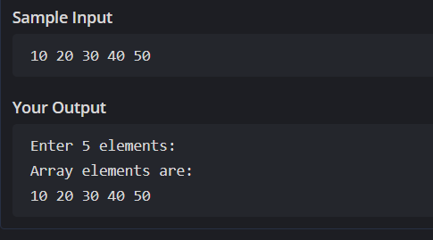

2. Program to Find Sum of Array Elements
Code:
import java.util.Scanner;
public class SumArray {
public static void main(String[] args) {
Scanner sc = new Scanner(System.in);
int[] arr = new int[5];
int sum = 0;
System.out.println("Enter 5 elements:");
for(int i = 0; i < 5; i++)
arr[i] = sc.nextInt();
for(int i = 0; i < 5; i++)
sum += arr[i];
System.out.println("Sum = " + sum);
}
}
OUTPUT:
Input:
5 10 15 20 25
Output:
Sum = 75
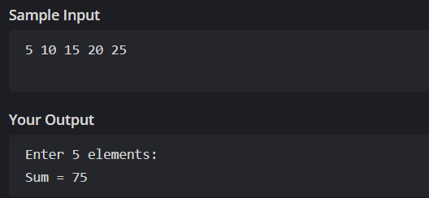
3. Program to Find Largest Element in an Array
Code:
import java.util.Scanner;
public class LargestElement {
public static void main(String[] args) {
Scanner sc = new Scanner(System.in);
int[] arr = new int[5];
System.out.println("Enter 5 elements:");
for(int i = 0; i < 5; i++)
arr[i] = sc.nextInt();
int max = arr[0];
for(int i = 1; i < 5; i++)
if(arr[i] > max)
max = arr[i];
System.out.println("Largest element = " + max);
}
}
OUTPUT:
Input:
12 45 23 9 30
Output:
Largest element = 45
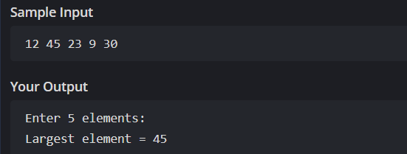

4. Program to Reverse an Array
Code:
import java.util.Scanner;

public class ReverseArray {
public static void main(String[] args) {
Scanner sc = new Scanner(System.in);
int[] arr = new int[5];
System.out.println("Enter 5 elements:");
for(int i = 0; i < 5; i++)
arr[i] = sc.nextInt();
System.out.println("Reversed array:");
for(int i = 4; i >= 0; i--)
System.out.print(arr[i] + " ");
}
}
OUTPUT:
Input:
1 2 3 4 5
Output:
Reversed array:
5 4 3 2 1
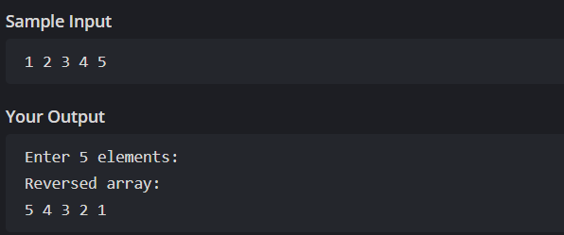

5. Program to Count Even and Odd Numbers
Code:
import java.util.Scanner;
public class EvenOddCount {
public static void main(String[] args) {
Scanner sc = new Scanner(System.in);
int[] arr = new int[5];
int even = 0, odd = 0;
System.out.println("Enter 5 elements:");
for(int i = 0; i < 5; i++)
arr[i] = sc.nextInt();
for(int i = 0; i < 5; i++) {
if(arr[i] % 2 == 0)
even++;
else
odd++;
}

System.out.println("Even = " + even);
System.out.println("Odd = " + odd);
}
}
OUTPUT:
Input:
2 7 4 9 10
Output:
Even = 3
Odd = 2
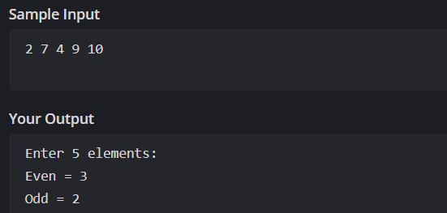
6. Program to Sort Array in Ascending Order
Code:
import java.util.Scanner;
public class SortArray {
public static void main(String[] args) {
Scanner sc = new Scanner(System.in);
int[] arr = new int[5];
int temp;
System.out.println("Enter 5 elements:");
for(int i = 0; i < 5; i++)
arr[i] = sc.nextInt();
for(int i = 0; i < 5; i++) {
for(int j = i + 1; j < 5; j++) {
if(arr[i] > arr[j]) {
temp = arr[i];
arr[i] = arr[j];
arr[j] = temp;
}
}
}
System.out.println("Sorted array:");
for(int i = 0; i < 5; i++)
System.out.print(arr[i] + " ");
}
}
OUTPUT:
Input:
45 12 78 23 9
Output:
Sorted array:
9 12 23 45 78
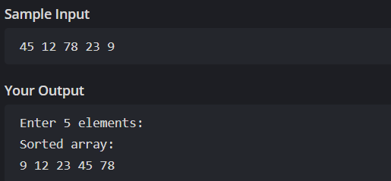

7. Program to Find Second Largest Element
Code:
import java.util.Scanner;
public class SecondLargest {
public static void main(String[] args) {
Scanner sc = new Scanner(System.in);
int[] arr = new int[5];

System.out.println("Enter 5 elements:");
for(int i = 0; i < 5; i++)
arr[i] = sc.nextInt();
int largest = arr[0];
int second = arr[0];
for(int i = 0; i < 5; i++) {
if(arr[i] > largest) {
second = largest;
largest = arr[i];
}
}
System.out.println("Second largest = " + second);
}
}
OUTPUT:
Input:
10 45 23 89 67
Output:
Second largest = 45
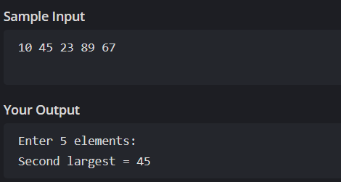

8. Program for Matrix Addition (2D Array)
Code:
import java.util.Scanner;
public class MatrixAddition {
public static void main(String[] args) {
Scanner sc = new Scanner(System.in);
int[][] a = new int[2][2];
int[][] b = new int[2][2];
int[][] sum = new int[2][2];
System.out.println("Enter elements of matrix A:");
for(int i = 0; i < 2; i++)
for(int j = 0; j < 2; j++)
a[i][j] = sc.nextInt();
System.out.println("Enter elements of matrix B:");
for(int i = 0; i < 2; i++)
for(int j = 0; j < 2; j++)
b[i][j] = sc.nextInt();
for(int i = 0; i < 2; i++)
for(int j = 0; j < 2; j++)
sum[i][j] = a[i][j] + b[i][j];
System.out.println("Sum matrix:");
for(int i = 0; i < 2; i++) {
for(int j = 0; j < 2; j++)
System.out.print(sum[i][j] + " ");
System.out.println();
}
}
}
OUTPUT:
Matrix A:
1 2
3 4
Matrix B:
5 6
7 8
Sum matrix:
6 8
10 12
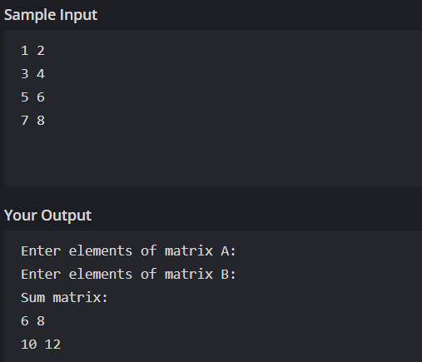

POST LAB EXERCISE
1. Why is array indexing usually started from zero instead of one?
Array indexing starts from zero because it simplifies memory addressing, where the index directly represents the offset from the starting memory location of the array.
2. What happens if we try to access an array element outside its declared size?
Accessing an element beyond the declared size of an array results in a runtime error, specifically an ArrayIndexOutOfBoundsException, which terminates program execution.
3. How does memory allocation differ for static arrays and dynamic arrays?
Static arrays have a fixed size decided at compile time, while dynamic arrays allow memory allocation during runtime, offering greater flexibility in handling varying data sizes.
4. Why is searching faster in arrays compared to linked lists?
Searching in arrays is faster because elements are stored in contiguous memory locations, allowing direct access using index values, unlike linked lists which require sequential traversal.
5. What is the difference between contiguous and non-contiguous memory allocation?
In contiguous memory allocation, data elements are stored in adjacent memory locations, improving access speed, whereas non-contiguous allocation stores elements separately and connects them using references.

Result:

Thus the array operations were executed successfully.

ASSESSMENT

Description | Max Marks | Marks Awarded
Pre Lab Exercise | 5
In Lab Exercise | 10
Post Lab Exercise | 5
Viva | 10
Total | 30
Faculty Signature

