Experiment Number : 06 Date: 05.02.26

ABSTRACT CLASSES
Aim:
To understand and implement inheritance concepts in Java.
PRE LAB EXERCISE
QUESTIONS
- What is an abstract class?
An abstract class is a class that cannot be instantiated and may contain abstract methods (without body) as well as concrete methods (with body). It is used as a base class for other classes.

- Why are abstract methods used?
Abstract methods are used to force child classes to provide their own implementation for those methods, ensuring a common interface while allowing flexibility.

- Difference between abstract class and interface.
Feature | Abstract Class | Interface
Instantiation | Cannot be instantiated | Cannot be instantiated
Methods | Can have abstract and concrete methods | By default, only abstract methods (Java 8+ can have default & static methods)
Variables | Can have instance variables | Only static final variables (constants)
Inheritance | A class can extend only one abstract class | A class can implement multiple interfaces
Access Modifiers | Can have any access modifier | Methods are public by default

IN LAB EXERCISE
Objective:
To implement abstract class and demonstrate abstraction.
PROGRAMS:
1.University System
Scenario:
A university has different types of courses: Online, Offline, and Hybrid. Each course has a getDetails() method.
Question:
Create an abstract class Course with abstract method getDetails(). Implement OnlineCourse, OfflineCourse, and HybridCourse classes.
Code:
abstract class Course {
abstract void getDetails();
}

class OnlineCourse extends Course {
void getDetails() {
System.out.println("Online Course: Attend via Internet");
}
}

class OfflineCourse extends Course {
void getDetails() {
System.out.println("Offline Course: Attend in classroom");
}
}

class HybridCourse extends Course {
void getDetails() {
System.out.println("Hybrid Course: Combination of online and offline");
}
}

public class Main {
public static void main(String[] args) {
Course c1 = new OnlineCourse();
Course c2 = new OfflineCourse();
Course c3 = new HybridCourse();

c1.getDetails();
c2.getDetails();
c3.getDetails();
}
}
Output:
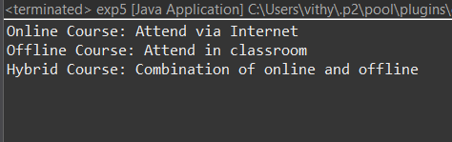
2. Employee Payroll System
Scenario:
A company has different types of employees — Regular and Contract. All employees have a salary, but the calculation differs for each type.
Question:
Design an abstract class Employee with an abstract method calculateSalary(). Implement subclasses RegularEmployee and ContractEmployee to calculate salary differently.
Code:
import java.util.Scanner;
abstract class Employee {
String name;
double baseSalary;

// Abstract method to calculate total salary
abstract void calculateSalary();
}

class RegularEmployee extends Employee {
double bonusRate = 0.1; // 10% bonus

void calculateSalary() {
double totalSalary = baseSalary + (baseSalary * bonusRate);
System.out.println("Regular Employee: " + name);
System.out.println("Base Salary: " + baseSalary);
System.out.println("Total Salary (with 10% bonus): " + totalSalary);
}
}

class ContractEmployee extends Employee {
void calculateSalary() {
System.out.println("Contract Employee: " + name);
System.out.println("Total Salary: " + baseSalary);
}
}

public class Main {
public static void main(String[] args) {
Scanner sc = new Scanner(System.in);

// Input for Regular Employee
System.out.print("Enter Regular Employee Name: ");
String regName = sc.nextLine();
System.out.print("Enter Base Salary: ");
double regSalary = sc.nextDouble();
sc.nextLine(); // Consume newline

// Input for Contract Employee
System.out.print("Enter Contract Employee Name: ");
String conName = sc.nextLine();
System.out.print("Enter Base Salary: ");
double conSalary = sc.nextDouble();

// Create objects
Employee e1 = new RegularEmployee();
e1.name = regName;
e1.baseSalary = regSalary;

Employee e2 = new ContractEmployee();
e2.name = conName;
e2.baseSalary = conSalary;

System.out.println("\n--- Salary Details ---");
e1.calculateSalary();
System.out.println();
e2.calculateSalary();

sc.close();
}
}
Output:
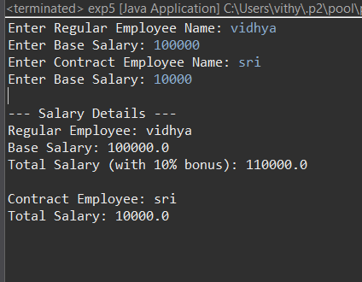
3.Banking System
Scenario:
A bank has different types of accounts: Savings and Current. Both accounts need a method to calculate interest, but the calculation differs for each account type.
Question:
Use an abstract class BankAccount with an abstract method calculateInterest() and implement it in SavingsAccount and CurrentAccount classes.
Code
abstract class BankAccount {
String accountHolder;
double balance;

BankAccount(String name, double bal) {
accountHolder = name;
balance = bal;
}

abstract void calculateInterest(); // Abstract method
}

class SavingsAccount extends BankAccount {
double interestRate = 0.04; // 4% interest

SavingsAccount(String name, double bal) {
super(name, bal);
}

void calculateInterest() {
double interest = balance * interestRate;
System.out.println("Savings Account Interest for " + accountHolder + " = " + interest);
}
}

class CurrentAccount extends BankAccount {
double interestRate = 0.02; // 2% interest

CurrentAccount(String name, double bal) {
super(name, bal);
}

void calculateInterest() {
double interest = balance * interestRate;
System.out.println("Current Account Interest for " + accountHolder + " = " + interest);
}
}

public class Main {
public static void main(String[] args) {
BankAccount acc1 = new SavingsAccount("Ram", 50000);
BankAccount acc2 = new CurrentAccount("Ravi", 80000);

acc1.calculateInterest();
acc2.calculateInterest();
}
}

Output
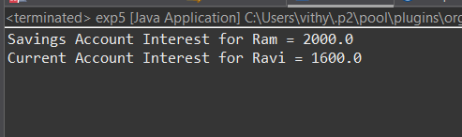

POST LAB EXERCISE
- How is an abstract class different from a regular class?
  - An abstract class cannot be instantiated.
  - It can contain abstract methods (methods without a body) that must be implemented by subclasses.
  - A regular class can be instantiated and cannot have abstract methods.

- Can you create an object of an abstract class? Why or why not?
  - No. Abstract classes cannot be instantiated because they may have abstract methods without implementations, so Java does not know what behavior to execute.

- What happens if a subclass does not implement an abstract method?
• The subclass must also be declared abstract.
• If it’s not abstract and does not implement all abstract methods from the parent, the code will fail to compile

- Can an abstract class exist without any abstract methods?
Yes. An abstract class can have only concrete methods. Declaring it abstract prevents it from being instantiated, usually because it’s meant to be a base class.

- Can an abstract class extend another abstract class?
Yes. An abstract class can extend another abstract class and inherit its methods (abstract or concrete). Subclasses are still responsible for implementing abstract methods unless they remain abstract

Result:

Thus the abstract classes and methods were implemented and executed successfully.

ASSESSMENT

Description | Max Marks | Marks Awarded
Pre Lab Exercise | 5
In Lab Exercise | 10
Post Lab Exercise | 5
Viva | 10
Total | 30
Faculty Signature

