Experiment Number : 07 Date:

METHOD OVERLOADING AND METHOD OVERRIDING
Aim:
To understand and implement method overloading and method overriding.
PRE LAB EXERCISE
QUESTIONS
1. What is method overloading?
Method overloading is a feature in which multiple methods share the same name but differ in their parameter list, enabling compile-time polymorphism.
2. What is method overriding?
Method overriding occurs when a subclass provides its own implementation of a method already defined in its parent class, enabling runtime polymorphism.
3. Difference between overloading and overriding.
Method overloading occurs within the same class with different parameters, whereas method overriding occurs between parent and child classes with the same method signature.
IN LAB EXERCISE
Objective:
To demonstrate compile-time and runtime polymorphism.
PROGRAMS:
1.Student Result System (Method Overriding)
Description:
- Base class Student has method displayResult().
- Subclasses UGStudent and PGStudent override the method to show different grading systems.

Code :
import java.util.Scanner;

// Base class
class Student {
String name;

void displayResult() {
System.out.println("Student Result");
}
}

// UG Student subclass
class UGStudent extends Student {
int marks;

UGStudent(String n, int m) {
name = n;
marks = m;
}

@Override
void displayResult() {
double percentage = (marks / 100.0) * 100;
System.out.println("UG Student: " + name);
System.out.println("Marks: " + marks);
System.out.println("Percentage: " + percentage + "%");
}
}

// PG Student subclass
class PGStudent extends Student {
double gpa;

PGStudent(String n, double g) {
name = n;
gpa = g;
}

@Override
void displayResult() {
System.out.println("PG Student: " + name);
System.out.println("GPA: " + gpa + " / 10");
}
}

// Main class
public class Main {
public static void main(String[] args) {
Scanner sc = new Scanner(System.in);

// Input for UG student
System.out.print("Enter UG Student Name: ");
String ugName = sc.nextLine();
System.out.print("Enter UG Student Marks (out of 100): ");
int ugMarks = sc.nextInt();
sc.nextLine(); // consume newline

// Input for PG student
System.out.print("Enter PG Student Name: ");
String pgName = sc.nextLine();
System.out.print("Enter PG Student GPA (0-10): ");
double pgGpa = sc.nextDouble();

// Create objects
Student s1 = new UGStudent(ugName, ugMarks);
Student s2 = new PGStudent(pgName, pgGpa);

System.out.println("\n--- Student Results ---");
s1.displayResult();
System.out.println();
s2.displayResult();

sc.close();
}
}
OUTPUT:

Sample Input:
Enter UG Student Name: Ram
Enter UG Student Marks (out of 100): 85
Enter PG Student Name: Ravi
Enter PG Student GPA (0-10): 9.2
Output:
--- Student Results ---
UG Student: Ram
Marks: 85
Percentage: 85.0%
PG Student: Ravi
GPA: 9.2 / 10
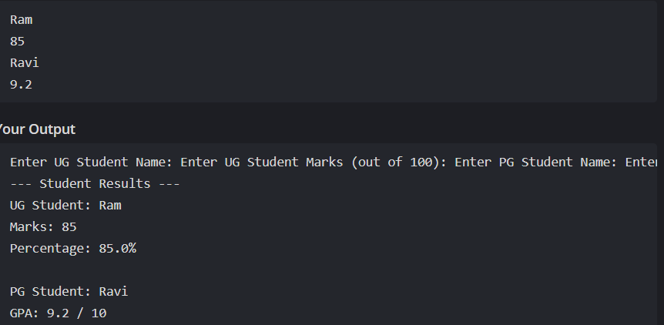
2. Calculator Program (Method Overloading)
Description:
Create a Calculator class with multiple add() methods to calculate:
- Addition of 2 integers
- Addition of 3 integers
- Addition of 2 double numbers
Code:
import java.util.Scanner;
class Calculator {
int add(int a, int b) {
return a + b;
}

int add(int a, int b, int c) {
return a + b + c;
}

double add(double a, double b) {
return a + b;
}
}
public class Main {
public static void main(String[] args) {
Scanner sc = new Scanner(System.in);
Calculator calc = new Calculator();

System.out.print("Enter two integers: ");
int x = sc.nextInt();
int y = sc.nextInt();
System.out.println("Sum of two integers: " + calc.add(x, y));

System.out.print("Enter three integers: ");
int p = sc.nextInt();
int q = sc.nextInt();
int r = sc.nextInt();
System.out.println("Sum of three integers: " + calc.add(p, q, r));

System.out.print("Enter two decimal numbers: ");
double a = sc.nextDouble();
double b = sc.nextDouble();
System.out.println("Sum of two doubles: " + calc.add(a, b));

sc.close();
}
}
Output:
Sample Input:
Enter two integers: 10 20
Enter three integers: 5 10 15
Enter two decimal numbers: 2.5 3.5
Output:
Sum of two integers: 30
Sum of three integers: 30
Sum of two doubles: 6.0
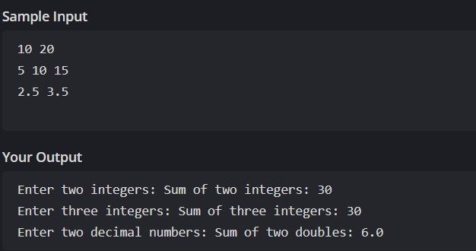

POST LAB EXERCISE
1. Is return type important in method overloading and method overriding?
In method overloading, the return type is not considered because methods are differentiated based on their parameter list. In method overriding, the return type must be the same or compatible with the parent class method to ensure correct runtime behavior.
2. Can you overload a method by changing only the return type?
No, a method cannot be overloaded by changing only the return type. Java identifies overloaded methods based on the number, type, or order of parameters, not by the return type alone.
3. Can static methods be overridden? Can they be overloaded?
Static methods cannot be overridden because they belong to the class rather than the object. However, static methods can be overloaded since overloading depends on method signatures at compile time.
4. Can a method be overridden if the parameter list is different?
No, if the parameter list is different, the method is considered overloaded rather than overridden. For overriding, the method signature must be exactly the same as that of the parent class.
5. Why is method overloading called compile-time polymorphism and method overriding called runtime polymorphism?
Method overloading is resolved at compile time because the compiler decides which method to call based on the method signature. Method overriding is resolved at runtime because the method call depends on the actual object type created during program execution.
Result:
Thus the method overloading and overriding concepts were implemented and executed successfully.
ASSESSMENT

Description | Max Marks | Marks Awarded
Pre Lab Exercise | 5
In Lab Exercise | 10
Post Lab Exercise | 5
Viva | 10
Total | 30
Faculty Signature

