Experiment Number : 04 Date: 05.02.2026

ARRAYS
Aim:
To understand and implement array operations in Java.
PRE LAB EXERCISE
QUESTIONS
- What is an array?
An array is a collection of elements of the same data type stored in contiguous memory locations and accessed using a single name with an index.
- Why are arrays used?
Arrays are used to:
- Store multiple values of the same type in one structure
- Access data easily using index numbers
- Reduce the need for many separate variables
- Make programs more organized and efficient
- Simplify operations like sorting, searching, and iteration

- What is the difference between array and variable?
Variable | Array
Stores only one value at a time | Stores multiple values
Has a single memory location | Uses multiple continuous memory locations
Accessed by name | Accessed by name with index (e.g., arr[0])
Example: int a = 10; | Example: int a[5] = {1,2,3,4,5};

IN LAB EXERCISE
Objective:
To perform array operations using simple programs.
PROGRAMS:
1. Program to Read and Print Array Elements
Code:
import java.util.Scanner;
public class ReadPrintArray {
public static void main(String[] args) {
Scanner sc = new Scanner(System.in);
int[] arr = new int[5];
System.out.println("Enter 5 elements:");
for(int i = 0; i < 5; i++)
arr[i] = sc.nextInt();
System.out.println("Array elements are:");
for(int i = 0; i < 5; i++)
System.out.print(arr[i] + " ");
}
}
OUTPUT:
Input:
10 20 30 40 50
Output:
Array elements are:
10 20 30 40 50
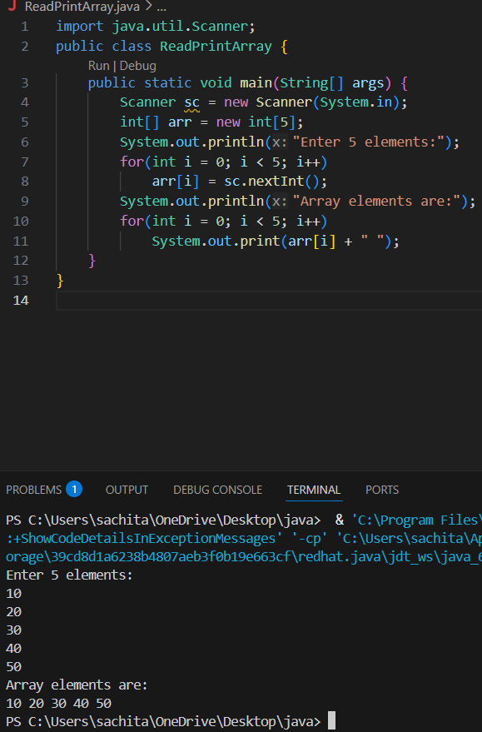

2. Program to Find Sum of Array Elements
Code:
import java.util.Scanner;
public class SumArray {
public static void main(String[] args) {
Scanner sc = new Scanner(System.in);
int[] arr = new int[5];
int sum = 0;
System.out.println("Enter 5 elements:");
for(int i = 0; i < 5; i++)
arr[i] = sc.nextInt();
for(int i = 0; i < 5; i++)
sum += arr[i];
System.out.println("Sum = " + sum);
}
}
OUTPUT:
Input:
5 10 15 20 25
Output:
Sum = 75
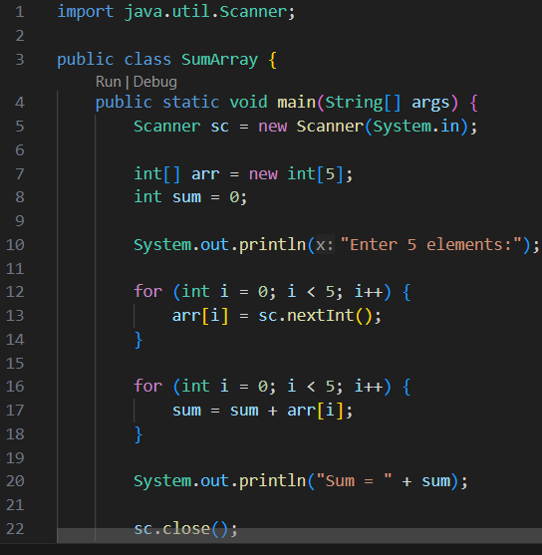

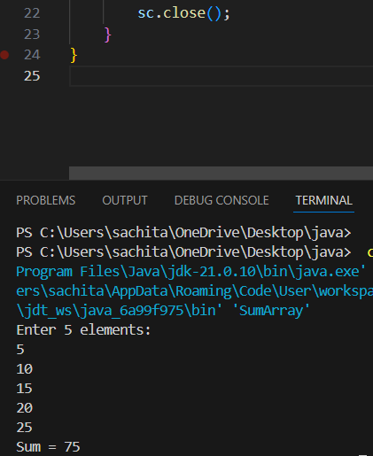

3. Program to Find Largest Element in an Array
Code:
import java.util.Scanner;
public class LargestElement {
public static void main(String[] args) {
Scanner sc = new Scanner(System.in);
int[] arr = new int[5];
System.out.println("Enter 5 elements:");
for(int i = 0; i < 5; i++)
arr[i] = sc.nextInt();
int max = arr[0];
for(int i = 1; i < 5; i++)
if(arr[i] > max)
max = arr[i];
System.out.println("Largest element = " + max);
}
}
OUTPUT:
Input:
12 45 23 9 30
Output:
Largest element = 45
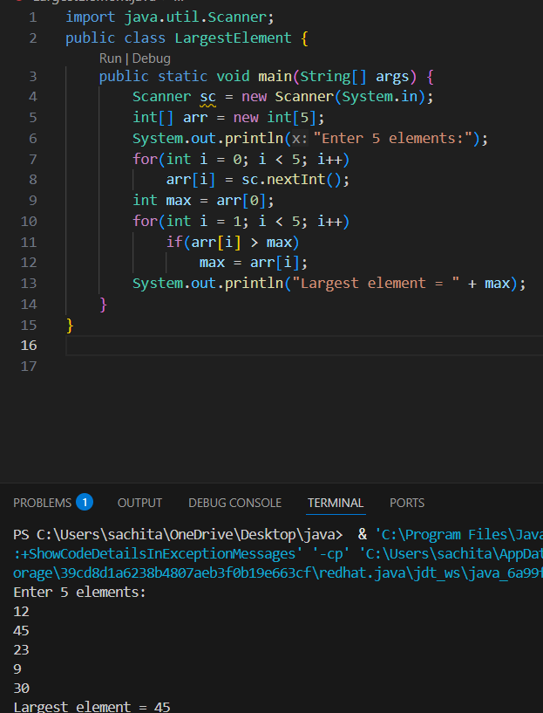

4. Program to Reverse an Array
Code:
import java.util.Scanner;

public class ReverseArray {
public static void main(String[] args) {
Scanner sc = new Scanner(System.in);
int[] arr = new int[5];
System.out.println("Enter 5 elements:");
for(int i = 0; i < 5; i++)
arr[i] = sc.nextInt();
System.out.println("Reversed array:");
for(int i = 4; i >= 0; i--)
System.out.print(arr[i] + " ");
}
}
OUTPUT:
Input:
1 2 3 4 5
Output:
Reversed array:
5 4 3 2 1
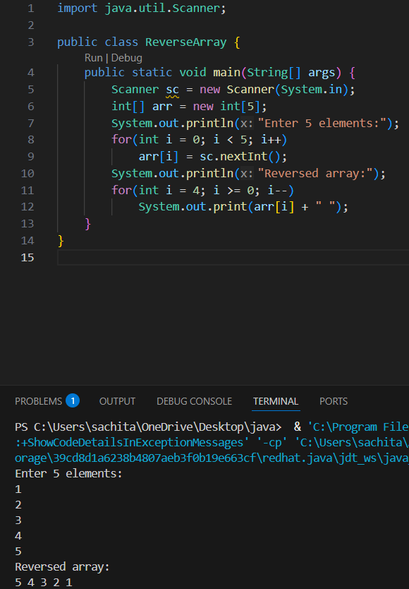

5. Program to Count Even and Odd Numbers
Code:
import java.util.Scanner;
public class EvenOddCount {
public static void main(String[] args) {
Scanner sc = new Scanner(System.in);
int[] arr = new int[5];
int even = 0, odd = 0;
System.out.println("Enter 5 elements:");
for(int i = 0; i < 5; i++)
arr[i] = sc.nextInt();
for(int i = 0; i < 5; i++) {
if(arr[i] % 2 == 0)
even++;
else
odd++;
}

System.out.println("Even = " + even);
System.out.println("Odd = " + odd);
}
}
OUTPUT:
Input:
2 7 4 9 10
Output:
Even = 3
Odd = 2
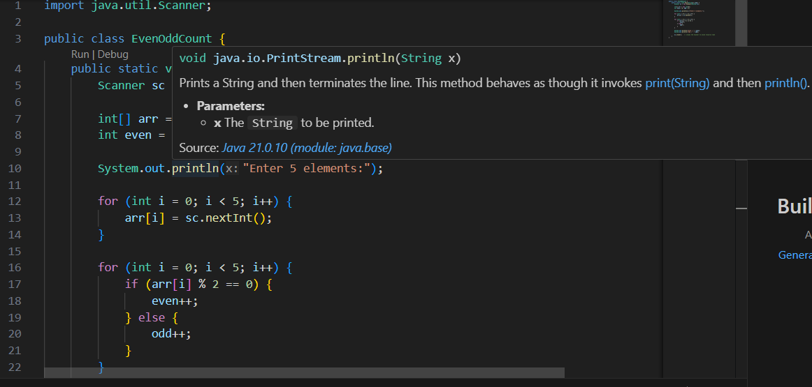
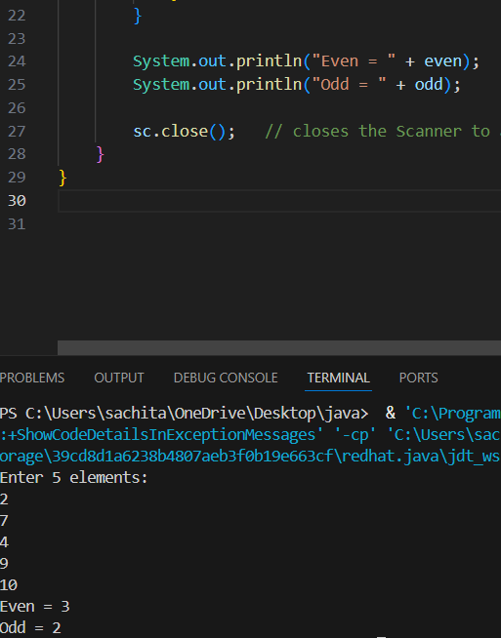
6. Program to Sort Array in Ascending Order
Code:
import java.util.Scanner;
public class SortArray {
public static void main(String[] args) {
Scanner sc = new Scanner(System.in);
int[] arr = new int[5];
int temp;
System.out.println("Enter 5 elements:");
for(int i = 0; i < 5; i++)
arr[i] = sc.nextInt();
for(int i = 0; i < 5; i++) {
for(int j = i + 1; j < 5; j++) {
if(arr[i] > arr[j]) {
temp = arr[i];
arr[i] = arr[j];
arr[j] = temp;
}
}
}
System.out.println("Sorted array:");
for(int i = 0; i < 5; i++)
System.out.print(arr[i] + " ");
}
}
OUTPUT:
Input:
45 12 78 23 9
Output:
Sorted array:
9 12 23 45 78
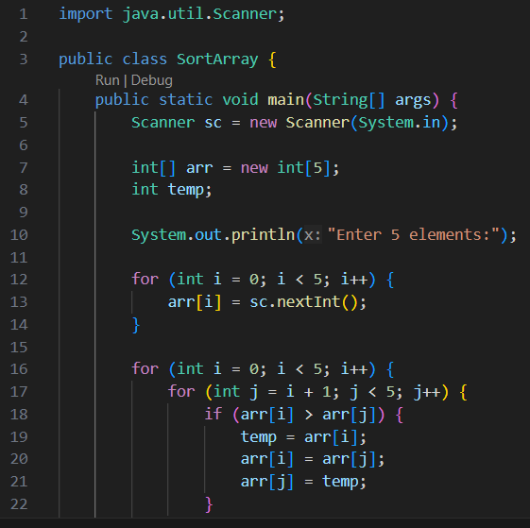
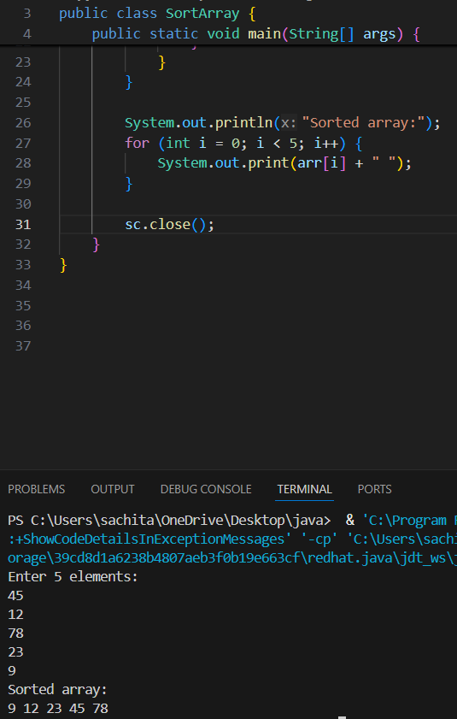

7. Program to Find Second Largest Element
Code:
import java.util.Scanner;
public class SecondLargest {
public static void main(String[] args) {
Scanner sc = new Scanner(System.in);
int[] arr = new int[5];

System.out.println("Enter 5 elements:");
for(int i = 0; i < 5; i++)
arr[i] = sc.nextInt();
int largest = arr[0];
int second = arr[0];
for(int i = 0; i < 5; i++) {
if(arr[i] > largest) {
second = largest;
largest = arr[i];
}
}
System.out.println("Second largest = " + second);
}
}
OUTPUT:
Input:
10 45 23 89 67
Output:
Second largest = 67
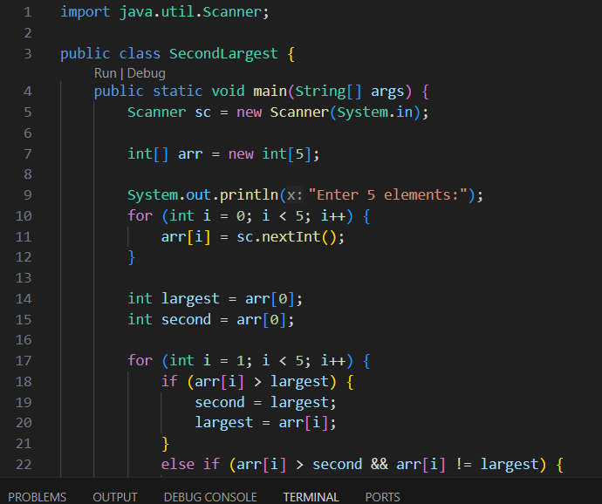
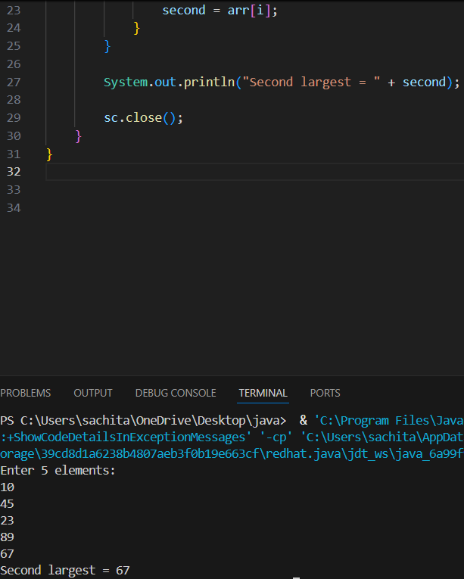

8. Program for Matrix Addition (2D Array)
Code:
import java.util.Scanner;
public class MatrixAddition {
public static void main(String[] args) {
Scanner sc = new Scanner(System.in);
int[][] a = new int[2][2];
int[][] b = new int[2][2];
int[][] sum = new int[2][2];
System.out.println("Enter elements of matrix A:");
for(int i = 0; i < 2; i++)
for(int j = 0; j < 2; j++)
a[i][j] = sc.nextInt();
System.out.println("Enter elements of matrix B:");
for(int i = 0; i < 2; i++)
for(int j = 0; j < 2; j++)
b[i][j] = sc.nextInt();
for(int i = 0; i < 2; i++)
for(int j = 0; j < 2; j++)
sum[i][j] = a[i][j] + b[i][j];
System.out.println("Sum matrix:");
for(int i = 0; i < 2; i++) {
for(int j = 0; j < 2; j++)
System.out.print(sum[i][j] + " ");
System.out.println();
}
}
}
OUTPUT:
Matrix A:
1 2
3 4
Matrix B:
5 6
7 8
Sum matrix:
6 8
10 12
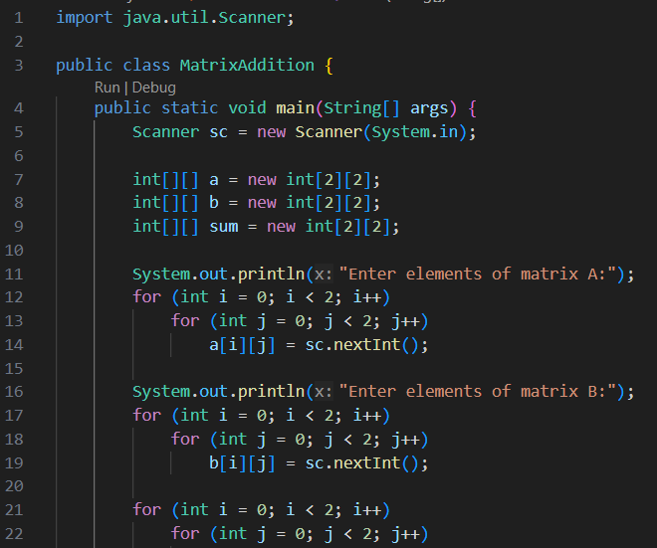
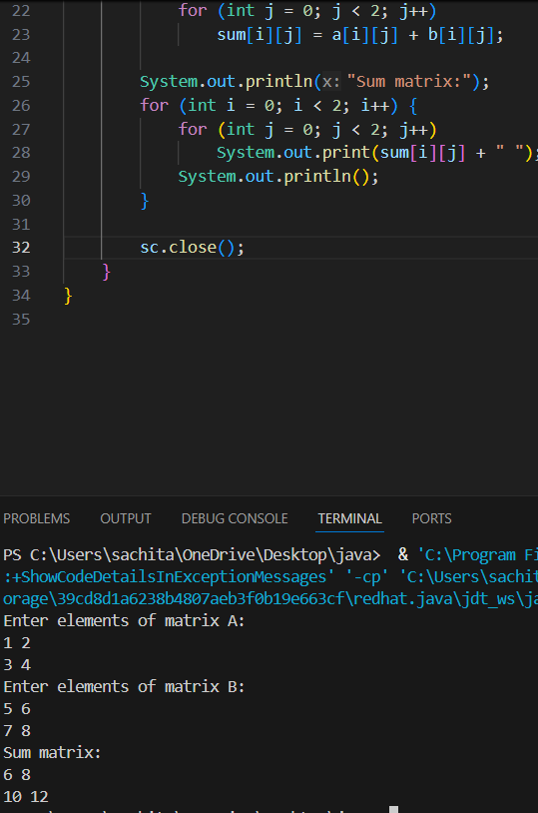

POST LAB EXERCISE
- Why is array indexing usually started from zero instead of one?
- Arrays store elements in contiguous memory.
- The index represents the offset from the starting address.
- First element → offset 0 → base address + 0.
- This makes address calculation simple and fast in programming languages.

- What happens if we try to access an array element outside its declared size?
It causes an error at runtime.
In Java: ArrayIndexOutOfBoundsException occurs.
In C/C++: may access garbage values or crash the program.

- How does memory allocation differ for static arrays and dynamic arrays?

Static Array | Dynamic Array

Size fixed at compile time | Size decided at runtime

Memory allocated before execution | Memory allocated during execution

Cannot be resized | Can be resized

Example: int arr[5]; | Example: new int[n]; in Java

- Why is searching faster in arrays compared to linked lists?
Because array elements are stored in continuous memory and can be accessed directly using an index.
Linked lists require sequential traversal node by node, so it is slower.
- What is the difference between contiguous and non-contiguous memory allocation?
Contiguous memory:
Data stored in continuous memory locations.
Example: Array
Faster access using index.
Non-contiguous memory:
Data stored at different memory locations linked using pointers.
Example: Linked list
Access is slower because traversal is required.

Result:

Thus the array operations were executed successfully.

ASSESSMENT

Description | Max Marks | Marks Awarded
Pre Lab Exercise | 5
In Lab Exercise | 10
Post Lab Exercise | 5
Viva | 10
Total | 30
Faculty Signature

