Experiment Number: 02 Date: 28-01-2026

Input and Output Statements in Java
Aim:
To understand and use input and output statements in Java using the Scanner class.
PRE LAB EXERCISE
QUESTIONS
- What is input in a program?
Input is the data given to a program for processing.
Example: numbers, name, marks.
- What is output in a program?
Output is the information or result that a program displays after performing the required operations on the given input. It shows the final outcome of the program’s execution.
Example: total marks, average, grade, or any message displayed on the screen.
3.Which class is used to read input from the user in Java?
In Java, the Scanner class from the package java.util.Scanner is used to read input from the user through the keyboard. It allows reading different types of data such as integers, floats, and strings.
IN LAB EXERCISE
Objective:
To read input from the user and display the output using Java input and output statements.
INPUT STATEMENT:
SCANNER CLASS
- The Scanner class in Java is used to read input from the user through the keyboard.
It is available in the package java.util.
- The Scanner object reads different types of input such as integer, float, double, and string and stores them in variables.
- To use the Scanner class, it must be imported before using it in the program.
SYNTAX:
- Scanner sc = new Scanner(System.in);
Commonly Used Scanner Methods:
- nextInt() – reads an integer value
- nextFloat() – reads a float value
- nextDouble() – reads a double value
- next() – reads a single word
- nextLine() – reads a complete line of text

PROGRAMS:
Program 1: Read and Display Name
Source Code:
import java.util.Scanner;
class ReadName {
public static void main(String[] args) {
Scanner sc = new Scanner(System.in);
System.out.print("Enter your name: ");
String name = sc.nextLine();
System.out.println("Your name is: " + name);
}
}
Output:
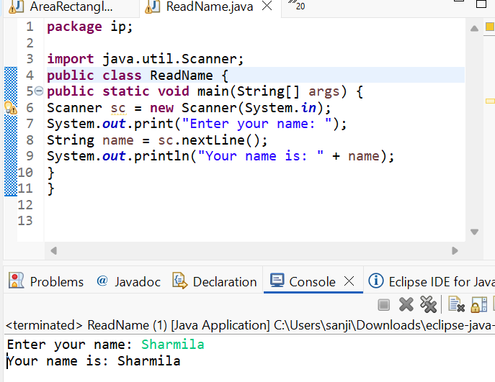
Program 2: Read Two Numbers and Print Sum
Source Code:
import java.util.Scanner;
class SumInput {
public static void main(String[] args) {
Scanner sc = new Scanner(System.in);
System.out.print("Enter first number: ");
int a = sc.nextInt();
System.out.print("Enter second number: ");
int b = sc.nextInt();
int sum = a + b;
System.out.println("Sum = " + sum);
}
}
Output:
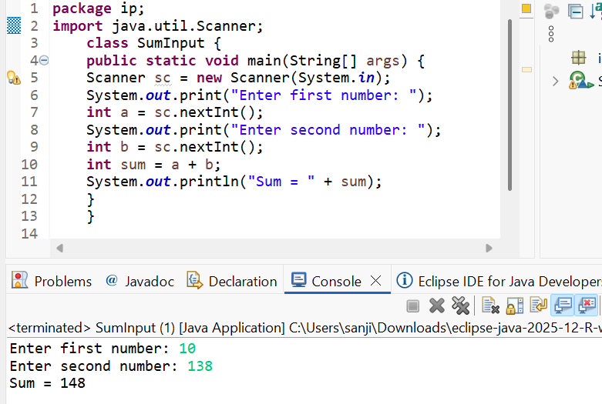
Program 3: Read Length and Breadth and Find Area of Rectangle
Source Code:
import java.util.Scanner;

class AreaRectangleInput {
public static void main(String[] args) {
Scanner sc = new Scanner(System.in);
System.out.print("Enter length: ");
int length = sc.nextInt();
System.out.print("Enter breadth: ");
int breadth = sc.nextInt();
int area = length * breadth;
System.out.println("Area of Rectangle = " + area);
}
}
Output:
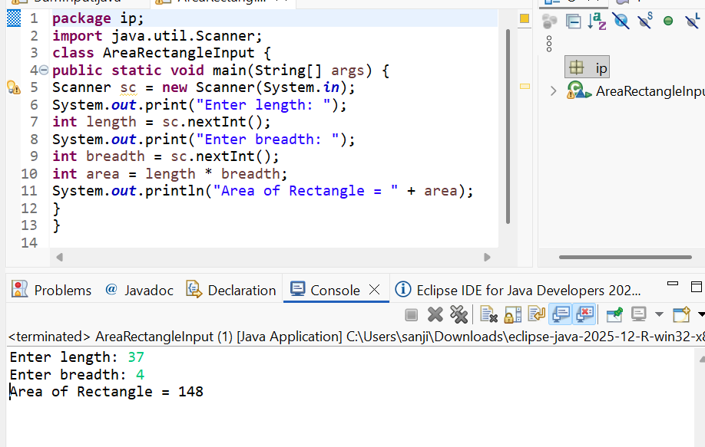

POST LAB EXERCISE
- What is the use of the Scanner class in Java?
      - Used to take input from the user through the keyboard.
      - Helps to read different types of data such as integer,float,double,string

- Which package contains the Scanner class?
      - Scanner class belongs to java.util package.
      - To use Scanner, we must import it.
Example: import java.util.Scanner;

- What does System.in represent?
- Represents the standard input stream in Java.
- Used to take input from the user (keyboard).
- Scanner uses System.in to read input.
Example:
Scanner sc = new Scanner(System.in);

What does System.out represent?
- Represents the standard output stream in Java.
- Used to display output on the screen (console).
- Used with print() and println() methods.
Example: System.out.println("Hello World");

- Name any two methods used to read input using Scanner.
Any two methods are:
nextInt() → reads integer value
nextLine() → reads full line/sentence
(Other methods: next(), nextDouble(), nextFloat() etc.)

- What is the difference between next() and nextLine()?
next() reads only one word (stops at space).
nextLine() reads the entire line including spaces until Enter is pressed.
Example:
Input: Sharmila S M
next() →Sharmila
nextLine() → Sharmila S M

Result:

Thus the input was successfully read from the user and the corresponding output was displayed using Java input and output statements.

ASSESSMENT

Description | Max Marks | Marks Awarded
Pre Lab Exercise | 5
In Lab Exercise | 10
Post Lab Exercise | 5
Viva | 10
Total | 30
Faculty Signature

