Experiment Number : 07 Date: 05/02/2026

METHOD OVERLOADING AND METHOD OVERRIDING
Aim:
To understand and implement method overloading and method overriding.
PRE LAB EXERCISE
QUESTIONS
- What is method overloading?
Method overloading means having multiple methods with the same name but different parameter lists in the same class.

- What is method overriding?
Method overriding means redefining a parent class method in a child class with the same method signature.

- Difference between overloading and overriding.
Method overloading uses the same method name with different parameters and is decided at compile time.
Method overriding uses the same method name with the same parameters in parent–child classes and is decided at runtime.

IN LAB EXERCISE
Objective:
To demonstrate compile-time and runtime polymorphism.
PROGRAMS:
1.Student Result System (Method Overriding)
Description:
- Base class Student has method displayResult().
- Subclasses UGStudent and PGStudent override the method to show different grading systems.

Code :
import java.util.Scanner;

// Base class
class Student {
String name;

void displayResult() {
System.out.println("Student Result");
}
}

// UG Student subclass
class UGStudent extends Student {
int marks;

UGStudent(String n, int m) {
name = n;
marks = m;
}

@Override
void displayResult() {
double percentage = (marks / 100.0) * 100;
System.out.println("UG Student: " + name);
System.out.println("Marks: " + marks);
System.out.println("Percentage: " + percentage + "%");
}
}

// PG Student subclass
class PGStudent extends Student {
double gpa;

PGStudent(String n, double g) {
name = n;
gpa = g;
}

@Override
void displayResult() {
System.out.println("PG Student: " + name);
System.out.println("GPA: " + gpa + " / 10");
}
}

// Main class
public class Main {
public static void main(String[] args) {
Scanner sc = new Scanner(System.in);

// Input for UG student
System.out.print("Enter UG Student Name: ");
String ugName = sc.nextLine();
System.out.print("Enter UG Student Marks (out of 100): ");
int ugMarks = sc.nextInt();
sc.nextLine(); // consume newline

// Input for PG student
System.out.print("Enter PG Student Name: ");
String pgName = sc.nextLine();
System.out.print("Enter PG Student GPA (0-10): ");
double pgGpa = sc.nextDouble();

// Create objects
Student s1 = new UGStudent(ugName, ugMarks);
Student s2 = new PGStudent(pgName, pgGpa);

System.out.println("\n--- Student Results ---");
s1.displayResult();
System.out.println();
s2.displayResult();

sc.close();
}
}
OUTPUT:

Sample Input:
Enter UG Student Name: Ram
Enter UG Student Marks (out of 100): 85
Enter PG Student Name: Ravi
Enter PG Student GPA (0-10): 9.2
Output:
--- Student Results ---
UG Student: Ram
Marks: 85
Percentage: 85.0%
PG Student: Ravi
GPA: 9.2 / 10
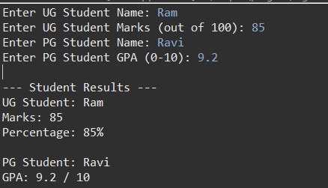
2. Calculator Program (Method Overloading)
Description:
Create a Calculator class with multiple add() methods to calculate:
- Addition of 2 integers
- Addition of 3 integers
- Addition of 2 double numbers
Code:
import java.util.Scanner;
class Calculator {
int add(int a, int b) {
return a + b;
}

int add(int a, int b, int c) {
return a + b + c;
}

double add(double a, double b) {
return a + b;
}
}
public class Main {
public static void main(String[] args) {
Scanner sc = new Scanner(System.in);
Calculator calc = new Calculator();

System.out.print("Enter two integers: ");
int x = sc.nextInt();
int y = sc.nextInt();
System.out.println("Sum of two integers: " + calc.add(x, y));

System.out.print("Enter three integers: ");
int p = sc.nextInt();
int q = sc.nextInt();
int r = sc.nextInt();
System.out.println("Sum of three integers: " + calc.add(p, q, r));

System.out.print("Enter two decimal numbers: ");
double a = sc.nextDouble();
double b = sc.nextDouble();
System.out.println("Sum of two doubles: " + calc.add(a, b));

sc.close();
}
}
Output:
Sample Input:
Enter two integers: 10 20
Enter three integers: 5 10 15
Enter two decimal numbers: 2.5 3.5
Output:
Sum of two integers: 30
Sum of three integers: 30
Sum of two doubles: 6.0
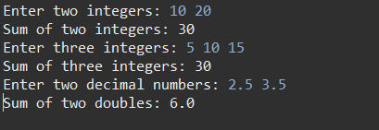
POST LAB EXERCISE
- Is return type important in method overloading and method overriding?
In method overloading, return type alone is not important; parameters must be different.
In method overriding, return type must be same (or covariant) as the parent class method.

- Can you overload a method by changing only the return type?
No. Changing only the return type does not overload a method; the parameter list must change.

- Can static methods be overridden? Can they be overloaded?
• Static methods cannot be overridden (they are class-level).
• Static methods can be overloaded.
- Can a method be overridden if the parameter list is different?
No. If the parameter list is different, it becomes method overloading, not overriding.

Result:
Thus the method overloading and overriding concepts were implemented and executed successfully.
ASSESSMENT

Description | Max Marks | Marks Awarded
Pre Lab Exercise | 5
In Lab Exercise | 10
Post Lab Exercise | 5
Viva | 10
Total | 30
Faculty Signature

