Experiment Number : 02 Date: 28-01-2026

Input and Output Statements in Java
Aim:
To understand and use input and output statements in Java using the Scanner class.
PRE LAB EXERCISE
QUESTIONS
What is input in a program?
Input is the data that a program receives to work with. It can come from the user (like typing on a keyboard), a file, a sensor, or another program.
Example: entering your name or age into a program.
What is output in a program?
Output is the result produced by a program after processing the input. It’s how the program shows information back to the user or another system.
Example: displaying a message, a calculated result, or writing data to a file.
Which class is used to read input from the user in Java?
The most commonly used class is Scanner, from the java.util package
IN LAB EXERCISE
Objective:
To read input from the user and display the output using Java input and output statements.
INPUT STATEMENT:
SCANNER CLASS
- The Scanner class in Java is used to read input from the user through the keyboard.
It is available in the package java.util.
- The Scanner object reads different types of input such as integer, float, double, and string and stores them in variables.
- To use the Scanner class, it must be imported before using it in the program.
SYNTAX:
- Scanner sc = new Scanner(System.in);
Commonly Used Scanner Methods:
- nextInt() – reads an integer value
- nextFloat() – reads a float value
- nextDouble() – reads a double value
- next() – reads a single word
- nextLine() – reads a complete line of text

PROGRAMS:
Program 1: Read and Display Name
Source Code:
import java.util.Scanner;
class ReadName {
public static void main(String[] args) {
Scanner sc = new Scanner(System.in);
System.out.print("Enter your name: ");
String name = sc.nextLine();
System.out.println("Your name is: " + name);
}
}
Output:
Enter your name: Anitha
Your name is: Anitha
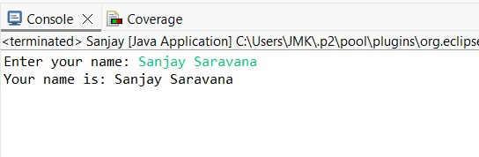
Program 2: Read Two Numbers and Print Sum
Source Code:
import java.util.Scanner;
class SumInput {
public static void main(String[] args) {
Scanner sc = new Scanner(System.in);
System.out.print("Enter first number: ");
int a = sc.nextInt();
System.out.print("Enter second number: ");
int b = sc.nextInt();
int sum = a + b;
System.out.println("Sum = " + sum);
}
}
Output:
Enter first number: 5
Enter second number: 3
Sum = 8
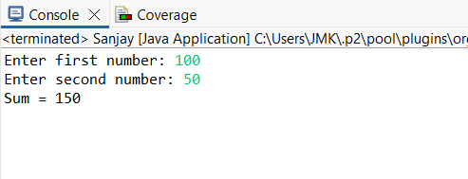
Program 3: Read Length and Breadth and Find Area of Rectangle
Source Code:
import java.util.Scanner;

class AreaRectangleInput {
public static void main(String[] args) {
Scanner sc = new Scanner(System.in);
System.out.print("Enter length: ");
int length = sc.nextInt();
System.out.print("Enter breadth: ");
int breadth = sc.nextInt();
int area = length * breadth;
System.out.println("Area of Rectangle = " + area);
}
}
Output:
Enter length: 10
Enter breadth: 5
Area of Rectangle = 50
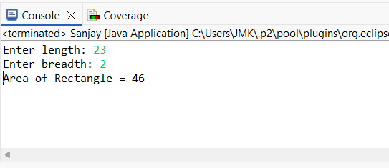

POST LAB EXERCISE
- What is the use of the Scanner class in Java?
The Scanner class is used to take input from the user. It reads different types of data such as integers, strings, floats, etc., from the keyboard or other input sources.

- Which package contains the Scanner class?
The Scanner class is found in the java.util package.

- What does System.in represent?
System.in represents the standard input stream, which is usually the keyboard. It is used to take input from the user.

- What does System.out represent?
System.out represents the standard output stream, which is usually the screen/console. It is used to display output to the user.

- Name any two methods used to read input using Scanner.
• nextInt() – reads an integer value
• nextLine() – reads a line of text

- What is the difference between next() and nextLine()?
The next() method reads only a single word from the input. It stops reading when it encounters a space or any whitespace, so it cannot read input that contains spaces.
The nextLine() method reads the entire line of input. It reads everything until the user presses the Enter key, including spaces between words.
Example:
If the input is Hello World
next() will read only Hello
nextLine() will read Hello World

Result:
Thus the input was successfully read from the user and the corresponding output was displayed using Java input and output statements.

ASSESSMENT

Description | Max Marks | Marks Awarded
Pre Lab Exercise | 5
In Lab Exercise | 10
Post Lab Exercise | 5
Viva | 10
Total | 30
Faculty Signature

