Experiment Number : 03 Date: 28-01-2026

Control Statements in Java
Aim:
To understand and implement decision-making and looping control statements in Java.
PRE LAB EXERCISE
QUESTIONS
- List different control statements in Java.
Control statements in Java are used to control the flow of execution of a program. They are mainly of three types:
- Selection statements: if, if-else, switch
- Looping (iteration) statements: for, while, do-while
- Jump statements: break, continue, return
- Difference between for, while, and do-while loops.
The for loop is used when the number of iterations is known in advance. Initialization, condition, and update are written in one line.
The while loop is used when the number of iterations is not known beforehand. The condition is checked before executing the loop body.
The do-while loop is similar to the while loop, but the condition is checked after executing the loop body. This means the loop body runs at least once, even if the condition is false.

- What is the use of break and continue?
The break statement is used to terminate the loop or switch statement immediately and transfer control outside it.
The continue statement is used to skip the current iteration of a loop and move to the next iteration without executing the remaining code inside the loop.

IN LAB EXERCISE
Objective:
To implement if-else and looping statements.
INPUT STATEMENT:
SCANNER CLASS
- The Scanner class in Java is used to read input from the user through the keyboard.
It is available in the package java.util.
- The Scanner object reads different types of input such as integer, float, double, and string and stores them in variables.
- To use the Scanner class, it must be imported before using it in the program.
SYNTAX:
- Scanner sc = new Scanner(System.in);
Commonly Used Scanner Methods:
- nextInt() – reads an integer value
- nextFloat() – reads a float value
- nextDouble() – reads a double value
- next() – reads a single word
- nextLine() – reads a complete line of text

PROGRAMS:
Program 1: Check Whether a Number is Positive
class PositiveNumber {
public static void main(String[] args) {
int n = 5;
if (n > 0) {
System.out.println("Positive Number");
}
}
}
Output:
Positive Number
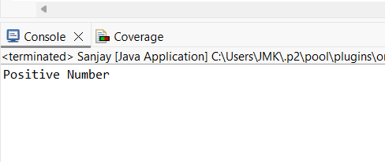
Program 2: Check Whether a Number is Even or Odd
class EvenOdd {
public static void main(String[] args) {
int n = 6;
if (n % 2 == 0)
System.out.println("Even Number");
else
System.out.println("Odd Number");
}
}
Output:
Even Number
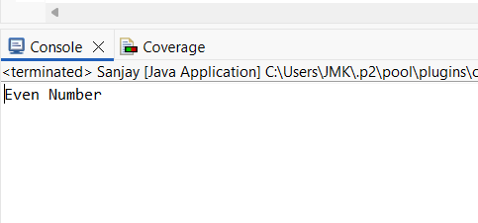
Program 3: Find Largest of Two Numbers
class LargestTwo {
public static void main(String[] args) {
int a = 10, b = 20;
if (a > b)
System.out.println("A is largest");
else
System.out.println("B is largest");
}
}
Output:
B is largest
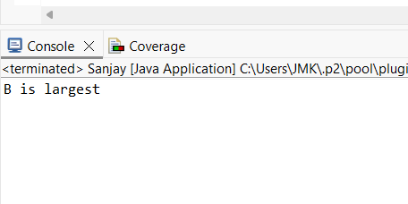
Program 4: Grade Calculation
class Grade {
public static void main(String[] args) {
int marks = 75;
if (marks >= 90)
System.out.println("Grade A");
else if (marks >= 75)
System.out.println("Grade B");
else if (marks >= 50)
System.out.println("Grade C");
else
System.out.println("Fail");
}
}
Output:
Grade B
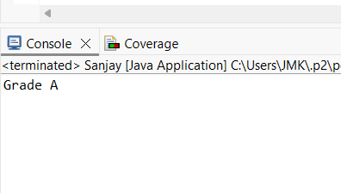
Program 5: Day of the Week
class DaySwitch {
public static void main(String[] args) {
int day = 3;
switch (day) {
case 1: System.out.println("Monday"); break;
case 2: System.out.println("Tuesday"); break;
case 3: System.out.println("Wednesday"); break;
case 4: System.out.println("Thursday"); break;
case 5: System.out.println("Friday"); break;
default: System.out.println("Invalid Day");
}
}
}
Output:
Wednesday
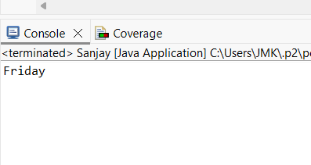
Program 6: Print Numbers from 1 to 5
class ForLoop {
public static void main(String[] args) {
for (int i = 1; i <= 5; i++) {
System.out.println(i);
}
}
}
Output:
1
2
3
4
5
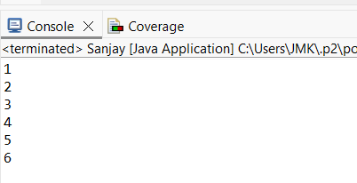

Program 7: Print Numbers from 1 to 5
class WhileLoop {
public static void main(String[] args) {
int i = 1;
while (i <= 5) {
System.out.println(i);
i++;
}
}
}
Output:
1
2
3
4
5
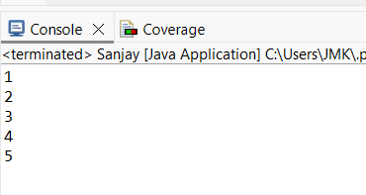

Program 8: Print Numbers from 1 to 5
class DoWhileLoop {
public static void main(String[] args) {
int i = 1;
do {
System.out.println(i);
i++;
} while (i <= 5);
}
}
Output:
1
2
3
4
5
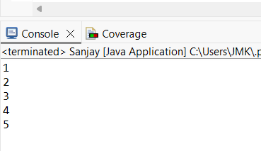

Program 9: Sum of First 6 Natural Numbers
class SumNumbers {
public static void main(String[] args) {
int sum = 0;
for (int i = 1; i <= 5; i++) {
sum = sum + i;
}
System.out.println("Sum = " + sum);
}
}
Output:
Sum = 15
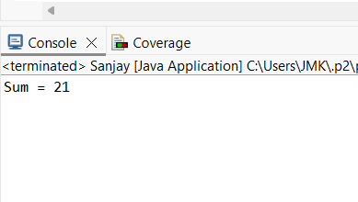
Program 10: Multiplication Table of a Number
class MultiplicationTable {
public static void main(String[] args) {
int n = 5;
for (int i = 1; i <= 10; i++) {
System.out.println(n + " x " + i + " = " + (n * i));
}
}
}
Output:
5 x 1 = 5
5 x 2 = 10
5 x 3 = 15
5 x 4 = 20
5 x 5 = 25
5 x 6 = 30
5 x 7 = 35
5 x 8 = 40
5 x 9 = 45
5 x 10 = 50
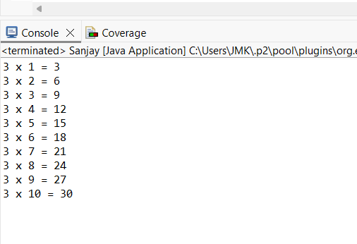

POST LAB EXERCISE
- What is the use of if statement?
The if statement is used to check a condition. If the condition is true, a specific block of code is executed.
- Difference between if-else and else-if ladder.
The if-else statement is used to choose between two options based on a condition.
The else-if ladder is used to check multiple conditions one after another and execute the block of code whose condition becomes true.
- Why is switch statement used?
The switch statement is used to select one block of code from multiple options based on the value of a variable or expression. It makes the program easier to read and manage when there are many conditions.
- Difference between for, while, and do-while loops.
The for loop is used when the number of iterations is known in advance.
The while loop is used when the number of iterations is not known and the condition is checked before the loop runs.
The do-while loop checks the condition after executing the loop body, so the loop runs at least once.
- Which loop executes at least once?
The do-while loop executes at least once because the condition is checked after the loop body runs.

Result:

Thus the different control statements were executed successfully with expected output.

ASSESSMENT

Description | Max Marks | Marks Awarded
Pre Lab Exercise | 5
In Lab Exercise | 10
Post Lab Exercise | 5
Viva | 10
Total | 30
Faculty Signature

