Experiment Number : 04 Date: 04-02-2026

ARRAYS
Aim:
To understand and implement array operations in Java.
PRE LAB EXERCISE
QUESTIONS
- What is an array?
An array is a data structure that stores multiple values of the same data type in a single variable, using index positions.
- Why are arrays used?
Arrays are used to store and manage many related values easily, making programs shorter, faster, and easier to use with loops.
- What is the difference between array and variable?
A variable can store only one value at a time, whereas an array can store many values of the same data type in consecutive memory locations.

IN LAB EXERCISE
Objective:
To perform array operations using simple programs.
PROGRAMS:
1. Program to Read and Print Array Elements
Code:
import java.util.Scanner;
public class ReadPrintArray {
public static void main(String[] args) {
Scanner sc = new Scanner(System.in);
int[] arr = new int[5];
System.out.println("Enter 5 elements:");
for(int i = 0; i < 5; i++)
arr[i] = sc.nextInt();
System.out.println("Array elements are:");
for(int i = 0; i < 5; i++)
System.out.print(arr[i] + " ");
}
}
OUTPUT:
Input:
10 20 30 40 50
Output:
Array elements are:
10 20 30 40 50
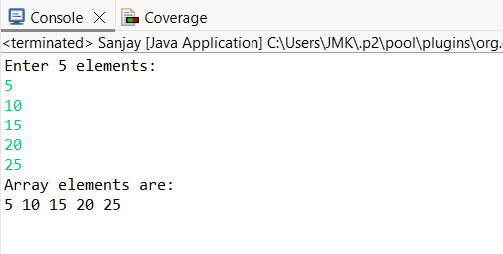

2. Program to Find Sum of Array Elements
Code:
import java.util.Scanner;
public class SumArray {
public static void main(String[] args) {
Scanner sc = new Scanner(System.in);
int[] arr = new int[5];
int sum = 0;
System.out.println("Enter 5 elements:");
for(int i = 0; i < 5; i++)
arr[i] = sc.nextInt();
for(int i = 0; i < 5; i++)
sum += arr[i];
System.out.println("Sum = " + sum);
}
}
OUTPUT:
Input:
5 10 15 20 25
Output:
Sum = 75
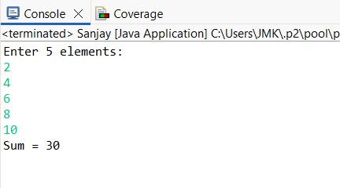

3. Program to Find Largest Element in an Array
Code:
import java.util.Scanner;
public class LargestElement {
public static void main(String[] args) {
Scanner sc = new Scanner(System.in);
int[] arr = new int[5];
System.out.println("Enter 5 elements:");
for(int i = 0; i < 5; i++)
arr[i] = sc.nextInt();
int max = arr[0];
for(int i = 1; i < 5; i++)
if(arr[i] > max)
max = arr[i];
System.out.println("Largest element = " + max);
}
}
OUTPUT:
Input:
12 45 23 9 30
Output:
Largest element = 45
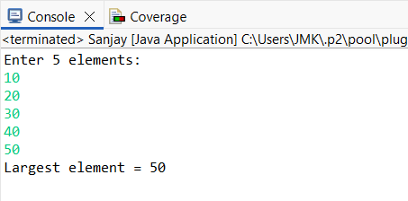
4. Program to Reverse an Array
Code:
import java.util.Scanner;

public class ReverseArray {
public static void main(String[] args) {
Scanner sc = new Scanner(System.in);
int[] arr = new int[5];
System.out.println("Enter 5 elements:");
for(int i = 0; i < 5; i++)
arr[i] = sc.nextInt();
System.out.println("Reversed array:");
for(int i = 4; i >= 0; i--)
System.out.print(arr[i] + " ");
}
}
OUTPUT:
Input:
1 2 3 4 5
Output:
Reversed array:
5 4 3 2 1
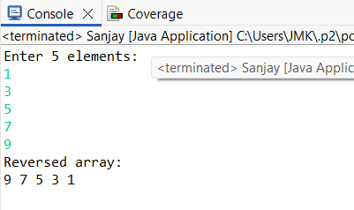
5. Program to Count Even and Odd Numbers
Code:
import java.util.Scanner;
public class EvenOddCount {
public static void main(String[] args) {
Scanner sc = new Scanner(System.in);
int[] arr = new int[5];
int even = 0, odd = 0;
System.out.println("Enter 5 elements:");
for(int i = 0; i < 5; i++)
arr[i] = sc.nextInt();
for(int i = 0; i < 5; i++) {
if(arr[i] % 2 == 0)
even++;
else
odd++;
}

System.out.println("Even = " + even);
System.out.println("Odd = " + odd);
}
}
OUTPUT:
Input:
2 7 4 9 10
Output:
Even = 3
Odd = 2
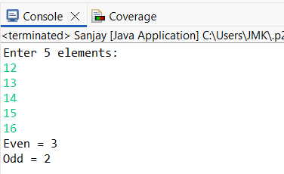
6. Program to Sort Array in Ascending Order
Code:
import java.util.Scanner;
public class SortArray {
public static void main(String[] args) {
Scanner sc = new Scanner(System.in);
int[] arr = new int[5];
int temp;
System.out.println("Enter 5 elements:");
for(int i = 0; i < 5; i++)
arr[i] = sc.nextInt();
for(int i = 0; i < 5; i++) {
for(int j = i + 1; j < 5; j++) {
if(arr[i] > arr[j]) {
temp = arr[i];
arr[i] = arr[j];
arr[j] = temp;
}
}
}
System.out.println("Sorted array:");
for(int i = 0; i < 5; i++)
System.out.print(arr[i] + " ");
}
}
OUTPUT:
Input:
45 12 78 23 9
Output:
Sorted array:
9 12 23 45 78
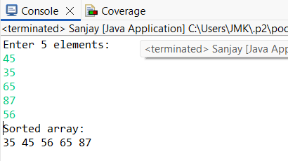
7. Program to Find Second Largest Element
Code:
import java.util.Scanner;
public class SecondLargest {
public static void main(String[] args) {
Scanner sc = new Scanner(System.in);
int[] arr = new int[5];

System.out.println("Enter 5 elements:");
for(int i = 0; i < 5; i++)
arr[i] = sc.nextInt();
int largest = arr[0];
int second = arr[0];
for(int i = 0; i < 5; i++) {
if(arr[i] > largest) {
second = largest;
largest = arr[i];
}
}
System.out.println("Second largest = " + second);
}
}
OUTPUT:
Input:
10 45 23 89 67
Output:
Second largest = 67
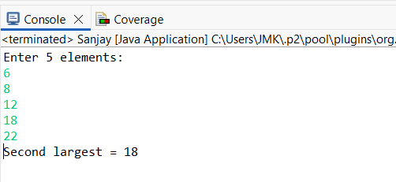

8. Program for Matrix Addition (2D Array)
Code:
import java.util.Scanner;
public class MatrixAddition {
public static void main(String[] args) {
Scanner sc = new Scanner(System.in);
int[][] a = new int[2][2];
int[][] b = new int[2][2];
int[][] sum = new int[2][2];
System.out.println("Enter elements of matrix A:");
for(int i = 0; i < 2; i++)
for(int j = 0; j < 2; j++)
a[i][j] = sc.nextInt();
System.out.println("Enter elements of matrix B:");
for(int i = 0; i < 2; i++)
for(int j = 0; j < 2; j++)
b[i][j] = sc.nextInt();
for(int i = 0; i < 2; i++)
for(int j = 0; j < 2; j++)
sum[i][j] = a[i][j] + b[i][j];
System.out.println("Sum matrix:");
for(int i = 0; i < 2; i++) {
for(int j = 0; j < 2; j++)
System.out.print(sum[i][j] + " ");
System.out.println();
}
}
}
OUTPUT:
Matrix A:
1 2
3 4
Matrix B:
5 6
7 8
Sum matrix:
6 8
10 12
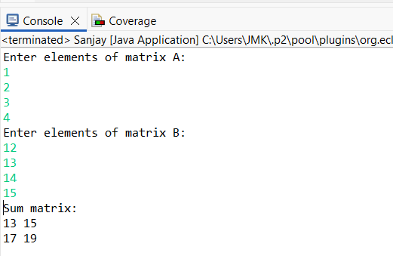

POST LAB EXERCISE
- Why is array indexing usually started from zero instead of one?
Array indexing starts from zero because it directly represents the offset from the first memory location, making access faster and simpler.
- What happens if we try to access an array element outside its declared size?
Accessing an element outside the array size causes undefined behavior, which may lead to incorrect results, errors, or program crashes.
- How does memory allocation differ for static arrays and dynamic arrays?
Static arrays are allocated memory at compile time, while dynamic arrays are allocated memory at runtime using functions like malloc or new.
- Why is searching faster in arrays compared to linked lists?
Arrays allow direct access to elements using index values, whereas linked lists must be traversed sequentially, making searching slower.
- What is the difference between contiguous and non-contiguous memory allocation?
In contiguous allocation, memory locations are stored next to each other, while in non-contiguous allocation, memory locations are scattered and connected using pointers

Result:

Thus the array operations were executed successfully.

ASSESSMENT

Description | Max Marks | Marks Awarded
Pre Lab Exercise | 5
In Lab Exercise | 10
Post Lab Exercise | 5
Viva | 10
Total | 30
Faculty Signature

