aExperiment Number : 02 Date: 28-01-2026

Input and Output Statements in Java
Aim:
To understand and use input and output statements in Java using the Scanner class.
PRE LAB EXERCISE
QUESTIONS
What is input in a program?
-> Input is the data or information that is given to a program by the user or another source so that the program can process it.
Example: Numbers entered through keyboard.

What is output in a program?
-> Output is the result or information produced by a program after processing the input data.
Example: Result displayed on the screen.

Which class is used to read input from the user in Java?
-> The Scanner class is used to read input from the user in Java.
It belongs to the package java.util.
Example:
Scanner sc = new Scanner(System.in);

IN LAB EXERCISE
Objective:
To read input from the user and display the output using Java input and output statements.
INPUT STATEMENT:
SCANNER CLASS
- The Scanner class in Java is used to read input from the user through the keyboard.
It is available in the package java.util.
- The Scanner object reads different types of input such as integer, float, double, and string and stores them in variables.
- To use the Scanner class, it must be imported before using it in the program.
SYNTAX:
- Scanner sc = new Scanner(System.in);
Commonly Used Scanner Methods:
- nextInt() – reads an integer value
- nextFloat() – reads a float value
- nextDouble() – reads a double value
- next() – reads a single word
- nextLine() – reads a complete line of text

PROGRAMS:
Program 1: Read and Display Name
Source Code:
import java.util.Scanner;
class ReadName {
public static void main(String[] args) {
Scanner sc = new Scanner(System.in);
System.out.print("Enter your name: ");
String name = sc.nextLine();
System.out.println("Your name is: " + name);
}
}
Output:
Enter your name: Sanjitha C
Your name is: Sanjitha C
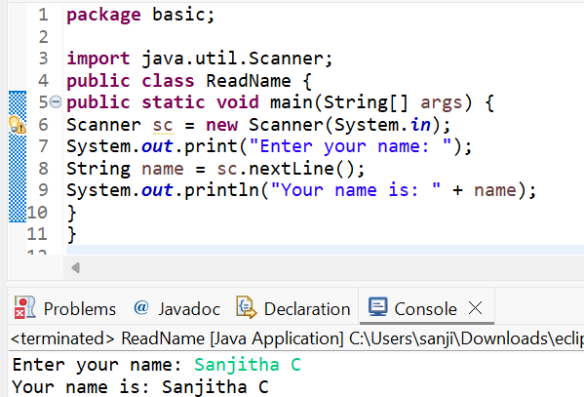
Program 2: Read Two Numbers and Print Sum
Source Code:
import java.util.Scanner;
class SumInput {
public static void main(String[] args) {
Scanner sc = new Scanner(System.in);
System.out.print("Enter first number: ");
int a = sc.nextInt();
System.out.print("Enter second number: ");
int b = sc.nextInt();
int sum = a + b;
System.out.println("Sum = " + sum);
}
}
Output:
Enter first number: 242
Enter second number: 4
Sum = 246
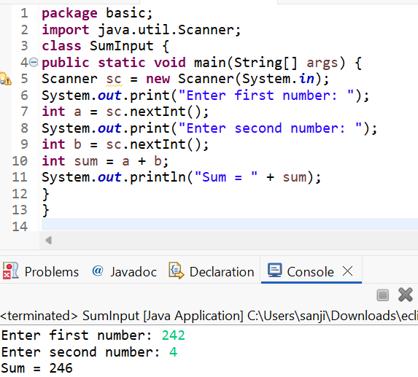
Program 3: Read Length and Breadth and Find Area of Rectangle
Source Code:
import java.util.Scanner;

class AreaRectangleInput {
public static void main(String[] args) {
Scanner sc = new Scanner(System.in);
System.out.print("Enter length: ");
int length = sc.nextInt();
System.out.print("Enter breadth: ");
int breadth = sc.nextInt();
int area = length * breadth;
System.out.println("Area of Rectangle = " + area);
}
}
Output:
Enter length: 10
Enter breadth: 5
Area of Rectangle = 50
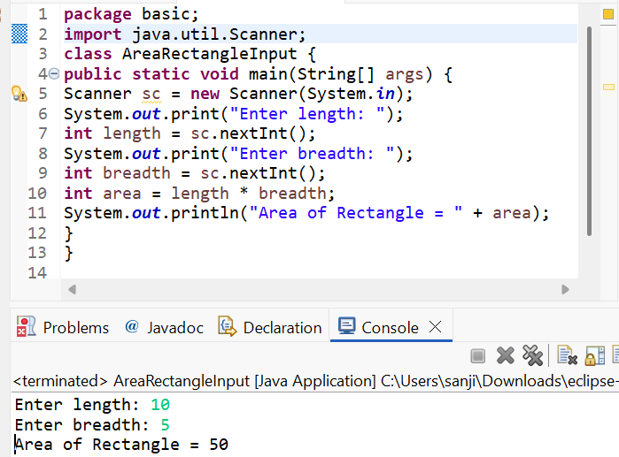

POST LAB EXERCISE
- What is the use of the Scanner class in Java?
The Scanner class is used to take input from the user during program execution.
Example:
Scanner sc = new Scanner(System.in);
int age = sc.nextInt();

- Which package contains the Scanner class?
Scanner class is available in the java.util package.
Example:
import java.util.Scanner;

- What does System.in represent?
System.in represents the standard input stream, which reads input from the keyboard.
Example:
Scanner sc = new Scanner(System.in);

- What does System.out represent?
System.out represents the standard output stream, which is used to display output on the screen.
Example:
System.out.println("Welcome");

- Name any two methods used to read input using Scanner.
Two commonly used Scanner methods are:
- nextInt() – reads an integer
- nextLine() – reads a string line
Example:
int num = sc.nextInt();
String name = sc.nextLine();

- What is the difference between next() and nextLine()?
next()
- Reads only one word
- Stops reading at space
Example:
String word = sc.next();
Input: Hello World
Output: Hello

nextLine()
- Reads the entire line
- Stops at newline
Example:
String line = sc.nextLine();
Input: Hello World
Output: Hello World

Result:

Thus the input was successfully read from the user and the corresponding output was displayed using Java input and output statements.

ASSESSMENT

Description | Max Marks | Marks Awarded
Pre Lab Exercise | 5
In Lab Exercise | 10
Post Lab Exercise | 5
Viva | 10
Total | 30
Faculty Signature

