Experiment Number : 05 Date: 05/02/26

INHERITANCE
Aim:
To understand and implement inheritance concepts in Java.
PRE LAB EXERCISE
QUESTIONS
- What is inheritance?
Inheritance is a mechanism where one class acquires the properties and methods of another class.
- What is code reusability?
Code reusability means using existing code again instead of writing it repeatedly.
- What is the use of extends keyword?
The extends keyword is used to inherit one class into another class.

IN LAB EXERCISE
Objective:
To implement all types of inheritance.
PROGRAMS:
Student Result System (Single Inheritance)
Question:
A school wants to store student details and calculate marks. Create a base class Student and a derived class Result.
Code:
class Student {
String name;
int rollNo;

void getDetails() {
name = "Anitha";
rollNo = 101;
}
}

class Result extends Student {
int marks = 85;

void display() {
System.out.println("Name: " + name);
System.out.println("Roll No: " + rollNo);
System.out.println("Marks: " + marks);
}
}

public class Main {
public static void main(String[] args) {
Result r = new Result();
r.getDetails();
r.display();
}
}
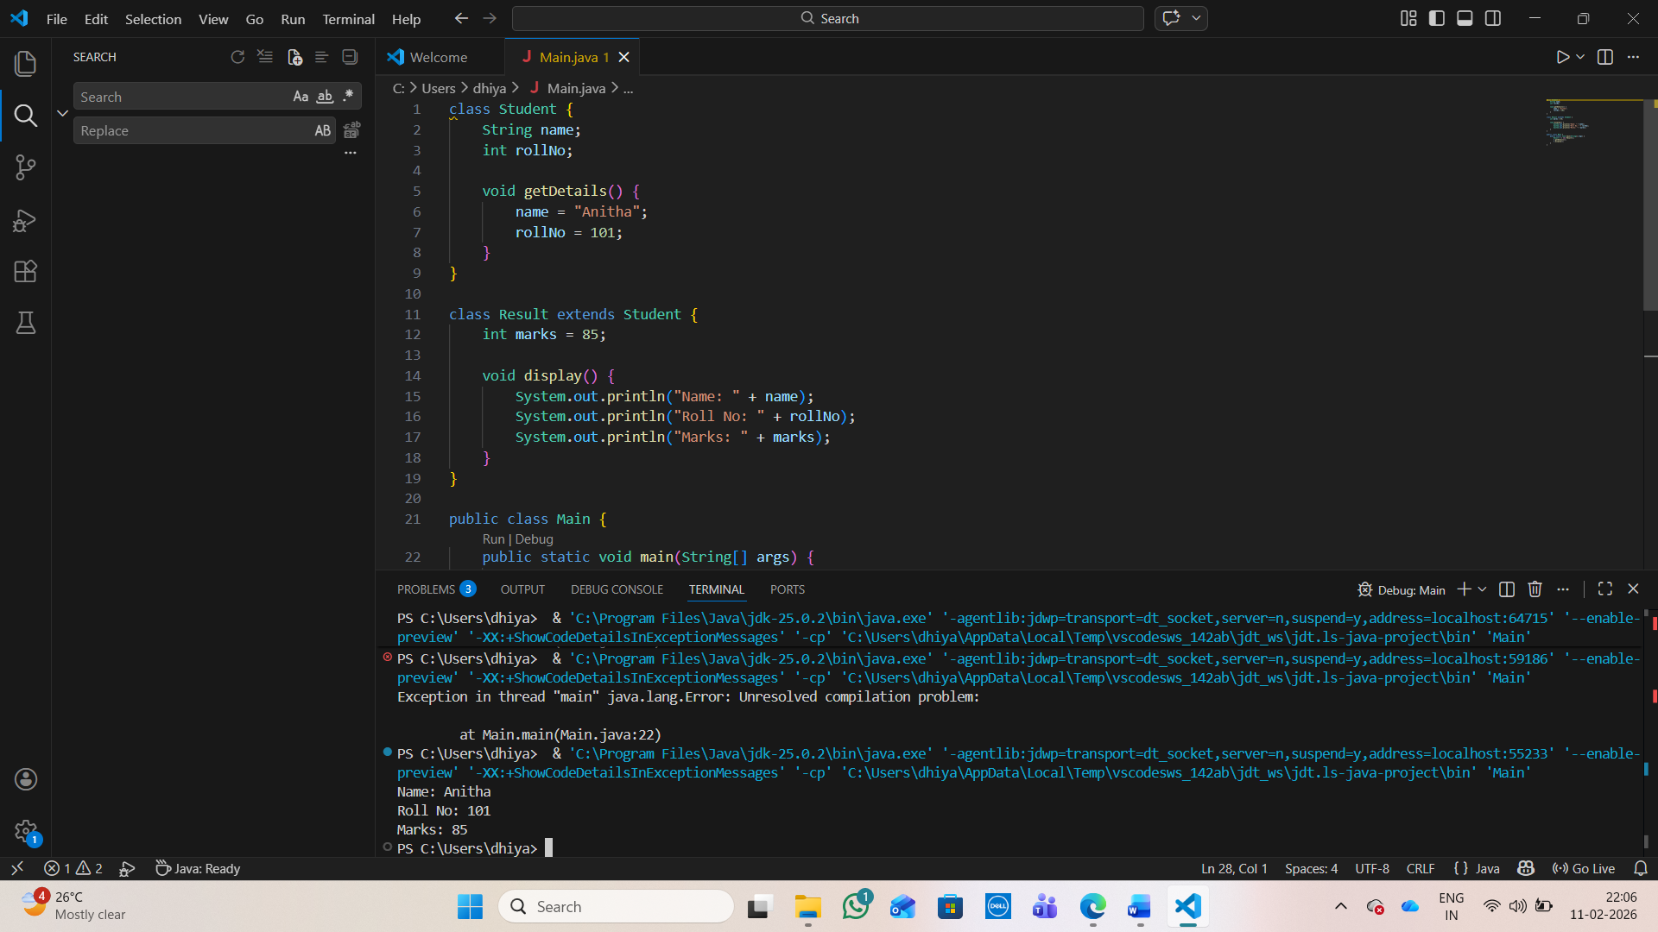

Output:
Name: RAM
Roll No: 101
Marks: 85

2. Bank Account System (Hierarchical Inheritance)
Question:
A bank has Savings and Current accounts. Both inherit from a common Account class.
Code:
class Account {
void showAccountType() {
System.out.println("Bank Account");
}
}

class SavingsAccount extends Account {
void interest() {
System.out.println("Savings Account gives interest");
}
}

class CurrentAccount extends Account {
void overdraft() {
System.out.println("Current Account supports overdraft");
}
}

public class Main {
public static void main(String[] args) {
SavingsAccount s = new SavingsAccount();
CurrentAccount c = new CurrentAccount();

s.showAccountType();
s.interest();

c.showAccountType();
c.overdraft();
}
}
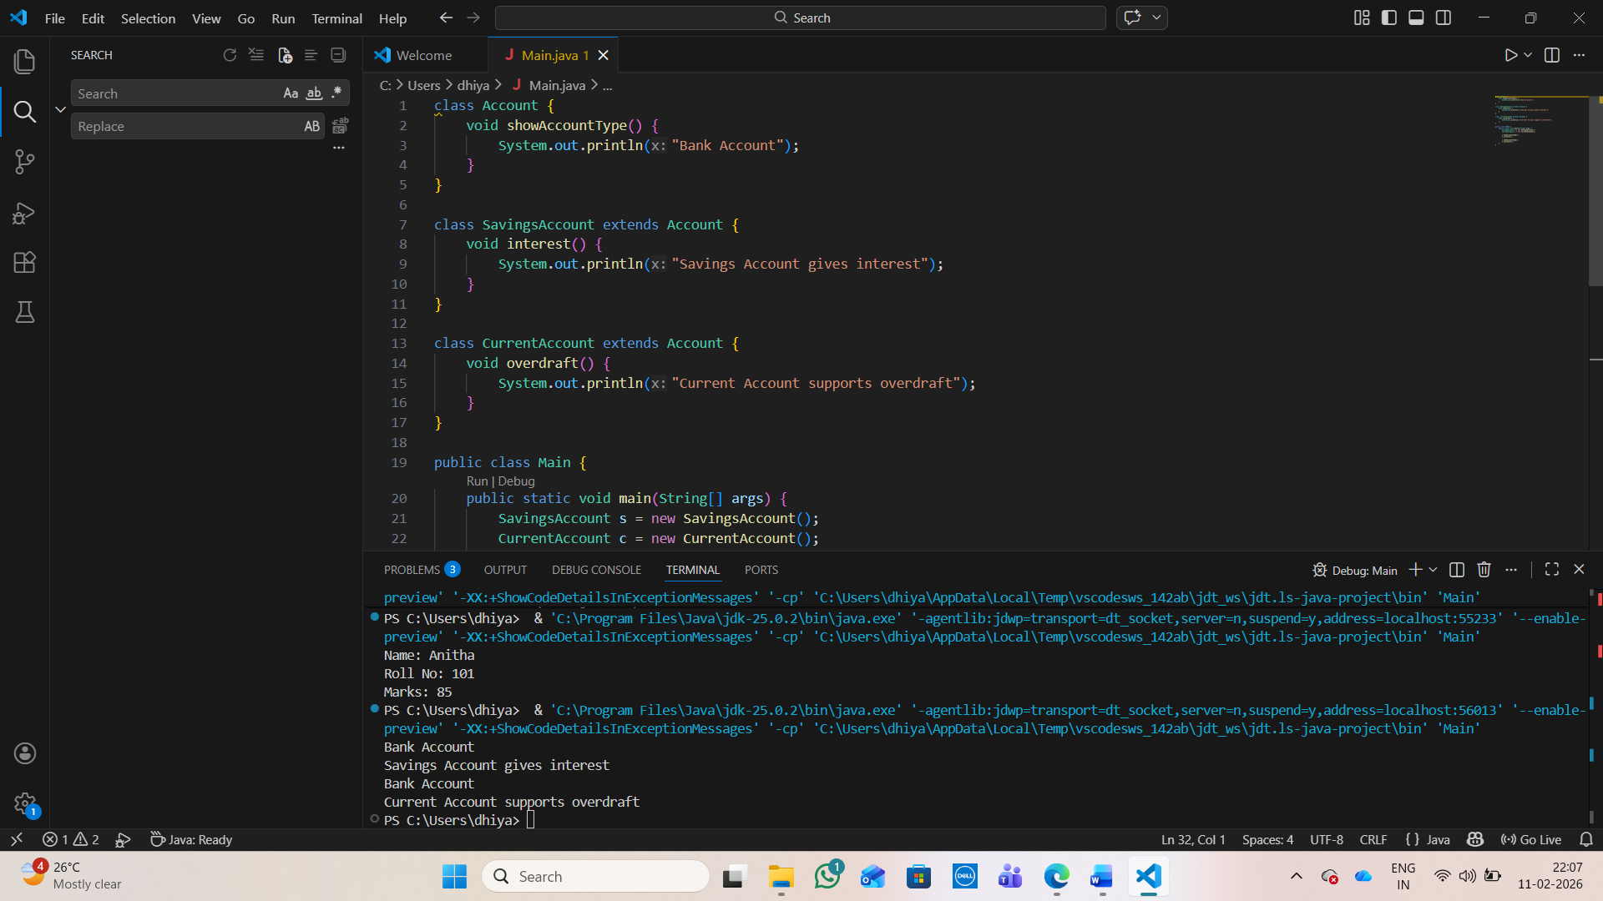

Output:
Bank Account
Savings Account gives interest
Bank Account
Current Account supports overdraft

3. Vehicle System (Multilevel Inheritance)
Question:
A company classifies vehicles as Vehicle → Car → ElectricCar.
Code:
class Vehicle {
void start() {
System.out.println("Vehicle starts");
}
}

class Car extends Vehicle {
void fuelType() {
System.out.println("Car uses petrol");
}
}

class ElectricCar extends Car {
void battery() {
System.out.println("Electric car uses battery");
}
}

public class Main {
public static void main(String[] args) {
ElectricCar e = new ElectricCar();
e.start();
e.fuelType();
e.battery();
}
}
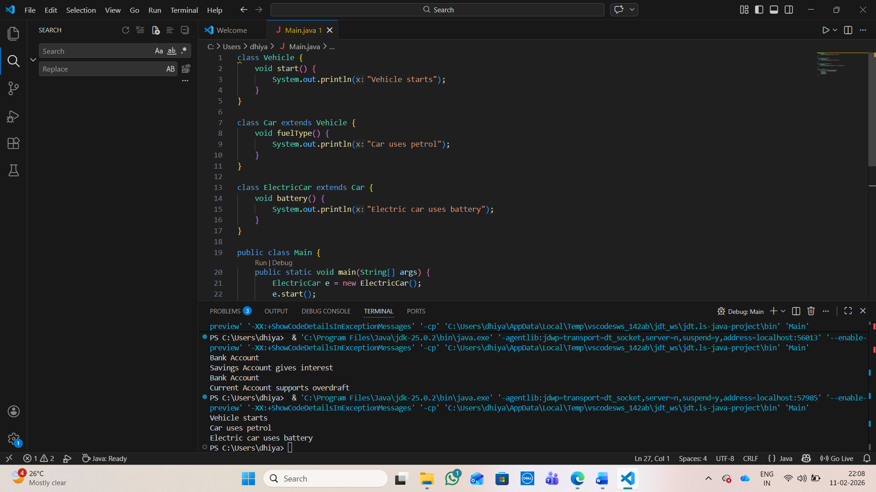

Output:
Vehicle starts
Car uses petrol
Electric car uses battery
POST LAB EXERCISE
- Why Java does not support multiple inheritance using classes and how it is implemented?
Java avoids multiple inheritance with classes to prevent ambiguity (diamond problem). It is implemented using interfaces.
- What is the role of the super keyword? Give examples.
super is used to access parent class variables, methods, and constructors.
Example: super.display();, super(x);
- Can a child class access private members of the parent class? Why?
No, because private members are accessible only within the same class.

- Explain why hybrid inheritance is not supported in Java.
Hybrid inheritance can cause ambiguity and complexity, so Java does not support it using classes.
Result:

Thus the different types of inheritance were implemented and executed successfully.

ASSESSMENT

Description | Max Marks | Marks Awarded
Pre Lab Exercise | 5
In Lab Exercise | 10
Post Lab Exercise | 5
Viva | 10
Total | 30
Faculty Signature

