Experiment Number : 01 Date:

Installation of Java and Simple Java Programs
Aim:
To install Java Development Kit (JDK), configure the environment, and write simple Java programs including Hello World.
PRE LAB EXERCISE
QUESTIONS
- What is JDK and why is it required?
- Using the compiler (javac) to compile Java source code to use the Java runtime to execute Java programs and to supply development tools such as documentation tools and debuggers
- Difference between JDK, JRE, and JVM.
- The Java Development Kit (JDK): JRE, compiler (javac), debugger, and libraries are used in the development of Java applications.

- The Java Runtime Environment, or JRE, is used to run Java programs. It has the JVM and essential libraries, but it is unable to compile code.

- Java Virtual Machine (JVM): Provides platform independence and executes Java bytecode by translating it into machine code.
- What is the purpose of the main() method in Java?
- A Java program cannot run without the main() method, which is the entry point where execution begins.

IN LAB EXERCISE
Objective:
To verify Java installation and execute a basic Java program.
INSTALLATION STEPS:
STEP 1: Open Browser
- Open your browser and go to the official URL Eclipse Downloads page.

STEP 2: Download Eclipse Installer
- Then, click on the "Download" button to download Eclipse IDE.

STEP 3: Download EXE
- Now, click on the "Download x86_64" button.


STEP 4: Then click on the "Download" button. After clicking on the download button the .exe file for the eclipse will be downloaded.



STEP 5: Open Download EXE
- Now go to File Explorer and click on "Downloads" after that click on the "eclipse-inst-jre-win64.exe" file for installing Eclipse IDE.

STEP 6: Install Eclipse
- Then, click on "Eclipse IDE for Java Developers".


STEP 7: Then, click on the "Install" button.


Step 8: Create New Project
Now click on "Create a new Java project".

STEP 9:Create a new java project
- By clicking on the File menu and choosing New → Java Project.
- By right clicking anywhere in the Project Explorer and selecting New → Java Project.
- By clicking on the New button ( ) in the Tool bar and selecting Java Project.
STEP 10: Enter the Project Name
- Select the Java Runtime Environment (JRE) or leave it at the default
- Select the Project Layout which determines whether there would be a separate folder for the source codes and class files. The recommended option is to create separate folders for sources and class files.
- 
STEP 11: Create a new java package
- By clicking on the File menu and selecting New → Package.
- By right click in the package explorer and selecting New → Package.
- By clicking on the package icon which is in the tool bar( ).
STEP 11:
- Enter/confirm the source folder name.
- Enter the package name.
- Click on the Finish button.


STEP 12:Create a New Java class.
- By clicking on the File menu and selecting New → Class.
- By right clicking in the package explorer and selecting New → Class.
- By clicking on the class drop down button ( ) and selecting class ( ).
STEP 13:
- Ensure the source folder and package are correct.
- Enter the class name.
- Select the appropriate class modifier.
- Enter the super class name or click on the Browse button to search for an existing class.
- Click on the Add button to select the interfaces implemented by this class.
- Examine and modify the check boxes related to method stubs and comments.


STEP 14: Class created successfully.

BASIC PROGRAMS:
Program 1: Hello World Program
Source Code:
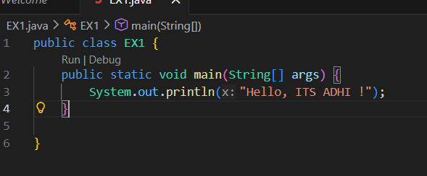
Output:
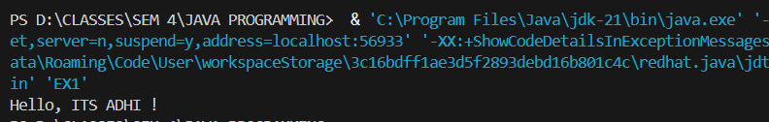Program 2: Display Personal Details
Source Code:
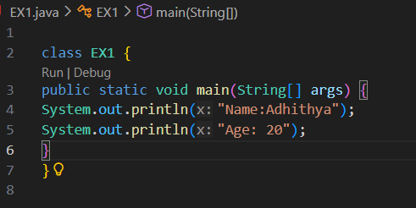
Output:
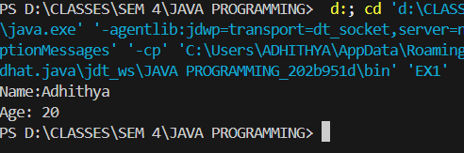
Program 3: Addition of Two Numbers
Source Code:
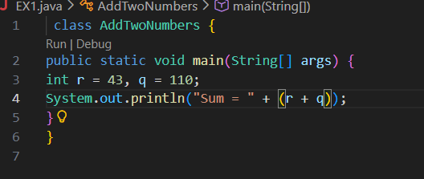

Output:
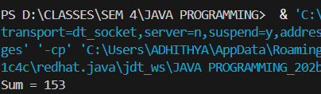
Program 4: Area of a Rectangle
Source Code:
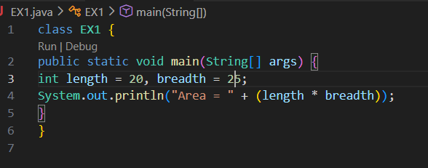
Output:
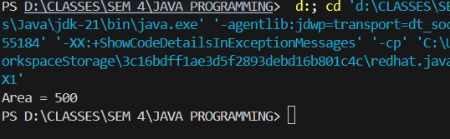
Program 5: Simple Interest Calculation
Source Code:
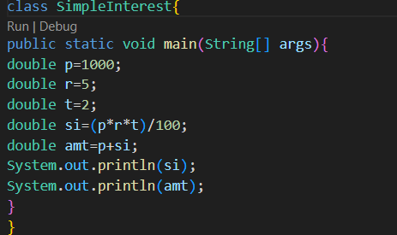
Output:
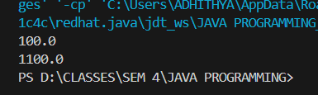

POST LAB EXERCISE
- Write a Java program to display your name and department.
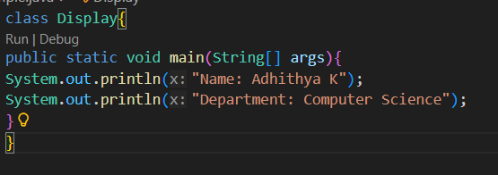
It use uses System.out.println() to print text messages directly to the output screen, with each statement printing on a new line.
- Modify the program to print the output in same line.
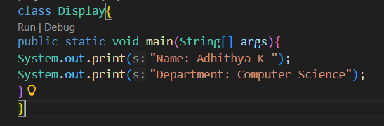
Output : The program uses System.out.print() instead of println() so that multiple outputs appear on the same line.
- What happens if main() is written without static?
The JVM cannot call main() if it is not declared as static, and the program will generate a runtime error stating that the main method is not found.
- Why is Java called platform independent?
Java programs can run on any system with a JVM, regardless of operating system, because they are compiled into bytecode, which makes Java platform independent.
- Write a program to find the cube of a number.
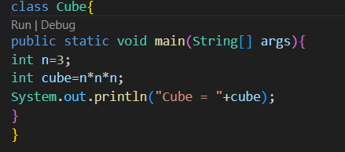
Output: cube =27

Result:

Thus the Java IDE was successfully installed and a simple Java program was executed.

ASSESSMENT

Description | Max Marks | Marks Awarded
Pre Lab Exercise | 5
In Lab Exercise | 10
Post Lab Exercise | 5
Viva | 10
Total | 30
Faculty Signature

