Experiment Number : 03 Date: 27.01.2026

Control Statements in Java
Aim:
To understand and implement decision-making and looping control statements in Java.
PRE LAB EXERCISE
QUESTIONS
- List different control statements in Java.
Control statements in Java are used to control the flow of execution of a program.
They are mainly classified into:
- Selection statements
  - if
  - if-else
  - switch
- Looping (Iteration) statements
  - for
  - while
  - do-while
- Jump statements
  - break
  - continue
  - return

- Difference between for, while, and do-while loops.

Feature | for loop | while loop | do-while loop
Condition check | Before loop | Before loop | After loop
Minimum execution | 0 times | 0 times | At least 1 time
Best used when | Number of iterations is known | Iterations not fixed | Loop must run at least once
Syntax type | Compact | Simple | Simple

- What is the use of break and continue?
break
- Used to terminate the loop or switch statement
- Control moves outside the loop
continue
- Used to skip the current iteration
- Control moves to the next iteration of the loop

IN LAB EXERCISE
Objective:
To implement if-else and looping statements.
INPUT STATEMENT:
SCANNER CLASS
- The Scanner class in Java is used to read input from the user through the keyboard.
It is available in the package java.util.
- The Scanner object reads different types of input such as integer, float, double, and string and stores them in variables.
- To use the Scanner class, it must be imported before using it in the program.
SYNTAX:
- Scanner sc = new Scanner(System.in);
Commonly Used Scanner Methods:
- nextInt() – reads an integer value
- nextFloat() – reads a float value
- nextDouble() – reads a double value
- next() – reads a single word
- nextLine() – reads a complete line of text

PROGRAMS:

Program 1: Check Whether a Number is Positive
class PositiveNumber {
public static void main(String[] args) {
int n = 5;
if (n > 0) {
System.out.println("Positive Number");
}
}
}
Output:
Positive Number
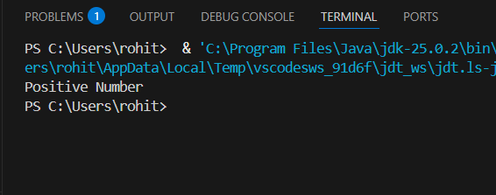
Program 2: Check Whether a Number is Even or Odd
class EvenOdd {
public static void main(String[] args) {
int n = 6;
if (n % 2 == 0)
System.out.println("Even Number");
else
System.out.println("Odd Number");
}
}
Output:
Even Number
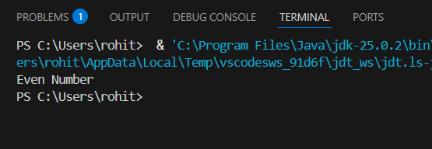
Program 3: Find Largest of Two Numbers
class LargestTwo {
public static void main(String[] args) {
int a = 10, b = 20;
if (a > b)
System.out.println("A is largest");
else
System.out.println("B is largest");
}
}
Output:
B is largest
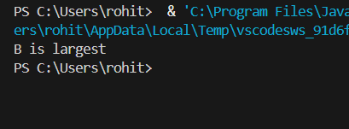

Program 4: Grade Calculation
class Grade {
public static void main(String[] args) {
int marks = 75;
if (marks >= 90)
System.out.println("Grade A");
else if (marks >= 75)
System.out.println("Grade B");
else if (marks >= 50)
System.out.println("Grade C");
else
System.out.println("Fail");
}
}
Output:
Grade B
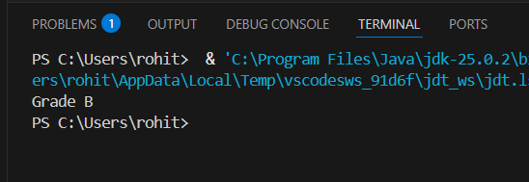
Program 5: Day of the Week
class DaySwitch {
public static void main(String[] args) {
int day = 3;
switch (day) {
case 1: System.out.println("Monday"); break;
case 2: System.out.println("Tuesday"); break;
case 3: System.out.println("Wednesday"); break;
case 4: System.out.println("Thursday"); break;
case 5: System.out.println("Friday"); break;
default: System.out.println("Invalid Day");
}
}
}
Output:
Wednesday
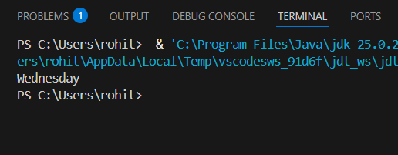
Program 6: Print Numbers from 1 to 5
class ForLoop {
public static void main(String[] args) {
for (int i = 1; i <= 5; i++) {
System.out.println(i);
}
}
}
Output:
1
2
3
4
5
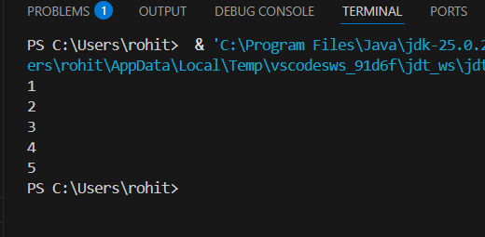

Program 7: Print Numbers from 1 to 5
class WhileLoop {
public static void main(String[] args) {
int i = 1;
while (i <= 5) {
System.out.println(i);
i++;
}
}
}
Output:
1
2
3
4
5
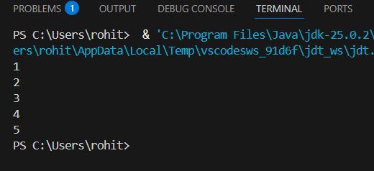

Program 8: Print Numbers from 1 to 5
class DoWhileLoop {
public static void main(String[] args) {
int i = 1;
do {
System.out.println(i);
i++;
} while (i <= 5);
}
}
Output:
1
2
3
4
5


Program 9: Sum of First 5 Natural Numbers
class SumNumbers {
public static void main(String[] args) {
int sum = 0;
for (int i = 1; i <= 5; i++) {
sum = sum + i;
}
System.out.println("Sum = " + sum);
}
}
Output:
Sum = 15
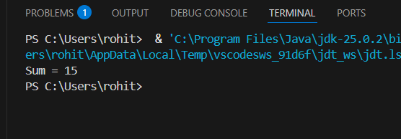
Program 10: Multiplication Table of a Number
class MultiplicationTable {
public static void main(String[] args) {
int n = 5;
for (int i = 1; i <= 10; i++) {
System.out.println(n + " x " + i + " = " + (n * i));
}
}
}
Output:
5 x 1 = 5
5 x 2 = 10
5 x 3 = 15
5 x 4 = 20
5 x 5 = 25
5 x 6 = 30
5 x 7 = 35
5 x 8 = 40
5 x 9 = 45
5 x 10 = 50
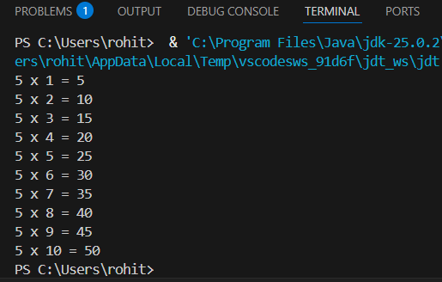
POST LAB EXERCISE
- What is the use of if statement?
The if statement is used to execute a block of code only when a given condition is true.

- Difference between if-else and else-if ladder.

Feature | if-else | else-if ladder
Number of conditions | One condition | Multiple conditions
Execution | Executes either if or else block | Checks conditions one by one
Use case | Simple decision making | Multiple choice decision making

- Why is switch statement used?
The switch statement is used to select one block of code from multiple options based on the value of an expression.
It improves readability and performance compared to multiple else-if statements.

- Difference between for, while, and do-while loops.

Feature | for loop | while loop | do-while loop
Condition check | Before loop | Before loop | After loop
Minimum execution | 0 times | 0 times | At least 1 time
Best used when | Iterations known | Iterations unknown | Must execute once

- Which loop executes at least once?
The do-while loop executes at least once, because the condition is checked after the loop body.

Result:

Thus the different control statements were executed successfully with expected output.

ASSESSMENT

Description | Max Marks | Marks Awarded
Pre Lab Exercise | 5
In Lab Exercise | 10
Post Lab Exercise | 5
Viva | 10
Total | 30
Faculty Signature

