Experiment Number : 06 Date: 5/2/205

ABSTRACT CLASSES
Aim:
To understand and implement inheritance concepts in Java.
PRE LAB EXERCISE
QUESTIONS
- What is an abstract class?
An abstract class is a class that cannot be instantiated and may contain abstract and non-abstract methods.

- Why are abstract methods used?
Abstract methods are used to force child classes to implement the method.

- Difference between abstract class and interface.
Abstract Class | Interface
Can have abstract and concrete methods | Has only abstract methods (by default)
Supports constructors | Does not support constructors
Supports inheritance | Supports multiple inheritance

IN LAB EXERCISE
Objective:
To implement abstract class and demonstrate abstraction.
PROGRAMS:
1.University System
Scenario:
A university has different types of courses: Online, Offline, and Hybrid. Each course has a getDetails() method.
Question:
Create an abstract class Course with abstract method getDetails(). Implement OnlineCourse, OfflineCourse, and HybridCourse classes.
Code:
abstract class Course {
abstract void getDetails();
}

class OnlineCourse extends Course {
void getDetails() {
System.out.println("Online Course: Attend via Internet");
}
}

class OfflineCourse extends Course {
void getDetails() {
System.out.println("Offline Course: Attend in classroom");
}
}

class HybridCourse extends Course {
void getDetails() {
System.out.println("Hybrid Course: Combination of online and offline");
}
}

public class Main {
public static void main(String[] args) {
Course c1 = new OnlineCourse();
Course c2 = new OfflineCourse();
Course c3 = new HybridCourse();

c1.getDetails();
c2.getDetails();
c3.getDetails();
}
}
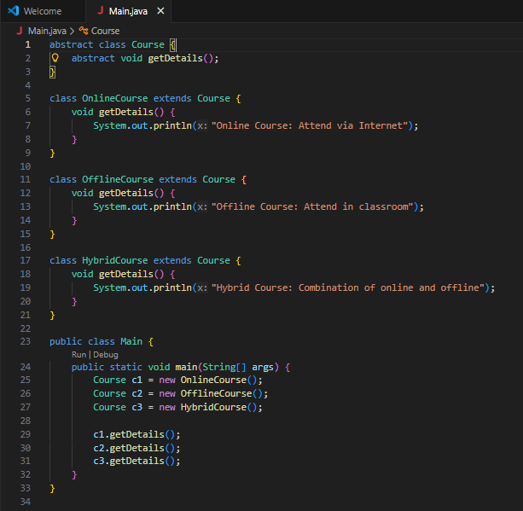
Output:
Online Course: Attend via Internet
Offline Course: Attend in classroom
Hybrid Course: Combination of online and offline
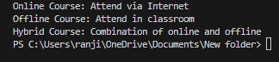

2. Employee Payroll System
Scenario:
A company has different types of employees — Regular and Contract. All employees have a salary, but the calculation differs for each type.
Question:
Design an abstract class Employee with an abstract method calculateSalary(). Implement subclasses RegularEmployee and ContractEmployee to calculate salary differently.
Code:
import java.util.Scanner;
abstract class Employee {
String name;
double baseSalary;

// Abstract method to calculate total salary
abstract void calculateSalary();
}

class RegularEmployee extends Employee {
double bonusRate = 0.1; // 10% bonus

void calculateSalary() {
double totalSalary = baseSalary + (baseSalary * bonusRate);
System.out.println("Regular Employee: " + name);
System.out.println("Base Salary: " + baseSalary);
System.out.println("Total Salary (with 10% bonus): " + totalSalary);
}
}

class ContractEmployee extends Employee {
void calculateSalary() {
System.out.println("Contract Employee: " + name);
System.out.println("Total Salary: " + baseSalary);
}
}

public class Main {
public static void main(String[] args) {
Scanner sc = new Scanner(System.in);

// Input for Regular Employee
System.out.print("Enter Regular Employee Name: ");
String regName = sc.nextLine();
System.out.print("Enter Base Salary: ");
double regSalary = sc.nextDouble();
sc.nextLine(); // Consume newline

// Input for Contract Employee
System.out.print("Enter Contract Employee Name: ");
String conName = sc.nextLine();
System.out.print("Enter Base Salary: ");
double conSalary = sc.nextDouble();

// Create objects
Employee e1 = new RegularEmployee();
e1.name = regName;
e1.baseSalary = regSalary;

Employee e2 = new ContractEmployee();
e2.name = conName;
e2.baseSalary = conSalary;

System.out.println("\n--- Salary Details ---");
e1.calculateSalary();
System.out.println();
e2.calculateSalary();

sc.close();
}
}
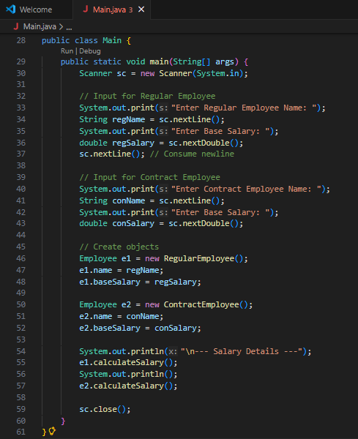
Output:
Enter Regular Employee Name: Ram
Enter Base Salary: 30000
Enter Contract Employee Name: Ravi
Enter Base Salary: 20000

--- Salary Details ---
Regular Employee: Anitha
Base Salary: 30000.0
Total Salary (with 10% bonus): 33000.0

Contract Employee: Ravi
Total Salary: 20000.0

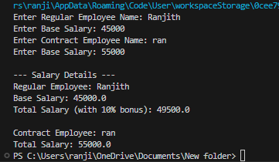

3.Banking System
Scenario:
A bank has different types of accounts: Savings and Current. Both accounts need a method to calculate interest, but the calculation differs for each account type.
Question:
Use an abstract class BankAccount with an abstract method calculateInterest() and implement it in SavingsAccount and CurrentAccount classes.
Code
abstract class BankAccount {
String accountHolder;
double balance;

BankAccount(String name, double bal) {
accountHolder = name;
balance = bal;
}

abstract void calculateInterest(); // Abstract method
}

class SavingsAccount extends BankAccount {
double interestRate = 0.04; // 4% interest

SavingsAccount(String name, double bal) {
super(name, bal);
}

void calculateInterest() {
double interest = balance * interestRate;
System.out.println("Savings Account Interest for " + accountHolder + " = " + interest);
}
}

class CurrentAccount extends BankAccount {
double interestRate = 0.02; // 2% interest

CurrentAccount(String name, double bal) {
super(name, bal);
}

void calculateInterest() {
double interest = balance * interestRate;
System.out.println("Current Account Interest for " + accountHolder + " = " + interest);
}
}

public class Main {
public static void main(String[] args) {
BankAccount acc1 = new SavingsAccount("Ram", 50000);
BankAccount acc2 = new CurrentAccount("Ravi", 80000);

acc1.calculateInterest();
acc2.calculateInterest();
}
}

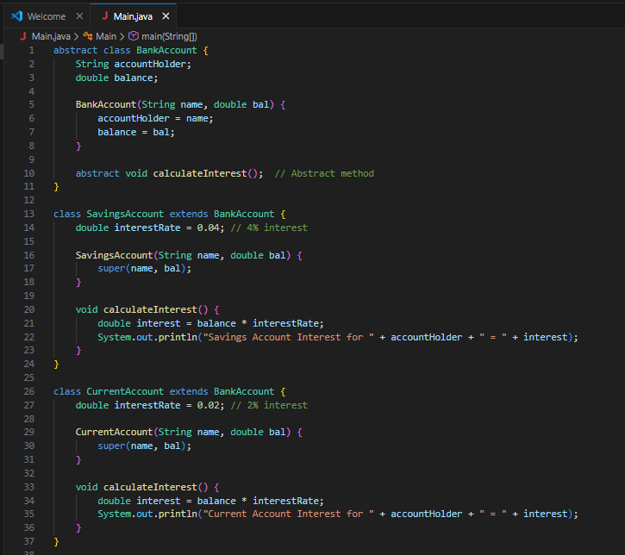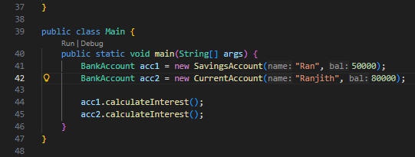
Output
Savings Account Interest for Ram = 2000.0
Current Account Interest for Ravi = 1600.0
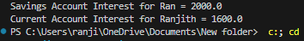

POST LAB EXERCISE
- How is an abstract class different from a regular class?
An abstract class cannot be instantiated and may contain abstract methods, while a regular class can be instantiated.
- Can you create an object of an abstract class? Why or why not?
No, because an abstract class is incomplete and meant to be extended.
- What happens if a subclass does not implement an abstract method?
The subclass must be declared abstract, otherwise a compile-time error occurs.
- Can an abstract class exist without any abstract methods?
Yes, an abstract class can exist without abstract methods.

- Can an abstract class extend another abstract class?
Yes, an abstract class can extend another abstract class.

Result:

Thus the abstract classes and methods were implemented and executed successfully.

ASSESSMENT

Description | Max Marks | Marks Awarded
Pre Lab Exercise | 5
In Lab Exercise | 10
Post Lab Exercise | 5
Viva | 10
Total | 30
Faculty Signature

