Experiment Number : 05 Date: 05/02/2026

INHERITANCE
Aim:
To understand and implement inheritance concepts in Java.
PRE LAB EXERCISE
QUESTIONS
- What is inheritance?
Inheritance is an OOP concept where one class acquires the properties and methods of another class.
- What is code reusability?
Code reusability means using the same code again in different programs or classes, reducing duplication and saving time.

- What is the use of extends keyword?
The extends keyword is used to inherit one class into another class, allowing the child class to access parent class members.

IN LAB EXERCISE
Objective:
To implement all types of inheritance.
PROGRAMS:
Student Result System (Single Inheritance)
Question:
A school wants to store student details and calculate marks. Create a base class Student and a derived class Result.
Code:
class Student {
String name;
int rollNo;

void getDetails() {
name = "Anitha";
rollNo = 101;
}
}

class Result extends Student {
int marks = 85;

void display() {
System.out.println("Name: " + name);
System.out.println("Roll No: " + rollNo);
System.out.println("Marks: " + marks);
}
}

public class Main {
public static void main(String[] args) {
Result r = new Result();
r.getDetails();
r.display();
}
}
Output:
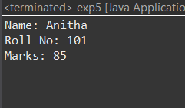
2. Bank Account System (Hierarchical Inheritance)
Question:
A bank has Savings and Current accounts. Both inherit from a common Account class.
Code:
class Account {
void showAccountType() {
System.out.println("Bank Account");
}
}

class SavingsAccount extends Account {
void interest() {
System.out.println("Savings Account gives interest");
}
}

class CurrentAccount extends Account {
void overdraft() {
System.out.println("Current Account supports overdraft");
}
}

public class Main {
public static void main(String[] args) {
SavingsAccount s = new SavingsAccount();
CurrentAccount c = new CurrentAccount();

s.showAccountType();
s.interest();

c.showAccountType();
c.overdraft();
}
}

Output:
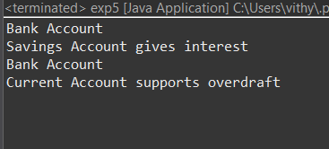
3. Vehicle System (Multilevel Inheritance)
Question:
A company classifies vehicles as Vehicle → Car → ElectricCar.
Code:
class Vehicle {
void start() {
System.out.println("Vehicle starts");
}
}

class Car extends Vehicle {
void fuelType() {
System.out.println("Car uses petrol");
}
}

class ElectricCar extends Car {
void battery() {
System.out.println("Electric car uses battery");
}
}

public class Main {
public static void main(String[] args) {
ElectricCar e = new ElectricCar();
e.start();
e.fuelType();
e.battery();
}
}
Output:
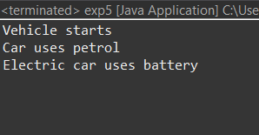
POST LAB EXERCISE
- Why Java does not support multiple inheritance using classes and how it is implemented?
Java avoids multiple inheritance using classes to prevent ambiguity (Diamond Problem).
It is implemented using interfaces.
- What is the role of the super keyword? Give examples.
super is used to access parent class variables, methods, and constructors.

- Can a child class access private members of the parent class? Why?
No. Private members are accessible only within the same class and are not inherited.

- Explain why hybrid inheritance is not supported in Java.
Hybrid inheritance is not supported using classes due to ambiguity and complexity, but it is possible using interfaces.

Result:

Thus the different types of inheritance were implemented and executed successfully.

ASSESSMENT

Description | Max Marks | Marks Awarded
Pre Lab Exercise | 5
In Lab Exercise | 10
Post Lab Exercise | 5
Viva | 10
Total | 30
Faculty Signature

