Experiment Number : 03 Date: 28/01/2026

Control Statements in Java
Aim:
To understand and implement decision-making and looping control statements in Java.
PRE LAB EXERCISE
QUESTIONS
- List different control statements in Java.

Control statements in Java are used to control the flow of execution of a program.
They include selection statements, iteration statements, and jump statements.

- Difference between for, while, and do-while loops.

The for loop is used when the number of iterations is known in advance, while the while loop is used when the condition is checked before each iteration.
The do-while loop executes the loop body at least once because the condition is checked after execution.

- What is the use of break and continue?

The break statement is used to terminate a loop or switch statement immediately.
The continue statement is used to skip the current iteration and move to the next iteration of the loop.

IN LAB EXERCISE
Objective:
To implement if-else and looping statements.
INPUT STATEMENT:
SCANNER CLASS
- The Scanner class in Java is used to read input from the user through the keyboard.
It is available in the package java.util.
- The Scanner object reads different types of input such as integer, float, double, and string and stores them in variables.
- To use the Scanner class, it must be imported before using it in the program.
SYNTAX:
- Scanner sc = new Scanner(System.in);
Commonly Used Scanner Methods:
- nextInt() – reads an integer value
- nextFloat() – reads a float value
- nextDouble() – reads a double value
- next() – reads a single word
- nextLine() – reads a complete line of text

PROGRAMS:
Program 1: Check Whether a Number is Positive
class PositiveNumber {
public static void main(String[] args) {
int n = 5;
if (n > 0) {
System.out.println("Positive Number");
}
}
}
Output:
Positive Number
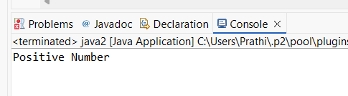

Program 2: Check Whether a Number is Even or Odd
class EvenOdd {
public static void main(String[] args) {
int n = 6;
if (n % 2 == 0)
System.out.println("Even Number");
else
System.out.println("Odd Number");
}
}
Output:
Even Number
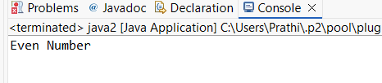
Program 3: Find Largest of Two Numbers
class LargestTwo {
public static void main(String[] args) {
int a = 10, b = 20;
if (a > b)
System.out.println("A is largest");
else
System.out.println("B is largest");
}
}
Output:
B is largest
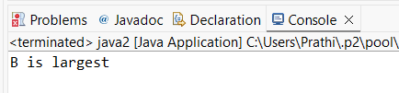
Program 4: Grade Calculation
class Grade {
public static void main(String[] args) {
int marks = 75;
if (marks >= 90)
System.out.println("Grade A");
else if (marks >= 75)
System.out.println("Grade B");
else if (marks >= 50)
System.out.println("Grade C");
else
System.out.println("Fail");
}
}
Output:
Grade B
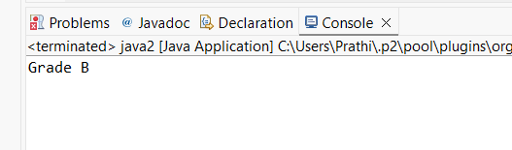
Program 5: Day of the Week
class DaySwitch {
public static void main(String[] args) {
int day = 3;
switch (day) {
case 1: System.out.println("Monday"); break;
case 2: System.out.println("Tuesday"); break;
case 3: System.out.println("Wednesday"); break;
case 4: System.out.println("Thursday"); break;
case 5: System.out.println("Friday"); break;
default: System.out.println("Invalid Day");
}
}
}
Output:
Wednesday
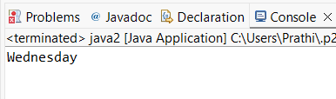
Program 6: Print Numbers from 1 to 5
class ForLoop {
public static void main(String[] args) {
for (int i = 1; i <= 5; i++) {
System.out.println(i);
}
}
}
Output:
1
2
3
4
5

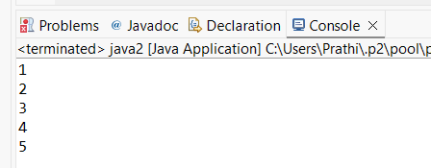

Program 7: Print Numbers from 1 to 5
class WhileLoop {
public static void main(String[] args) {
int i = 1;
while (i <= 5) {
System.out.println(i);
i++;
}
}
}
Output:
1
2
3
4
5
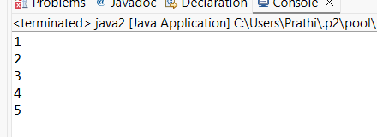

Program 8: Print Numbers from 1 to 5
class DoWhileLoop {
public static void main(String[] args) {
int i = 1;
do {
System.out.println(i);
i++;
} while (i <= 5);
}
}
Output:
1
2
3
4
5
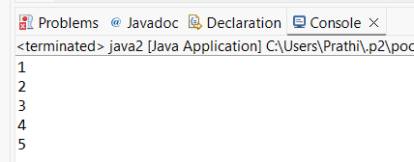

Program 9: Sum of First 5 Natural Numbers
class SumNumbers {
public static void main(String[] args) {
int sum = 0;
for (int i = 1; i <= 5; i++) {
sum = sum + i;
}
System.out.println("Sum = " + sum);
}
}
Output:
Sum = 15
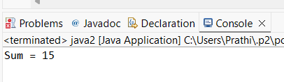
Program 10: Multiplication Table of a Number
class MultiplicationTable {
public static void main(String[] args) {
int n = 5;
for (int i = 1; i <= 10; i++) {
System.out.println(n + " x " + i + " = " + (n * i));
}
}
}
Output:
5 x 1 = 5
5 x 2 = 10
5 x 3 = 15
5 x 4 = 20
5 x 5 = 25
5 x 6 = 30
5 x 7 = 35
5 x 8 = 40
5 x 9 = 45
5 x 10 = 50
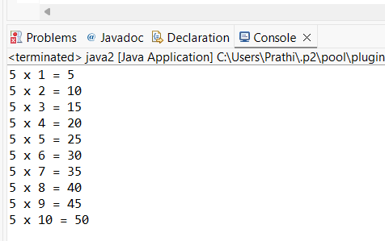

POST LAB EXERCISE
- What is the use of if statement?

The if statement is used to test a condition in a program.
It executes a block of code only when the condition is true.

- Difference between if-else and else-if ladder.

The if-else statement is used to choose between two conditions, whereas the else-if ladder is used to check multiple conditions.
In an else-if ladder, only the first true condition is executed.

- Why is switch statement used?

The switch statement is used to execute one block of code from many possible options.
It is mainly used when comparing a variable with multiple constant values.

- Difference between for, while, and do-while loops.

The for loop is used when the number of iterations is known, while the while loop checks the condition before execution.
The do-while loop executes first and then checks the condition, so it runs at least once.

- Which loop executes at least once?

The do-while loop executes at least once.
This is because the condition is checked only after the loop body is executed.

Result:

Thus the different control statements were executed successfully with expected output.

ASSESSMENT

Description | Max Marks | Marks Awarded
Pre Lab Exercise | 5
In Lab Exercise | 10
Post Lab Exercise | 5
Viva | 10
Total | 30
Faculty Signature

