Experiment Number : 04 Date: 05-02-2025

ARRAYS
Aim:
To understand and implement array operations in Java.
PRE LAB EXERCISE
QUESTIONS
1.What is an array?
An array is a data structure that stores multiple values of the same data type under a single name, and each value is accessed using an index.
Example:
int marks[5] = {80, 75, 90, 85, 70};

2.Why are arrays used?
Arrays are used because they:
- Store many related values using one variable name
- Make programs shorter and easier to manage
- Allow easy access to data using index positions
- Are useful for loops, searching, sorting, and calculations
- Improve memory organization

3.What is the difference between array and variable?
Feature | Variable | Array
Stores | Single value | Multiple values
Data type | One value of a type | Multiple values of same type
Memory | One memory location | Continuous memory locations
Access | By variable name | By index (e.g., a[0])
Example | int x = 10; | int a[3] = {1,2,3};

IN LAB EXERCISE
Objective:
To perform array operations using simple programs.
PROGRAMS:
1. Program to Read and Print Array Elements
Code:
import java.util.Scanner;
public class ReadPrintArray {
public static void main(String[] args) {
Scanner sc = new Scanner(System.in);
int[] arr = new int[5];
System.out.println("Enter 5 elements:");
for(int i = 0; i < 5; i++)
arr[i] = sc.nextInt();
System.out.println("Array elements are:");
for(int i = 0; i < 5; i++)
System.out.print(arr[i] + " ");
}
}
OUTPUT:
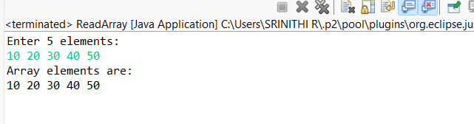
2. Program to Find Sum of Array Elements
Code:
import java.util.Scanner;
public class SumArray {
public static void main(String[] args) {
Scanner sc = new Scanner(System.in);
int[] arr = new int[5];
int sum = 0;
System.out.println("Enter 5 elements:");
for(int i = 0; i < 5; i++)
arr[i] = sc.nextInt();
for(int i = 0; i < 5; i++)
sum += arr[i];
System.out.println("Sum = " + sum);
}
}
OUTPUT:
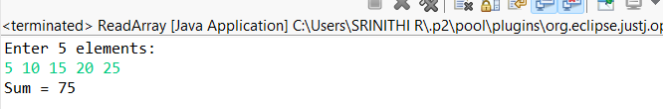
3. Program to Find Largest Element in an Array
Code:
import java.util.Scanner;
public class LargestElement {
public static void main(String[] args) {
Scanner sc = new Scanner(System.in);
int[] arr = new int[5];
System.out.println("Enter 5 elements:");
for(int i = 0; i < 5; i++)
arr[i] = sc.nextInt();
int max = arr[0];
for(int i = 1; i < 5; i++)
if(arr[i] > max)
max = arr[i];
System.out.println("Largest element = " + max);
}
}
OUTPUT:
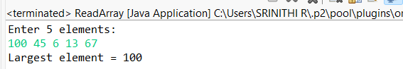
4. Program to Reverse an Array
Code:
import java.util.Scanner;

public class ReverseArray {
public static void main(String[] args) {
Scanner sc = new Scanner(System.in);
int[] arr = new int[5];
System.out.println("Enter 5 elements:");
for(int i = 0; i < 5; i++)
arr[i] = sc.nextInt();
System.out.println("Reversed array:");
for(int i = 4; i >= 0; i--)
System.out.print(arr[i] + " ");
}
}
OUTPUT:
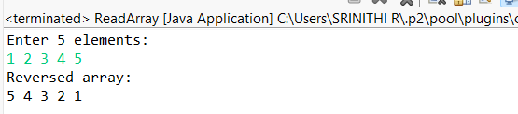
5. Program to Count Even and Odd Numbers
Code:
import java.util.Scanner;
public class EvenOddCount {
public static void main(String[] args) {
Scanner sc = new Scanner(System.in);
int[] arr = new int[5];
int even = 0, odd = 0;
System.out.println("Enter 5 elements:");
for(int i = 0; i < 5; i++)
arr[i] = sc.nextInt();
for(int i = 0; i < 5; i++) {
if(arr[i] % 2 == 0)
even++;
else
odd++;
}

System.out.println("Even = " + even);
System.out.println("Odd = " + odd);
}
}
OUTPUT:
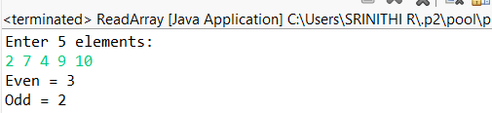
6. Program to Sort Array in Ascending Order
Code:
import java.util.Scanner;
public class SortArray {
public static void main(String[] args) {
Scanner sc = new Scanner(System.in);
int[] arr = new int[5];
int temp;
System.out.println("Enter 5 elements:");
for(int i = 0; i < 5; i++)
arr[i] = sc.nextInt();
for(int i = 0; i < 5; i++) {
for(int j = i + 1; j < 5; j++) {
if(arr[i] > arr[j]) {
temp = arr[i];
arr[i] = arr[j];
arr[j] = temp;
}
}
}
System.out.println("Sorted array:");
for(int i = 0; i < 5; i++)
System.out.print(arr[i] + " ");
}
}
OUTPUT:
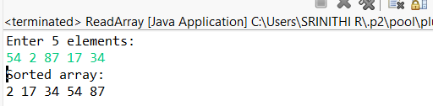
7. Program to Find Second Largest Element
Code:
import java.util.Scanner;
public class SecondLargest {
public static void main(String[] args) {
Scanner sc = new Scanner(System.in);
int[] arr = new int[5];
System.out.println("Enter 5 elements:");
for (int i = 0; i < 5; i++) {
arr[i] = sc.nextInt();
}
int largest = Integer.MIN_VALUE;
int second = Integer.MIN_VALUE;
for (int i = 0; i < 5; i++) {
if (arr[i] > largest) {
second = largest;
largest = arr[i];
} else if (arr[i] > second && arr[i] != largest) {
second = arr[i];
}
}
if (second == Integer.MIN_VALUE) {
System.out.println("No second largest element");
} else {
System.out.println("Second largest = " + second);
}
}
}
OUTPUT:
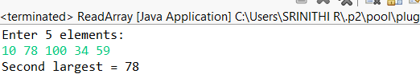
8. Program for Matrix Addition (2D Array)
Code:
import java.util.Scanner;
public class MatrixAddition {
public static void main(String[] args) {
Scanner sc = new Scanner(System.in);
int[][] a = new int[2][2];
int[][] b = new int[2][2];
int[][] sum = new int[2][2];
System.out.println("Enter elements of matrix A:");
for(int i = 0; i < 2; i++)
for(int j = 0; j < 2; j++)
a[i][j] = sc.nextInt();
System.out.println("Enter elements of matrix B:");
for(int i = 0; i < 2; i++)
for(int j = 0; j < 2; j++)
b[i][j] = sc.nextInt();
for(int i = 0; i < 2; i++)
for(int j = 0; j < 2; j++)
sum[i][j] = a[i][j] + b[i][j];
System.out.println("Sum matrix:");
for(int i = 0; i < 2; i++) {
for(int j = 0; j < 2; j++)
System.out.print(sum[i][j] + " ");
System.out.println();
}
}
}
OUTPUT:
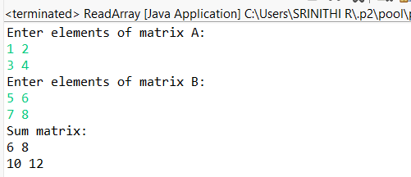

POST LAB EXERCISE
1.Why is array indexing usually started from zero instead of one?
Array indexing starts from zero because:
- The index represents the offset from the starting memory address
- The first element is at offset 0, so index = 0
- This makes address calculation faster and simpler for the system

2.What happens if we try to access an array element outside its declared size?
• It causes undefined behavior
• The program may:
- Produce wrong output
- Crash or throw an error
- Access unintended memory
• In some languages (like Java, Python), it throws a runtime error
- Example: ArrayIndexOutOfBoundsException

3.How does memory allocation differ for static arrays and dynamic arrays?
Static Array | Dynamic Array
Size fixed at compile time | Size decided at runtime
Memory allocated in stack | Memory allocated in heap
Cannot be resized | Can be resized
Faster access | Slightly slower due to overhead
Example: int a[10]; | int* a = malloc(10*sizeof(int));

4.Why is searching faster in arrays compared to linked lists?
• Arrays support direct access using index
• Binary search can be applied (if sorted)
• Linked lists require sequential traversal
• Hence, arrays offer faster searching

5.What is the difference between contiguous and non-contiguous memory allocation?
Contiguous Memory | Non-Contiguous Memory
Memory blocks are consecutive | Memory blocks are scattered
Faster access | Slower access
Used in arrays | Used in linked lists
Simple address calculation | Needs pointers
Example: Array | Example: Linked List

Result:

Thus the array operations were executed successfully.

ASSESSMENT

Description | Max Marks | Marks Awarded
Pre Lab Exercise | 5
In Lab Exercise | 10
Post Lab Exercise | 5
Viva | 10
Total | 30
Faculty Signature

