Experiment Number : 07 Date: 05-02-2026

METHOD OVERLOADING AND METHOD OVERRIDING
Aim:
To understand and implement method overloading and method overriding.
PRE LAB EXERCISE
QUESTIONS
1.What is method overloading?
- Method overloading means having multiple methods with the same name in the same class, but with different parameters (number, type, or order).
- It is an example of compile-time polymorphism.
2.What is method overriding?
- Method overriding occurs when a subclass provides a specific implementation of a method already defined in its parent class, with the same method signature.
- It is an example of runtime polymorphism.
3.Difference between overloading and overriding.
Feature | Method Overloading | Method Overriding
Occurs in | Same class | Parent–child classes
Method name | Same | Same
Parameters | Must be different | Must be same
Return type | Can be same or different | Must be same (or covariant)
Polymorphism | Compile-time | Runtime
Inheritance | Not required | Required

IN LAB EXERCISE
Objective:
To demonstrate compile-time and runtime polymorphism.
PROGRAMS:
1.Student Result System (Method Overriding)
Description:
- Base class Student has method displayResult().
- Subclasses UGStudent and PGStudent override the method to show different grading systems.

Code :
import java.util.Scanner;

// Base class
class Student {
String name;

void displayResult() {
System.out.println("Student Result");
}
}

// UG Student subclass
class UGStudent extends Student {
int marks;

UGStudent(String n, int m) {
name = n;
marks = m;
}

@Override
void displayResult() {
double percentage = (marks / 100.0) * 100;
System.out.println("UG Student: " + name);
System.out.println("Marks: " + marks);
System.out.println("Percentage: " + percentage + "%");
}
}

// PG Student subclass
class PGStudent extends Student {
double gpa;

PGStudent(String n, double g) {
name = n;
gpa = g;
}

@Override
void displayResult() {
System.out.println("PG Student: " + name);
System.out.println("GPA: " + gpa + " / 10");
}
}

// Main class
public class Main {
public static void main(String[] args) {
Scanner sc = new Scanner(System.in);

// Input for UG student
System.out.print("Enter UG Student Name: ");
String ugName = sc.nextLine();
System.out.print("Enter UG Student Marks (out of 100): ");
int ugMarks = sc.nextInt();
sc.nextLine(); // consume newline

// Input for PG student
System.out.print("Enter PG Student Name: ");
String pgName = sc.nextLine();
System.out.print("Enter PG Student GPA (0-10): ");
double pgGpa = sc.nextDouble();

// Create objects
Student s1 = new UGStudent(ugName, ugMarks);
Student s2 = new PGStudent(pgName, pgGpa);

System.out.println("\n--- Student Results ---");
s1.displayResult();
System.out.println();
s2.displayResult();

sc.close();
}
}
OUTPUT:
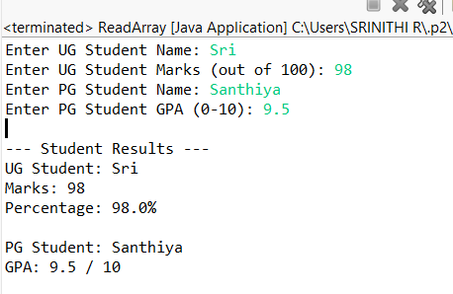
2. Calculator Program (Method Overloading)
Description:
Create a Calculator class with multiple add() methods to calculate:
- Addition of 2 integers
- Addition of 3 integers
- Addition of 2 double numbers
Code:
import java.util.Scanner;
class Calculator {
int add(int a, int b) {
return a + b;
}

int add(int a, int b, int c) {
return a + b + c;
}

double add(double a, double b) {
return a + b;
}
}
public class Main {
public static void main(String[] args) {
Scanner sc = new Scanner(System.in);
Calculator calc = new Calculator();

System.out.print("Enter two integers: ");
int x = sc.nextInt();
int y = sc.nextInt();
System.out.println("Sum of two integers: " + calc.add(x, y));

System.out.print("Enter three integers: ");
int p = sc.nextInt();
int q = sc.nextInt();
int r = sc.nextInt();
System.out.println("Sum of three integers: " + calc.add(p, q, r));

System.out.print("Enter two decimal numbers: ");
double a = sc.nextDouble();
double b = sc.nextDouble();
System.out.println("Sum of two doubles: " + calc.add(a, b));

sc.close();
}
}
Output:
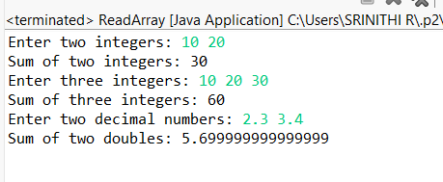
POST LAB EXERCISE
1.Is return type important in method overloading and method overriding?
- Method Overloading:
Return type alone is NOT important
Overloading depends on parameter list
- Method Overriding:
Return type must be same or covariant (subclass type)
2.Can you overload a method by changing only the return type?
No, changing only the return type does not overload a method.
Why?
Java identifies methods using method signature (name + parameters), not return type.
int show() { }
double show() { }
3.Can static methods be overridden? Can they be overloaded?
- Static methods cannot be overridden
- They can be overloaded
🔹 Static methods belong to the class, not to objects
🔹 Method hiding happens, not overriding
static void display(int a) { }
static void display(int a, int b) { }
4.Can a method be overridden if the parameter list is different?
No, a method cannot be overridden if the parameter list is different.
✔ Same parameter list → Overriding
✔ Different parameter list → Overloading

Result:
Thus the method overloading and overriding concepts were implemented and executed successfully.
ASSESSMENT

Description | Max Marks | Marks Awarded
Pre Lab Exercise | 5
In Lab Exercise | 10
Post Lab Exercise | 5
Viva | 10
Total | 30
Faculty Signature

