Experiment Number : 03 Date: 29/01/2025

Control Statements in Java
Aim:
To understand and implement decision-making and looping control statements in Java.
PRE LAB EXERCISE
QUESTIONS
- List different control statements in Java.
  - Decision-making statements: if, if-else, else-if, switch
  - Looping statements: for, while, do-while
  - Jump statements: break, continue, return

- Difference between for, while, and do-while loops.
Loop | Description
for loop | Used when the number of iterations is known in advance
while loop | Used when the number of iterations is not known
do-while loop | Executes the loop body at least once before checking the condition

- What is the use of break and continue?
• break: Terminates the loop or switch statement immediately.
• continue: Skips the current iteration and continues with the next iteration.

IN LAB EXERCISE
Objective:
To implement if-else and looping statements.
INPUT STATEMENT:
SCANNER CLASS
- The Scanner class in Java is used to read input from the user through the keyboard.
It is available in the package java.util.
- The Scanner object reads different types of input such as integer, float, double, and string and stores them in variables.
- To use the Scanner class, it must be imported before using it in the program.
SYNTAX:
- Scanner sc = new Scanner(System.in);
Commonly Used Scanner Methods:
- nextInt() – reads an integer value
- nextFloat() – reads a float value
- nextDouble() – reads a double value
- next() – reads a single word
- nextLine() – reads a complete line of text

PROGRAMS:
Program 1: Check Whether a Number is Positive
class PositiveNumber {
public static void main(String[] args) {
int n = 5;
if (n > 0) {
System.out.println("Positive Number");
}
}
}
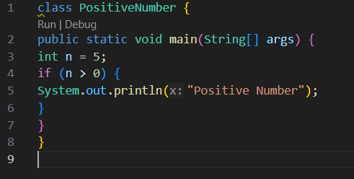
Output:
Positive Number
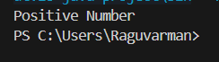
Program 2: Check Whether a Number is Even or Odd
class EvenOdd {
public static void main(String[] args) {
int n = 6;
if (n % 2 == 0)
System.out.println("Even Number");
else
System.out.println("Odd Number");
}
}
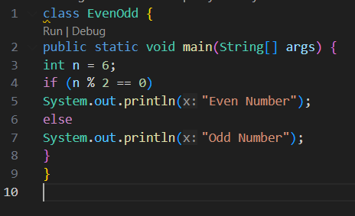
Output:
Even Number
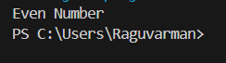
Program 3: Find Largest of Two Numbers
class LargestTwo {
public static void main(String[] args) {
int a = 10, b = 20;
if (a > b)
System.out.println("A is largest");
else
System.out.println("B is largest");
}
}
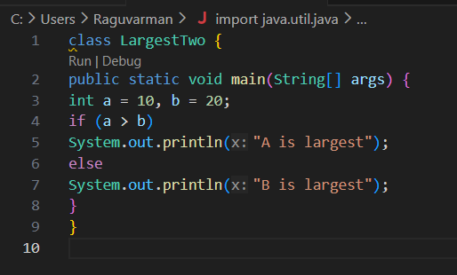
Output:
B is largest
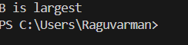

Program 4: Grade Calculation
class Grade {
public static void main(String[] args) {
int marks = 75;
if (marks >= 90)
System.out.println("Grade A");
else if (marks >= 75)
System.out.println("Grade B");
else if (marks >= 50)
System.out.println("Grade C");
else
System.out.println("Fail");
}
}
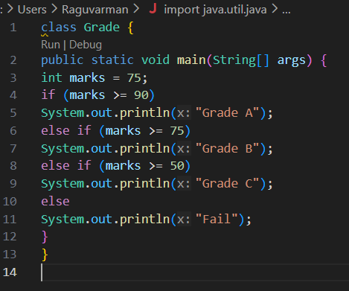
Output:
Grade B
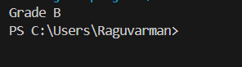
Program 5: Day of the Week
class DaySwitch {
public static void main(String[] args) {
int day = 3;
switch (day) {
case 1: System.out.println("Monday"); break;
case 2: System.out.println("Tuesday"); break;
case 3: System.out.println("Wednesday"); break;
case 4: System.out.println("Thursday"); break;
case 5: System.out.println("Friday"); break;
default: System.out.println("Invalid Day");
}
}
}
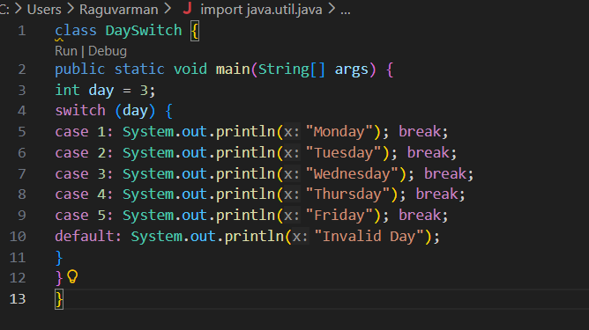
Output:
Wednesday
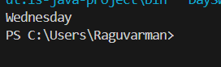
Program 6: Print Numbers from 1 to 5
class ForLoop {
public static void main(String[] args) {
for (int i = 1; i <= 5; i++) {
System.out.println(i);
}
}
}
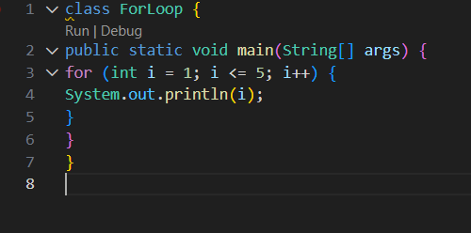
Output:
1
2
3
4
5
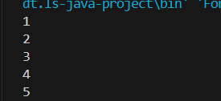

Program 7: Print Numbers from 1 to 5
class WhileLoop {
public static void main(String[] args) {
int i = 1;
while (i <= 5) {
System.out.println(i);
i++;
}
}
}
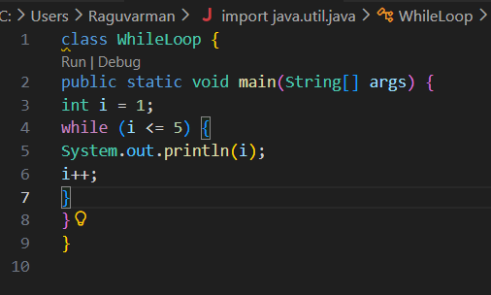
Output:
1
2
3
4
5
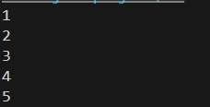

Program 8: Print Numbers from 1 to 5
class DoWhileLoop {
public static void main(String[] args) {
int i = 1;
do {
System.out.println(i);
i++;
} while (i <= 5);
}
}
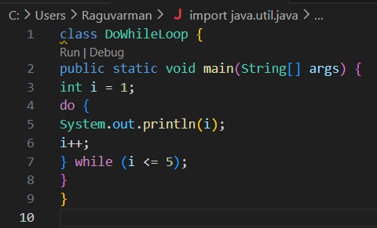
Output:
1
2
3
4
5
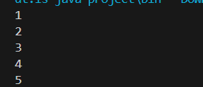

Program 9: Sum of First 5 Natural Numbers
class SumNumbers {
public static void main(String[] args) {
int sum = 0;
for (int i = 1; i <= 5; i++) {
sum = sum + i;
}
System.out.println("Sum = " + sum);
}
}
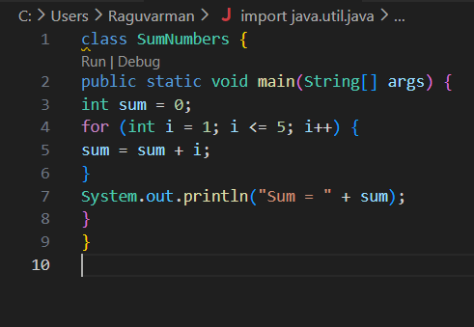
Output:
Sum = 15
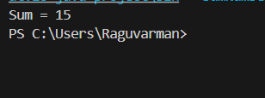
Program 10: Multiplication Table of a Number
class MultiplicationTable {
public static void main(String[] args) {
int n = 5;
for (int i = 1; i <= 10; i++) {
System.out.println(n + " x " + i + " = " + (n * i));
}
}
}
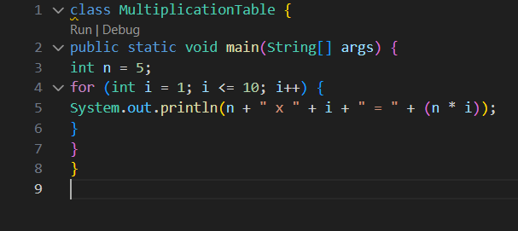
Output:
5 x 1 = 5
5 x 2 = 10
5 x 3 = 15
5 x 4 = 20
5 x 5 = 25
5 x 6 = 30
5 x 7 = 35
5 x 8 = 40
5 x 9 = 45
5 x 10 = 50
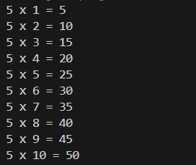

POST LAB EXERCISE
- What is the use of if statement?
The if statement is used to execute a block of code only when a specified condition is true.

- Difference between if-else and else-if ladder.
Feature | if-else | else-if ladder
Conditions | Two conditions | Multiple conditions
Usage | Simple decision | Multiple choices

- Why is switch statement used?
The switch statement is used to execute one block of code among many options based on the value of an expression.

- Difference between for, while, and do-while loops.
Loop | Condition Check | Minimum Execution
for | Before loop | 0 times
while | Before loop | 0 times
do-while | After loop | At least once

- Which loop executes at least once?
The do-while loop executes at least once.

Result:

Thus the different control statements were executed successfully with expected output.

ASSESSMENT

Description | Max Marks | Marks Awarded
Pre Lab Exercise | 5
In Lab Exercise | 10
Post Lab Exercise | 5
Viva | 10
Total | 30
Faculty Signature

