Experiment Number : 05 Date: 4/3/26

INHERITANCE
Aim:
To understand and implement inheritance concepts in Java.
PRE LAB EXERCISE
QUESTIONS
- What is inheritance?
Inheritance is a mechanism where one class acquires the properties and methods of another class.
- What is code reusability?
Using existing code (parent class) in new classes without rewriting it.
- What is the use of extends keyword?
It allows a class to inherit another class.
Example: class Dog extends Animal
IN LAB EXERCISE
Objective:
To implement all types of inheritance.
PROGRAMS:
Student Result System (Single Inheritance)
Question:
A school wants to store student details and calculate marks. Create a base class Student and a derived class Result.
Code:
class Student {
String name;
int rollNo;

void getDetails() {
name = "raguvarman";
rollNo = 217;
}
}

class Result extends Student {
int marks = 85;

void display() {
System.out.println("Name: " + name);
System.out.println("Roll No: " + rollNo);
System.out.println("Marks: " + marks);
}
}

public class Main {
public static void main(String[] args) {
Result r = new Result();
r.getDetails();
r.display();
}
}
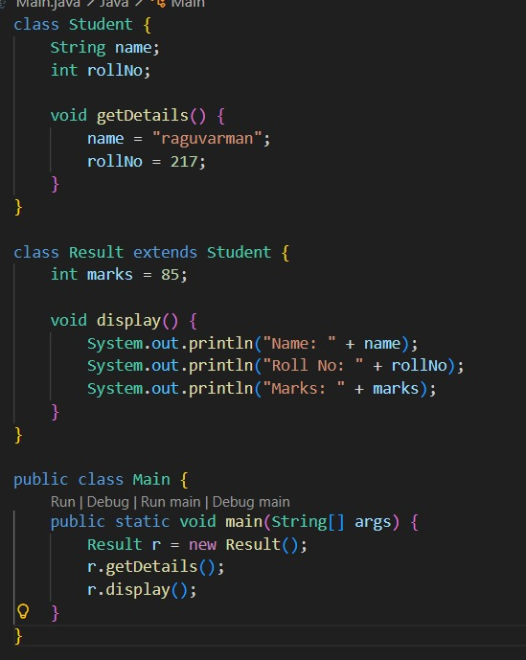

Output:
Name: RAGUVARMAN
Roll No: 217
Marks: 85


2. Bank Account System (Hierarchical Inheritance)
Question:
A bank has Savings and Current accounts. Both inherit from a common Account class.
Code:
class Account {
void showAccountType() {
System.out.println("Bank Account");
}
}

class SavingsAccount extends Account {
void interest() {
System.out.println("Savings Account gives interest");
}
}

class CurrentAccount extends Account {
void overdraft() {
System.out.println("Current Account supports overdraft");
}
}

public class Main {
public static void main(String[] args) {
SavingsAccount s = new SavingsAccount();
CurrentAccount c = new CurrentAccount();

s.showAccountType();
s.interest();

c.showAccountType();
c.overdraft();
}
}
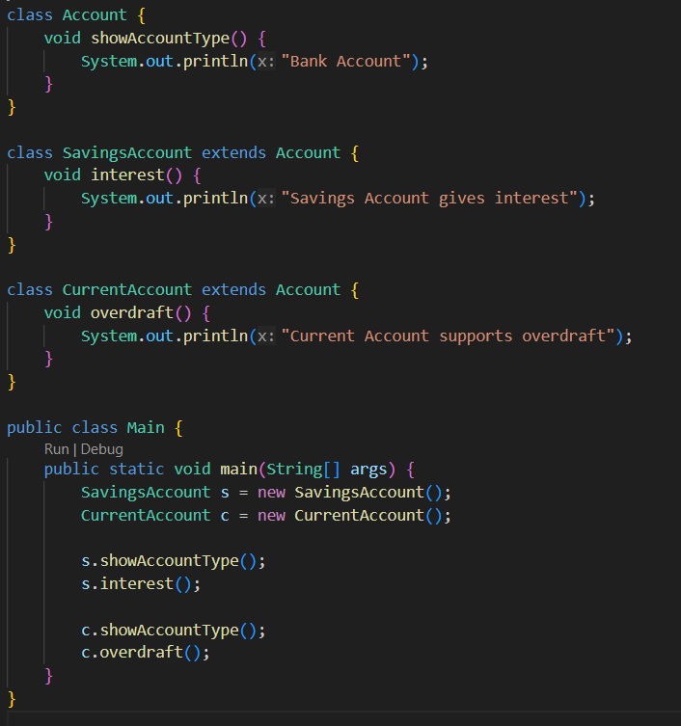

Output:
Bank Account
Savings Account gives interest
Bank Account
Current Account supports overdraft



3. Vehicle System (Multilevel Inheritance)
Question:
A company classifies vehicles as Vehicle → Car → ElectricCar.
Code:
class Vehicle {
void start() {
System.out.println("Vehicle starts");
}
}

class Car extends Vehicle {
void fuelType() {
System.out.println("Car uses petrol");
}
}

class ElectricCar extends Car {
void battery() {
System.out.println("Electric car uses battery");
}
}

public class Main {
public static void main(String[] args) {
ElectricCar e = new ElectricCar();
e.start();
e.fuelType();
e.battery();
}
}
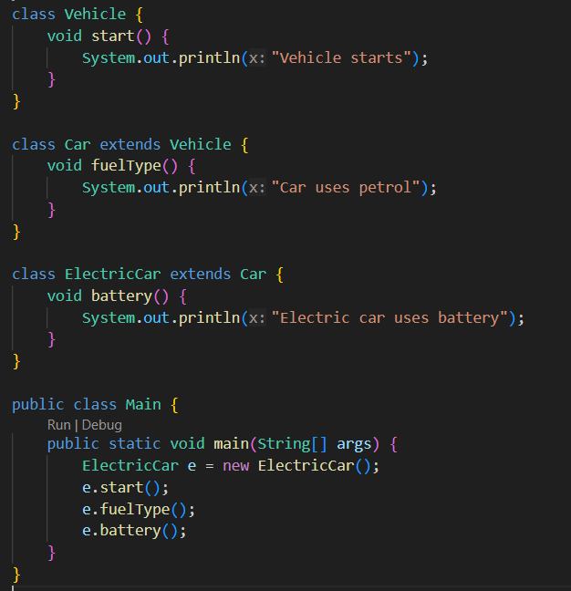
Output:
Vehicle starts
Car uses petrol
Electric car uses battery
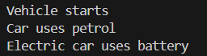
POST LAB EXERCISE
- Why Java does not support multiple inheritance using classes and how it is implemented?
Java does not support multiple inheritance using classes to avoid ambiguity (Diamond Problem).
It is implemented using interfaces, which allow multiple inheritance without confusion.

- What is the role of the super keyword? Give examples.
The super keyword is used to access parent class variables, methods, and constructors.

- Can a child class access private members of the parent class? Why?
No, a child class cannot access private members because private members are accessible only within the same class.

- Explain why hybrid inheritance is not supported in Java.
Hybrid inheritance is not supported to avoid ambiguity and complexity, especially due to multiple inheritance using classes.

Result:

Thus the different types of inheritance were implemented and executed successfully.

ASSESSMENT

Description | Max Marks | Marks Awarded
Pre Lab Exercise | 5
In Lab Exercise | 10
Post Lab Exercise | 5
Viva | 10
Total | 30
Faculty Signature

