Experiment Number : 04 Date: 05/02/2026

ARRAYS
Aim:
To understand and implement array operations in Java.
PRE LAB EXERCISE
QUESTIONS
- What is an array?
An array is a collection of elements of the same data type stored in consecutive memory locations and accessed using an index. It allows multiple values to be stored under one name and accessed efficiently.
- Why are arrays used?
Arrays are used to store and manage large sets of similar data in a structured way. They make data processing easier through indexed access and looping.
- What is the difference between array and variable?
A variable stores only a single value at a time, while an array can store many values of the same type. A variable uses one memory location, but an array uses multiple continuous locations.

IN LAB EXERCISE
Objective:
To perform array operations using simple programs.
PROGRAMS:
1. Program to Read and Print Array Elements
Code:
import java.util.Scanner;
public class ReadPrintArray {
public static void main(String[] args) {
Scanner sc = new Scanner(System.in);
int[] arr = new int[5];
System.out.println("Enter 5 elements:");
for(int i = 0; i < 5; i++)
arr[i] = sc.nextInt();
System.out.println("Array elements are:");
for(int i = 0; i < 5; i++)
System.out.print(arr[i] + " ");
}
}
OUTPUT:
Input:
10 20 30 40 50
Output:
Array elements are:
10 20 30 40 50
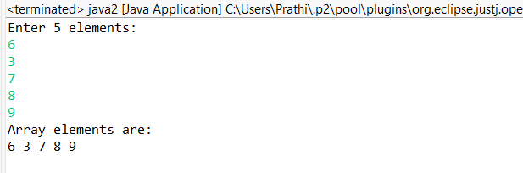

2. Program to Find Sum of Array Elements
Code:
import java.util.Scanner;
public class SumArray {
public static void main(String[] args) {
Scanner sc = new Scanner(System.in);
int[] arr = new int[5];
int sum = 0;
System.out.println("Enter 5 elements:");
for(int i = 0; i < 5; i++)
arr[i] = sc.nextInt();
for(int i = 0; i < 5; i++)
sum += arr[i];
System.out.println("Sum = " + sum);
}
}
OUTPUT:
Input:
5 10 15 20 25
Output:
Sum = 75
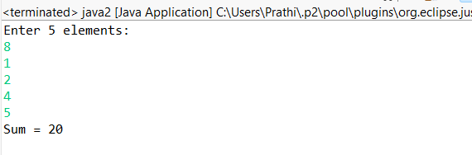

3. Program to Find Largest Element in an Array
Code:
import java.util.Scanner;
public class LargestElement {
public static void main(String[] args) {
Scanner sc = new Scanner(System.in);
int[] arr = new int[5];
System.out.println("Enter 5 elements:");
for(int i = 0; i < 5; i++)
arr[i] = sc.nextInt();
int max = arr[0];
for(int i = 1; i < 5; i++)
if(arr[i] > max)
max = arr[i];
System.out.println("Largest element = " + max);
}
}
OUTPUT:
Input:
12 45 23 9 30
Output:
Largest element = 45
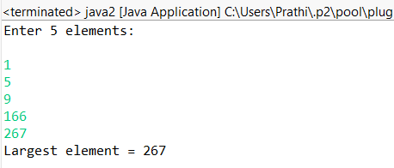

4. Program to Reverse an Array
Code:
import java.util.Scanner;

public class ReverseArray {
public static void main(String[] args) {
Scanner sc = new Scanner(System.in);
int[] arr = new int[5];
System.out.println("Enter 5 elements:");
for(int i = 0; i < 5; i++)
arr[i] = sc.nextInt();
System.out.println("Reversed array:");
for(int i = 4; i >= 0; i--)
System.out.print(arr[i] + " ");
}
}
OUTPUT:
Input:
1 2 3 4 5
Output:
Reversed array:
5 4 3 2 1
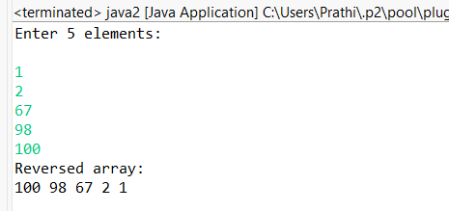

5. Program to Count Even and Odd Numbers
Code:
import java.util.Scanner;
public class EvenOddCount {
public static void main(String[] args) {
Scanner sc = new Scanner(System.in);
int[] arr = new int[5];
int even = 0, odd = 0;
System.out.println("Enter 5 elements:");
for(int i = 0; i < 5; i++)
arr[i] = sc.nextInt();
for(int i = 0; i < 5; i++) {
if(arr[i] % 2 == 0)
even++;
else
odd++;
}

System.out.println("Even = " + even);
System.out.println("Odd = " + odd);
}
}
OUTPUT:
Input:
2 7 4 9 10
Output:
Even = 3
Odd = 2
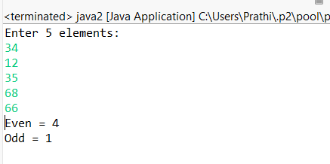

6. Program to Sort Array in Ascending Order
Code:
import java.util.Scanner;
public class SortArray {
public static void main(String[] args) {
Scanner sc = new Scanner(System.in);
int[] arr = new int[5];
int temp;
System.out.println("Enter 5 elements:");
for(int i = 0; i < 5; i++)
arr[i] = sc.nextInt();
for(int i = 0; i < 5; i++) {
for(int j = i + 1; j < 5; j++) {
if(arr[i] > arr[j]) {
temp = arr[i];
arr[i] = arr[j];
arr[j] = temp;
}
}
}
System.out.println("Sorted array:");
for(int i = 0; i < 5; i++)
System.out.print(arr[i] + " ");
}
}
OUTPUT:
Input:
45 12 78 23 9
Output:
Sorted array:
9 12 23 45 78
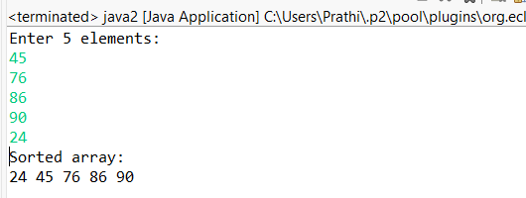

7. Program to Find Second Largest Element
Code:
import java.util.Scanner;
public class SecondLargest {
public static void main(String[] args) {
Scanner sc = new Scanner(System.in);
int[] arr = new int[5];

System.out.println("Enter 5 elements:");
for(int i = 0; i < 5; i++)
arr[i] = sc.nextInt();
int largest = arr[0];
int second = arr[0];
for(int i = 0; i < 5; i++) {
if(arr[i] > largest) {
second = largest;
largest = arr[i];
}
}
System.out.println("Second largest = " + second);
}
}
OUTPUT:
Input:
10 45 23 89 67
Output:
Second largest = 67
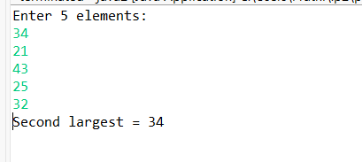

8. Program for Matrix Addition (2D Array)
Code:
import java.util.Scanner;
public class MatrixAddition {
public static void main(String[] args) {
Scanner sc = new Scanner(System.in);
int[][] a = new int[2][2];
int[][] b = new int[2][2];
int[][] sum = new int[2][2];
System.out.println("Enter elements of matrix A:");
for(int i = 0; i < 2; i++)
for(int j = 0; j < 2; j++)
a[i][j] = sc.nextInt();
System.out.println("Enter elements of matrix B:");
for(int i = 0; i < 2; i++)
for(int j = 0; j < 2; j++)
b[i][j] = sc.nextInt();
for(int i = 0; i < 2; i++)
for(int j = 0; j < 2; j++)
sum[i][j] = a[i][j] + b[i][j];
System.out.println("Sum matrix:");
for(int i = 0; i < 2; i++) {
for(int j = 0; j < 2; j++)
System.out.print(sum[i][j] + " ");
System.out.println();
}
}
}
OUTPUT:
Matrix A:
1 2
3 4
Matrix B:
5 6
7 8
Sum matrix:
6 8
10 12
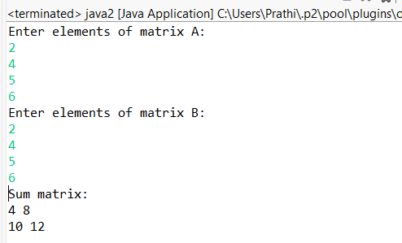

POST LAB EXERCISE
- Why is array indexing usually started from zero instead of one?
Array indexing usually starts from zero because the index represents the offset from the starting memory address. The first element is at offset zero, so indexing begins at 0.

- What happens if we try to access an array element outside its declared size?
If we try to access an array element outside its declared size, it causes an out-of-bounds error or exception. This may lead to program crash or unpredictable results depending on the language.
- How does memory allocation differ for static arrays and dynamic arrays?
Static arrays get memory allocated at compile time and their size cannot be changed later. Dynamic arrays get memory at runtime and their size can be resized when needed.
- Why is searching faster in arrays compared to linked lists?
Searching is faster in arrays because elements are stored in contiguous memory and can be accessed directly using index. Linked lists require sequential traversal from the start node.
- What is the difference between contiguous and non-contiguous memory allocation?
Contiguous memory allocation stores elements in continuous memory blocks for faster access. Non-contiguous allocation stores elements in scattered locations connected using pointers.

Result:

Thus the array operations were executed successfully.

ASSESSMENT

Description | Max Marks | Marks Awarded
Pre Lab Exercise | 5
In Lab Exercise | 10
Post Lab Exercise | 5
Viva | 10
Total | 30
Faculty Signature

