Experiment Number : 07 Date: 05.02.2025

METHOD OVERLOADING AND METHOD OVERRIDING
Aim:
To understand and implement method overloading and method overriding.
PRE LAB EXERCISE
QUESTIONS
- What is method overloading?
Method overloading is a feature of Java that allows a class to have more than one method with the same name but with different parameters. The difference in parameters may be in their number, data type, or order. Method overloading is used to increase the readability of a program by allowing methods to perform similar operations with different inputs. It occurs within the same class and is an example of compile-time polymorphism.
- What is method overriding?
Method overriding is a feature in which a subclass provides its own implementation of a method that is already defined in its parent class. In method overriding, the method name, return type, and parameters must be the same in both the parent and child classes. It supports runtime polymorphism and is used to provide specific behavior for a method in the subclass. Inheritance is mandatory for method overriding.
- Difference between overloading and overriding.
Method overloading occurs within the same class and involves methods with the same name but different parameters, whereas method overriding occurs in different classes through inheritance and involves methods with the same name and parameters. Overloading is resolved at compile time, while overriding is resolved at runtime. Overloading improves code readability, whereas overriding allows a subclass to provide its own behavior for a method.
IN LAB EXERCISE
Objective:
To demonstrate compile-time and runtime polymorphism.
PROGRAMS:
1.Student Result System (Method Overriding)
Description:
- Base class Student has method displayResult().
- Subclasses UGStudent and PGStudent override the method to show different grading systems.

Code :
import java.util.Scanner;

// Base class
class Student {
String name;

void displayResult() {
System.out.println("Student Result");
}
}

// UG Student subclass
class UGStudent extends Student {
int marks;

UGStudent(String n, int m) {
name = n;
marks = m;
}

@Override
void displayResult() {
double percentage = (marks / 100.0) * 100;
System.out.println("UG Student: " + name);
System.out.println("Marks: " + marks);
System.out.println("Percentage: " + percentage + "%");
}
}

// PG Student subclass
class PGStudent extends Student {
double gpa;

PGStudent(String n, double g) {
name = n;
gpa = g;
}

@Override
void displayResult() {
System.out.println("PG Student: " + name);
System.out.println("GPA: " + gpa + " / 10");
}
}

// Main class
public class Main {
public static void main(String[] args) {
Scanner sc = new Scanner(System.in);

// Input for UG student
System.out.print("Enter UG Student Name: ");
String ugName = sc.nextLine();
System.out.print("Enter UG Student Marks (out of 100): ");
int ugMarks = sc.nextInt();
sc.nextLine(); // consume newline

// Input for PG student
System.out.print("Enter PG Student Name: ");
String pgName = sc.nextLine();
System.out.print("Enter PG Student GPA (0-10): ");
double pgGpa = sc.nextDouble();

// Create objects
Student s1 = new UGStudent(ugName, ugMarks);
Student s2 = new PGStudent(pgName, pgGpa);

System.out.println("\n--- Student Results ---");
s1.displayResult();
System.out.println();
s2.displayResult();

sc.close();
}
}
OUTPUT:

Sample Input:
Enter UG Student Name: Ram
Enter UG Student Marks (out of 100): 85
Enter PG Student Name: Ravi
Enter PG Student GPA (0-10): 9.2
Output:
--- Student Results ---
UG Student: Ram
Marks: 85
Percentage: 85.0%
PG Student: Ravi
GPA: 9.2 / 10
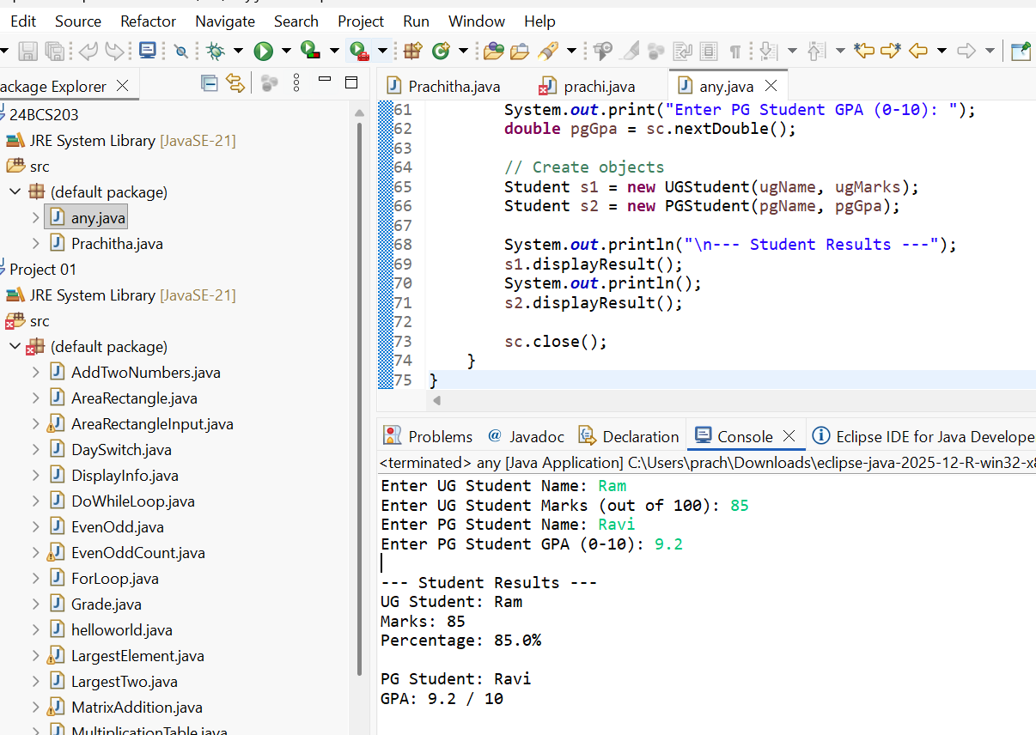

2. Calculator Program (Method Overloading)
Description:
Create a Calculator class with multiple add() methods to calculate:
- Addition of 2 integers
- Addition of 3 integers
- Addition of 2 double numbers
Code:
import java.util.Scanner;
class Calculator {
int add(int a, int b) {
return a + b;
}

int add(int a, int b, int c) {
return a + b + c;
}

double add(double a, double b) {
return a + b;
}
}
public class Main {
public static void main(String[] args) {
Scanner sc = new Scanner(System.in);
Calculator calc = new Calculator();

System.out.print("Enter two integers: ");
int x = sc.nextInt();
int y = sc.nextInt();
System.out.println("Sum of two integers: " + calc.add(x, y));

System.out.print("Enter three integers: ");
int p = sc.nextInt();
int q = sc.nextInt();
int r = sc.nextInt();
System.out.println("Sum of three integers: " + calc.add(p, q, r));

System.out.print("Enter two decimal numbers: ");
double a = sc.nextDouble();
double b = sc.nextDouble();
System.out.println("Sum of two doubles: " + calc.add(a, b));

sc.close();
}
}
Output:
Sample Input:
Enter two integers: 10 20
Enter three integers: 5 10 15
Enter two decimal numbers: 2.5 3.5
Output:
Sum of two integers: 30
Sum of three integers: 30
Sum of two doubles: 6.0
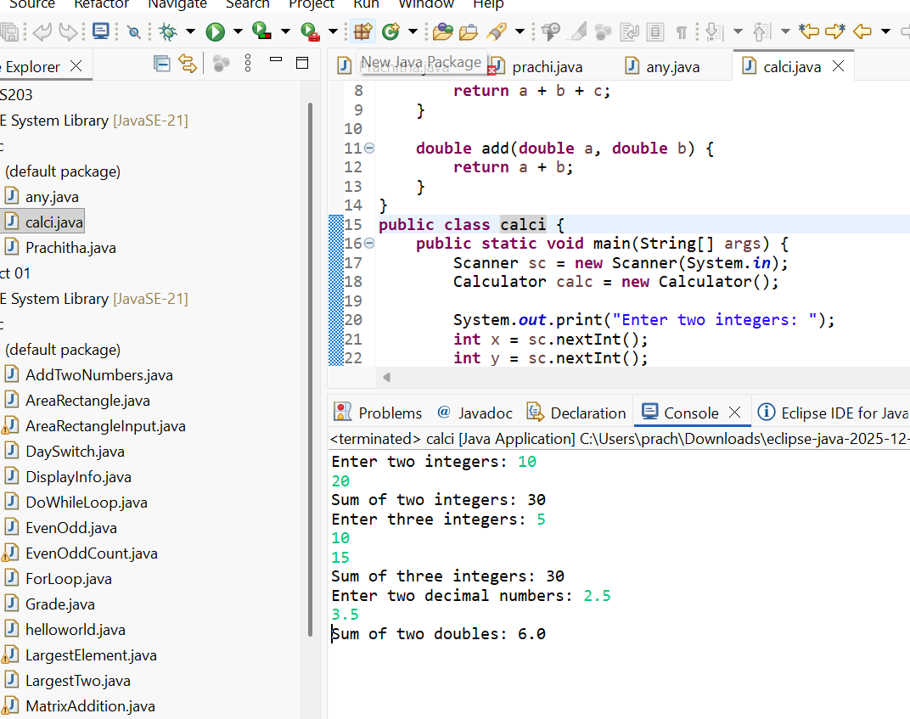

POST LAB EXERCISE
- Is return type important in method overloading and method overriding?
In method overloading, the return type alone is not important because overloading depends on a difference in the parameter list, such as number, type, or order of parameters. Changing only the return type does not create a valid overloaded method. In method overriding, the return type is important and must be the same as, or a compatible subtype (covariant return type) of, the return type in the parent class method.
- Can you overload a method by changing only the return type?
No, a method cannot be overloaded by changing only the return type. Java does not consider the return type when distinguishing overloaded methods. The parameter list must be different; otherwise, the compiler will generate an error.
- Can static methods be overridden? Can they be overloaded?
Static methods cannot be overridden because overriding is based on runtime polymorphism, and static methods are resolved at compile time. However, static methods can be overloaded by changing the parameter list, just like instance methods.
- Can a method be overridden if the parameter list is different?
No, a method cannot be overridden if the parameter list is different. For method overriding, the method name, parameter list, and return type must be the same as in the parent class. If the parameter list is different, it becomes method overloading, not overriding.
Result:
Thus the method overloading and overriding concepts were implemented and executed successfully.
ASSESSMENT

Description | Max Marks | Marks Awarded
Pre Lab Exercise | 5
In Lab Exercise | 10
Post Lab Exercise | 5
Viva | 10
Total | 30
Faculty Signature

