Experiment Number : 04 Date: 04-02026

ARRAYS
Aim:
To understand and implement array operations in Java.
PRE LAB EXERCISE
QUESTIONS
- What is an array?
An array is a collection of elements of the same data type stored in continuous memory locations.
Each element is accessed using an index number.
Example:
int[] a = {10, 20, 30, 40};

- Why are arrays used?
Arrays are used because:
- They store multiple values using a single variable name
- They provide easy access to elements using index
- They make data processing faster
- They help in implementing sorting, searching, matrices, etc.

- What is the difference between array and variable?
Variable | Array
Stores only one value | Stores multiple values
Holds a single data item | Holds a collection of items
Example: int x = 10; | Example: int[] x = new int[5];
Simple memory usage | Uses continuous memory

IN LAB EXERCISE
Objective:
To perform array operations using simple programs.
PROGRAMS:
1. Program to Read and Print Array Elements
Code:
import java.util.Scanner;
public class ReadPrintArray {
public static void main(String[] args) {
Scanner sc = new Scanner(System.in);
int[] arr = new int[5];
System.out.println("Enter 5 elements:");
for(int i = 0; i < 5; i++)
arr[i] = sc.nextInt();
System.out.println("Array elements are:");
for(int i = 0; i < 5; i++)
System.out.print(arr[i] + " ");
}
}
OUTPUT:
Input:
10 20 30 40 50
Output:
Array elements are:
10 20 30 40 50

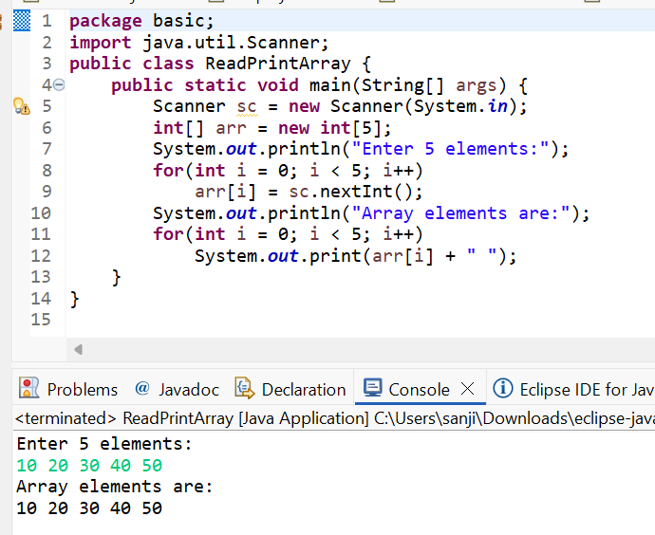

2. Program to Find Sum of Array Elements
Code:
import java.util.Scanner;
public class SumArray {
public static void main(String[] args) {
Scanner sc = new Scanner(System.in);
int[] arr = new int[5];
int sum = 0;
System.out.println("Enter 5 elements:");
for(int i = 0; i < 5; i++)
arr[i] = sc.nextInt();
for(int i = 0; i < 5; i++)
sum += arr[i];
System.out.println("Sum = " + sum);
}
}
OUTPUT:
Input:
5 10 15 20 25
Output:
Sum = 75
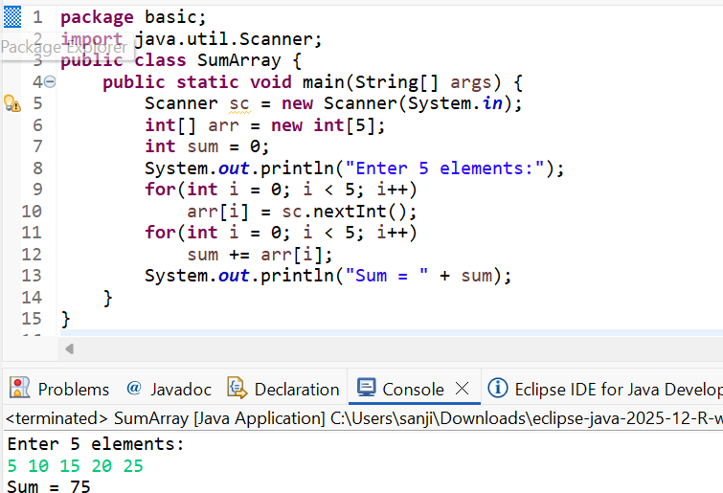

3. Program to Find Largest Element in an Array
Code:
import java.util.Scanner;
public class LargestElement {
public static void main(String[] args) {
Scanner sc = new Scanner(System.in);
int[] arr = new int[5];
System.out.println("Enter 5 elements:");
for(int i = 0; i < 5; i++)
arr[i] = sc.nextInt();
int max = arr[0];
for(int i = 1; i < 5; i++)
if(arr[i] > max)
max = arr[i];
System.out.println("Largest element = " + max);
}
}
OUTPUT:
Input:
12 45 23 9 30
Output:
Largest element = 45

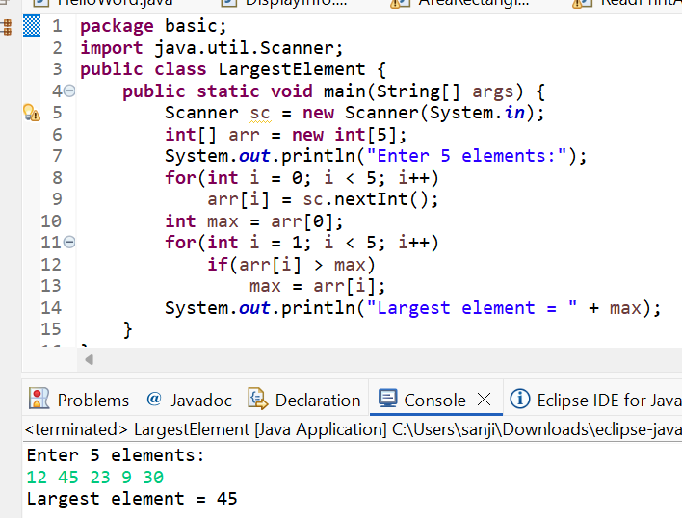
4. Program to Reverse an Array
Code:
import java.util.Scanner;

public class ReverseArray {
public static void main(String[] args) {
Scanner sc = new Scanner(System.in);
int[] arr = new int[5];
System.out.println("Enter 5 elements:");
for(int i = 0; i < 5; i++)
arr[i] = sc.nextInt();
System.out.println("Reversed array:");
for(int i = 4; i >= 0; i--)
System.out.print(arr[i] + " ");
}
}
OUTPUT:
Input:
1 2 3 4 5
Output:
Reversed array:
5 4 3 2 1

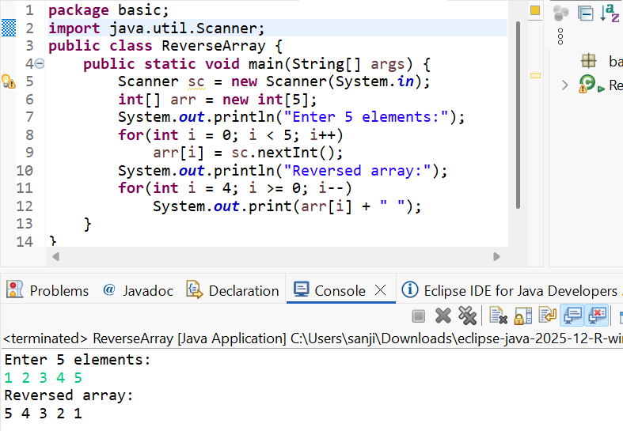

5. Program to Count Even and Odd Numbers
Code:
import java.util.Scanner;
public class EvenOddCount {
public static void main(String[] args) {
Scanner sc = new Scanner(System.in);
int[] arr = new int[5];
int even = 0, odd = 0;
System.out.println("Enter 5 elements:");
for(int i = 0; i < 5; i++)
arr[i] = sc.nextInt();
for(int i = 0; i < 5; i++) {
if(arr[i] % 2 == 0)
even++;
else
odd++;
}

System.out.println("Even = " + even);
System.out.println("Odd = " + odd);
}
}
OUTPUT:
Input:
2 7 4 9 10
Output:
Even = 3
Odd = 2
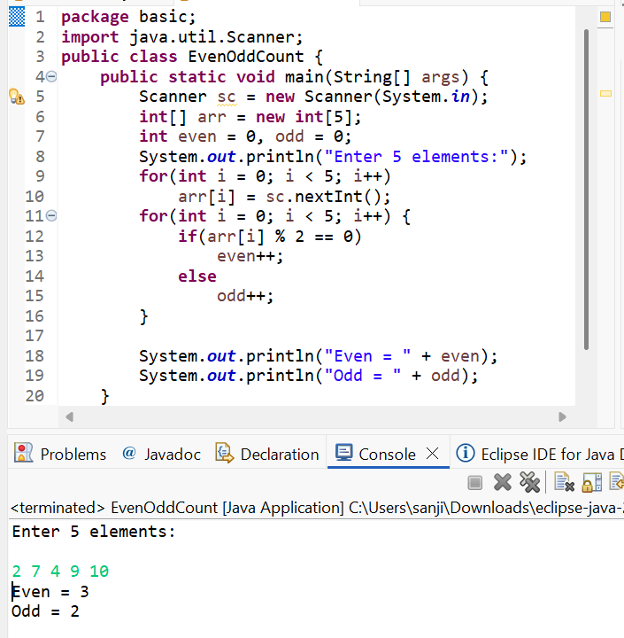

6. Program to Sort Array in Ascending Order
Code:
import java.util.Scanner;
public class SortArray {
public static void main(String[] args) {
Scanner sc = new Scanner(System.in);
int[] arr = new int[5];
int temp;
System.out.println("Enter 5 elements:");
for(int i = 0; i < 5; i++)
arr[i] = sc.nextInt();
for(int i = 0; i < 5; i++) {
for(int j = i + 1; j < 5; j++) {
if(arr[i] > arr[j]) {
temp = arr[i];
arr[i] = arr[j];
arr[j] = temp;
}
}
}
System.out.println("Sorted array:");
for(int i = 0; i < 5; i++)
System.out.print(arr[i] + " ");
}
}
OUTPUT:
Input:
45 12 78 23 9
Output:
Sorted array:
9 12 23 45 78

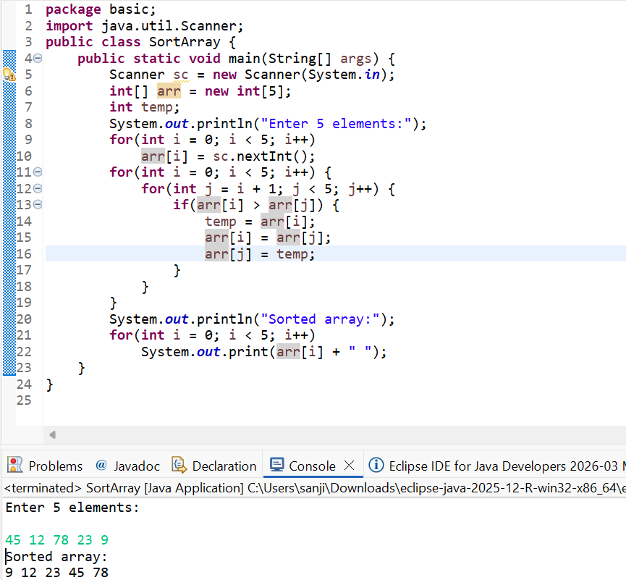

7. Program to Find Second Largest Element
Code:
import java.util.Scanner;

public class SecondLargest {
public static void main(String[] args) {
Scanner sc = new Scanner(System.in);
int[] arr = new int[5];

System.out.println("Enter 5 elements:");
for (int i = 0; i < 5; i++)
arr[i] = sc.nextInt();

int largest = arr[0];
int second = Integer.MIN_VALUE;

for (int i = 1; i < 5; i++) {
if (arr[i] > largest) {
second = largest;
largest = arr[i];
}
else if (arr[i] > second && arr[i] != largest) {
second = arr[i];
}
}

System.out.println("Second largest = " + second);
}
}
OUTPUT:
Input:
10 45 23 89 67
Output:
Second largest = 67

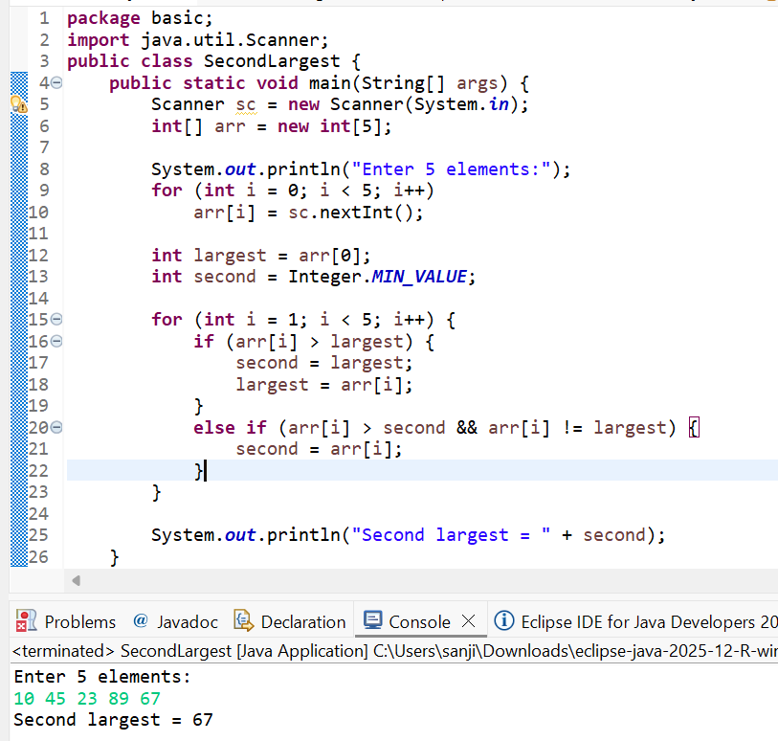

8. Program for Matrix Addition (2D Array)
Code:
import java.util.Scanner;
public class MatrixAddition {
public static void main(String[] args) {
Scanner sc = new Scanner(System.in);
int[][] a = new int[2][2];
int[][] b = new int[2][2];
int[][] sum = new int[2][2];
System.out.println("Enter elements of matrix A:");
for(int i = 0; i < 2; i++)
for(int j = 0; j < 2; j++)
a[i][j] = sc.nextInt();
System.out.println("Enter elements of matrix B:");
for(int i = 0; i < 2; i++)
for(int j = 0; j < 2; j++)
b[i][j] = sc.nextInt();
for(int i = 0; i < 2; i++)
for(int j = 0; j < 2; j++)
sum[i][j] = a[i][j] + b[i][j];
System.out.println("Sum matrix:");
for(int i = 0; i < 2; i++) {
for(int j = 0; j < 2; j++)
System.out.print(sum[i][j] + " ");
System.out.println();
}
}
}
OUTPUT:
Matrix A:
1 2
3 4
Matrix B:
5 6
7 8
Sum matrix:
6 8
10 12
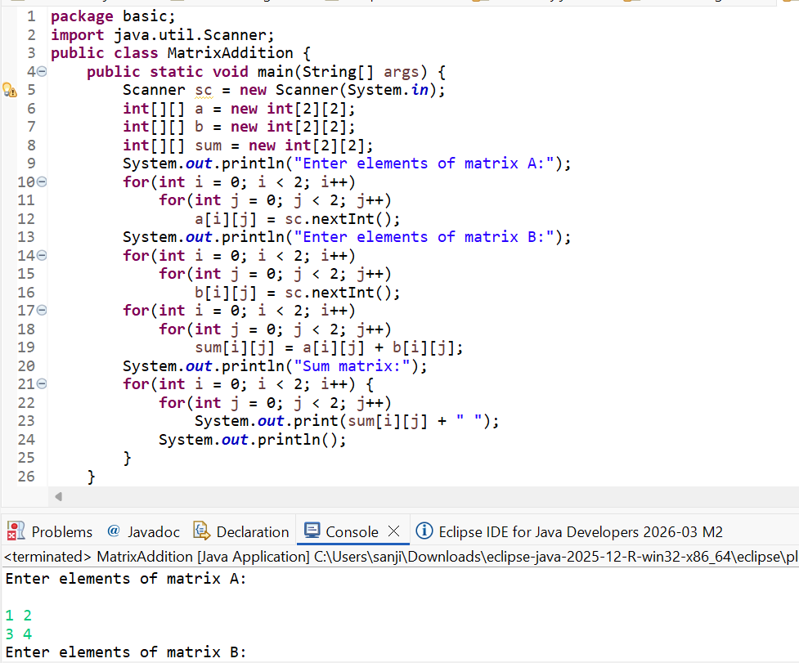
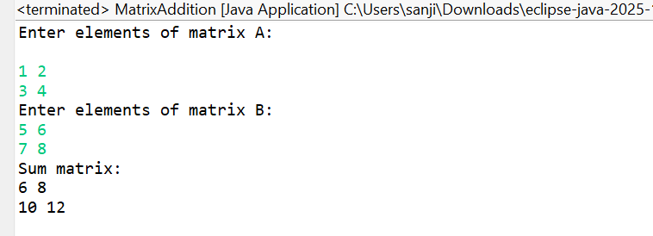

POST LAB EXERCISE
- Why is array indexing usually started from zero instead of one?
Array indexing usually started from zero because:
- Arrays are stored in memory blocks
- The index represents the offset from the base address
- First element is at base address + 0
- This improves performance and memory calculation
Example:
arr[0] refers to the first element

- What happens if we try to access an array element outside its declared size?
It causes a runtime error.
In Java, it throws:
ArrayIndexOutOfBoundsException
Example:
int[] a = new int[5];
System.out.println(a[6]); // Error

- How does memory allocation differ for static arrays and dynamic arrays?

Static Array | Dynamic Array
Size is fixed at compile time | Size can be decided at runtime
Cannot change size | Can change size (using collections like ArrayList)
Faster access | Slightly slower
Example: int a[5]; | Example: new int[n];

- Why is searching faster in arrays compared to linked lists?
Searching faster in arrays than linked lists because:
- Arrays support direct access using index
- Time complexity is O(1) for accessing elements
- Linked lists require traversing node by node
- Hence, searching in arrays is faster

- What is the difference between contiguous and non-contiguous memory allocation?
Contiguous Memory | Non-Contiguous Memory
Memory blocks are continuous | Memory blocks are scattered
Used in arrays | Used in linked lists
Faster access | Slower access
Easy indexing | No direct indexing

Result:

Thus the array operations were executed successfully.

ASSESSMENT

Description | Max Marks | Marks Awarded
Pre Lab Exercise | 5
In Lab Exercise | 10
Post Lab Exercise | 5
Viva | 10
Total | 30
Faculty Signature

