Experiment Number : 05 Date: 05.02.26

INHERITANCE
Aim:
To understand and implement inheritance concepts in Java.
PRE LAB EXERCISE
QUESTIONS
- What is inheritance?
Inheritance is an OOP concept where a class (child/subclass) acquires properties and methods of another class (parent/superclass).

- What is code reusability?
Code reusability means using existing code (methods, classes) in new programs without rewriting it, saving time and effort

- What is the use of extends keyword?
The extends keyword is used in Java to indicate that a class is inheriting from another class.

IN LAB EXERCISE
Objective:
To implement all types of inheritance.
PROGRAMS:
Student Result System (Single Inheritance)
Question:
A school wants to store student details and calculate marks. Create a base class Student and a derived class Result.
Code:
class Student {
String name;
int rollNo;

void getDetails() {
name = "Anitha";
rollNo = 101;
}
}

class Result extends Student {
int marks = 85;

void display() {
System.out.println("Name: " + name);
System.out.println("Roll No: " + rollNo);
System.out.println("Marks: " + marks);
}
}

public class Main {
public static void main(String[] args) {
Result r = new Result();
r.getDetails();
r.display();
}
}
Output:
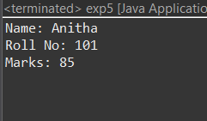
2. Bank Account System (Hierarchical Inheritance)
Question:
A bank has Savings and Current accounts. Both inherit from a common Account class.
Code:
class Account {
void showAccountType() {
System.out.println("Bank Account");
}
}

class SavingsAccount extends Account {
void interest() {
System.out.println("Savings Account gives interest");
}
}

class CurrentAccount extends Account {
void overdraft() {
System.out.println("Current Account supports overdraft");
}
}

public class Main {
public static void main(String[] args) {
SavingsAccount s = new SavingsAccount();
CurrentAccount c = new CurrentAccount();

s.showAccountType();
s.interest();

c.showAccountType();
c.overdraft();
}
}

Output:
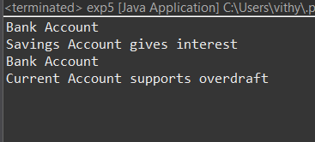
3. Vehicle System (Multilevel Inheritance)
Question:
A company classifies vehicles as Vehicle → Car → ElectricCar.
Code:
class Vehicle {
void start() {
System.out.println("Vehicle starts");
}
}

class Car extends Vehicle {
void fuelType() {
System.out.println("Car uses petrol");
}
}

class ElectricCar extends Car {
void battery() {
System.out.println("Electric car uses battery");
}
}

public class Main {
public static void main(String[] args) {
ElectricCar e = new ElectricCar();
e.start();
e.fuelType();
e.battery();
}
}
Output:
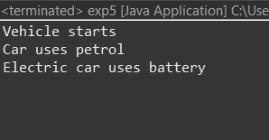
POST LAB EXERCISE
- Why Java does not support multiple inheritance using classes and how it is implemented?
Java avoids multiple inheritance with classes to prevent ambiguity (the “Diamond Problem”) when two parent classes have methods with the same name.
Implementation in Java: Multiple inheritance is achieved using interfaces instead of classes, since a class can implement multiple interfaces safely

- What is the role of the super keyword? Give examples.
The super keyword is used to:
- Call the parent class constructor.
- Access parent class methods overridden in the child.
- Access parent class variables hidden by child class variables
class Parent {
int x = 10;
void show() {
System.out.println("Parent method");
}
}

class Child extends Parent {
int x = 20;
void show() {
System.out.println("Child method");
}
void display() {
System.out.println("Parent x = " + super.x); // Access parent variable
super.show(); // Call parent method
}
}

public class Test {
public static void main(String[] args) {
Child c = new Child();
c.display();
}
}

- Can a child class access private members of the parent class? Why?
No. Private members are accessible only within the class where they are declared. Child classes cannot directly access them; they can use public/protected getter and setter methods if needed.

- Explain why hybrid inheritance is not supported in Java.
Hybrid inheritance combines multiple and multilevel inheritance, which can lead to the Diamond Problem and ambiguity. Java avoids it for classes but allows it using interfaces, which safely support multiple inheritance
Result:

Thus the different types of inheritance were implemented and executed successfully.

ASSESSMENT

Description | Max Marks | Marks Awarded
Pre Lab Exercise | 5
In Lab Exercise | 10
Post Lab Exercise | 5
Viva | 10
Total | 30
Faculty Signature

