Experiment Number : 04 Date: 4/2/26

ARRAYS
Aim:
To understand and implement array operations in Java.
PRE LAB EXERCISE
QUESTIONS
- What is an array?
An array is a collection of elements of the same data type stored in contiguous memory locations and accessed using a single name with index values.

- Why are arrays used?
Arrays are used to:
Store multiple values of the same type
Access elements easily using index
Reduce code size
Improve program efficiency and organization

- What is the difference between array and variable?
Variable:
Stores only one value
Uses a single memory location
No index is required to access the value
Can store only one data item
Example: int x;
Array:
Stores multiple values of the same data type
Uses multiple contiguous memory locations
Elements are accessed using an index
Can store many data items
Example: int a[5];

IN LAB EXERCISE
Objective:
To perform array operations using simple programs.
PROGRAMS:
1. Program to Read and Print Array Elements
Code:
import java.util.Scanner;
public class ReadPrintArray {
public static void main(String[] args) {
Scanner sc = new Scanner(System.in);
int[] arr = new int[5];
System.out.println("Enter 5 elements:");
for(int i = 0; i < 5; i++)
arr[i] = sc.nextInt();
System.out.println("Array elements are:");
for(int i = 0; i < 5; i++)
System.out.print(arr[i] + " ");
}
}
OUTPUT:
Input:
10 20 30 40 50
Output:
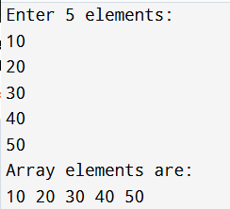
2. Program to Find Sum of Array Elements
Code:
import java.util.Scanner;
public class SumArray {
public static void main(String[] args) {
Scanner sc = new Scanner(System.in);
int[] arr = new int[5];
int sum = 0;
System.out.println("Enter 5 elements:");
for(int i = 0; i < 5; i++)
arr[i] = sc.nextInt();
for(int i = 0; i < 5; i++)
sum += arr[i];
System.out.println("Sum = " + sum);
}
}
OUTPUT:
Input:
5 10 15 20 25
Output:
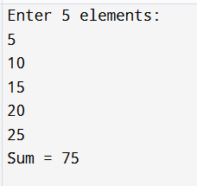
3. Program to Find Largest Element in an Array
Code:
import java.util.Scanner;
public class LargestElement {
public static void main(String[] args) {
Scanner sc = new Scanner(System.in);
int[] arr = new int[5];
System.out.println("Enter 5 elements:");
for(int i = 0; i < 5; i++)
arr[i] = sc.nextInt();
int max = arr[0];
for(int i = 1; i < 5; i++)
if(arr[i] > max)
max = arr[i];
System.out.println("Largest element = " + max);
}
}
OUTPUT:
Input:
12 45 23 9 30
Output:
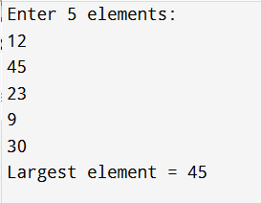
4. Program to Reverse an Array
Code:
import java.util.Scanner;

public class ReverseArray {
public static void main(String[] args) {
Scanner sc = new Scanner(System.in);
int[] arr = new int[5];
System.out.println("Enter 5 elements:");
for(int i = 0; i < 5; i++)
arr[i] = sc.nextInt();
System.out.println("Reversed array:");
for(int i = 4; i >= 0; i--)
System.out.print(arr[i] + " ");
}
}
OUTPUT:
Input:
1 2 3 4 5
Output:
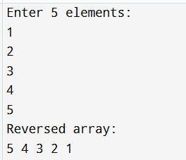
5. Program to Count Even and Odd Numbers
Code:
import java.util.Scanner;
public class EvenOddCount {
public static void main(String[] args) {
Scanner sc = new Scanner(System.in);
int[] arr = new int[5];
int even = 0, odd = 0;
System.out.println("Enter 5 elements:");
for(int i = 0; i < 5; i++)
arr[i] = sc.nextInt();
for(int i = 0; i < 5; i++) {
if(arr[i] % 2 == 0)
even++;
else
odd++;
}

System.out.println("Even = " + even);
System.out.println("Odd = " + odd);
}
}
OUTPUT:
Input:
2 7 4 9 10
Output:
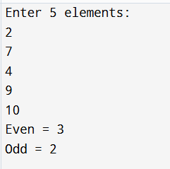
6. Program to Sort Array in Ascending Order
Code:
import java.util.Scanner;
public class SortArray {
public static void main(String[] args) {
Scanner sc = new Scanner(System.in);
int[] arr = new int[5];
int temp;
System.out.println("Enter 5 elements:");
for(int i = 0; i < 5; i++)
arr[i] = sc.nextInt();
for(int i = 0; i < 5; i++) {
for(int j = i + 1; j < 5; j++) {
if(arr[i] > arr[j]) {
temp = arr[i];
arr[i] = arr[j];
arr[j] = temp;
}
}
}
System.out.println("Sorted array:");
for(int i = 0; i < 5; i++)
System.out.print(arr[i] + " ");
}
}
OUTPUT:
Input:
45 12 78 23 9
Output:
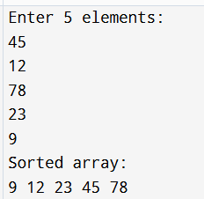
7. Program to Find Second Largest Element
Code:
import java.util.Scanner;
public class SecondLargest {
public static void main(String[] args) {
Scanner sc = new Scanner(System.in);
int[] arr = new int[5];
System.out.println("Enter 5 elements:");
for (int i = 0; i < 5; i++) {
arr[i] = sc.nextInt();
}
int largest = arr[0];
int second = Integer.MIN_VALUE;
for (int i = 0; i < 5; i++) {
if (arr[i] > largest) {
second = largest;
largest = arr[i];
}
else if (arr[i] > second && arr[i] != largest) {
second = arr[i];
}
}
System.out.println("Second largest = " + second);
}
}
OUTPUT:
Input:
10 45 23 89 67
Output:
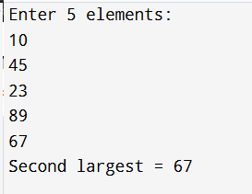
8. Program for Matrix Addition (2D Array)
Code:
import java.util.Scanner;
public class MatrixAddition {
public static void main(String[] args) {
Scanner sc = new Scanner(System.in);
int[][] a = new int[2][2];
int[][] b = new int[2][2];
int[][] sum = new int[2][2];
System.out.println("Enter elements of matrix A:");
for(int i = 0; i < 2; i++)
for(int j = 0; j < 2; j++)
a[i][j] = sc.nextInt();
System.out.println("Enter elements of matrix B:");
for(int i = 0; i < 2; i++)
for(int j = 0; j < 2; j++)
b[i][j] = sc.nextInt();
for(int i = 0; i < 2; i++)
for(int j = 0; j < 2; j++)
sum[i][j] = a[i][j] + b[i][j];
System.out.println("Sum matrix:");
for(int i = 0; i < 2; i++) {
for(int j = 0; j < 2; j++)
System.out.print(sum[i][j] + " ");
System.out.println();
}
}
}
OUTPUT:
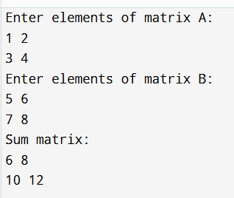

POST LAB EXERCISE
- Why is array indexing usually started from zero instead of one?
Because arrays are stored in memory as continuous blocks, and the index represents the offset from the first element.
Index 0 means 0 steps away from the first element (starting address).
Index 1 means 1 step away, and so on.
Starting from 0 makes this calculation simple and efficient.

- What happens if we try to access an array element outside its declared size?
This is called out of bounds access.

Possible outcomes:
Runtime error / exception (like in Python, Java)
Garbage value (like in C/C++)
Program crash / segmentation fault
May overwrite other memory (dangerous in C/C++)
Example: array size = 5 (indexes 0–4)
Accessing arr[5] is invalid.

- How does memory allocation differ for static arrays and dynamic arrays?

Static Array:
Memory allocated at compile time
Size is fixed
Stored in stack / static memory
Example: int a[10];

Dynamic Array:
Memory allocated at runtime
Size can be changed
Stored in heap memory
Example: int *a = new int[n]; (C++), malloc() (C)
✅ Dynamic arrays are more flexible but need proper memory handling.

- Why is searching faster in arrays compared to linked lists?
Because arrays allow direct access using index.

Array:
Random access possible
Access time: O(1)
Binary search possible (if sorted): O(log n)

Linked List:
No direct access
Must traverse node by node
Searching time: O(n) always
So arrays are faster for searching because of random access and contiguous memory.

- What is the difference between contiguous and non-contiguous memory allocation?

Contiguous Memory Allocation
Memory stored in continuous blocks
Example: Arrays
Faster access due to locality
Easy to calculate address
Example:
[1000][1004][1008][1012]

Non-contiguous Memory Allocation
Memory stored in separate blocks
Example: Linked List
Nodes connected using pointers
Slower access due to traversal
Example:
[1000] -> [3500] -> [8900]

Result:

Thus the array operations were executed successfully.

ASSESSMENT

Description | Max Marks | Marks Awarded
Pre Lab Exercise | 5
In Lab Exercise | 10
Post Lab Exercise | 5
Viva | 10
Total | 30
Faculty Signature

