Experiment Number : 02 Date: 28/01/2026

INPUT AND OUTPUT STATEMENTS IN JAVA
Aim:
To understand and use input and output statements in Java using the Scanner class.
PRE LAB EXERCISE
QUESTIONS
1.What is input in a program?
Data provided to a program for processing by the user or another source is called input.
2.What is output in a program?
A program's output is the outcome it produces following input processing.
3.Which class is used to read input from the user in Java?
In Java, the Scanner class is used to read user input.
IN LAB EXERCISE
Objective:
To read input from the user and display the output using Java input and output statements.
INPUT STATEMENT:
SCANNER CLASS
- The Scanner class in Java is used to read input from the user through the keyboard.
It is available in the package java.util.
- The Scanner object reads different types of input such as integer, float, double, and string and stores them in variables.
- To use the Scanner class, it must be imported before using it in the program.
SYNTAX:
- Scanner sc = new Scanner(System.in);
Commonly Used Scanner Methods:
- nextInt() – reads an integer value
- nextFloat() – reads a float value
- nextDouble() – reads a double value
- next() – reads a single word
- nextLine() – reads a complete line of text

PROGRAMS:
Program 1: Read and Display Name
Source Code:
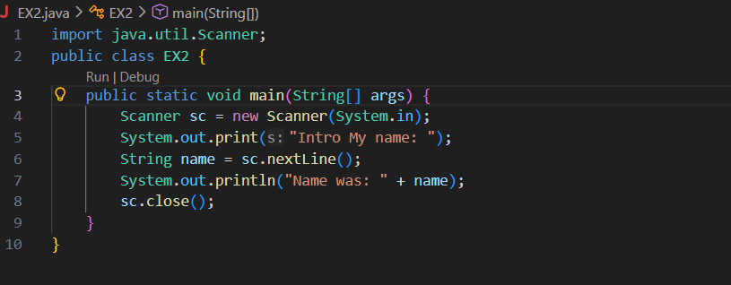Output:
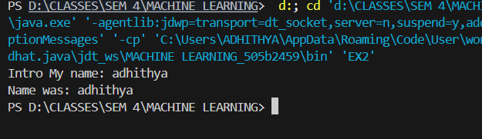
Program 2: Read Two Numbers and Print Sum
Source Code:
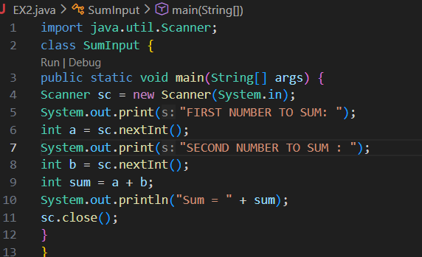Output:
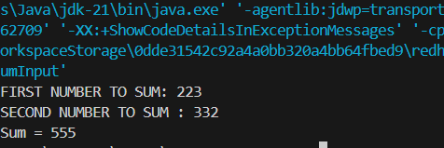
Program 3: Read Length and Breadth and Find Area of Rectangle
Source Code:
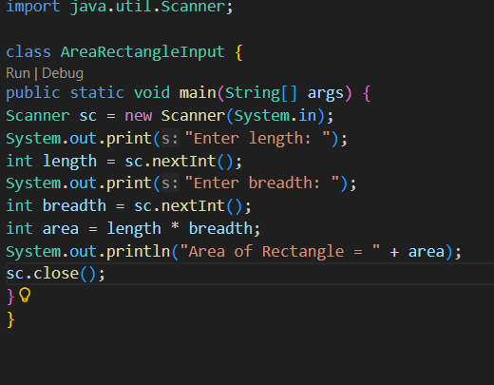
Output:
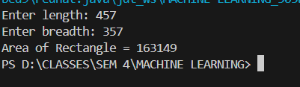

POST LAB EXERCISE
- What is the use of the Scanner class in Java?
  - When we want our program to take user input while it's operating, such as entering a name, age, or marks on the keyboard, we use the Scanner class.
- Which package contains the Scanner class?
  - Before utilizing Scanner, we must import the java.util package, which contains the Scanner class.
- What does System.in represent?
  - System.in denotes the program's input source, which is typically the keyboard. It indicates to Java the source of the input.
- What does System.out represent?
  - The output is shown on the screen using System.out. The console displays whatever we print using System.out.println().
- Name any two methods used to read input using Scanner.
  - Common scanner techniques include:

  - The function nextInt() is used to read numbers six.Only one word is read by the next() method, which ends when it encounters a space.
  - The entire sentence, including spaces, is read by the nextLine() method up until the Enter
- What is the difference between next() and nextLine()?
  - The next() method reads only one word and stops when it finds a space.
The nextLine() method reads the entire sentence, including spaces, until the Enter key is pressed.
Example:
If the input is Java is easy
- next() reads → Java
- nextLine() reads → Java is easy
Result:

Thus the input was successfully read from the user and the corresponding output was displayed using Java input and output statements.

ASSESSMENT

Description | Max Marks | Marks Awarded
Pre Lab Exercise | 5
In Lab Exercise | 10
Post Lab Exercise | 5
Viva | 10
Total | 30
Faculty Signature

