Experiment Number : 05 Date: 4/2/26

INHERITANCE
Aim:
To understand and implement inheritance concepts in Java.
PRE LAB EXERCISE
QUESTIONS
- What is inheritance?
Inheritance is an OOP concept where one class acquires the properties and methods of another class.
It helps create a new class based on an existing class.
- What is code reusability?
Code reusability means using existing code again instead of writing it from scratch.It saves time, reduces errors, and improves maintainability.
- What is the use of extends keyword?
The extends keyword is used to create a subclass from a superclass in Java.It allows the child class to inherit fields and methods from the parent class.
IN LAB EXERCISE
Objective:
To implement all types of inheritance.
PROGRAMS:
Student Result System (Single Inheritance)
Question:
A school wants to store student details and calculate marks. Create a base class Student and a derived class Result.
Code:
class Student {
String name;
int rollNo;

void getDetails() {
name = "Anitha";
rollNo = 101;
}
}

class Result extends Student {
int marks = 85;

void display() {
System.out.println("Name: " + name);
System.out.println("Roll No: " + rollNo);
System.out.println("Marks: " + marks);
}
}

public class Main {
public static void main(String[] args) {
Result r = new Result();
r.getDetails();
r.display();
}
}
Output:
Name: RAM
Roll No: 101
Marks: 85
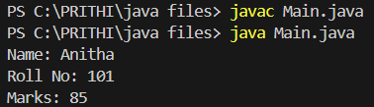

2. Bank Account System (Hierarchical Inheritance)
Question:
A bank has Savings and Current accounts. Both inherit from a common Account class.
Code:
class Account {
void showAccountType() {
System.out.println("Bank Account");
}
}
class SavingsAccount extends Account {
void interest() {
System.out.println("Savings Account gives interest");
}
}
class CurrentAccount extends Account {
void overdraft() {
System.out.println("Current Account supports overdraft");
}
}
public class Main {
public static void main(String[] args) {
SavingsAccount s = new SavingsAccount();
CurrentAccount c = new CurrentAccount();

s.showAccountType();
s.interest();

c.showAccountType();
c.overdraft();
}
}

Output:
Bank Account
Savings Account gives interest
Bank Account
Current Account supports overdraft
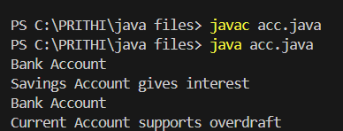
3. Vehicle System (Multilevel Inheritance)
Question:
A company classifies vehicles as Vehicle → Car → ElectricCar.
Code:
class Vehicle {
void start() {
System.out.println("Vehicle starts");
}
}
class Car extends Vehicle {
void fuelType() {
System.out.println("Car uses petrol");
}
}
class ElectricCar extends Car {
void battery() {
System.out.println("Electric car uses battery");
}
}
public class car {
public static void main(String[] args) {
ElectricCar e = new ElectricCar();
e.start();
e.fuelType();
e.battery();
}
}
Output:
Vehicle starts
Car uses petrol
Electric car uses battery
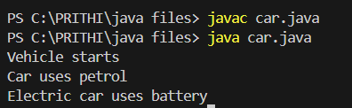

POST LAB EXERCISE
- Why Java does not support multiple inheritance using classes and how it is implemented?
Java does not support multiple inheritance with classes to avoid ambiguity and diamond problems.It is implemented using interfaces, where a class can implement multiple interfaces.

- What is the role of the super keyword? Give examples.
- super is used to access parent class variables, methods, and constructors.
Example: super.name; or super.show(); or super(); calls parent constructor.

- Can a child class access private members of the parent class? Why?
No, private members are not accessible outside the parent class. They are hidden to ensure data security and encapsulation.
- Explain why hybrid inheritance is not supported in Java.
Hybrid inheritance combines multiple and hierarchical inheritance, which can cause ambiguity.Since Java avoids multiple class inheritance, hybrid inheritance is also not supported (only via interfaces).
Result:
Thus the different types of inheritance were implemented and executed successfully.

ASSESSMENT

Description | Max Marks | Marks Awarded
Pre Lab Exercise | 5
In Lab Exercise | 10
Post Lab Exercise | 5
Viva | 10
Total | 30
Faculty Signature

