Experiment Number : 04 Date: 05.02.26

ARRAYS
Aim:
To understand and implement array operations in Java.
PRE LAB EXERCISE
QUESTIONS
- What is an array?
An array is a collection of elements of the same data type stored in continuous memory locations. Each element in an array is accessed using an index number.
Example: An array can store marks of 50 students in a single variable.

- Why are arrays used?
Arrays are used because:
- They store multiple values under a single name.
- They make programs shorter and easier to manage.
- They allow easy access to data using index positions.
- They help in performing operations like sorting, searching, and looping efficiently.

- What is the difference between array and variable?
Variable Array
Stores only one value Stores multiple values
Uses a single memory location Uses multiple memory locations
Cannot store a list of data Can store a list of same-type data
Example: int a = 10; Example: int a[5] = {1,2,3,4,5};
IN LAB EXERCISE
Objective:
To perform array operations using simple programs.
PROGRAMS:
1. Program to Read and Print Array Elements
Code:
import java.util.Scanner;
public class ReadPrintArray {
public static void main(String[] args) {
Scanner sc = new Scanner(System.in);
int[] arr = new int[5];
System.out.println("Enter 5 elements:");
for(int i = 0; i < 5; i++)
arr[i] = sc.nextInt();
System.out.println("Array elements are:");
for(int i = 0; i < 5; i++)
System.out.print(arr[i] + " ");
}
}
OUTPUT:
Input:
2 4 5 6 7
Output:
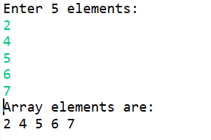
2. Program to Find Sum of Array Elements
Code:
import java.util.Scanner;
public class SumArray {
public static void main(String[] args) {
Scanner sc = new Scanner(System.in);
int[] arr = new int[5];
int sum = 0;
System.out.println("Enter 5 elements:");
for(int i = 0; i < 5; i++)
arr[i] = sc.nextInt();
for(int i = 0; i < 5; i++)
sum += arr[i];
System.out.println("Sum = " + sum);
}
}
OUTPUT:
Input:
5 8 3 9 2
Output:
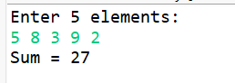

3. Program to Find Largest Element in an Array
Code:
import java.util.Scanner;
public class LargestElement {
public static void main(String[] args) {
Scanner sc = new Scanner(System.in);
int[] arr = new int[5];
System.out.println("Enter 5 elements:");
for(int i = 0; i < 5; i++)
arr[i] = sc.nextInt();
int max = arr[0];
for(int i = 1; i < 5; i++)
if(arr[i] > max)
max = arr[i];
System.out.println("Largest element = " + max);
}
}
OUTPUT:
Input:
129 276 90 498 388
Output:
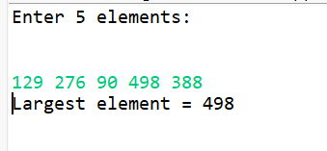
4. Program to Reverse an Array
Code:
import java.util.Scanner;

public class ReverseArray {
public static void main(String[] args) {
Scanner sc = new Scanner(System.in);
int[] arr = new int[5];
System.out.println("Enter 5 elements:");
for(int i = 0; i < 5; i++)
arr[i] = sc.nextInt();
System.out.println("Reversed array:");
for(int i = 4; i >= 0; i--)
System.out.print(arr[i] + " ");
}
}
OUTPUT:
Input:
1 2 3 4 5
Output:
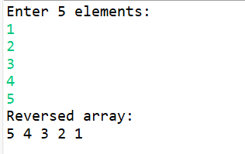
5. Program to Count Even and Odd Numbers
Code:
import java.util.Scanner;
public class EvenOddCount {
public static void main(String[] args) {
Scanner sc = new Scanner(System.in);
int[] arr = new int[5];
int even = 0, odd = 0;
System.out.println("Enter 5 elements:");
for(int i = 0; i < 5; i++)
arr[i] = sc.nextInt();
for(int i = 0; i < 5; i++) {
if(arr[i] % 2 == 0)
even++;
else
odd++;
}

System.out.println("Even = " + even);
System.out.println("Odd = " + odd);
}
}
OUTPUT:
Input:
4 9 2 5 1
Output:
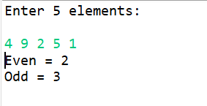
6. Program to Sort Array in Ascending Order
Code:
import java.util.Scanner;
public class SortArray {
public static void main(String[] args) {
Scanner sc = new Scanner(System.in);
int[] arr = new int[5];
int temp;
System.out.println("Enter 5 elements:");
for(int i = 0; i < 5; i++)
arr[i] = sc.nextInt();
for(int i = 0; i < 5; i++) {
for(int j = i + 1; j < 5; j++) {
if(arr[i] > arr[j]) {
temp = arr[i];
arr[i] = arr[j];
arr[j] = temp;
}
}
}
System.out.println("Sorted array:");
for(int i = 0; i < 5; i++)
System.out.print(arr[i] + " ");
}
}
OUTPUT:
Input:
45 89 76 32 44
Output:
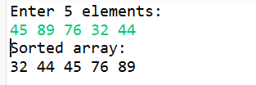
7. Program to Find Second Largest Element
Code:
import java.util.Scanner;
public class SecondLargest {
public static void main(String[] args) {
Scanner sc = new Scanner(System.in);
int[] arr = new int[5];

System.out.println("Enter 5 elements:");
for(int i = 0; i < 5; i++)
arr[i] = sc.nextInt();
int largest = arr[0];
int second = arr[0];
for(int i = 0; i < 5; i++) {
if(arr[i] > largest) {
second = largest;
largest = arr[i];
}
}
System.out.println("Second largest = " + second);
}
}
OUTPUT:
Input:
34 56 87 23 45
Output:
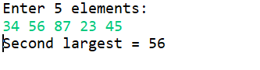
8. Program for Matrix Addition (2D Array)
Code:
import java.util.Scanner;
public class MatrixAddition {
public static void main(String[] args) {
Scanner sc = new Scanner(System.in);
int[][] a = new int[2][2];
int[][] b = new int[2][2];
int[][] sum = new int[2][2];
System.out.println("Enter elements of matrix A:");
for(int i = 0; i < 2; i++)
for(int j = 0; j < 2; j++)
a[i][j] = sc.nextInt();
System.out.println("Enter elements of matrix B:");
for(int i = 0; i < 2; i++)
for(int j = 0; j < 2; j++)
b[i][j] = sc.nextInt();
for(int i = 0; i < 2; i++)
for(int j = 0; j < 2; j++)
sum[i][j] = a[i][j] + b[i][j];
System.out.println("Sum matrix:");
for(int i = 0; i < 2; i++) {
for(int j = 0; j < 2; j++)
System.out.print(sum[i][j] + " ");
System.out.println();
}
}
}
OUTPUT:
Matrix A:
4 5
9 8
Matrix B:
3 5
9 0
Sum matrix:
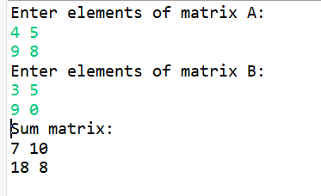

POST LAB EXERCISE
- Why is array indexing usually started from zero instead of one?
Array indexing starts from zero because the index represents the offset from the starting memory address.
- Index 0 means the first element is at the base address.
- This makes address calculation faster and more efficient for the computer.

- What happens if we try to access an array element outside its declared size?
Accessing an element outside the array size causes an error or unexpected behavior.
- It may produce garbage values
- It can cause a runtime error or program crash
- It may overwrite other data in memory
This is called array index out of bounds.

- How does memory allocation differ for static arrays and dynamic arrays?
Static Array | Dynamic Array
Size is fixed at compile time | Size can be changed at runtime
Memory allocated in stack | Memory allocated in heap
Faster but less flexible | Slower but more flexible
Example: int a[10]; | Example: malloc(), new

- Why is searching faster in arrays compared to linked lists?
Searching is faster in arrays because:
- Arrays support direct access using index numbers.
- Binary search can be applied on sorted arrays.
- Linked lists require sequential access, checking each node one by one.

- What is the difference between contiguous and non-contiguous memory allocation?
Contiguous Memory Allocation | Non-Contiguous Memory Allocation
Memory is stored in continuous locations | Memory is stored in separate locations
Faster data access | Slower data access
Used in arrays | Used in linked lists
Easy address calculation | Requires pointers

Result:

Thus the array operations were executed successfully.

ASSESSMENT

Description | Max Marks | Marks Awarded
Pre Lab Exercise | 5
In Lab Exercise | 10
Post Lab Exercise | 5
Viva | 10
Total | 30
Faculty Signature

