Experiment Number : 03 Date: 28/01/2026

CONTROL STATEMENTS IN JAVA
Aim:
To understand and implement decision-making and looping control statements in Java.
PRE LAB EXERCISE
QUESTIONS
- List different control statements in Java.
Decision statements: if, if-else, switch Looping statements: for, while, do-while Jump statements: break, continue, return

- Difference between for, while, and do-while loops.
for – Used when the number of iterations is known. while – Used when the condition is checked first. do-while – Executes at least once before checking if the condition
- What is the use of break and continue?
break – Stops the loop immediately.
continue – Skips the current iteration and continues the loop.

IN LAB EXERCISE
Objective:
To implement if-else and looping statements.
INPUT STATEMENT:
SCANNER CLASS
- The Scanner class in Java is used to read input from the user through the keyboard.
It is available in the package java.util.
- The Scanner object reads different types of input such as integer, float, double, and string and stores them in variables.
- To use the Scanner class, it must be imported before using it in the program.
SYNTAX:
- Scanner sc = new Scanner(System.in);
Commonly Used Scanner Methods:
- nextInt() – reads an integer value
- nextFloat() – reads a float value
- nextDouble() – reads a double value
- next() – reads a single word
- nextLine() – reads a complete line of text

PROGRAMS:
Program 1: Check Whether a Number is Positive
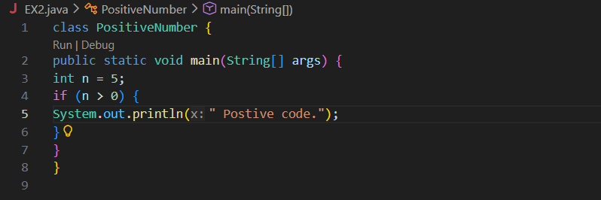
Output:
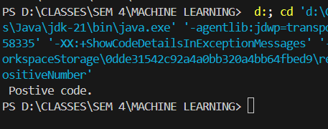
Program 2: Check Whether a Number is Even or Odd
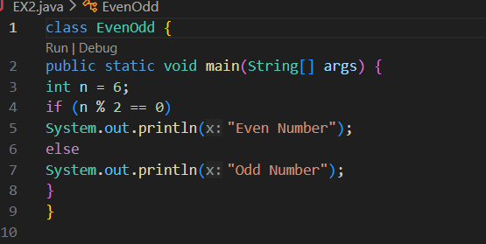
Output:
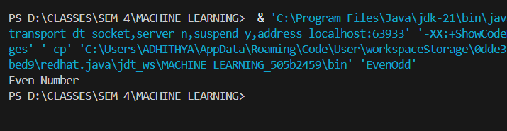Program 3: Find Largest of Two Numbers
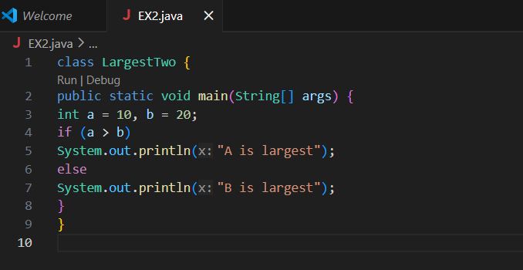Output:
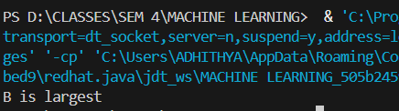
Program 4: Grade Calculation
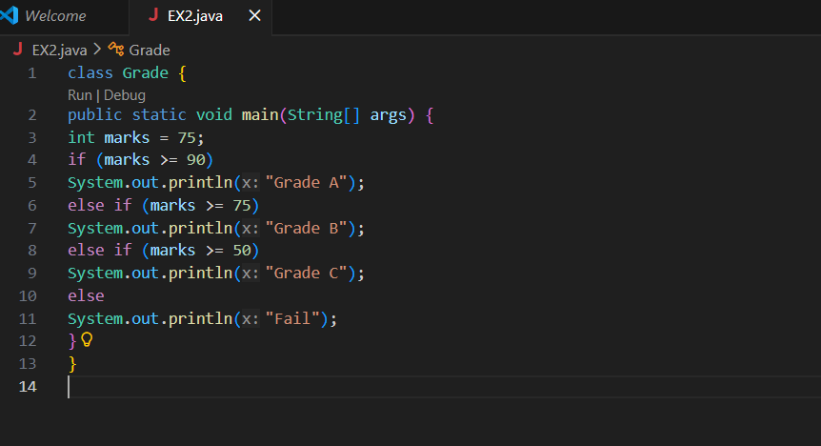Output:
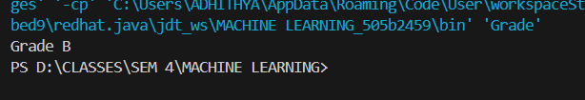
Program 5: Day of the Week
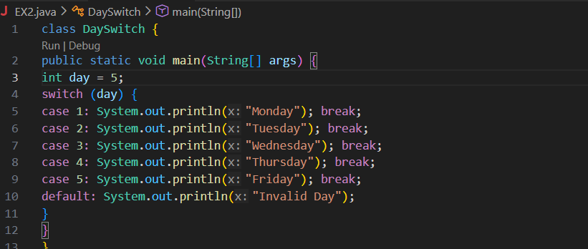Output:
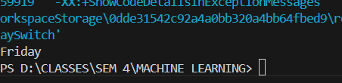
Program 6: Print Numbers from 1 to 5
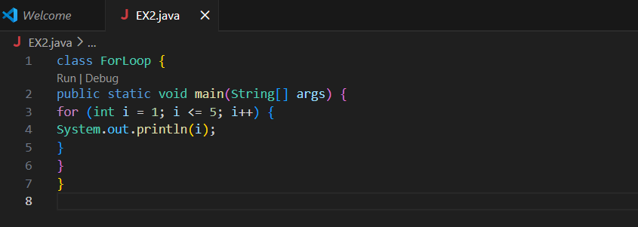
Output:
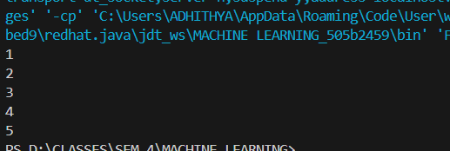

Program 7: Print Numbers from 1 to 5
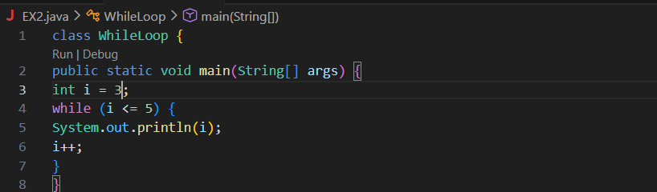
Output:
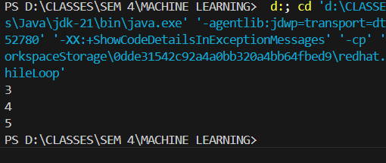

Program 8: Print Numbers from 1 to 5
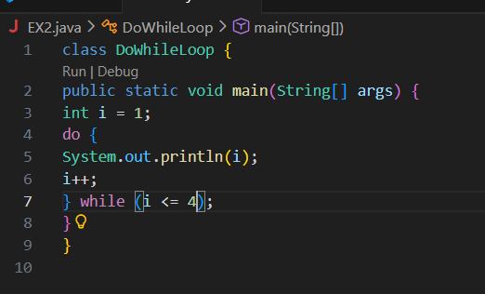
Output:
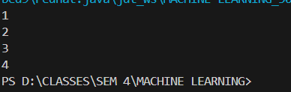
Program 9: Sum of First 5 Natural Numbers
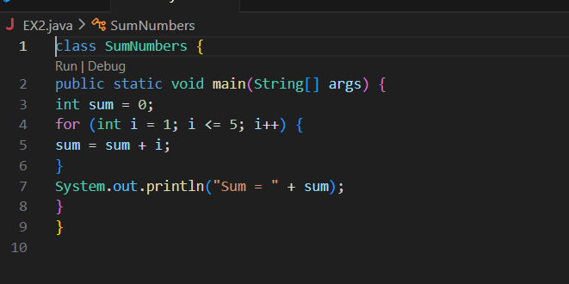Output:
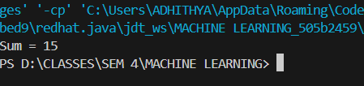
Program 10: Multiplication Table of a Number
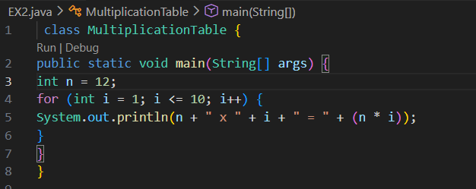
Output:
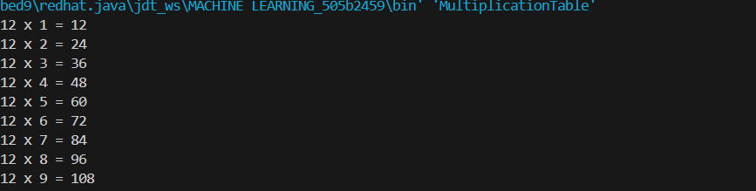

POST LAB EXERCISE
- What is the use of if statement?
If statement is used to execute code only when a condition is true.

- Difference between if-else and else-if ladder.
If-else handles two outcomes, while else-if ladder handles multiple conditions.

3.Why is switch statement used?
Switch statement is used to select one option from many based on a single expression.

4.Difference between for, while, and do-while loops.
For is for known iterations, while for unknown iterations, and do-while ensures one execution before checking.

- Which loop executes at least once?
Do-while loop executes at least once regardless of the condition.

.

Result:

Thus the different control statements were executed successfully with expected output.

ASSESSMENT

Description | Max Marks | Marks Awarded
Pre Lab Exercise | 5
In Lab Exercise | 10
Post Lab Exercise | 5
Viva | 10
Total | 30
Faculty Signature

