Experiment Number : 03 Date: 28.01.26

Control Statements in Java
Aim:
To understand and implement decision-making and looping control statements in Java.
PRE LAB EXERCISE
QUESTIONS
- List different control statements in Java.
Control statements in Java are used to control the flow of execution of a program. They are classified into:
a) Selection (Decision-making) statements
- if
- if-else
- switch
b) Iteration (Looping) statements
- for
- while
- do-while
c) Jump statements
- break
- continue
- return

- Difference between for, while, and do-while loops.
Feature | for loop | while loop | do-while loop
Condition checking | Before loop starts | Before loop starts | After loop execution
Minimum execution | May execute 0 times | May execute 0 times | Executes at least once
Usage | When number of iterations is known | When iterations are unknown | When loop must run at least once
Syntax structure | Initialization, condition, update in one line | Only condition in loop | Condition at the end

- What is the use of break and continue?
break
Used to terminate the loop or switch statement immediately and transfer control outside it.
continue
Used to skip the current iteration of a loop and continue with the next iteration.

IN LAB EXERCISE
Objective:
To implement if-else and looping statements.
INPUT STATEMENT:
SCANNER CLASS
- The Scanner class in Java is used to read input from the user through the keyboard.
It is available in the package java.util.
- The Scanner object reads different types of input such as integer, float, double, and string and stores them in variables.
- To use the Scanner class, it must be imported before using it in the program.
SYNTAX:
- Scanner sc = new Scanner(System.in);
Commonly Used Scanner Methods:
- nextInt() – reads an integer value
- nextFloat() – reads a float value
- nextDouble() – reads a double value
- next() – reads a single word
- nextLine() – reads a complete line of text

PROGRAMS:
Program 1: Check Whether a Number is Positive
class PositiveNumber {
public static void main(String[] args) {
int n = 5;
if (n > 0) {
System.out.println("Positive Number");
}
}
}
Output:
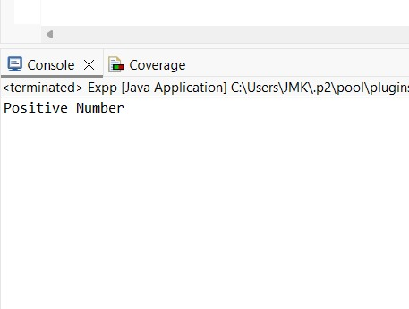
Program 2: Check Whether a Number is Even or Odd
class EvenOdd {
public static void main(String[] args) {
int n = 6;
if (n % 2 == 0)
System.out.println("Even Number");
else
System.out.println("Odd Number");
}
}
Output:

Program 3: Find Largest of Two Numbers
class LargestTwo {
public static void main(String[] args) {
int a = 10, b = 20;
if (a > b)
System.out.println("A is largest");
else
System.out.println("B is largest");
}
}
Output:
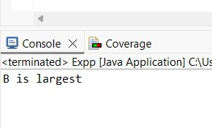

Program 4: Grade Calculation
class Grade {
public static void main(String[] args) {
int marks = 75;
if (marks >= 90)
System.out.println("Grade A");
else if (marks >= 75)
System.out.println("Grade B");
else if (marks >= 50)
System.out.println("Grade C");
else
System.out.println("Fail");
}
}
Output:

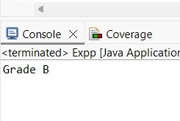
Program 5: Day of the Week
class DaySwitch {
public static void main(String[] args) {
int day = 4;
switch (day) {
case 1: System.out.println("Monday"); break;
case 2: System.out.println("Tuesday"); break;
case 3: System.out.println("Wednesday"); break;
case 4: System.out.println("Thursday"); break;
case 5: System.out.println("Friday"); break;
default: System.out.println("Invalid Day");
}
}
}
Output:
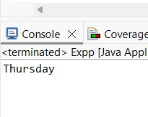

Program 6: Print Numbers from 1 to 5
class ForLoop {
public static void main(String[] args) {
for (int i = 1; i <= 5; i++) {
System.out.println(i);
}
}
}
Output:
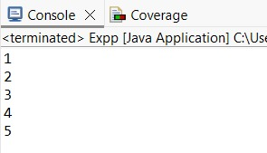

Program 7: Print Numbers from 1 to 5
class WhileLoop {
public static void main(String[] args) {
int i = 1;
while (i <= 5) {
System.out.println(i);
i++;
}
}
}
Output:
Program 8: Print Numbers from 1 to 5
class DoWhileLoop {
public static void main(String[] args) {
int i = 1;
do {
System.out.println(i);
i++;
} while (i <= 5);
}
}
Output:

Program 9: Sum of First 5 Natural Numbers
class SumNumbers {
public static void main(String[] args) {
int sum = 0;
for (int i = 1; i <= 5; i++) {
sum = sum + i;
}
System.out.println("Sum = " + sum);
}
}
Output:
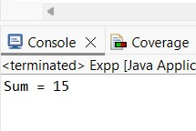

Program 10: Multiplication Table of a Number
class MultiplicationTable {
public static void main(String[] args) {
int n = 5;
for (int i = 1; i <= 10; i++) {
System.out.println(n + " x " + i + " = " + (n * i));
}
}
}
Output:

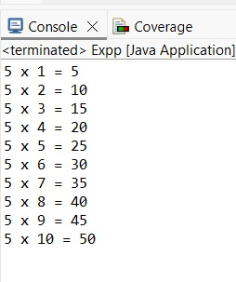

POST LAB EXERCISE
- What is the use of if statement?
The if statement is used to test a condition and execute a block of code only if the condition is true.

- Difference between if-else and else-if ladder.
if-else | else-if ladder
Used to check one condition | Used to check multiple conditions
Has only two paths (true / false) | Has multiple conditions evaluated in order
Simple decision making | Multi-way decision making

- Why is switch statement used?
The switch statement is used to select one block of code from multiple options based on the value of an expression.
It improves readability and efficiency when comparing many fixed values.

- Difference between for, while, and do-while loops.

Feature | for | while | do-while
Condition check | Before loop | Before loop | After loop
Minimum execution | 0 times | 0 times | At least once
Best used when | Iteration count is known | Iteration count is unknown | Loop must run at least once

- Which loop executes at least once?
The do-while loop executes at least once because the condition is checked after the loop body.
Result:

Thus the different control statements were executed successfully with expected output.

ASSESSMENT

Description | Max Marks | Marks Awarded
Pre Lab Exercise | 5
In Lab Exercise | 10
Post Lab Exercise | 5
Viva | 10
Total | 30
Faculty Signature

