Experiment Number : 03 Date: 29/01/2026

Control Statements in Java
Aim:
To understand and implement decision-making and looping control statements in Java.
PRE LAB EXERCISE
QUESTIONS
- List different control statements in Java.

- Decision (selection) statements
  - ‎`if`
  - ‎`if-else`
  - ‎`if-else if-else`
  - ‎`switch`
- Looping (iteration) statements
  - ‎`for`
  - ‎`while`
  - ‎`do-while`
  - (Enhanced ‎`for-each` loop)
- Jump statements
  - ‎`break`
  - ‎`continue`
  - ‎`return`

- Difference between for, while, and do-while loops.

- ‎`for` loop
  - Syntax: initialization, condition, update all in one line.
  - Used when you know in advance how many times to repeat.
  - Condition is checked before each iteration.
  - May execute zero or more times.
- ‎`while` loop
  - Condition is checked before each iteration.
  - Used when you don’t know the number of iterations and loop depends on a condition.
  - May execute zero or more times.
- ‎`do-while` loop
  - Body runs first, then condition is checked.
  - So it executes at least once, even if the condition is false the first time.
  - Used when you want the loop body to run at least once (e.g., menu, asking input).

- What is the use of break and continue?

- ‎`break`
  - Immediately exits the nearest loop (‎`for`, ‎`while`, ‎`do-while`) or ‎`switch` block.
  - Control moves to the statement after the loop/switch.
  - Used when you want to stop the loop early.
- ‎`continue`
  - Skips the rest of the current iteration and jumps to the next iteration of the loop.
  - In ‎`for`: goes to the update step, then checks condition.
  - In ‎`while`/‎`do-while`: directly goes to condition check.
  - Used when you want to ignore some cases but keep looping.

IN LAB EXERCISE
Objective:
To implement if-else and looping statements.
INPUT STATEMENT:
SCANNER CLASS
- The Scanner class in Java is used to read input from the user through the keyboard.
It is available in the package java.util.
- The Scanner object reads different types of input such as integer, float, double, and string and stores them in variables.
- To use the Scanner class, it must be imported before using it in the program.
SYNTAX:
- Scanner sc = new Scanner(System.in);
Commonly Used Scanner Methods:
- nextInt() – reads an integer value
- nextFloat() – reads a float value
- nextDouble() – reads a double value
- next() – reads a single word
- nextLine() – reads a complete line of text

PROGRAMS:
Program 1: Check Whether a Number is Positive
class PositiveNumber {
public static void main(String[] args) {
int n = 5;
if (n > 0) {
System.out.println("Positive Number");
}
}
}
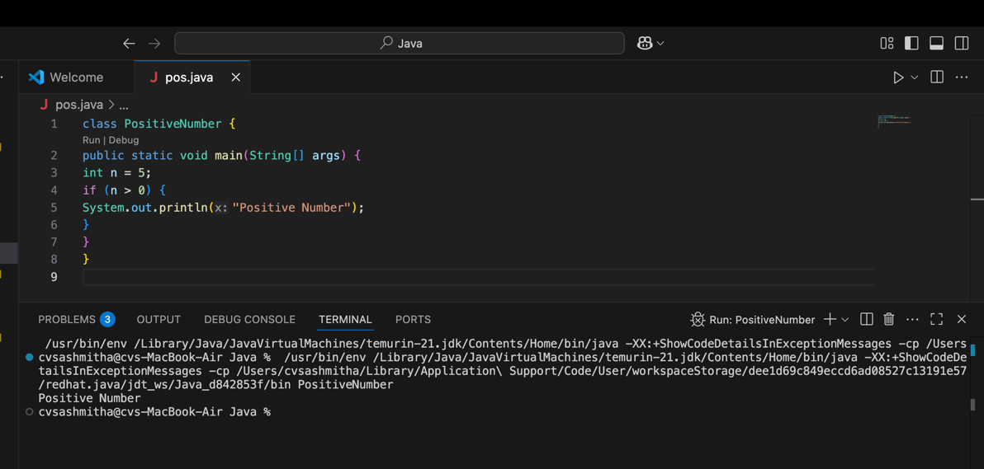
Output:
Positive Number
Program 2: Check Whether a Number is Even or Odd
class EvenOdd {
public static void main(String[] args) {
int n = 6;
if (n % 2 == 0)
System.out.println("Even Number");
else
System.out.println("Odd Number");
}
}
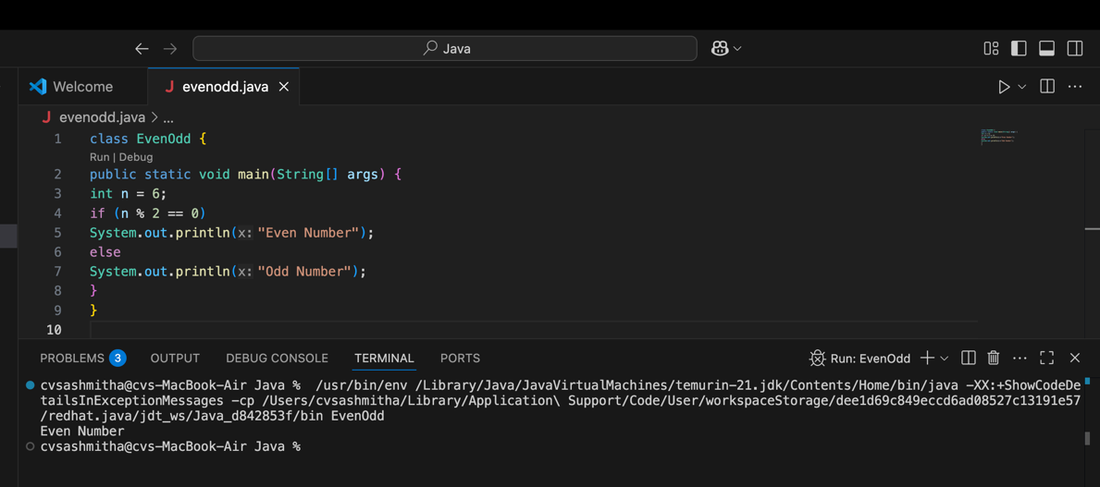
Output:
Even Number
Program 3: Find Largest of Two Numbers
class LargestTwo {
public static void main(String[] args) {
int a = 10, b = 20;
if (a > b)
System.out.println("A is largest");
else
System.out.println("B is largest");
}
}
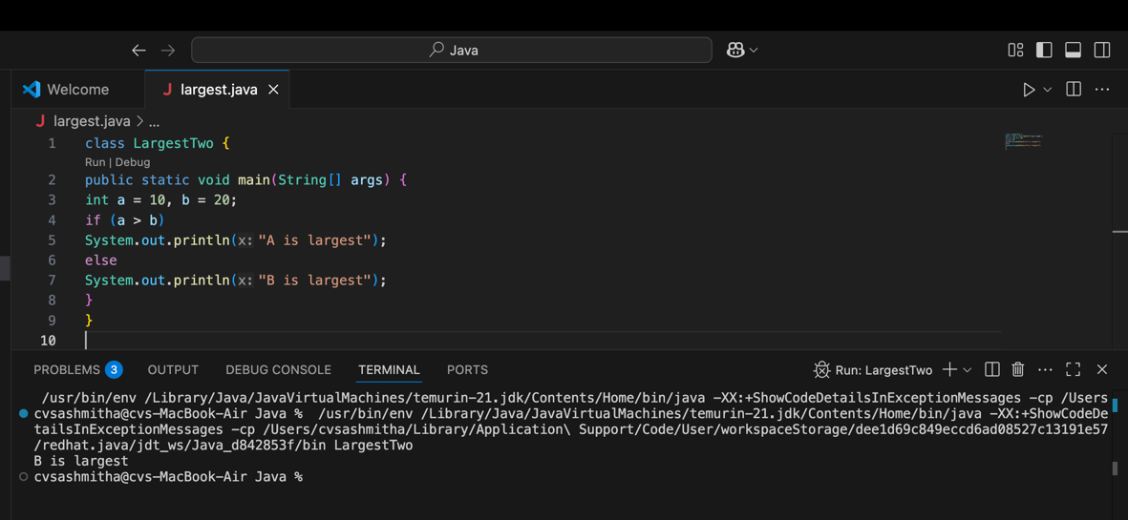
Output:
B is largest
Program 4: Grade Calculation
class Grade {
public static void main(String[] args) {
int marks = 75;
if (marks >= 90)
System.out.println("Grade A");
else if (marks >= 75)
System.out.println("Grade B");
else if (marks >= 50)
System.out.println("Grade C");
else
System.out.println("Fail");
}
}
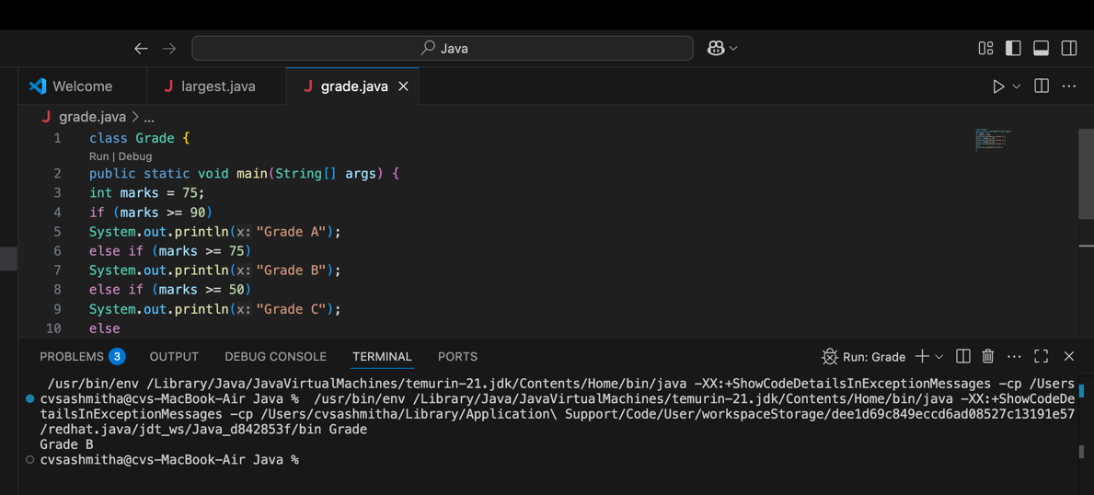
Output:
Grade B
Program 5: Day of the Week
class DaySwitch {
public static void main(String[] args) {
int day = 3;
switch (day) {
case 1: System.out.println("Monday"); break;
case 2: System.out.println("Tuesday"); break;
case 3: System.out.println("Wednesday"); break;
case 4: System.out.println("Thursday"); break;
case 5: System.out.println("Friday"); break;
default: System.out.println("Invalid Day");
}
}
}
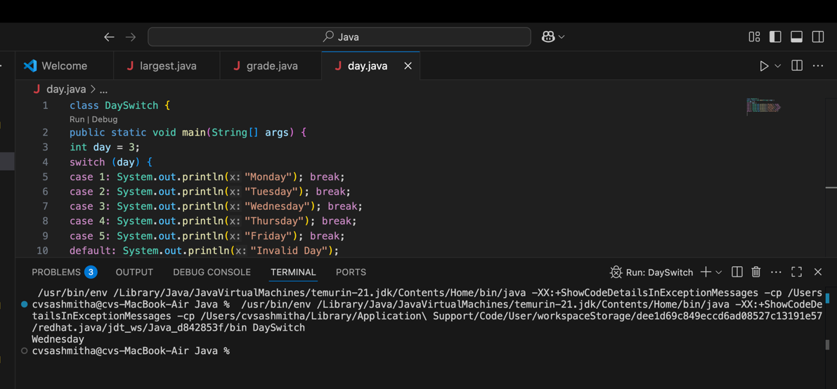
Output:
Wednesday
Program 6: Print Numbers from 1 to 5
class ForLoop {
public static void main(String[] args) {
for (int i = 1; i <= 5; i++) {
System.out.println(i);
}
}
}
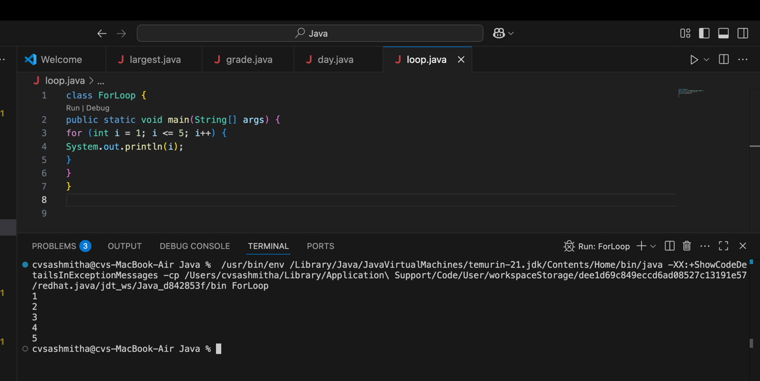
Output:
1
2
3
4
5

Program 7: Print Numbers from 1 to 5
class WhileLoop {
public static void main(String[] args) {
int i = 1;
while (i <= 5) {
System.out.println(i);
i++;
}
}
}
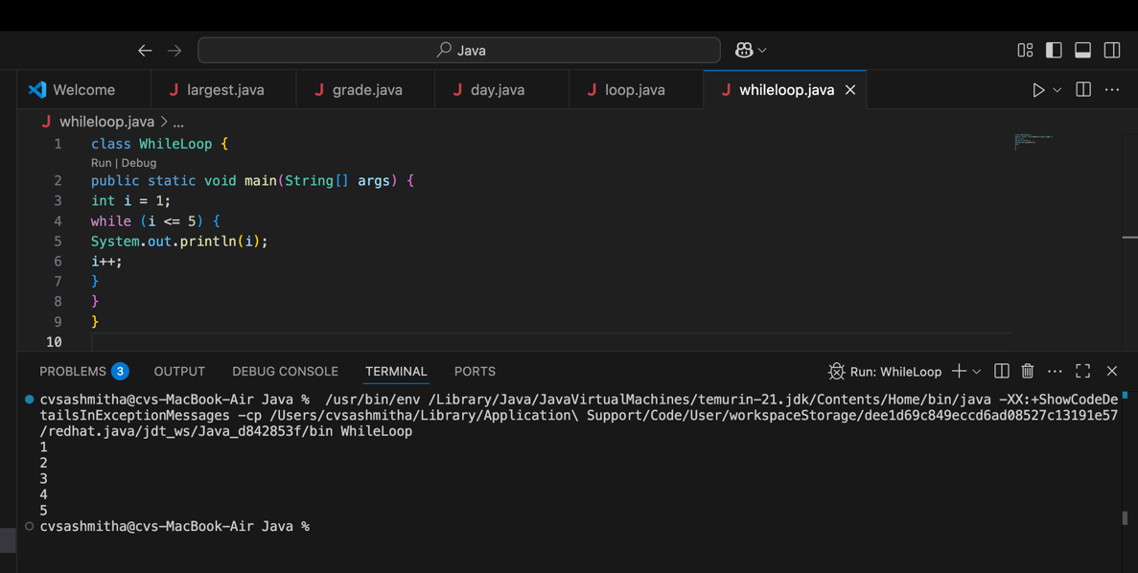
Output:
1
2
3
4
5

Program 8: Print Numbers from 1 to 5
class DoWhileLoop {
public static void main(String[] args) {
int i = 1;
do {
System.out.println(i);
i++;
} while (i <= 5);
}
}
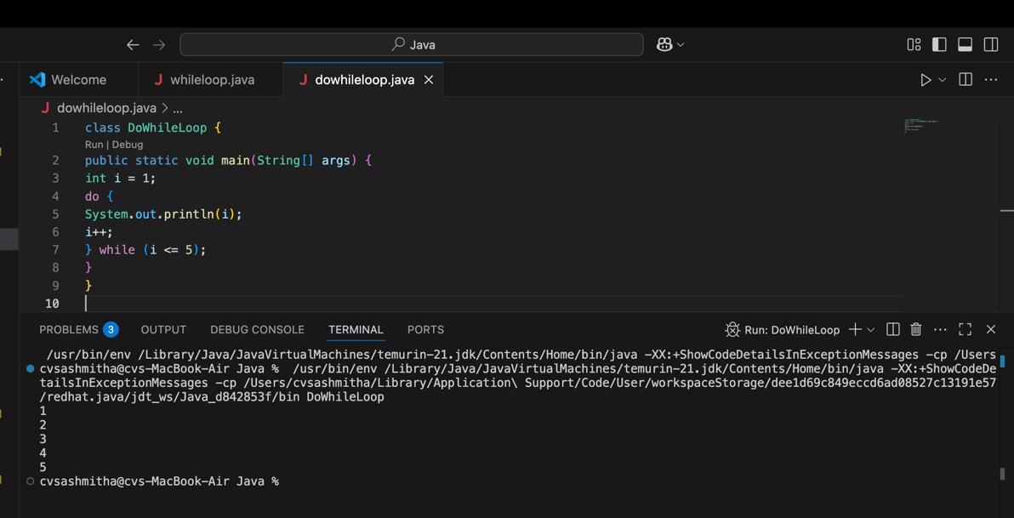
Output:
1
2
3
4
5

Program 9: Sum of First 5 Natural Numbers
class SumNumbers {
public static void main(String[] args) {
int sum = 0;
for (int i = 1; i <= 5; i++) {
sum = sum + i;
}
System.out.println("Sum = " + sum);
}
}
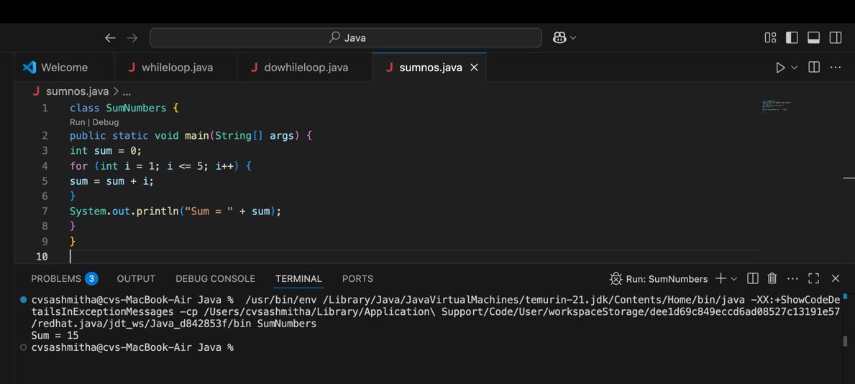
Output:
Sum = 15
Program 10: Multiplication Table of a Number
class MultiplicationTable {
public static void main(String[] args) {
int n = 5;
for (int i = 1; i <= 10; i++) {
System.out.println(n + " x " + i + " = " + (n * i));
}
}
}
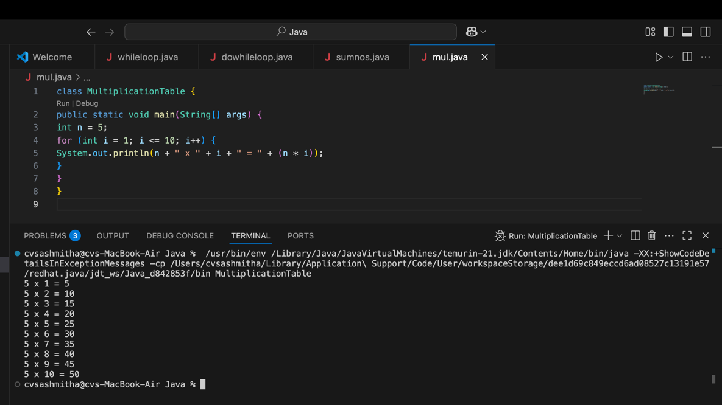
Output:
5 x 1 = 5
5 x 2 = 10
5 x 3 = 15
5 x 4 = 20
5 x 5 = 25
5 x 6 = 30
5 x 7 = 35
5 x 8 = 40
5 x 9 = 45
5 x 10 = 50

POST LAB EXERCISE
- What is the use of if statement?
`if` is used for decision-making.
It allows the program to execute a block of code only if a given condition is true.

- Difference between if-else and else-if ladder.
‎`if-else`
  - Used when there are two choices: one for ‎`true`, one for ‎`false`.
  - Only one condition is checked
`else-if` ladder
  - Used when there are more than two possible conditions.
  - Multiple conditions are checked one by one from top to bottom.
  - As soon as one condition is true, that block runs and the rest are skipped.

- Why is switch statement used?
`switch` is used for multi-way selection based on the value of a single expression (like ‎`int`, ‎`char`, ‎`String`, etc.).
It is often cleaner and more readable than writing many ‎`else-if` statements when you are comparing the same variable to many constant values.

- Difference between for, while, and do-while loops.
`for` loop
  - Initialization, condition, and update are in one line.
  - Best when the number of iterations is known.
  - Condition is checked before each iteration.
  - Executes 0 or more times.
`while` loop
  - Only condition in the loop line.
  - Used when the number of iterations is not known and depends on a condition.
  - Condition is checked before each iteration.
  - Executes 0 or more times.

‎`do-while` loop
  - The loop body runs first, then condition is checked.
  - Executes at least once, even if the condition is false initially.
  - Used when you need the body to run at least once (e.g., menus, asking for input once).

- Which loop executes at least once?
The ‎`do-while` loop always executes its body at least once, because the condition is checked after the body is executed.

Result:

Thus the different control statements were executed successfully with expected output.

ASSESSMENT

Description | Max Marks | Marks Awarded
Pre Lab Exercise | 5
In Lab Exercise | 10
Post Lab Exercise | 5
Viva | 10
Total | 30
Faculty Signature

