Experiment Number : 05 Date: 05.02.2026

INHERITANCE
Aim:
To understand and implement inheritance concepts in Java.
PRE LAB EXERCISE
QUESTIONS
- What is inheritance?
Inheritance is an OOP concept where one class acquires the properties and behaviors (variables and methods) of another class.
It helps create a relationship between classes.
- What is code reusability?
Code reusability means using existing code again instead of writing it from scratch.
Inheritance allows a child class to reuse the parent class methods and variables, saving time and effort.
- What is the use of extends keyword?
The extends keyword is used to inherit one class from another class in Java.
IN LAB EXERCISE
Objective:
To implement all types of inheritance.
PROGRAMS:
Student Result System (Single Inheritance)
Question:
A school wants to store student details and calculate marks. Create a base class Student and a derived class Result.
Code:
class Student {
String name;
int rollNo;

void getDetails() {
name = "Anitha";
rollNo = 101;
}
}

class Result extends Student {
int marks = 85;

void display() {
System.out.println("Name: " + name);
System.out.println("Roll No: " + rollNo);
System.out.println("Marks: " + marks);
}
}

public class Main {
public static void main(String[] args) {
Result r = new Result();
r.getDetails();
r.display();
}
}
Output:
Name: RAM
Roll No: 101
Marks: 85
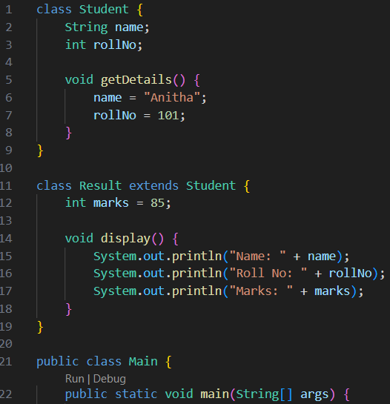
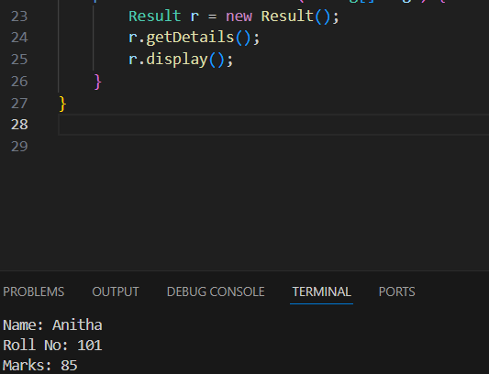

2. Bank Account System (Hierarchical Inheritance)
Question:
A bank has Savings and Current accounts. Both inherit from a common Account class.
Code:
class Account {
void showAccountType() {
System.out.println("Bank Account");
}
}

class SavingsAccount extends Account {
void interest() {
System.out.println("Savings Account gives interest");
}
}

class CurrentAccount extends Account {
void overdraft() {
System.out.println("Current Account supports overdraft");
}
}

public class Main {
public static void main(String[] args) {
SavingsAccount s = new SavingsAccount();
CurrentAccount c = new CurrentAccount();

s.showAccountType();
s.interest();

c.showAccountType();
c.overdraft();
}
}
Output:
Bank Account
Savings Account gives interest
Bank Account
Current Account supports overdraft
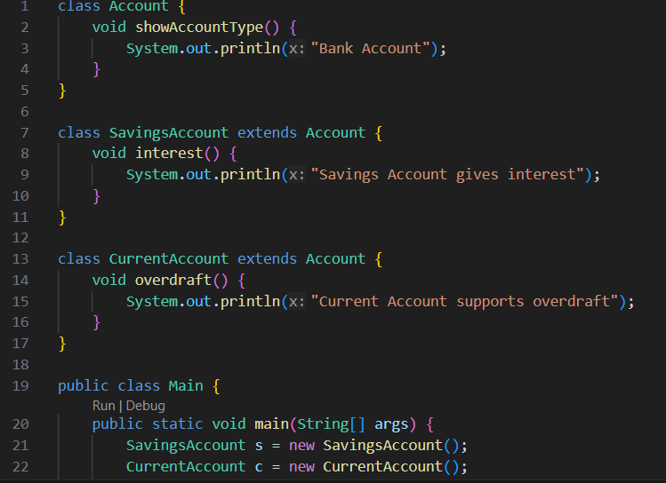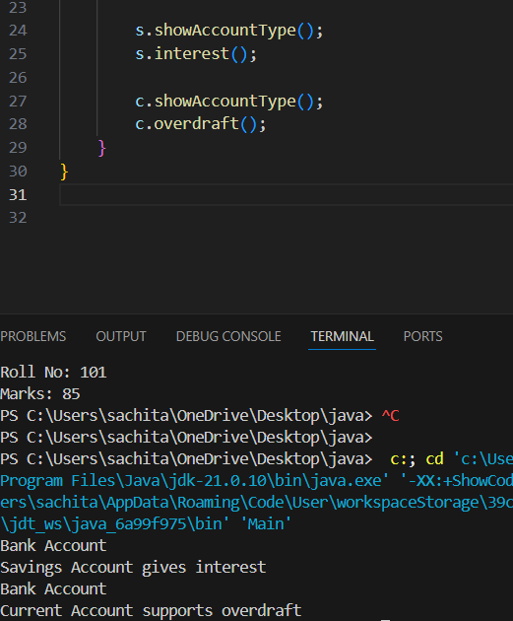


3. Vehicle System (Multilevel Inheritance)
Question:
A company classifies vehicles as Vehicle → Car → ElectricCar.
Code:
class Vehicle {
void start() {
System.out.println("Vehicle starts");
}
}

class Car extends Vehicle {
void fuelType() {
System.out.println("Car uses petrol");
}
}

class ElectricCar extends Car {
void battery() {
System.out.println("Electric car uses battery");
}
}

public class Main {
public static void main(String[] args) {
ElectricCar e = new ElectricCar();
e.start();
e.fuelType();
e.battery();
}
}
Output:
Vehicle starts
Car uses petrol
Electric car uses battery
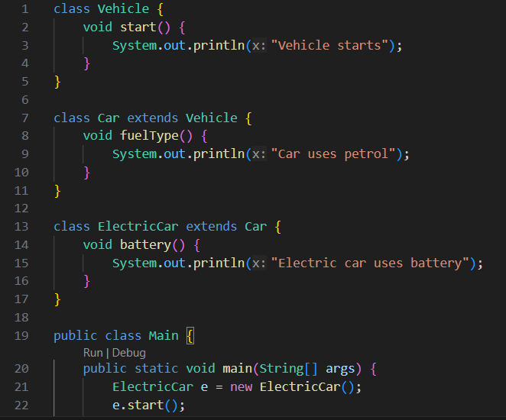
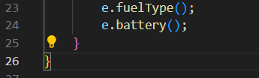
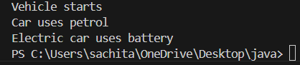

POST LAB EXERCISE
- Why Java does not support multiple inheritance using classes and how it is implemented?
Multiple inheritance means one class inherits from more than one parent class.
Java does NOT support it with classes to avoid ambiguity (Diamond Problem).
Example: If two parent classes have the same method, Java won’t know which one to use.
Instead, Java implements multiple inheritance using interfaces
- What is the role of the super keyword? Give examples.
super refers to the parent class object.
Uses:
- Access parent class variables
- Call parent class methods
- Call parent class constructor
Example:
class Animal {
Animal() {
System.out.println("Animal constructor");
}

void eat() {
System.out.println("Animal eating");
}
}

class Dog extends Animal {
Dog() {
super(); // calls parent constructor
}

void show() {
super.eat(); // calls parent method
}
}
- Can a child class access private members of the parent class? Why?
No.
- Private members are accessible only within the same class.
- They are not inherited by the child class.
- This ensures data hiding and security.
However, they can be accessed indirectly using public methods (getters/setters)

- Explain why hybrid inheritance is not supported in Java.
Hybrid inheritance = combination of multiple + hierarchical inheritance.
Java does not support it with classes because:
- It involves multiple inheritance.
- Leads to ambiguity and complexity (diamond problem).

Result:

Thus the different types of inheritance were implemented and executed successfully.

ASSESSMENT

Description | Max Marks | Marks Awarded
Pre Lab Exercise | 5
In Lab Exercise | 10
Post Lab Exercise | 5
Viva | 10
Total | 30
Faculty Signature

