Experiment Number : 07 Date: 05-02-2026

METHOD OVERLOADING AND METHOD OVERRIDING
Aim:
To understand and implement method overloading and method overriding.
PRE LAB EXERCISE
QUESTIONS
- What is method overloading?
- Method overloading means having multiple methods with the same name in the same class.
- The methods must differ in number, type, or order of parameters.
- It is an example of compile-time polymorphism in Java.
- It improves readability and flexibility by allowing similar operations with different inputs.

- What is method overriding?
- Method overriding occurs when a subclass provides a new implementation for a method already defined in its parent class.
- The method name and parameter list must be exactly the same as in the parent class.
- It is an example of run-time polymorphism in Java.
- It allows subclasses to provide specific behavior based on their requirements.

- Difference between overloading and overriding.

Method Overloading | Method Overriding
Same method name with different parameters. | Same method name with same parameters.
Occurs within the same class. | Occurs between parent and child classes.
Resolved at compile time. | Resolved at run time.
Does not require inheritance. | Requires inheritance.

IN LAB EXERCISE
Objective:
To demonstrate compile-time and runtime polymorphism.
PROGRAMS:
1.Student Result System (Method Overriding)
Description:
- Base class Student has method displayResult().
- Subclasses UGStudent and PGStudent override the method to show different grading systems.

Code :
import java.util.Scanner;

// Base class
class Student {
String name;

void displayResult() {
System.out.println("Student Result");
}
}

// UG Student subclass
class UGStudent extends Student {
int marks;

UGStudent(String n, int m) {
name = n;
marks = m;
}

@Override
void displayResult() {
double percentage = (marks / 100.0) * 100;
System.out.println("UG Student: " + name);
System.out.println("Marks: " + marks);
System.out.println("Percentage: " + percentage + "%");
}
}

// PG Student subclass
class PGStudent extends Student {
double gpa;

PGStudent(String n, double g) {
name = n;
gpa = g;
}

@Override
void displayResult() {
System.out.println("PG Student: " + name);
System.out.println("GPA: " + gpa + " / 10");
}
}

// Main class
public class Main {
public static void main(String[] args) {
Scanner sc = new Scanner(System.in);

// Input for UG student
System.out.print("Enter UG Student Name: ");
String ugName = sc.nextLine();
System.out.print("Enter UG Student Marks (out of 100): ");
int ugMarks = sc.nextInt();
sc.nextLine(); // consume newline

// Input for PG student
System.out.print("Enter PG Student Name: ");
String pgName = sc.nextLine();
System.out.print("Enter PG Student GPA (0-10): ");
double pgGpa = sc.nextDouble();

// Create objects
Student s1 = new UGStudent(ugName, ugMarks);
Student s2 = new PGStudent(pgName, pgGpa);

System.out.println("\n--- Student Results ---");
s1.displayResult();
System.out.println();
s2.displayResult();

sc.close();
}
}
OUTPUT:

Sample Input:
Enter UG Student Name: Ram
Enter UG Student Marks (out of 100): 85
Enter PG Student Name: Ravi
Enter PG Student GPA (0-10): 9.2
Output:
--- Student Results ---
UG Student: Ram
Marks: 85
Percentage: 85.0%
PG Student: Ravi
GPA: 9.2 / 10
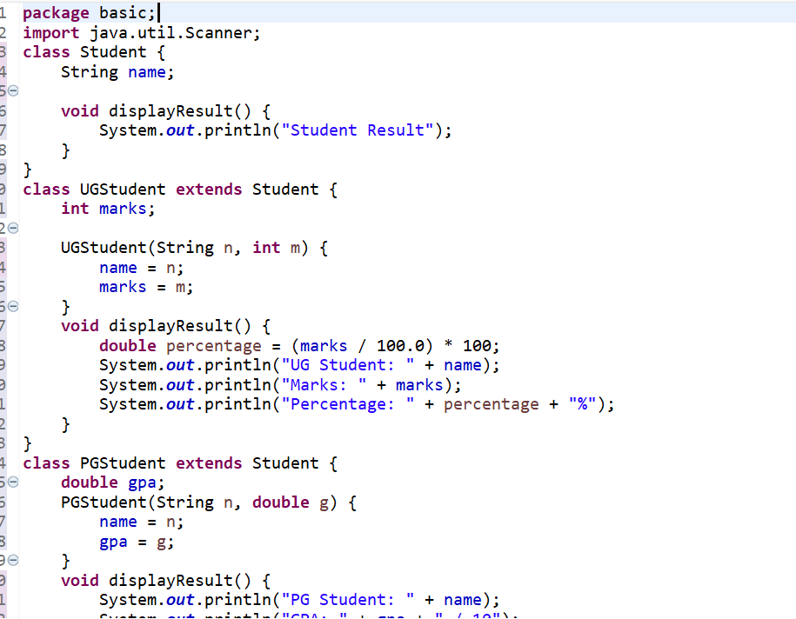
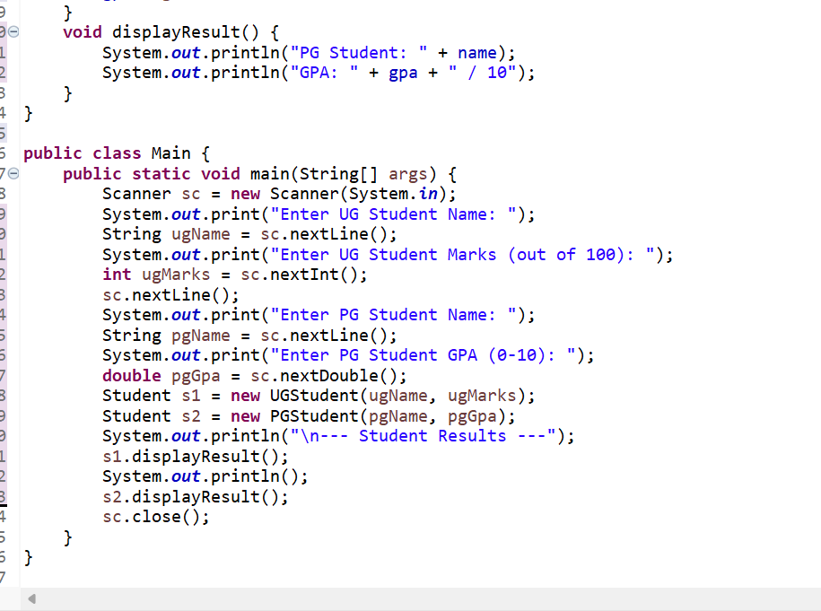

2. Calculator Program (Method Overloading)
Description:
Create a Calculator class with multiple add() methods to calculate:
- Addition of 2 integers
- Addition of 3 integers
- Addition of 2 double numbers
Code:
import java.util.Scanner;
class Calculator {
int add(int a, int b) {
return a + b;
}

int add(int a, int b, int c) {
return a + b + c;
}

double add(double a, double b) {
return a + b;
}
}
public class Main {
public static void main(String[] args) {
Scanner sc = new Scanner(System.in);
Calculator calc = new Calculator();

System.out.print("Enter two integers: ");
int x = sc.nextInt();
int y = sc.nextInt();
System.out.println("Sum of two integers: " + calc.add(x, y));

System.out.print("Enter three integers: ");
int p = sc.nextInt();
int q = sc.nextInt();
int r = sc.nextInt();
System.out.println("Sum of three integers: " + calc.add(p, q, r));

System.out.print("Enter two decimal numbers: ");
double a = sc.nextDouble();
double b = sc.nextDouble();
System.out.println("Sum of two doubles: " + calc.add(a, b));

sc.close();
}
}
Output:
Sample Input:
Enter two integers: 10 20
Enter three integers: 5 10 15
Enter two decimal numbers: 2.5 3.5
Output:
Sum of two integers: 30
Sum of three integers: 30
Sum of two doubles: 6.0
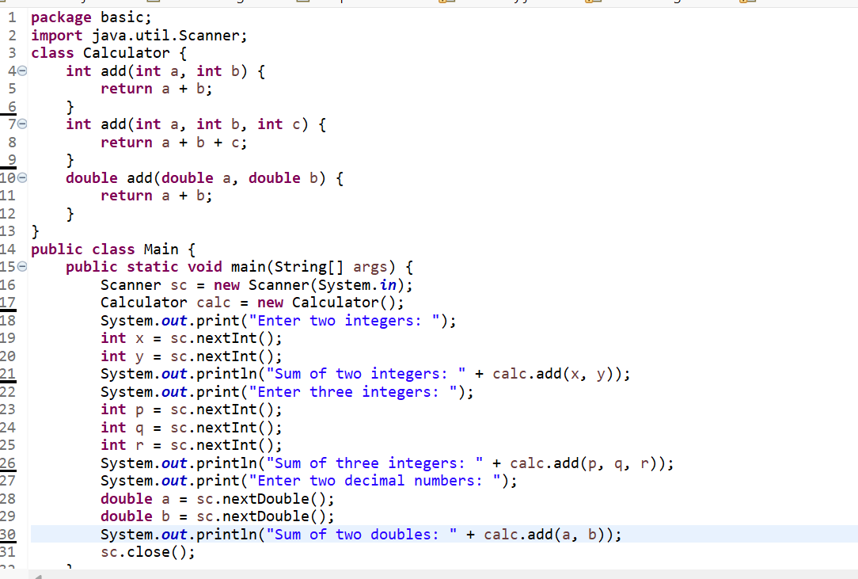
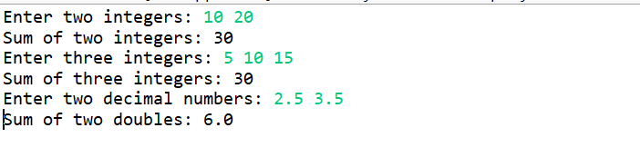

POST LAB EXERCISE
- Is return type important in method overloading and method overriding?
- In method overloading, the return type alone is not considered for distinguishing methods.
- Overloaded methods must differ in parameter list (number/type/order), not just return type.
- In method overriding, the return type must be same or covariant (subtype of parent’s return type).
- If return type rules are violated in overriding, it leads to a compile-time error.

- Can you overload a method by changing only the return type?
- No, a method cannot be overloaded by changing only the return type.
- The compiler identifies overloaded methods based on the method signature, which includes method name and parameter list.
- If only the return type is changed, it causes ambiguity for the compiler.
- Therefore, parameters must be different to achieve valid method overloading.

- Can static methods be overridden? Can they be overloaded?
- Static methods cannot be overridden because they belong to the class, not to the object.
- Defining a static method with the same signature in a subclass is called method hiding, not overriding.
- Static methods can be overloaded by changing the parameter list in the same class.
- Overloading of static methods works the same way as instance method overloading.
- Can a method be overridden if the parameter list is different?
- No, a method cannot be overridden if the parameter list is different.
- For overriding, the method signature (name + parameters) must be exactly the same as in the parent class.
- If the parameter list is different, it becomes method overloading, not overriding.
- This rule ensures correct run-time polymorphism behavior in Java.

Result:
Thus the method overloading and overriding concepts were implemented and executed successfully.
ASSESSMENT

Description | Max Marks | Marks Awarded
Pre Lab Exercise | 5
In Lab Exercise | 10
Post Lab Exercise | 5
Viva | 10
Total | 30
Faculty Signature

