Experiment Number : 06 Date: 05.02.2026

ABSTRACT CLASSES
Aim:
To understand and implement inheritance concepts in Java.
PRE LAB EXERCISE
QUESTIONS
- What is an abstract class?
An abstract class is a class that cannot be instantiated (cannot create objects) and is used as a base class for other classes.
It may contain:
- abstract methods (without body)
- normal methods (with body)
- variables and constructors

- Why are abstract methods used?
Abstract methods are declared without implementation so that child classes must provide their own implementation.
Purpose:
- Enforce method overriding
- Provide a common structure
- Achieve abstraction (hide implementation details)

- Difference between abstract class and interface.
Abstract Class | Interface
Declared using abstract keyword | Declared using interface keyword
Can have abstract + normal methods | Mainly contains abstract methods (Java 8+: can have default/static methods)
Supports constructors | No constructors
Supports variables (instance) | Variables are public, static, final by default
Single inheritance | Multiple inheritance supported
Use extends keyword | Use implements keyword

IN LAB EXERCISE
Objective:
To implement abstract class and demonstrate abstraction.
PROGRAMS:
1.University System
Scenario:
A university has different types of courses: Online, Offline, and Hybrid. Each course has a getDetails() method.
Question:
Create an abstract class Course with abstract method getDetails(). Implement OnlineCourse, OfflineCourse, and HybridCourse classes.
Code:
abstract class Course {
abstract void getDetails();
}

class OnlineCourse extends Course {
void getDetails() {
System.out.println("Online Course: Attend via Internet");
}
}

class OfflineCourse extends Course {
void getDetails() {
System.out.println("Offline Course: Attend in classroom");
}
}

class HybridCourse extends Course {
void getDetails() {
System.out.println("Hybrid Course: Combination of online and offline");
}
}

public class Main {
public static void main(String[] args) {
Course c1 = new OnlineCourse();
Course c2 = new OfflineCourse();
Course c3 = new HybridCourse();

c1.getDetails();
c2.getDetails();
c3.getDetails();
}
}
Output:
Online Course: Attend via Internet
Offline Course: Attend in classroom
Hybrid Course: Combination of online and offline
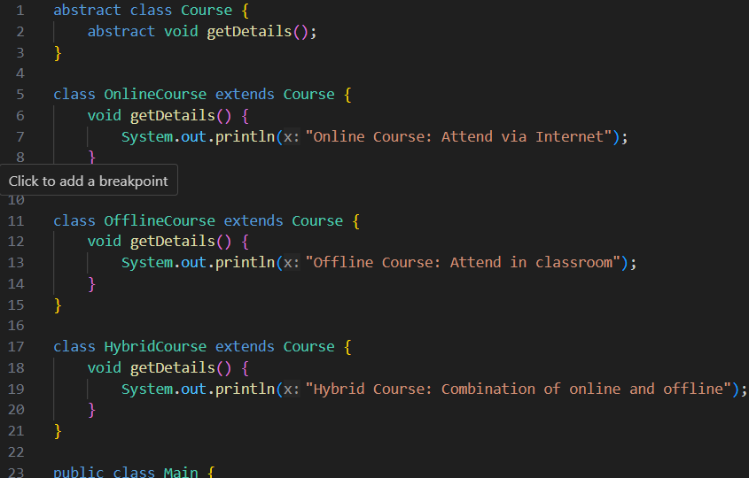
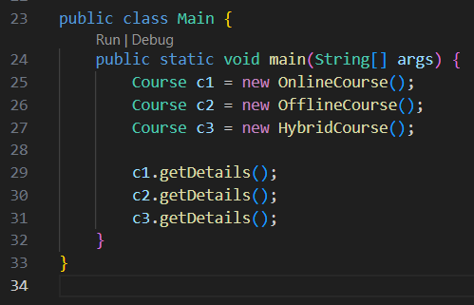
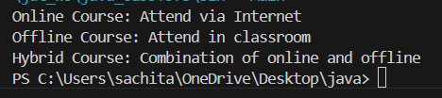
2. Employee Payroll System
Scenario:
A company has different types of employees — Regular and Contract. All employees have a salary, but the calculation differs for each type.
Question:
Design an abstract class Employee with an abstract method calculateSalary(). Implement subclasses RegularEmployee and ContractEmployee to calculate salary differently.
Code:
import java.util.Scanner;
abstract class Employee {
String name;
double baseSalary;

// Abstract method to calculate total salary
abstract void calculateSalary();
}

class RegularEmployee extends Employee {
double bonusRate = 0.1; // 10% bonus

void calculateSalary() {
double totalSalary = baseSalary + (baseSalary * bonusRate);
System.out.println("Regular Employee: " + name);
System.out.println("Base Salary: " + baseSalary);
System.out.println("Total Salary (with 10% bonus): " + totalSalary);
}
}

class ContractEmployee extends Employee {
void calculateSalary() {
System.out.println("Contract Employee: " + name);
System.out.println("Total Salary: " + baseSalary);
}
}

public class Main {
public static void main(String[] args) {
Scanner sc = new Scanner(System.in);

// Input for Regular Employee
System.out.print("Enter Regular Employee Name: ");
String regName = sc.nextLine();
System.out.print("Enter Base Salary: ");
double regSalary = sc.nextDouble();
sc.nextLine(); // Consume newline

// Input for Contract Employee
System.out.print("Enter Contract Employee Name: ");
String conName = sc.nextLine();
System.out.print("Enter Base Salary: ");
double conSalary = sc.nextDouble();

// Create objects
Employee e1 = new RegularEmployee();
e1.name = regName;
e1.baseSalary = regSalary;

Employee e2 = new ContractEmployee();
e2.name = conName;
e2.baseSalary = conSalary;

System.out.println("\n--- Salary Details ---");
e1.calculateSalary();
System.out.println();
e2.calculateSalary();

sc.close();
}
}
Output:
Enter Regular Employee Name: Ram
Enter Base Salary: 30000
Enter Contract Employee Name: Ravi
Enter Base Salary: 20000

--- Salary Details ---
Regular Employee: Anitha
Base Salary: 30000.0
Total Salary (with 10% bonus): 33000.0

Contract Employee: Ravi
Total Salary: 20000.0
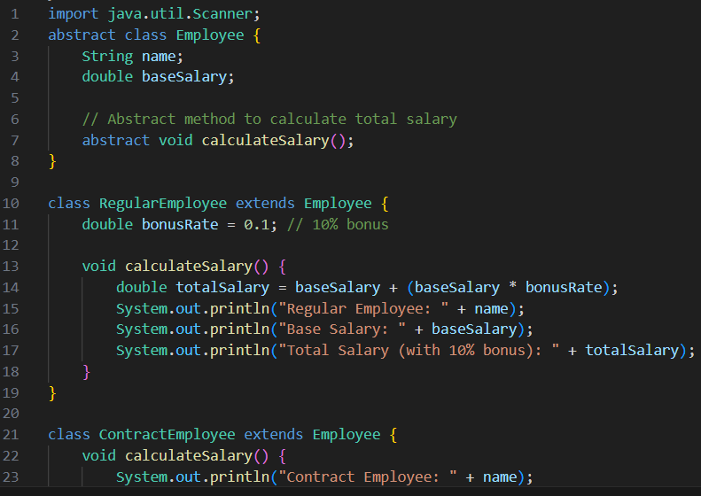
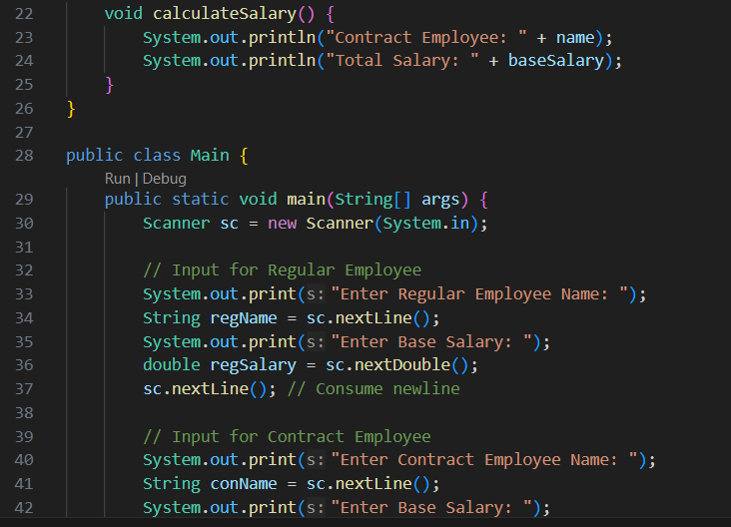
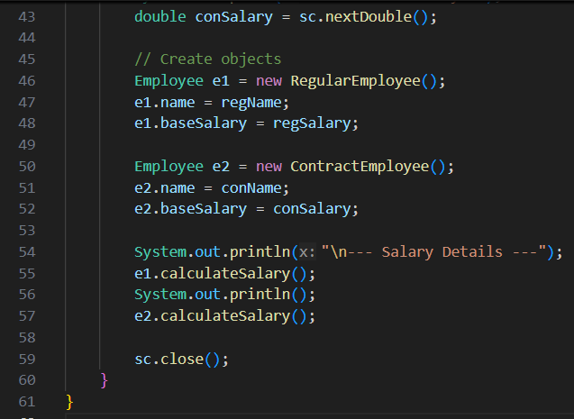
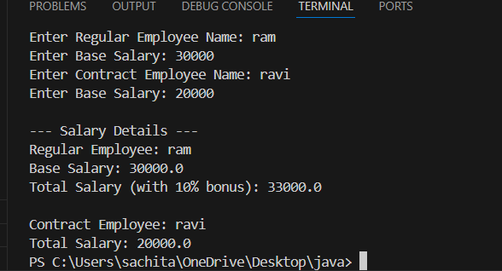
3.Banking System
Scenario:
A bank has different types of accounts: Savings and Current. Both accounts need a method to calculate interest, but the calculation differs for each account type.
Question:
Use an abstract class BankAccount with an abstract method calculateInterest() and implement it in SavingsAccount and CurrentAccount classes.
Code
abstract class BankAccount {
String accountHolder;
double balance;

BankAccount(String name, double bal) {
accountHolder = name;
balance = bal;
}

abstract void calculateInterest(); // Abstract method
}

class SavingsAccount extends BankAccount {
double interestRate = 0.04; // 4% interest

SavingsAccount(String name, double bal) {
super(name, bal);
}

void calculateInterest() {
double interest = balance * interestRate;
System.out.println("Savings Account Interest for " + accountHolder + " = " + interest);
}
}

class CurrentAccount extends BankAccount {
double interestRate = 0.02; // 2% interest

CurrentAccount(String name, double bal) {
super(name, bal);
}

void calculateInterest() {
double interest = balance * interestRate;
System.out.println("Current Account Interest for " + accountHolder + " = " + interest);
}
}

public class Main {
public static void main(String[] args) {
BankAccount acc1 = new SavingsAccount("Ram", 50000);
BankAccount acc2 = new CurrentAccount("Ravi", 80000);

acc1.calculateInterest();
acc2.calculateInterest();
}
}

Output
Savings Account Interest for Ram = 2000.0
Current Account Interest for Ravi = 1600.0
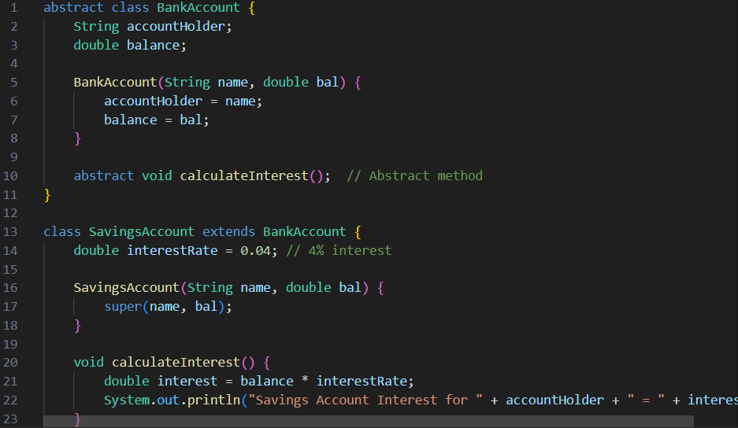
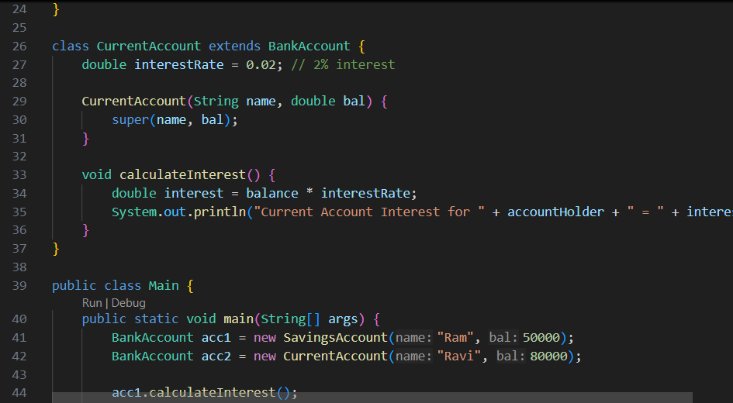
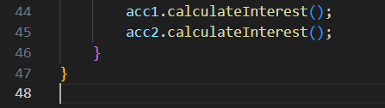


POST LAB EXERCISE
- How is an abstract class different from a regular class?
- Abstract class:
  - Declared using abstract keyword
  - Cannot be instantiated
  - May contain abstract and non-abstract methods
  - Used for inheritance and common structure
- Regular class:
  - Can be instantiated
  - Contains only implemented methods
  - Used to create objects directly

- Can you create an object of an abstract class? Why or why not?
No.
Because abstract classes may contain abstract methods without implementation.
So Java does not allow object creation until a subclass provides the implementation.

- What happens if a subclass does not implement an abstract method?
• The subclass must also be declared as abstract.
• Otherwise, a compilation error occurs.

- Can an abstract class exist without any abstract methods?
• It can contain only normal methods.
• It is still declared abstract to prevent object creation.

- Can an abstract class extend another abstract class?
• One abstract class can inherit from another.
• It may implement some or all abstract methods, or leave them for its subclass.

Result:

Thus the abstract classes and methods were implemented and executed successfully.

ASSESSMENT

Description | Max Marks | Marks Awarded
Pre Lab Exercise | 5
In Lab Exercise | 10
Post Lab Exercise | 5
Viva | 10
Total | 30
Faculty Signature

