Experiment Number : 07 Date: 06.02.2026

METHOD OVERLOADING AND METHOD OVERRIDING
Aim:
To understand and implement method overloading and method overriding.
PRE LAB EXERCISE
QUESTIONS
- What is method overloading?
Method overloading is a feature in OOP where multiple methods have the same name but different parameters (type, number, or order) within the same class.
- It is resolved at compile time.
- Used to perform similar operations with different inputs.

- What is method overriding?
Method overriding occurs when a subclass provides its own implementation of a method that is already defined in the parent class with the same method name, parameters, and return type.
- It is resolved at runtime.
- Used to achieve runtime polymorphism.

- Difference between overloading and overriding.
Basis | Method Overloading | Method Overriding
Definition | Same method name with different parameters | Same method name and parameters in parent and child class
Class requirement | Occurs in the same class | Requires inheritance (parent–child classes)
Parameters | Must be different | Must be same
Return type | May or may not be different | Must be same (or covariant)
Execution time | Compile-time (static binding) | Runtime (dynamic binding)
Purpose | Increase readability and flexibility | Achieve runtime polymorphism
Example | add(int,int) and add(double,double) | Parent sound() and child sound()

IN LAB EXERCISE
Objective:
To demonstrate compile-time and runtime polymorphism.
PROGRAMS:
1.Student Result System (Method Overriding)
Description:
- Base class Student has method displayResult().
- Subclasses UGStudent and PGStudent override the method to show different grading systems.

Code :
import java.util.Scanner;

// Base class
class Student {
String name;

void displayResult() {
System.out.println("Student Result");
}
}

// UG Student subclass
class UGStudent extends Student {
int marks;

UGStudent(String n, int m) {
name = n;
marks = m;
}

@Override
void displayResult() {
double percentage = (marks / 100.0) * 100;
System.out.println("UG Student: " + name);
System.out.println("Marks: " + marks);
System.out.println("Percentage: " + percentage + "%");
}
}

// PG Student subclass
class PGStudent extends Student {
double gpa;

PGStudent(String n, double g) {
name = n;
gpa = g;
}

@Override
void displayResult() {
System.out.println("PG Student: " + name);
System.out.println("GPA: " + gpa + " / 10");
}
}

// Main class
public class Main {
public static void main(String[] args) {
Scanner sc = new Scanner(System.in);

// Input for UG student
System.out.print("Enter UG Student Name: ");
String ugName = sc.nextLine();
System.out.print("Enter UG Student Marks (out of 100): ");
int ugMarks = sc.nextInt();
sc.nextLine(); // consume newline

// Input for PG student
System.out.print("Enter PG Student Name: ");
String pgName = sc.nextLine();
System.out.print("Enter PG Student GPA (0-10): ");
double pgGpa = sc.nextDouble();

// Create objects
Student s1 = new UGStudent(ugName, ugMarks);
Student s2 = new PGStudent(pgName, pgGpa);

System.out.println("\n--- Student Results ---");
s1.displayResult();
System.out.println();
s2.displayResult();

sc.close();
}
}
OUTPUT:

Sample Input:
Enter UG Student Name: Ram
Enter UG Student Marks (out of 100): 85
Enter PG Student Name: Ravi
Enter PG Student GPA (0-10): 9.2
Output:
--- Student Results ---
UG Student: Ram
Marks: 85
Percentage: 85.0%
PG Student: Ravi
GPA: 9.2 / 10
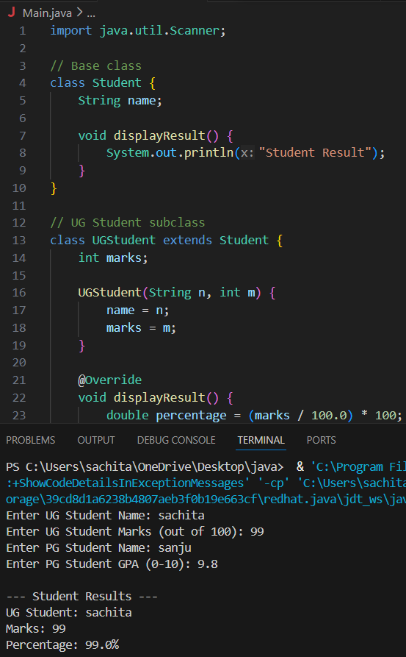
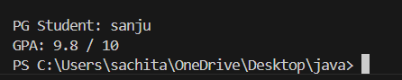

2. Calculator Program (Method Overloading)
Description:
Create a Calculator class with multiple add() methods to calculate:
- Addition of 2 integers
- Addition of 3 integers
- Addition of 2 double numbers
Code:
import java.util.Scanner;
class Calculator {
int add(int a, int b) {
return a + b;
}

int add(int a, int b, int c) {
return a + b + c;
}

double add(double a, double b) {
return a + b;
}
}
public class Main {
public static void main(String[] args) {
Scanner sc = new Scanner(System.in);
Calculator calc = new Calculator();

System.out.print("Enter two integers: ");
int x = sc.nextInt();
int y = sc.nextInt();
System.out.println("Sum of two integers: " + calc.add(x, y));

System.out.print("Enter three integers: ");
int p = sc.nextInt();
int q = sc.nextInt();
int r = sc.nextInt();
System.out.println("Sum of three integers: " + calc.add(p, q, r));

System.out.print("Enter two decimal numbers: ");
double a = sc.nextDouble();
double b = sc.nextDouble();
System.out.println("Sum of two doubles: " + calc.add(a, b));

sc.close();
}
}
Output:
Sample Input:
Enter two integers: 10 20
Enter three integers: 5 10 15
Enter two decimal numbers: 2.5 3.5
Output:
Sum of two integers: 30
Sum of three integers: 30
Sum of two doubles: 6.0
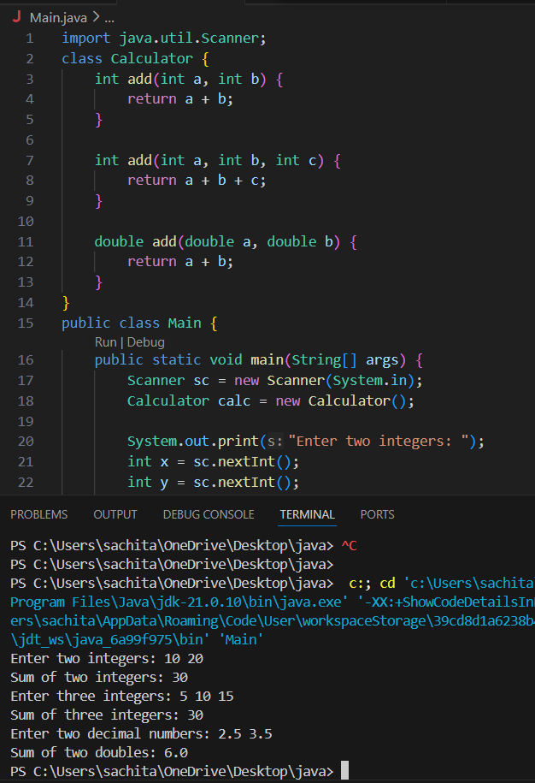

POST LAB EXERCISE
- Is return type important in method overloading and method overriding?
Method Overloading:
- Return type alone is not important.
- Overloading is based on different parameter lists.
- Return type may change, but it cannot be the only difference.
Method Overriding:
- Return type is important.
- The return type must be same or covariant (subclass type) as the parent method.

- Can you overload a method by changing only the return type?
No.
You cannot overload a method by changing only the return type because the compiler cannot differentiate methods based only on return type.
- Can static methods be overridden? Can they be overloaded?
• Static methods cannot be overridden because they belong to the class, not the object.
• They can only be hidden, not overridden.
• Static methods can be overloaded by changing parameters.

- Can a method be overridden if the parameter list is different?
No.
For overriding:
- Method name must be same
- Parameters must be same
- Return type must be same or compatible
If parameters are different, it becomes method overloading, not overriding.

Result:
Thus the method overloading and overriding concepts were implemented and executed successfully.
ASSESSMENT

Description | Max Marks | Marks Awarded
Pre Lab Exercise | 5
In Lab Exercise | 10
Post Lab Exercise | 5
Viva | 10
Total | 30
Faculty Signature

