Experiment Number : 05 Date: 06/02/2026

INHERITANCE
Aim:
To understand and implement inheritance concepts in Java.
PRE LAB EXERCISE
QUESTIONS
- What is inheritance?
Inheritance is a feature in Java where one class (child class) acquires the properties and methods of another class (parent class).

It helps in reusing existing code and creating a relationship between classes.
Example:
class Child extends Parent {}

- What is code reusability?
Code reusability means using already written code again without rewriting it.
In inheritance, a child class can reuse the fields and methods of the parent class, which saves time and reduces duplication.

- What is the use of extends keyword?
The extends keyword is used to inherit the properties and methods of a parent class into a child class.
Syntax:
class ChildClass extends ParentClass {}

It creates an "is-a" relationship between the classes.
Example:
class Result extends Student {}
Here, Result inherits from Student.

IN LAB EXERCISE
Objective:
To implement all types of inheritance.
PROGRAMS:
Student Result System (Single Inheritance)
Question:
A school wants to store student details and calculate marks. Create a base class Student and a derived class Result.
Code:
class Student {
String name;
int rollNo;

void getDetails() {
name = "Anitha";
rollNo = 101;
}
}

class Result extends Student {
int marks = 85;

void display() {
System.out.println("Name: " + name);
System.out.println("Roll No: " + rollNo);
System.out.println("Marks: " + marks);
}
}

public class Main {
public static void main(String[] args) {
Result r = new Result();
r.getDetails();
r.display();
}
}
Output:
Name: RAM
Roll No: 101
Marks: 85

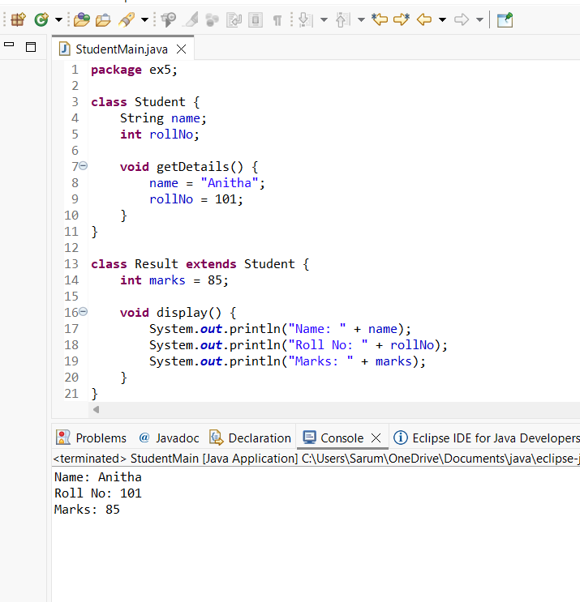

2. Bank Account System (Hierarchical Inheritance)
Question:
A bank has Savings and Current accounts. Both inherit from a common Account class.
Code:
class Account {
void showAccountType() {
System.out.println("Bank Account");
}
}

class SavingsAccount extends Account {
void interest() {
System.out.println("Savings Account gives interest");
}
}

class CurrentAccount extends Account {
void overdraft() {
System.out.println("Current Account supports overdraft");
}
}

public class Main {
public static void main(String[] args) {
SavingsAccount s = new SavingsAccount();
CurrentAccount c = new CurrentAccount();

s.showAccountType();
s.interest();

c.showAccountType();
c.overdraft();
}
}

Output:
Bank Account
Savings Account gives interest
Bank Account
Current Account supports overdraft

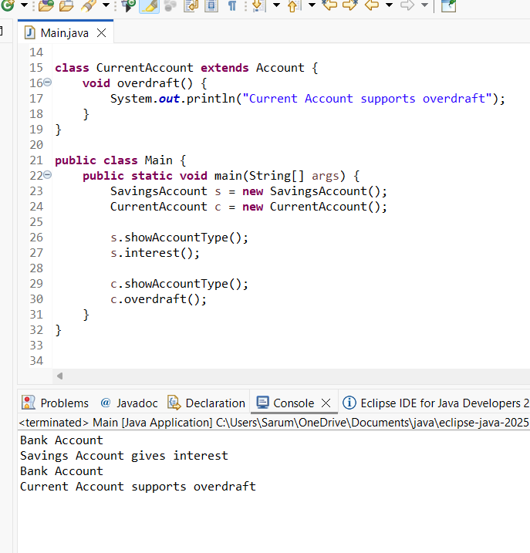

3. Vehicle System (Multilevel Inheritance)
Question:
A company classifies vehicles as Vehicle → Car → ElectricCar.
Code:
class Vehicle {
void start() {
System.out.println("Vehicle starts");
}
}

class Car extends Vehicle {
void fuelType() {
System.out.println("Car uses petrol");
}
}

class ElectricCar extends Car {
void battery() {
System.out.println("Electric car uses battery");
}
}

public class Main {
public static void main(String[] args) {
ElectricCar e = new ElectricCar();
e.start();
e.fuelType();
e.battery();
}
}
Output:
Vehicle starts
Car uses petrol
Electric car uses battery

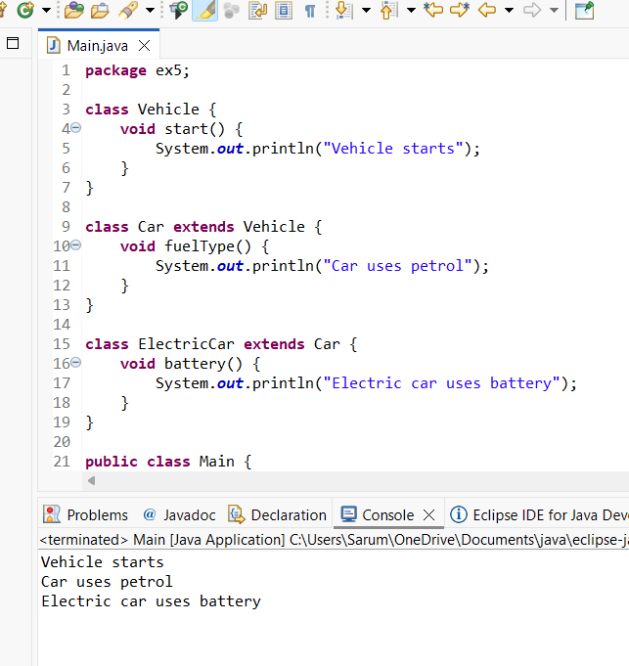

POST LAB EXERCISE
- Why Java does not support multiple inheritance using classes and how it is implemented?
Java does not support multiple inheritance using classes to avoid ambiguity problems (Diamond Problem).
If two parent classes have the same method, the child class will not know which method to inherit.
To solve this problem, Java supports multiple inheritance using interfaces.
Example:
interface A {
void show();
}

interface B {
void display();
}

class C implements A, B {
public void show() {
System.out.println("From A");
}

public void display() {
System.out.println("From B");
}
}
Here, class C inherits from multiple interfaces.

- What is the role of the super keyword? Give examples.
The super keyword is used to refer to the parent class.
It is mainly used to:
Access parent class variables
Call parent class methods
Call parent class constructor
Example 1 – Access parent variable:
class Parent {
int x = 10;
}

class Child extends Parent {
void show() {
System.out.println(super.x);
}
}

- Can a child class access private members of the parent class? Why?
No, a child class cannot directly access private members of the parent class.
Because private members are accessible only within the same class.
However, they can be accessed indirectly using public getter and setter methods.

- Explain why hybrid inheritance is not supported in Java.
Hybrid inheritance is a combination of more than one type of inheritance (like multiple + multilevel).
Java does not support hybrid inheritance using classes because it includes multiple inheritance, which may cause ambiguity.
However, hybrid inheritance can be achieved using interfaces.

Result:

Thus the different types of inheritance were implemented and executed successfully.

ASSESSMENT

Description | Max Marks | Marks Awarded
Pre Lab Exercise | 5
In Lab Exercise | 10
Post Lab Exercise | 5
Viva | 10
Total | 30
Faculty Signature

