Experiment Number : 05 Date: 05-02-2026

INHERITANCE
Aim:
To understand and implement inheritance concepts in Java.
PRE LAB EXERCISE
QUESTIONS
- What is inheritance?
Inheritance: This is the process by which a class picks up the characteristics and actions of another class.
- What is code reusability?
Code reusability: It minimises redundancy by enabling the reuse of existing code in new programs.
- What is the use of extends keyword?
- In Java, a child class uses the extends keyword to inherit another class.

IN LAB EXERCISE
Objective:
To implement all types of inheritance.
PROGRAMS:
Student Result System (Single Inheritance)
Question:
A school wants to store student details and calculate marks. Create a base class Student and a derived class Result.
Code:
class Student {
String name;
int rollNo;

void getDetails() {
name = "Anitha";
rollNo = 101;
}
}

class Result extends Student {
int marks = 85;

void display() {
System.out.println("Name: " + name);
System.out.println("Roll No: " + rollNo);
System.out.println("Marks: " + marks);
}
}

public class Main {
public static void main(String[] args) {
Result r = new Result();
r.getDetails();
r.display();
}
}
Output:
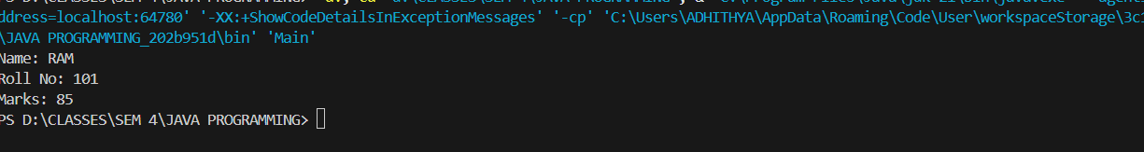
2. Bank Account System (Hierarchical Inheritance)
Question:
A bank has Savings and Current accounts. Both inherit from a common Account class.
Code:
class Account {
void showAccountType() {
System.out.println("Bank Account");
}
}

class SavingsAccount extends Account {
void interest() {
System.out.println("Savings Account gives interest");
}
}

class CurrentAccount extends Account {
void overdraft() {
System.out.println("Current Account supports overdraft");
}
}

public class Main {
public static void main(String[] args) {
SavingsAccount s = new SavingsAccount();
CurrentAccount c = new CurrentAccount();

s.showAccountType();
s.interest();

c.showAccountType();
c.overdraft();
}
}

Output:

3. Vehicle System (Multilevel Inheritance)
Question:
A company classifies vehicles as Vehicle → Car → ElectricCar.
Code:
class Vehicle {
void start() {
System.out.println("Vehicle starts");
}
}

class Car extends Vehicle {
void fuelType() {
System.out.println("Car uses petrol");
}
}

class ElectricCar extends Car {
void battery() {
System.out.println("Electric car uses battery");
}
}

public class Main {
public static void main(String[] args) {
ElectricCar e = new ElectricCar();
e.start();
e.fuelType();
e.battery();
}
}
Output:
POST LAB EXERCISE
- Why Java does not support multiple inheritance using classes and how it is implemented?
It is implemented safely using interfaces to avoid ambiguity and complexity such as the diamond problem.
- What is the role of the super keyword? Give examples.
The super keyword's function is to access constructors, methods, and variables of the parent class (e.g., super();, super.name).
- Can a child class access private members of the parent class? Why?
No, since private members can only be encapsulated within the same class.
- Explain why hybrid inheritance is not supported in Java.
Because Java only permits hybrid behaviour through interfaces, avoiding ambiguity and complexity.

Result:

Thus the different types of inheritance were implemented and executed successfully.

ASSESSMENT

Description | Max Marks | Marks Awarded
Pre Lab Exercise | 5
In Lab Exercise | 10
Post Lab Exercise | 5
Viva | 10
Total | 30
Faculty Signature

