Experiment Number : 04 Date: 05/02/2026

ARRAYS
Aim:
To understand and implement array operations in Java.
PRE LAB EXERCISE
QUESTIONS:
- What is an array?
An array is a collection of elements of the same data type stored in contiguous memory locations. It is used to store multiple values in a single variable, and each value can be accessed using an index number.
- Why are arrays used?
Arrays are used to store and manage multiple values of the same type efficiently. They help in:
- Reducing the number of variables needed
- Easy access to elements using index
- Simplifying operations like sorting and searching
- Efficient memory management and data handling

- What is the difference between array and variable?
Variable | Array
Stores only one value at a time | Stores multiple values of same type
Declared with a single name and data type | Declared with data type and size
Uses less memory | Uses more memory (for multiple elements)
Accessed directly by name | Accessed using index (like arr[0], arr[1])

IN LAB EXERCISE
Objective:
To perform array operations using simple programs.
PROGRAMS:
1. Program to Read and Print Array Elements
Code:
import java.util.Scanner;
public class ReadPrintArray {
public static void main(String[] args) {
Scanner sc = new Scanner(System.in);
int[] arr = new int[5];
System.out.println("Enter 5 elements:");
for(int i = 0; i < 5; i++)
arr[i] = sc.nextInt();
System.out.println("Array elements are:");
for(int i = 0; i < 5; i++)
System.out.print(arr[i] + " ");
}
}
OUTPUT:
Input:
10 20 30 40 50
Output:
Array elements are:
10 20 30 40 50
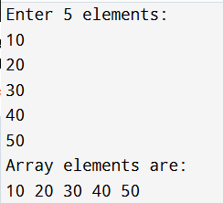

2. Program to Find Sum of Array Elements
Code:
import java.util.Scanner;
public class SumArray {
public static void main(String[] args) {
Scanner sc = new Scanner(System.in);
int[] arr = new int[5];
int sum = 0;
System.out.println("Enter 5 elements:");
for(int i = 0; i < 5; i++)
arr[i] = sc.nextInt();
for(int i = 0; i < 5; i++)
sum += arr[i];
System.out.println("Sum = " + sum);
}
}
OUTPUT:
Input:
5 10 15 20 25
Output:
Sum = 75
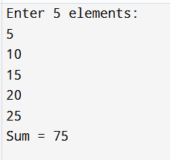

3. Program to Find Largest Element in an Array
Code:
import java.util.Scanner;
public class LargestElement {
public static void main(String[] args) {
Scanner sc = new Scanner(System.in);
int[] arr = new int[5];
System.out.println("Enter 5 elements:");
for(int i = 0; i < 5; i++)
arr[i] = sc.nextInt();
int max = arr[0];
for(int i = 1; i < 5; i++)
if(arr[i] > max)
max = arr[i];
System.out.println("Largest element = " + max);
}
}
OUTPUT:
Input:
12 45 23 9 30
Output:
Largest element = 45
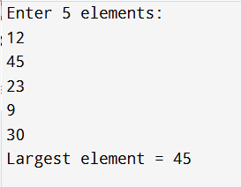

4. Program to Reverse an Array
Code:
import java.util.Scanner;

public class ReverseArray {
public static void main(String[] args) {
Scanner sc = new Scanner(System.in);
int[] arr = new int[5];
System.out.println("Enter 5 elements:");
for(int i = 0; i < 5; i++)
arr[i] = sc.nextInt();
System.out.println("Reversed array:");
for(int i = 4; i >= 0; i--)
System.out.print(arr[i] + " ");
}
}
OUTPUT:
Input:
1 2 3 4 5
Output:
Reversed array:
5 4 3 2 1
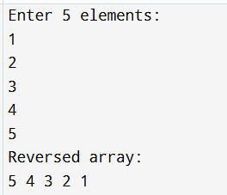

5. Program to Count Even and Odd Numbers
Code:
import java.util.Scanner;
public class EvenOddCount {
public static void main(String[] args) {
Scanner sc = new Scanner(System.in);
int[] arr = new int[5];
int even = 0, odd = 0;
System.out.println("Enter 5 elements:");
for(int i = 0; i < 5; i++)
arr[i] = sc.nextInt();
for(int i = 0; i < 5; i++) {
if(arr[i] % 2 == 0)
even++;
else
odd++;
}

System.out.println("Even = " + even);
System.out.println("Odd = " + odd);
}
}
OUTPUT:
Input:
2 7 4 9 10
Output:
Even = 3
Odd = 2
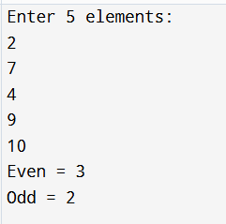

6. Program to Sort Array in Ascending Order
Code:
import java.util.Scanner;
public class SortArray {
public static void main(String[] args) {
Scanner sc = new Scanner(System.in);
int[] arr = new int[5];
int temp;
System.out.println("Enter 5 elements:");
for(int i = 0; i < 5; i++)
arr[i] = sc.nextInt();
for(int i = 0; i < 5; i++) {
for(int j = i + 1; j < 5; j++) {
if(arr[i] > arr[j]) {
temp = arr[i];
arr[i] = arr[j];
arr[j] = temp;
}
}
}
System.out.println("Sorted array:");
for(int i = 0; i < 5; i++)
System.out.print(arr[i] + " ");
}
}
OUTPUT:
Input:
45 12 78 23 9
Output:
Sorted array:
9 12 23 45 78
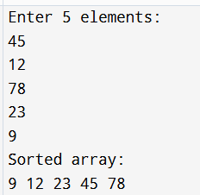

7. Program to Find Second Largest Element
Code:
import java.util.Scanner;
public class SecondLargest {
public static void main(String[] args) {
Scanner sc = new Scanner(System.in);
int[] arr = new int[5];

System.out.println("Enter 5 elements:");
for(int i = 0; i < 5; i++)
arr[i] = sc.nextInt();
int largest = arr[0];
int second = arr[0];
for(int i = 0; i < 5; i++) {
if(arr[i] > largest) {
second = largest;
largest = arr[i];
}
}
System.out.println("Second largest = " + second);
}
}
OUTPUT:
Input:
10 45 23 89 67
Output:
Second largest = 67
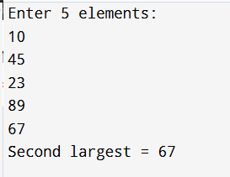

8. Program for Matrix Addition (2D Array)
Code:
import java.util.Scanner;
public class MatrixAddition {
public static void main(String[] args) {
Scanner sc = new Scanner(System.in);
int[][] a = new int[2][2];
int[][] b = new int[2][2];
int[][] sum = new int[2][2];
System.out.println("Enter elements of matrix A:");
for(int i = 0; i < 2; i++)
for(int j = 0; j < 2; j++)
a[i][j] = sc.nextInt();
System.out.println("Enter elements of matrix B:");
for(int i = 0; i < 2; i++)
for(int j = 0; j < 2; j++)
b[i][j] = sc.nextInt();
for(int i = 0; i < 2; i++)
for(int j = 0; j < 2; j++)
sum[i][j] = a[i][j] + b[i][j];
System.out.println("Sum matrix:");
for(int i = 0; i < 2; i++) {
for(int j = 0; j < 2; j++)
System.out.print(sum[i][j] + " ");
System.out.println();
}
}
}
OUTPUT:
Matrix A:
1 2
3 4
Matrix B:
5 6
7 8
Sum matrix:
6 8
10 12
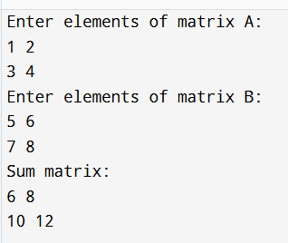

POST LAB EXERCISE
- Why is array indexing usually started from zero instead of one?
Array indexing starts from zero because the index represents the offset from the first memory location. The first element is stored at the base address, so its offset is 0. This makes calculations faster and easier for the computer.

- What happens if we try to access an array element outside its declared size?
If we access an element outside the array size, it results in an error. In Java, it throws an ArrayIndexOutOfBoundsException, which stops the program execution if not handled.

- How does memory allocation differ for static arrays and dynamic arrays?
- Static arrays: Memory size is fixed at the time of declaration and cannot be changed during execution.
- Dynamic arrays: Memory size can be changed during runtime (can grow or shrink), allowing flexible storage.

- Why is searching faster in arrays compared to linked lists?
Searching is faster in arrays because elements are stored in continuous memory locations, allowing direct access using an index. In linked lists, elements are stored in different locations and must be accessed sequentially, which takes more time.

- What is the difference between contiguous and non-contiguous memory allocation?
Contiguous Memory Allocation | Non-Contiguous Memory Allocation
Memory locations are continuous | Memory locations are scattered
Used in arrays | Used in linked lists
Faster access to elements | Slower access
Simple implementation | Complex implementation
Example: Array | Example: Linked List

Result:

Thus the array operations were executed successfully.

ASSESSMENT

Description | Max Marks | Marks Awarded
Pre Lab Exercise | 5
In Lab Exercise | 10
Post Lab Exercise | 5
Viva | 10
Total | 30
Faculty Signature

